ERCIYES UNIVERSITY FACULTY OF ENGINEERING DEPARTMENT OF SOFTWARE ENGINEERING



DATA SCIENCE FINAL PROJECT

AUTOMATED CYBERBULLYING DETECTION ON SOCIAL MEDIA:
A COMPARATIVE ANALYSIS OF DISTILBERT AND TRADITIONAL ML MODELS

PREPARED BY:
Ardil SUNGU
Student ID: 1031510019

Abstract
The exponential growth of social media has led to a significant increase in cyberbullying incidents, creating an urgent need for automated detection systems. This study aims to detect and classify cyberbullying content in text data by comparing traditional Machine Learning algorithms (Logistic Regression, SVM) with a modern Deep Learning architecture (DistilBERT). Using a dataset of approximately 47,000 tweets labeled with specific bullying types (e.g., racism, sexism, religion), the models were trained and evaluated based on Accuracy, Precision, Recall, and F1-Score metrics. The experimental results demonstrate that the DistilBERT model achieved the highest performance with an accuracy of 86%, significantly outperforming Logistic Regression (82%) and SVM (81%). Furthermore, the study highlights that while all models perform well on explicit hate speech, contextual models like DistilBERT provide superior results in detecting implicit bullying (e.g., irony, sarcasm). These findings suggest that transformer-based architectures are essential for effective moderation systems in complex social media environments.
Keywords: Cyberbullying Detection, NLP, DistilBERT, Machine Learning, Text Classification.
1. Introduction
1.1. General Introduction
The exponential increase in the use of social media platforms today has fundamentally changed the way individuals communicate. However, while digitalization has facilitated communication, it has also paved the way for the spread of malicious behaviors such as "cyberbullying.". With the massive data traffic generated by billions of users, manually detecting messages containing insults, threats, and harassment has become impossible. This has made the development of automated detection systems a necessity.
1.2. Problem Definition
The biggest technical challenge in detecting cyberbullying is the complex structure of natural language. Traditional and simple machine learning algorithms often fail to distinguish irony, slang, or contextual insults within text, yielding low accuracy rates. This project goes beyond standard approaches, addressing the need for a modeling approach that processes text data more efficiently and improves classification success.
1.3. Importance of the Study
The importance of this study lies in both social and technical dimensions. From a practical standpoint, the developed system aims to prevent psychological harm to victims by enabling the detection and filtering of bullying content on social media platforms within seconds. From a technical standpoint, it contributes to the literature by comparing the performance of different machine learning algorithms and revealing which model provides more reliable results in this field.
1.4. Purpose and Scope
This study encompasses the detection and classification of cyberbullying using Natural Language Processing (NLP) techniques on social media data. The study not only categorizes texts as "containing bullying" or "not containing bullying," but also identifies the type of bullying (e.g., sexism, racism, age discrimination, attacks on religious values, etc.). This lays the groundwork for taking more specific measures depending on the nature of the toxic content detected.

2. Aim of the Project
The main goal of the project is to develop a highly accurate automated system that not only detects but also analyzes the content of cyberbullying on social media platforms in order to prevent it.
Accordingly, the specific and measurable objectives of the project are as follows:
- Applying data preprocessing steps to a comprehensive dataset for the analysis of texts containing cyberbullying.
- To overcome the shortcomings of traditional methods, machine learning models should be trained to distinguish cyberbullying by its subtypes
- Comparison of Accuracy, Precision, Sensivity, and F1-Score performance for each type (class) of bullying across the models.
- Providing a model architecture that will facilitate moderation processes and contribute to cleaning up social media by also reporting the type of cyberbullying.

3. Literature Review
3.1. Summary of Previous Studies
Cyberbullying detection has become one of the most actively researched topics in the fields of Machine Learning (ML) and Natural Language Processing (NLP) over the last decade. In early studies, researchers generally focused on traditional supervised learning algorithms such as Naive Bayes, Support Vector Machines (SVM), and Logistic Regression. In these studies, texts were often converted into numerical vectors using "Bag-of-Words" (BoW) or "TF-IDF" methods. However, in recent years, with the introduction of Deep Learning approaches (CNN, BiLSTM) and especially Transformer-based models (BERT, RoBERTa), contextual analysis of texts has become more successful, and classification accuracy has significantly increased..
3.2. Datasets Used in Earlier Research
One of the biggest shortcomings in the literature is the scarcity of tagged and balanced datasets. Research often uses raw data pulled from Wikipedia Talk Pages or the Twitter API. However, the dataset used in this study, introduced to the literature by J. Wang et al., stands out by categorizing cyberbullying not just as "present/absent," but also according to its types (racism, sexism, etc.). This dataset contains approximately 47,000 tagged tweets and is one of the rare sources that minimizes the class imbalance problem compared to other datasets in the literature (e.g., Formspring, MySpace).
3.3. Methods Applied
Different methods have been compared in studies conducted on similar datasets.:
- Traditional Methods: SVM and Naive Bayes algorithms, when used with TF-IDF feature extraction, generally exhibited an accuracy in the 70-80% band.
- Deep Learning: Bi-LSTM and CNN models, when combined with word embedding techniques (Word2Vec, GloVe), increased this rate to levels of 85%.
- SOTA (State-of-the-Art): Current studies report that models like BERT achieve over 90% success, especially in complex sentences containing "indirect aggression".
3.4. Strengths and Limitations of Past Studies
The strength of past studies is their high success in detecting messages containing explicit insults. However, their biggest limitation is their failure to distinguish implicit bullying types containing irony, humor, or slang10. Furthermore, most studies have remained limited to "Binary Classification" (Bullying Present/Absent) and have been insufficient in detecting the type of bullying (Multiclass).
3.5. Novelty and Contribution of Your Study
The contribution of this study to the literature is addressing cyberbullying with a multi-class classification approach, detecting not only the presence of bullying but also its type (Religion, Age, Gender, Ethnicity, etc.)12. Additionally, by comparatively analyzing the performances of traditional machine learning algorithms in this complex classification problem, it provides detailed insight into which model better captures which type of bullying.

4. Materials
4.1. Dataset Description
This project utilized the "Cyberbullying Classification Dataset," compiled by J. Wang et al., which is considered a standard in cyberbullying detection research.
- Total Number of Samples: 47.692 tweet.
- Data Source: Kaggle (Original source: Twitter data).
- Data Type: Text data.
- Class Distribution): The dataset is divided into 6 different classes and has a fairly balanced distribution:
  - Age (Ageism)
  - Ethnicity (Racism)
  - Gender (Sexism)
  - Religion (Attacks on Religious Values)
  - Other Cyberbullying
  - Not Cyberbullying
4.2. Data Properties & Pre-processing
To maximize model performance, two different preprocessing pipelines have been designed, specific to the architecture being used (Traditional ML vs. BERT).
A. Pipeline for Traditional ML
Extensive cleaning and normalization have been applied to ensure that traditional algorithms (Naive Bayes, Random Forest, etc.) are not affected by data sparsity:
- Noise Removal: URLs, HTML tags (&lt;), user tags (@user), and Retweet tags (RT) have been cleaned using Regex..
- Text Enrichment :
  - Hashtag Decomposition: Hashtags written together (e.g., #ImACelebrity) are broken down into individual words (e.g., Im A Celebrity) using PascalCase.
  - Emoji Translation: Keyboard emojis and Unicode emojis (e.g., 😂) have been translated into their textual equivalents (e.g., :joy:) using the emoji library, thus preserving the emotion information.
  - Slang Expansion: Social media slang and abbreviations (e.g., lol, idk) have been translated into their full forms using a dictionary-based matching tool..
- Normalization:
  - All letters have been converted to lowercase..
  - The letter lengthenings in those words (e.g., cooooool -> cool) have been corrected using regex.
  - The abbreviations (Contractions) have been expanded (e.g., won't -> will not).
- Filtering & Lemmatization:
  - All punctuation marks and numbers have been removed.
  - Non-meaningful "stopwords" (conjunctions, etc.) have been removed, but negative suffixes (not, never) and personal pronouns (I, you) have been retained so that the model does not lose context.
  - In the final step, Lemmatizer was used to reduce the words to their root words..
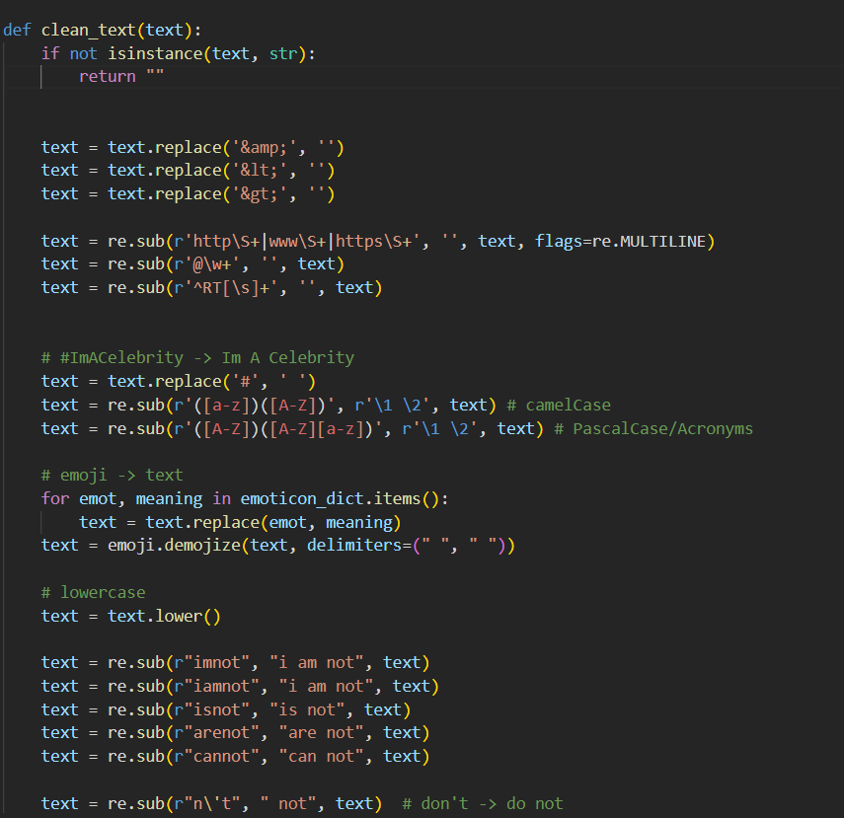
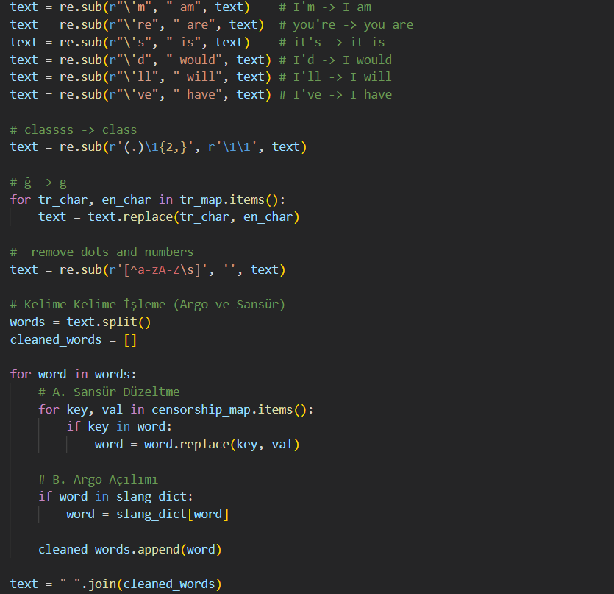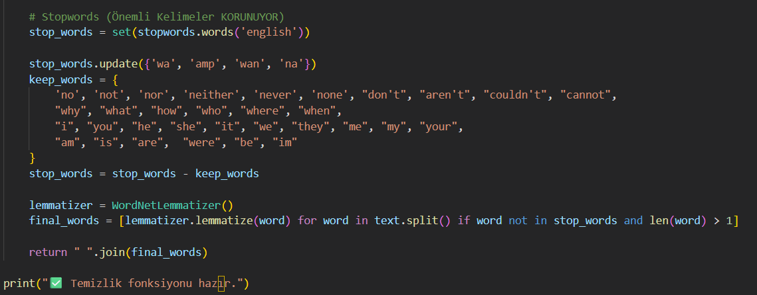

B. Pipeline for BERT:
Since Transformer-based models like BERT require context and syntax for the sentence, a more "minimalist" cleanup has been applied.:
- Context Preservation: Punctuation marks (., !, ?, ') have been preserved because they convey the emphasis and mood of the sentence.
- Structure Cleaning: Only URLs, HTML tags, and user tags have been cleaned; "Stopwords" (ineffective words) have not been removed.
- Formatting: The text has been converted to lowercase (uncased) and unnecessary whitespace has been normalized.
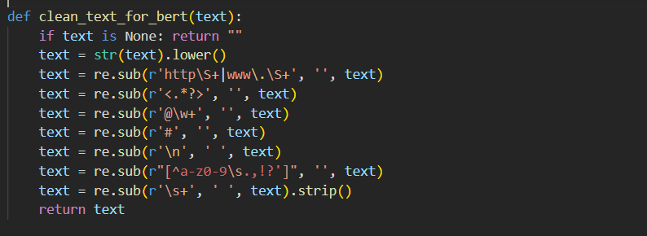

5. Methods
5.1. Data Splitting
To accurately measure the model's generalization ability and to perform parameter optimization during training, the dataset was divided into three parts: 70% Training, 15% Validation, and 15% Testing.
- Training Set (%70): Approximately 33,384 tweets. This is the main dataset used for the model to learn its weights.
- Validation Set (%15): Approximately 7,154 tweets. Used during the training process to measure the model's performance with interim assessments (midterm exams) and to optimize hyperparameter settings.
- Test Set (%15): 7,154 tweet. After the model's training is complete, it is set to report its final accuracy on data it has never seen before.
5.2. Machine Learning & Deep Learning Models
In this study, three different architectures were used for the purpose of performance comparison:
- Logistic Regression: It has been chosen as a basic classification algorithm. It aims to perform a linear separation based on the frequencies of words by running on TF-IDF vectors.
- SVM (Support Vector Machine - Linear SVC): SVM, which performs particularly well with high-dimensional text data, was used to create the hyperplane that finds the widest margin among classes.
- DistilBERT (Distilled BERT): Unlike traditional models, this is a Transformer-based deep learning model that focuses not only on the frequency of words but also on their context within a sentence. It was chosen because it is a lighter and faster version of BERT.

5.3. Libraries Used
The project was developed using the Python programming language. The libraries utilized in this study are categorized by their primary functions as follows:
Data Manipulation and Preprocessing:
- Pandas & NumPy: Used for data frame manipulation, numerical operations, and handling large datasets.
- Re (Regular Expressions): Utilized for advanced text cleaning patterns (removing URLs, HTML tags).
- Emoji: Used to convert emojis into their text descriptions (e.g., converting "😂" to ":joy:") to preserve semantic meaning.
Natural Language Processing (NLP):
- NLTK (Natural Language Toolkit): Employed for traditional text processing steps such as Stopword removal and Lemmatization (WordNetLemmatizer).
- Transformers (Hugging Face): Used to implement the pre-trained DistilBERT model (DistilBertForSequenceClassification) and its specific tokenizer.
- WordCloud: Used for visualizing the most frequent words in different cyberbullying categories.
Machine Learning & Deep Learning:
- Scikit-learn: Used for implementing traditional algorithms (Logistic Regression, LinearSVC), feature extraction (TfidfVectorizer), and data splitting (train_test_split).
- PyTorch (Torch): The underlying deep learning framework used to train and optimize the DistilBERT model on the GPU.
Evaluation & Visualization:
- Matplotlib & Seaborn: Used for plotting confusion matrices, class distribution graphs, and training loss curves.
- Scikit-learn Metrics: Utilized for calculating accuracy, precision, recall, and generating the classification report.

5.4. İmplementation Details & Hyperparameters
All experiments were conducted in a Python environment utilizing GPU acceleration to optimize the training of deep learning models.
Preprocessing: A custom text cleaning function was implemented for DistilBERT that removes HTML tags, URLs, and user mentions while preserving punctuation marks (.,!?) to maintain the semantic context required for transformer models.
Model Configuration: For the DistilBERT model, the pre-trained distilbert-base-uncased checkpoint from Hugging Face was fine-tuned using the following specific hyperparameters:
The model implementation relies on the Hugging Face ecosystem, which is currently the leading open-source platform for Natural Language Processing (NLP). Hugging Face serves as a central hub that hosts pre-trained transformer models and provides the necessary infrastructure (the Transformers library) to download, fine-tune, and deploy these architectures efficiently.
- Batch Size: 16 (for both training and evaluation)
- Epochs: 3
- Warmup Steps: 500
- Weight Decay: 0.01
- Precision: Mixed Precision (FP16) was enabled to reduce memory usage and speed up training.
- Max Sequence Length: 128 tokens
The dataset was stratified and split into 70% Training, 15% Validation, and 15% Test sets. The model with the best performance on the validation set was saved and used for final testing.

6. Results
This section presents the performance metrics obtained on the test set (7154 samples).
6.1. Performance Comparison
The overall accuracy rates and weighted average F1 scores for the three models are summarized in the table below. The DistilBERT model demonstrated the highest performance with an accuracy rate of 86%.
Model | Accuracy | Precision | Recall | F1-Score
Logistic Regression | 0.82 | 0.83 | 0.82 | 0.82
SVM (Linear SVC) | 0.81 | 0.82 | 0.81 | 0.81
DistilBERT | 0.86 | 0.86 | 0.86 | 0.86

6.2. Class-Based Performance
The success of the models varied depending on the type of cyberbullying.
- Most Successful Classes: All three models achieved near-perfect success rates of 97-98% in the "Ethnicity" and "Religion" classes. The presence of distinct keywords in these classes (such as "muslim" and "nigger" as seen in Word Cloud analysis) facilitated detection..
- Hardest Classes: The classes that the models struggled with the most were "Not_cyberbullying" and "Other_cyberbullying". Logistic Regression proved quite weak in detecting the "not_cyberbullying" class (Recall: 0.49).

Class (Cyberbullying Type) | Precision | Recall | F1-Score | Support
Age | 0.97 | 0.98 | 0.97 | 1199
Ethnicity | 0.98 | 0.99 | 0.98 | 1194
Gender | 0.89 | 0.90 | 0.90 | 1193
Not Cyberbullying | 0.69 | 0.59 | 0.63 | 1179
Other Cyberbullying | 0.68 | 0.76 | 0.72 | 1149
Religion | 0.96 | 0.96 | 0.96 | 1200
Accuracy |  |  | 0.86 | 7114
Macro Average | 0.86 | 0.86 | 0.86 | 7114
Weighted Average | 0.86 | 0.86 | 0.86 | 7114

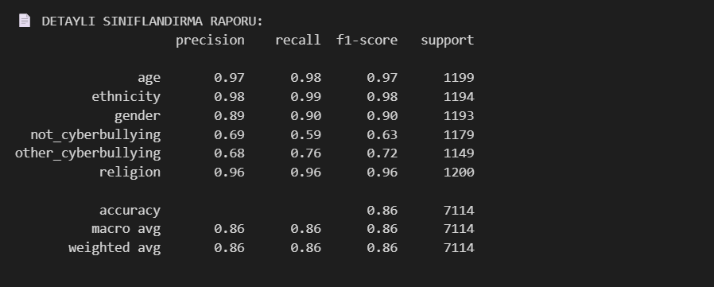
Raw Output of DistilBERT Classification Report (Test Set)

6.3. Confusion Matrix Analysis
When complexity matrices are examined:
- Logistic Regression & SVM: The "Other_cyberbullying" class was frequently confused with "Not_cyberbullying". For example, Logistic Regression mistakenly labeled 250 instances of "other bullying" as "no bullying".

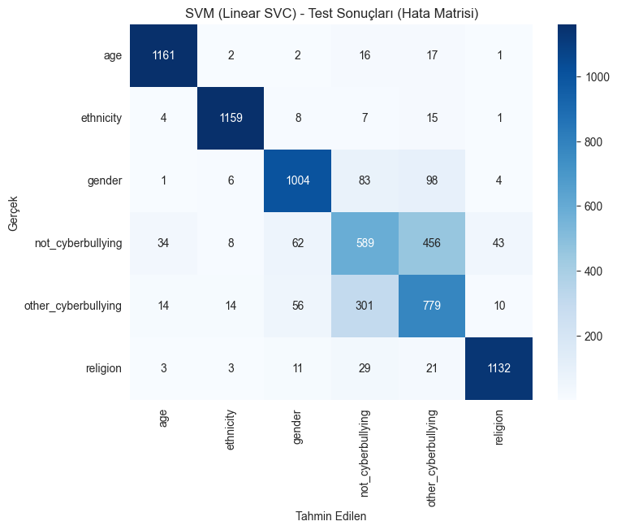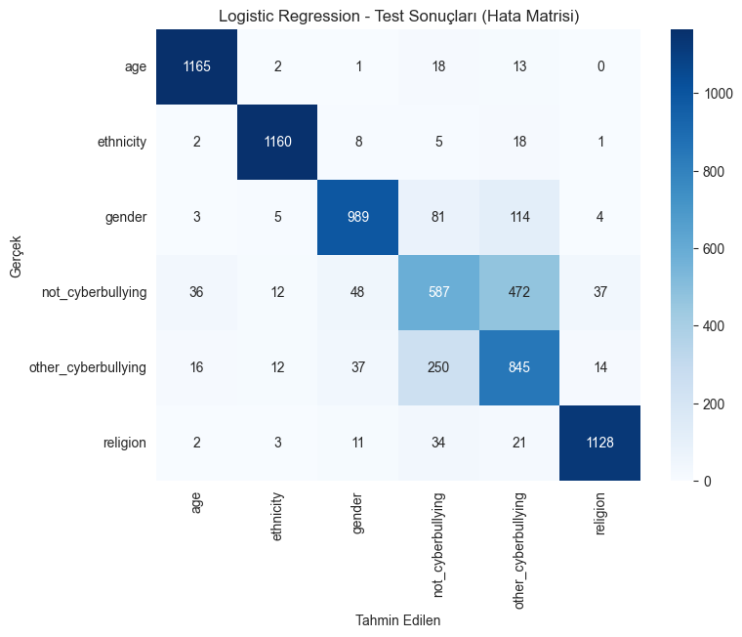
- DistilBERT: Thanks to its contextual learning capability, it reduced this confusion, increasing the F1 score for the "Not_cyberbullying" class from 0.54 (LogReg) to 0.63 (DistilBERT).

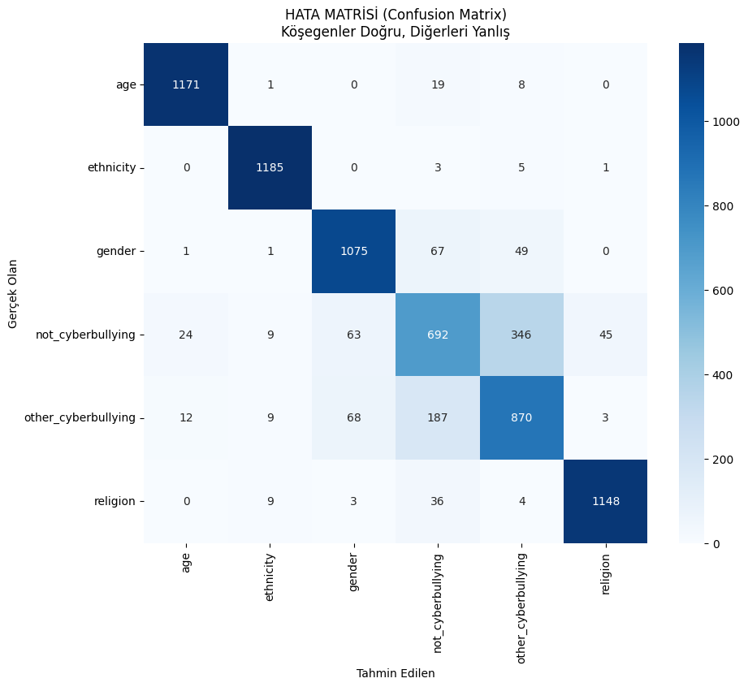

7. Discussion
7.1. Interpretation of Model Performances
The findings of the study showed that the architecture used in cyberbullying detection plays a decisive role in its success.
- The Power of Context: Traditional models (Logistic Regression and SVM) treat words as independent units (bag-of-words), making it difficult to distinguish between classes, particularly "Not_cyberbullying" and "Other_cyberbullying".
- Numerical Evidence: When the error matrices were examined, the Logistic Regression model mistakenly labeled 472 instances that were actually "No Bullying" as "Other Bullying." In contrast, the DistilBERT model, which has contextual learning capabilities, reduced this number of errors to 346. This demonstrates that DistilBERT provides more than a 25% improvement in understanding the intent of the statement and reduces the risk of innocent users being wrongly accused (False Positive).

7.2. Evaluation of Data Splitting Strategy
Dividing the dataset into 70% Training, 15% Validation, and 15% Testing increased the reliability of the model.
- The Role of Validation: The 15% validation set allocated during training acted as a "safety valve" to prevent the model from overfitting. The close relationship between the SVM model's validation success (82.29%) and test success (81.41%) confirms that the model is consistent and will demonstrate similar performance with real-world data.
7.3. Challenges: The "Other" Class Dilemma
A common challenge for all models is identifying situations where bullying occurs through implication, even if it doesn't involve explicitly offensive words (profanity, etc.).
- Analysis: While success rates reached up to 98% in classes like "Religion" and "Ethnicity," the fact that success remained around 70% in the "Other_cyberbullying" class supports the "implicit aggression" problem described in the literature. The fact that words like "school," "high," and "joke" appear in both normal conversations and bullying content, as seen in word cloud analysis, is a key factor that makes it difficult for the models to make decisions.

7.4. Limitations & Future Work
- Constraints: The low Sensitivity (Recall: 0.59) in the "Not_cyberbullying" class indicates that the system may mislabel some non-bullying, heated discussions.
- Future Work: To improve the model's performance, irony detection modules can be added.

8. Conclusion
This study aims to automatically detect and classify cyberbullying, which is becoming an increasingly significant threat on social media platforms, using artificial intelligence-based methods. Within the scope of the project, both traditional machine learning algorithms (Logistic Regression, SVM) and modern deep learning architectures (DistilBERT) were applied to a comprehensive dataset containing approximately 47,000 tweets, and their performances were analyzed comparatively.
The main findings of the study are as follows:
- Model Superiority: Experiments have shown that the DistilBERT model, with an accuracy rate of 86%, exhibits statistically superior performance compared to Logistic Regression (82%) and SVM (81%) models. This result highlights the need for Transformer architectures in natural language processing (NLP) problems, which analyze the context and semantic relationships of words within sentences, instead of simply counting words (frequency-based) methods.
- 2. Classification Success: The developed system was able to detect bullying content based specifically on "Religion" and "Ethnicity" with a very high success rate of 98%. This demonstrates that overt attacks containing hate speech can be easily filtered by artificial intelligence.
- Difficulties in Detection: The study also showed that the biggest obstacle to detecting cyberbullying is "Other Cyberbullying," which doesn't involve profanity but is done through innuendo or mockery. It has been observed that traditional models often classify such content as "normal," but context-oriented models (DistilBERT) minimize this error.
Contribution of the Study:
This project goes beyond the binary systems in the literature that simply state "bullying exists/doesn't exist," offering an end-to-end pipeline that also reports the type of bullying. The success of the developed model aims to automate moderation processes on social media platforms, reduce the workload of human moderators, and ultimately make the digital world safer for users.

9. References
- [Dataset Source] Andrewmvd. (2020). Cyberbullying Classification Dataset. Kaggle. Access Address: https://www.kaggle.com/datasets/andrewmvd/cyberbullying-classification
- [Original Dataset Paper] Wang, J., Fu, K., & Lu, C. T. (2016). Cyberbullying detection based on semantic-enhanced marginalized denoising auto-encoder. IEEE Transactions on Affective Computing, 7(4), 328-343.
- [Systematic Review] Al-Garadi, M. A., Hussain, M. R., Khan, N., Murdock, G., Bhandari, V., & Matwin, S. (2019). Online cyberbullying detection using machine learning techniques: A systematic review. IEEE Access, 7, 39589-39612.
- [DistilBERT Model] Sanh, V., Debut, L., Chaumond, J., & Wolf, T. (2019). DistilBERT, a distilled version of BERT: smaller, faster, cheaper and lighter. arXiv preprint arXiv:1910.01108.
- [BERT Foundation] Devlin, J., Chang, M. W., Lee, K., & Toutanova, K. (2018). BERT: Pre-training of deep bidirectional transformers for language understanding. arXiv preprint arXiv:1810.04805.
- [SVM Algorithm] Cortes, C., & Vapnik, V. (1995). Support-vector networks. Machine Learning, 20(3), 273-297.
- [Scikit-learn Library] Pedregosa, F., Varoquaux, G., Gramfort, A., Michel, V., Thirion, B., Grisel, O., ... & Duchesnay, E. (2011). Scikit-learn: Machine learning in Python. Journal of Machine Learning Research, 12, 2825-2830.
- [HuggingFace Transformers] Wolf, T., Debut, L., Sanh, V., Chaumond, J., Delangue, C., Moi, A., ... & Rush, A. M. (2020). Transformers: State-of-the-art natural language processing. Proceedings of the 2020 Conference on Empirical Methods in Natural Language Processing: System Demonstrations, 38-45.
- [NLTK Library] Bird, S., Klein, E., & Loper, E. (2009). Natural language processing with Python: analyzing text with the natural language toolkit. O'Reilly Media, Inc.

