Sprint 1
✔ repository
✔ packaging
✔ CI foundation
✔ Git workflow

Sprint 2
✔ package architecture
✔ configuration system
✔ ForecastPipeline
✔ Data Engine

Sprint 3
✔ preprocessing
✔ missing data handling
✔ feature engineering

Sprint 4
✔ ARIMA

Sprint 5
✔ Adaptive Kalman

Sprint 6
✔ GRU/LSTM

Sprint 7
✔ Hybrid Forecast

Sprint 8
✔ Bayesian uncertainty

Sprint 9
✔ Remaining Useful Life

Sprint 10
✔ Dashboard
File-Level Docstrings :

"""
Resampling utilities.

This module provides methods for converting battery measurements
between different sampling frequencies while preserving temporal
consistency.

These utilities are used during data preparation before statistical
analysis and forecasting.
"""

"""
Battery dataset abstraction.

This module defines the BatteryDataset class, which provides a unified
interface for loading, validating, cleaning, resampling, interpolating,
and analyzing battery degradation datasets.

All forecasting algorithms in ZenerEstimation operate on this class
rather than directly manipulating pandas DataFrames.
"""

"""
Feature engineering utilities.

This module provides common statistical features derived from battery
voltage measurements, including first differences, percentage changes,
rolling statistics, and other transformations used by forecasting
algorithms.
"""

"""
Missing-data interpolation utilities.

This module implements interpolation algorithms for restoring missing
battery measurements while preserving temporal consistency.

Supported methods include linear interpolation, forward fill,
backward fill, and future interpolation strategies.
"""

"""
Dataset validation utilities.

This module provides validation routines that verify dataset integrity,
required columns, datetime consistency, numeric measurements, and other
quality checks before forecasting.
"""

"""
ARIMA forecasting model.

This module implements statistical time-series forecasting using the
Autoregressive Integrated Moving Average (ARIMA) methodology,
including model fitting, diagnostics, and future prediction.
"""

"""
Adaptive Kalman filter.

This module implements an adaptive Kalman filtering framework for
battery voltage estimation, trend tracking, uncertainty estimation,
and Remaining Useful Life prediction.
"""

"""
Remaining Useful Life estimation.

This module estimates battery Remaining Useful Life (RUL) using
forecasting models, degradation trends, uncertainty propagation,
and configurable end-of-life criteria.
"""

"""
Forecasting pipeline.

This module coordinates the complete battery forecasting workflow,
including data preparation, preprocessing, model training,
forecast generation, evaluation, and reporting.
"""

Workflow:

Code
↓
pytest
↓
git status
↓
git add .
↓
git commit
↓
git push
↓
git log --oneline -5
↓
GitHub verification

This is a common design in scientific Python libraries:

- pandas → stores data
- matplotlib → plots data
- scikit-learn → models data

The same separation will make ZenerEstimation easier to maintain.

BatteryDataset
│
│
▼
DatasetPlotter
│
├── plot_series()
├── plot_missing()
├── plot_histogram()
├── plot_boxplot()
└── plot_trend()

Forecast Architecture:
BatteryDataset
│
▼
ForecastPipeline
│
├──────────────┐
│ │
ARIMA Kalman
│ │
└──────┬───────┘
│
ForecastResult
│
▼
Evaluation Engine
│
▼
Visualization
Final Architecture:
BatteryDataset
│
▼
ForecastPipeline
│
├──────── ARIMA
├──────── Kalman
├──────── LSTM
├──────── GRU
└──────── Hybrid
│
ForecastResult
│
▼
Evaluation Engine
│
▼
Visualization

Sprint Acceptance Test (SAT):
- Load dataset
- Validation
- Preparation
- Summary
- Battery Analysis Report
- Frequency detection
- Missing-period detection
- Resampling
- Rolling windows
- Visualization
┌──────────────────────────────────────────────┐
│ Applications │
│ CLI • Demo Scripts • Notebooks • Examples │
└──────────────────────────────────────────────┘
│
▼
┌──────────────────────────────────────────────┐
│ Forecast Pipeline Layer │
│ ForecastPipeline • Evaluation • RUL │
└──────────────────────────────────────────────┘
│
▼
┌──────────────────────────────────────────────┐
│ Forecast Model Layer │
│ ARIMA • Kalman • LSTM • GRU • Hybrid │
└──────────────────────────────────────────────┘
│
▼
┌──────────────────────────────────────────────┐
│ Data Processing Layer │
│ Validation • Resampling • Rolling Windows │
│ Interpolation • Statistics • Visualization │
└──────────────────────────────────────────────┘
│
▼
┌──────────────────────────────────────────────┐
│ Dataset Layer │
│ Smart Loader • BatteryDataset • CSV Reader │
└──────────────────────────────────────────────┘

Sprint 4 – Commit #2:

BaseForecastModel
▲
│
┌───────────────┼────────────────┐
│ │ │
▼ ▼ ▼
ARIMAModel KalmanModel LSTMModel
│
▼
ForecastPipeline
│
▼
Forecast Result

BatteryDataset  │  ▼  DatasetConfig | ForecastPipeline  │  ▼  ForecastConfig | RULEstimator  │  ▼  RULConfig

Sprint 1
---------
Project foundation

Sprint 2
---------
BatteryDataset

Validation

Interpolation

Frequency detection

Diagnostics

Sprint 3
---------
Resampling

Statistics

Visualization

Rolling windows

Reports

Sprint 4
---------
Smart Dataset Loader

ForecastPipeline

BaseForecastModel

Model Registry

↓

NOW

↓

First forecasting algorithm

ARIMA:

BatteryDataset

↓

ForecastPipeline

↓

ARIMAForecaster

↓

ForecastResult

ARIMA RMSE
Kalman RMSE
GRU RMSE
LSTM RMSE
Hybrid RMSE

Forecast Model Contract
───────────────────────
✓ fit(dataset)
✓ predict(steps)
✓ fit_predict(dataset, steps)
✓ returns ForecastResult
✓ correct horizon
✓ metadata exists

Sprint 1
- Package structure
- CI-ready project layout
- Base classes
Sprint 2
- Dataset handling
- Validation
- Missing-value support
- Diagnostics
- Reporting
Sprint 3
- Resampling
- Statistics
- Feature engineering
- Visualization
- Rolling windows
Sprint 4 (so far)
- Smart Loader
- ForecastPipeline
- ForecastResult
- ARIMA forecasting model ✔

Sprint 5
- Add ForecastPlot visualization engine

Demo:

Raw Battery CSV
│
▼
Smart Dataset Loader
│
▼
BatteryDataset
│
▼
Validation
│
▼
ForecastPipeline
│
▼
ARIMAForecaster
│
▼
ForecastResult
│
▼
Forecast Plot
│
▼
ExperimentResult
── PNG
── JSON
└── TXT

Current project status:

✓ Smart Dataset Loader
✓ BatteryDataset
✓ Validation
✓ Resampling
✓ Missing-data detection
✓ Feature engineering
✓ Rolling windows
✓ Visualization
✓ Dataset reports
✓ ForecastPipeline
✓ BaseForecastModel
✓ ForecastResult
✓ ARIMA model
✓ ExperimentResult
✓ Timestamped result management
✓ JSON metadata support
✓ ~45 automated tests

Component | Responsibility
BatteryDataset | Data
ForecastPipeline | Workflow
BaseForecastModel | Forecast interface
ForecastResult | Forecast output
ExperimentResult | Experiment artifacts
ForecastPlot | Visualization

Sprint 5 – Commit 1

The framework now has a complete chain:

Raw Dataset
│
▼
Smart Loader
│
▼
BatteryDataset
│
▼
ForecastPipeline
│
▼
ForecastModel
│
▼
ForecastResult
│
▼
ForecastPlot
│
▼
ExperimentResult
│
├── PNG
├── JSON
└── TXT

Sprint 5 – Commit 2:

• ✅ Experiment dataclass
• ✅ ExperimentRegistry
• ✅ Automatic experiment IDs
• ✅ JSON serialization
• ✅ Persistent history.json
• ✅ Unit tests
• ✅ Object-oriented registration API

Sprint 5 – Commit 3:

Real Battery CSV
│
▼
SmartDatasetLoader
│
▼
BatteryDataset
│
▼
ARIMAForecaster
│
▼
ForecastResult
│
▼
ForecastPlot
│
▼
Experiment
│
▼
ExperimentRegistry
│
▼
PNG + JSON + TXT + history.json

Complete Structure:

Configuration

↓

Banner

↓

Start timer

↓

Load dataset

↓

Dataset summary

↓

Forecast

↓

Plot

↓

Save artifacts

↓

Register experiment

↓

Experiment summary

↓

Footer

Architecture:

ZenerEstimation
│
┌─────────────────────────┼─────────────────────────┐
│ │ │
▼ ▼ ▼
Data Layer Forecast Layer Experiment Layer
│ │ │
BatteryDataset ForecastPipeline Experiment
SmartLoader BaseForecastModel ExperimentRegistry
Validation ARIMA Results
Cleaning ForecastResult

ZenerEstimation Framework

CSV Dataset
│
▼
SmartDatasetLoader
│
▼
BatteryDataset
│
▼
ARIMAForecaster
│
▼
ForecastResult
│
▼
ForecastPlot
│
▼
PNG + JSON + Report
│
▼
ExperimentRegistry
│
▼
history.json

Completed Sprint 5:

Highlights

• Completed the first end-to-end forecasting demonstration.
• Implemented ARIMAForecaster integration.
• Introduced ForecastResult support for optional fitted values.
• Enhanced ForecastPlot to visualize measured data, fitted model values and future forecasts.
• Improved experiment artifact generation.
• Added experiment registration and execution history.
• Improved console output and dataset summary.
• Refined demonstration workflow and framework architecture.
• Verified framework stability with the complete pytest suite.

This establishes the first production-quality forecasting workflow and serves as the reference implementation for future forecasting models (Kalman, ETS, LSTM and GRU).

Sprint 6:

Commit 1
Model-aware reporting
- generic report sections
- ARIMA metadata
- report templates
Commit 2
Adaptive Kalman Forecaster
- state model
- prediction
- update
- forecasting API
Commit 3
Kalman Demonstration
- console output
- plotting
- experiment registry
- report generation
Commit 4
Benchmark Framework
- compare ARIMA vs Kalman
- RMSE
- MAE
- execution time
- experiment summary

Kalman script:

The main architectural changes are:
- adaptive_kalman_filter() → fit()
- adaptive_kalman_forecast() → predict()
- kalman_bias_correction() → integrated into fit()
- estimate_kalman_noise() → integrated into fit()
- returns a ForecastResult, just like ARIMAForecaster

Monte Carlo engine:

Current Value
↓
Current Drift
↓
Noise
↓
Threshold
↓
Monte Carlo
↓
PrognosticResult

Prognostics Package:

Data
│
▼
Forecasting
│
▼
Prognostics

Architecture of PrognosticsResult:

Forecasting
↓
ForecastResult

Prognostics
↓
ThresholdEstimator
MonteCarloRUL
RULAnalyzer
PrognosticResult

Examples

Neural Network Infrastructure

zenerestimation/

forecasting/

neural/

__init__.py

base.py

windows.py

scaler.py

utils.py

Responsibilities
base.py
Contains
BaseNeuralForecaster
Responsible for
- common fit/predict interface
- preprocessing pipeline
- ForecastResult creation
- integration with the framework

windows.py
Contains
WindowGenerator
Responsible only for:
Series
↓
Sliding windows
↓
X
y
No normalization.
No TensorFlow.
Just window generation.

scaler.py
Contains
SequenceScaler
Responsible only for:
fit()
transform()
inverse_transform()
Initially it wraps
MinMaxScaler
Later we can swap
- StandardScaler
- RobustScaler
- QuantileTransformer
without touching any forecasting model.

utils.py
Contains small helper functions.
For example:
set_seed()
configure_tensorflow()
early_stopping()
check_gpu()
Nothing model-specific.

__init__.py
Exports
from .base import BaseNeuralForecaster
from .windows import WindowGenerator
from .scaler import SequenceScaler
Later
from .lstm import LSTMForecaster
from .gru import GRUForecaster
will simply be added.

Sprint 9 — Commit 2

Architecture :
Input Window
│
▼
LSTM(32)
│
▼
Dense(1)
│
▼
Forecast

Constructor :
LSTMForecaster(

window=6,

units=32,

epochs=100,

batch_size=8,

)

TensorFlow model :
Sequential(

[

LSTM(units),

Dense(1),

]

)

fit() :
Dataset
↓
prepare_data()
↓
build_model()
↓
model.fit()
↓
store history

predict() :
ForecastResult(
...
)
with the same API.
The outside world should not know
whether the forecast came from
- ARIMA
or
- Kalman
or
- LSTM.

Metadata :
window
units
epochs
batch_size

ForecastPlot

Tests :
test_lstm_constructor
test_fit_predict
test_forecast_result
test_metadata

Sprint 9:

Commit 1
Neural Infrastructure
forecasting/

neural/

__init__.py

base.py

windows.py

scaler.py

Commit 2
LSTMForecaster
forecasting/

neural/

lstm.py

Commit 3
demo_lstm.py
- demo_arima.py
- demo_kalman.py
- demo_rul.py

Commit 4
Instead of hyperparameter search...
NeuralModelConfig
For example:
config = NeuralModelConfig(
window=6,
units=32,
epochs=100,
batch_size=8,
learning_rate=0.001,
)

model = LSTMForecaster(config)

We also need to rethink another aspect. The variable equation "freq = ...", in particular, should be as independent of the data structure as possible. The calculation of "freq = ..." should depend on the data format detected by the 'SmartDatasetLoader'. I suspect this will also affect the other two "forecasters" we have already designed. Or am I mistaken?

Conceptually Pipeline:

raw CSV
│
▼
SmartDatasetLoader
│
▼
BatteryDataset
│
▼
Interpolation
│
▼
Forecasting

Formal Data Lifecycle:

datasets/
│
├── raw/
│ Original measurements
│
├── processed/
│ Cleaned + interpolated datasets
│
└── results/
Forecasts, RUL, reports

Trend Model
The trend model captures the deterministic long-term behaviour.
Examples:
- Kalman Filter
- ARIMA
- ETS

Residual Model
The residual model learns the nonlinear forecasting error.
Examples:
- LSTM
- GRU
- Transformer (planned)

zenerestimation/forecasting/kalman_filter.py

This first part contains:

• imports
• class definition
• constructor
• state initialization
• transition matrix
• measurement matrix

Instead of:
Forecast model
│
Trend model
│
Residual model

Model Pipeline:
Hybrid forecaster
│
Trend extractor
│
Residual forecaster

where
- Trend extractor → Linear regression, Kalman filter, polynomial fit, STL decomposition, etc.
- Residual forecaster → LSTM, GRU, Transformer, ARIMA, etc.

Commit 6:

"Implement production-grade Kalman–LSTM hybrid forecasting.”

- Improve residual extraction
  - Use the smoothed Kalman trend.
  - Ensure the identity

$$\text{measurement}=\text{trend}+\text{residual}$$

  - Store residuals for later diagnostics.
- Improve trend forecasting
  - Use the final Kalman state (level + drift).
  - Support arbitrary forecast horizons.
  - Return a standard ForecastResult.
- Improve forecast combination
  - Merge trend and residual forecasts.
  - Preserve the correct datetime index.
  - Merge metadata cleanly.
  - Include useful diagnostics such as:
    - bias correction
    - innovation σ
    - drift estimate
    - architecture version
- Hybrid diagnostics
innovations()
residuals()
trend()
drift()
sigma()

Revised priority

Phase 1 — Visualization improvements
- ✅ Show fitted/model values on the plot.
- ✅ Add the experiment information box (ID, battery, model, version, horizon).
Phase 2 — Hybrid diagnostics ⭐ (next major milestone)
This would introduce a dedicated diagnostics API for all hybrid forecasters.

Phase 3 — Hybrid diagnostic plots
- Measured vs Trend vs Hybrid
- Residual series
- Residual histogram
- Residual autocorrelation
- Trend forecast + Residual forecast + Hybrid forecast
- Residual correction contribution (how much the LSTM adjusted the Kalman prediction)

Phase 4 — Confidence intervals

- Kalman covariance propagation,
- LSTM residual variance estimation,
- Hybrid uncertainty propagation,
- Confidence bands on the final forecast.

Architecture of ‘HybridDiagnostics’ :

HybridDiagnostics

├── Decomposition

│ verify_decomposition()

│ trend_variance()

│ residual_variance()

│

├── Residual Statistics

│ residual_mean()

│ residual_std()

│ autocorrelation()

│ durbin_watson()

│ ljung_box()

│

└── Quality Assessment

quality_score()

quality_grade()

recommendations()

Sprint 11:

┌───────────────┐
│ Demo / Model │
└───────┬───────┘
│
▼
Standard Experiment
│
┌───────────┼───────────┐
▼ ▼ ▼
forecast.json evaluation diagnostics
│ │ │
└───────────┼───────────┘
▼
ForecastComparison
│
┌───────────┼───────────┐
▼ ▼ ▼
Ranking Stability Hybrid vs
Individual
│
▼
Comparative Report
│
▼
Comparative Plot

The registry's experiment ID is the true logical identity, while the directory name is the physical artifact location:

Experiment ID
│
└── 127
│
└── results/
└── 732B-5610110/
└── KalmanLSTM/
└── 20260813_150244_773043/

Processed dataset = structural/canonical preparation. Train-fitted transformations = evaluation/model pipeline.

That means ForecastEvaluator should continue to make the holdout split before anything that learns parameters from values.

processed dataset
↓
holdout split
├── training
│ ↓
│ fit scaler
│ ↓
│ create windows
│ ↓
│ train LSTM/GRU
│
└── validation
↓
transform using
TRAINING scaler

Sprint 12:
"What exactly is the common data and evaluation protocol?"

Sprint 13:
"What configuration makes each model perform best?"

Sprint 12 architecture

ForecastEvaluator
│
┌────────────────┼─────────────────┐
↓ ↓ ↓
Classical Neural Hybrid
│ │ │
ARIMA/Kalman LSTM/GRU Trend+LSTM
Kalman+LSTM
│ │ │
└────────────────┼─────────────────┘
↓
EvaluationResult
Expected Architecture

TRAINING VALIDATION
──────── ──────────

20.0 30.0
21.0 31.0
NaN ──► interpolation NaN ──► ERROR
23.0 33.0
│ │
▼ │
TemporalPreprocessor │
│ │
▼ │
complete training data │
│ │
▼ │
LSTM scaler │
│ │
LSTM windows │
│ │
LSTM.fit() │
│
never preprocessed

Architecture Symmetry

ForecastEvaluator
│
temporal holdout split
│
TemporalPreprocessor(train)
│
┌───────────┴───────────┐
↓ ↓
LSTM GRU
│ │
scaler fit on train scaler fit on train
windows from train windows from train
│ │
└───────────┬───────────┘
↓
EvaluationResult

LinearTrendLSTM historical fitted contract

The correct historical relationship is:
$${\hat{y}}_{t}={\hat{T}}_{t}+{\hat{r}}_{t}$$
where the linear trend is available for every training observation, while the residual LSTM fitted values begin only after its window.
Therefore, with window=4, the desired structure is:

Trend fitted: T0 T1 T2 T3 T4 T5 ...
Residual fitted: NaN NaN NaN NaN R4 R5 ...
Hybrid fitted: NaN NaN NaN NaN T4+R4 T5+R5 ...

That is scientifically preferable to filling the first four points with trend-only values, because those would not represent the fitted output of the complete hybrid model.

Historical period
┌──────────────────────────────────┐

Trend ────────────────────────────
Residual × × × × ───────────────────
Hybrid × × × × ───────────────────
↑
window=4

LinearTrendLSTM KalmanLSTM
│ │
processed dataset ──────┼─────────┤
↓ ↓
ForecastEvaluator ForecastEvaluator
│ │
holdout metrics holdout metrics
│ │
fresh final model fresh final model
│ │
full-data fit full-data fit
│ │
forecast forecast
│ │
diagnostics diagnostics
│ │
standard artifacts standard artifacts

Standard Hybrid Artifact Contract
│
┌─────────────┴─────────────┐
│ │
LinearTrendLSTM KalmanLSTM
│ │
└─────────────┬─────────────┘
│
forecast / evaluation / experiment
report / log / figure / loader

Milestone | Scope | Status
13.1 | Neural/hybrid contract audit | ✓
13.2 | Neural infrastructure hardening | ✓
13.3 | LSTM standardized evaluation | ✓
13.4 | GRU standardized evaluation | ✓
13.5 | Hybrid contract hardening | ✓
13.6 | Hybrid evaluator integration | ✓
13.7A | Standardized LSTM demo | ✓
13.7B | Standardized GRU demo | ✓
13.7C | Standardized LinearTrendLSTM demo + diagnostics + artifacts | ✓
13.7D | Standardized KalmanLSTM demo + fitted contract + artifacts | ✓
13.7E | Final review / Sprint closure | current

Processed BatteryDataset
│
▼
ForecastEvaluator
│
├── holdout split FIRST
│
▼
TemporalPreprocessor
(training partition only)
│
▼
Model.fit(training)
│
▼
Model.predict(validation horizon)
│
▼
EvaluationResult
RMSE / MAE / MAPE

Full processed dataset
│
TemporalPreprocessor
│
fresh model instance
│
fit
│
Forecast
BatteryDataset
↓
training-only scaling
↓
WindowGenerator
↓
neural fit
↓
historical fitted values
↓
recursive forecast
↓
ForecastResult

window = w

historical fitted:
[NaN ... NaN] [model fitted values ...]
└── w ─────┘

measurement
│
├──────────────► trend component
│
└──────────────► residual
│
▼
LSTM
│
▼
residual forecast

trend forecast + residual forecast
│
▼
hybrid forecast

LinearTrendLSTM
trend = linear regression

KalmanLSTM
trend = adaptive Kalman filter

Model | Standardized processed data | Holdout evaluator | Full-data final fit | Evaluation artifact | Model Fit | Diagnostics
ARIMA | ✓ | ✓ | ✓ | ✓ | ✓ | —
Kalman | ✓ | ✓ | ✓ | ✓ | ✓ | —
LSTM | ✓ | ✓ | ✓ | ✓ | ✓ | —
GRU | ✓ | ✓ | ✓ | ✓ | ✓ | —
LinearTrendLSTM | ✓ | ✓ | ✓ | ✓ | ✓ | ✓
KalmanLSTM | ✓ | ✓ | ✓ | ✓ | ✓ | ✓

results/
└── <battery>/
└── <model>/
└── <timestamp>_<run>/
├── forecast.png
├── forecast.json
├── evaluation.json
├── experiment.json
├── report.txt
└── experiment.log

Sprint 13 — Neural & Hybrid Evaluation Standardization

Standardized LSTM, GRU, LinearTrendLSTM, and KalmanLSTM forecasting under the common leakage-safe ForecastEvaluator contract. Hardened neural window/scaling behavior, standardized hybrid component contracts, corrected historical hybrid fitted-value semantics, integrated hybrid diagnostics into reporting and persisted artifacts, introduced processed-data standardized demonstrations, and established shared artifact regression coverage for both hybrid architectures.

Final regression status: 517 tests passed.

Sprint 14 — Model Optimization
Optimization must not repeatedly tune directly against the same final holdout that we later report as model performance. Otherwise the holdout stops being an independent evaluation set.
For neural models, this becomes especially important because window/unit/epoch selection against the 5- or 6-point benchmark itself would overfit model selection to those known future measurements.
That also means we should reconsider one part of the older experimental workflow: choosing LSTM hyperparameters by the real future RMSE was useful experimentally, but should not become the production optimization contract.

Processed Dataset
│
▼
Optimization Protocol
│
┌──────────┴──────────┐
│ │
Candidate Config A Candidate Config B ...
│ │
▼ ▼
same evaluation contract
│ │
└──────────┬──────────┘
▼
Candidate Results
│
▼
Selection Metric
│
▼
OptimizationResult
│
┌──────────────┼──────────────┐
▼ ▼ ▼
best parameters search history metadata
│
▼
fresh final model
│
▼
standardized forecast

Training history
│
├── optimization / internal validation
│
└── final untouched benchmark holdout
Sprint 14.1A:

FINAL BENCHMARK HOLDOUT
▲
│
never used for
parameter selection
│
┌────────┴────────┐
│ historical data │
└────────┬────────┘
│
optimization region
│
┌────────────┴────────────┐
│ │
candidate A candidate B
│ │
internal temporal internal temporal
validation validation
│ │
└────────────┬────────────┘
│
select best
│
▼
OptimizationResult
│
▼
selected config
│
▼
standardized final benchmark
ForecastEvaluator

Scientific Contract for Optimization:

COMPLETE DATA AVAILABLE
│
▼
benchmark boundary established
│
┌────────────┴────────────┐
│ │
▼ ▼
DEVELOPMENT REGION FINAL HOLDOUT
│ │
│ │
▼ │
optimization │
│ │
internal validation │
│ │
candidate selection │
│ │
▼ │
best parameters │
│ │
└────────────┬────────────┘
▼
final evaluation
│
▼
EvaluationResult

Internal Optimization Validation:
Strategy | Characteristics
Single internal temporal holdout | Simple and inexpensive
Expanding-window validation | More robust for time series
Rolling-window validation | More complex; changes training-history length
Fold 1
[──────── train ────────][validate]

Fold 2
[─────────── train ───────────][validate]

Fold 3
[──────────────── train ─────────────][validate]

14.1C — Scientific Contract:

OPTIMIZATION BENCHMARK
development region complete benchmark dataset
│ │
▼ ▼
internal temporal validation ForecastEvaluator
│ │
▼ ▼
candidate selection final holdout
│ │
▼ ▼
OptimizationResult EvaluationResult
The rule is:
OptimizationEvaluator may operate only on the development region supplied to it. It must have no knowledge of, or access to, the final benchmark holdout.
This is stronger than merely promising not to use the holdout.
14.1C.1 — Temporal fold contract:

For example:

validation_steps = 4
folds = 3

Fold 1
0 ─────────────────────────────── 87 | 88 ── 91
TRAIN VALIDATE

Fold 2
0 ─────────────────────────────────── 91 | 92 ── 95
TRAIN VALIDATE

Fold 3
0 ─────────────────────────────────────── 95 | 96 ── 99
TRAIN VALIDATE

- training always precedes validation
- training expands
- validation blocks never overlap

The final fold ends at the end of the supplied development dataset.
The benchmark holdout is absent because the caller must remove it before invoking optimization.

14.1D.1 — GenericOptimizer
parameter candidates
│
▼
GenericOptimizer
│
├── Candidate 1 → OptimizationEvaluator
├── Candidate 2 → OptimizationEvaluator
└── Candidate N → OptimizationEvaluator
│
▼
CandidateResult × N
│
select minimum
│
▼
OptimizationResult

OptimizationEvaluator
score candidate
GenericOptimizer
compare candidate scores
OptimizationResult
record the decision
14.2C.1 — Boundary Contract

COMPLETE BENCHMARK DATASET: N Observation
│
├──────────────── development ────────────────┐
│ │
│ ▼
│ GenericOptimizer
│ │
│ internal folds
│ │
│ ▼
│ best_params
│
└──────────── final benchmark H horizon ─────────────────┐
│
▼
ForecastEvaluator
evaluation_steps=H
│
▼
EvaluationResult

Internal Horizon

internal validation_steps = 4
final benchmark steps = 6

That's a mismatch.

Our selection problem is actually:
$$θ^{*}=\arg{\min_{θ}}\frac{1}{K}\sum_{k=1}^{K}{R}MSE\left(y_{k,1:6} , {\hat{y}}_{k,1:6}\left(θ\right)\right)$$
because the production task is six-quarter forecasting.

Potential future strategies include:

Mean RMSE
all historical folds equally important
Weighted RMSE
recent development folds more important
Worst-fold RMSE
select robust configuration
Mean + λ·Std
reward accuracy while penalizing instability

But those should become explicit optimization policies only after evidence from the development region supports them.
Sprint 14 rule:

Internal temporal validation horizon should equal the intended final benchmark horizon unless an experiment explicitly specifies otherwise.

We can formalize that later at the orchestration/configuration layer.

The scientifically defensible conclusion for this predefined 64-candidate search is:
Development-only selection:
ARIMA(12,1,1)
Internal temporal RMSE:
0.766376
Untouched benchmark RMSE:
0.849442
Existing fixed-reference RMSE:
0.407101

110 full processed dataset
│
evaluation_end
2024-03-01
│
┌─────────────┴─────────────┐
│ │
development final benchmark
≤ 2022-12 2023-03 → 2024-03
│ │
▼ │
5-step internal folds │
│ │
▼ │
GenericOptimizer │
│ │
▼ │
best ARIMA │
└──────────────┬────────────┘
▼
ForecastEvaluator
│
▼
EvaluationResult

Extendion of the optimization contract:
candidate
│
├── all folds succeed ──→ evaluated CandidateResult
│
└── any fold fails ─────→ failed CandidateResult
│
└── excluded from selection

There is a common signal:

Battery | Horizon | Selected order | Internal RMSE | Final RMSE
410 | 6 | (12,1,1) | 0.766376 | 0.849442
110 | 5 | (5,1,3) | 0.671862 | 0.447650

Both horizon-aligned searches selected an integrated model:

410 → (12,1,1)
110 → (5,1,3)
↑
d=1

Behavior for Kalman and neural optimization:

requested candidate
│
├── evaluates successfully → eligible for ranking
│
└── numerical failure → retained as failed
but not ranked

410
Development : through 2023-12
Benchmark : 2024-03 → 2025-06
Horizon : 6
Candidates : 64
Selected : ARIMA(12,1,1)
Internal : RMSE 0.766376
Benchmark : RMSE 0.849442

110
Development : through 2022-12
Benchmark : 2023-03 → 2024-03
Horizon : 5
Candidates : 64
Evaluated : 60
Failed : 4
Selected : ARIMA(5,1,3)
Internal : RMSE 0.671862
Benchmark : RMSE 0.447650

The 410 result did not beat its existing fixed reference; the 110 result should not yet be compared to the historical (20,1,0) result until that reference is regenerated under exactly the current standardized processed-data evaluation path.

Milestone 14.2E.1 — Optimization Artifact Contract

OptimizationResult
│
▼
optimization.json
│
│ model-selection evidence only
│
├──────────────────────────────┐
│ │
▼ ▼
selected parameters candidate history

EvaluationResult
│
▼
evaluation.json
│
│ final benchmark evidence only
▼
RMSE / MAE / MAPE / predictions

Scientific observations worth preserving

The two datasets tell substantially different stories.

For 410, the hybrid forecasts preserve the increasing degradation trajectory better than the standalone neural models. LSTM and GRU increasingly underpredict across the six-step horizon. KalmanLSTM has the lowest final RMSE here, although it initially overpredicts and then approaches the observations.

For 110, Kalman tracks the five held-out observations very closely. LSTM and GRU also remain close, while both hybrid models systematically overpredict. KalmanLSTM's overprediction grows substantially across the horizon.
This is useful evidence that model behavior is dataset-dependent. We should preserve it descriptively rather than turning it into new tuning rules.

There is another important result from the optimization architecture itself:

internal temporal validation performance
≠
guaranteed final benchmark performance

That is exactly why keeping the final holdout untouched was worthwhile.

ResultPackage
ResultPackage → ForecastComparison → ComparisonResult

ResultLoader
disk artifacts → ResultLoader → ResultPackage

existing ResultLoader tests
+
new optimized comparison tests
↓
disk artifact
→ ResultPackage
→ ForecastComparison
→ ComparisonResult

OptimizationResult ──► parameter-selection evidence
StabilityResult ──► seed-sensitivity evidence
EvaluationResult ──► final benchmark evidence

│
▼
14.9 reporting layer
│
▼
presentation / persistence

ComparisonResult ───────► benchmark metrics/reporting
│
EvaluationResult(s) ───────────┤
▼
BenchmarkPlotter
│
▼
benchmark_forecast.png

14.9E — Optimization & Stability Provenance Integration

actual holdout
│
├───────────── actual line
│
EvaluationResult ARIMA ───── prediction line
EvaluationResult Kalman ──── prediction line
EvaluationResult LSTM ────── prediction line
...

optimization.json ─┐
│
stability.json ────┼──► BenchmarkProvenance ──► provenance.json
│
benchmark.json ────┘

Each source remains authoritative for its own evidence.

┌── optimization.json
│
provenance.json ───┼── stability.json
│
└── benchmark.json
14.9E contract

optimization.json ─┐
optimization.json ─┤
│
stability.json ────┼──► BenchmarkProvenance
stability.json ────┤ │
│ ▼
benchmark.json ────┘ provenance.json

provenance.json = evidence relationships
≠ duplicated scientific evidence

Internal Python representation
Path("optimization/arima/optimization.json")
│
▼
Windows filesystem
optimization\arima\optimization.json

Portable provenance serialization
│
▼
optimization/arima/optimization.json

historical optimization evidence
│
├── ARIMA optimization.json
├── Kalman optimization.json
├── LSTM optimization.json
├── GRU optimization.json
├── LinearTrendLSTM optimization.json
└── KalmanLSTM optimization.json
│
▼
copy unchanged into bundle
│
├───────────────┐
│ │
frozen stability frozen optimized
reruns benchmark results
│ │
▼ ▼
stability/*.json benchmark.json/.csv
benchmark.txt
benchmark_forecast.png
│ │
└───────┬───────┘
▼
BenchmarkProvenance
│
▼
provenance.json

  - All configurations were frozen before final benchmark evaluation.

  - No benchmark result was used for parameter selection or seed selection.

These are statements about experimental integrity, not merely informational messages.

- All configurations were frozen before final benchmark evaluation.

It means that before the reserved 2024-03-01 through 2025-06-01 measurements were used for final scoring, every model's configuration had already been decided.

For example:

ARIMA
order = (12, 1, 1)

Kalman
process_noise = 0.01
drift_noise = 1e-5
regime_factor = 3.0
regime_multiplier = 10.0

LSTM
window = 4
units = 32

GRU
window = 4
units = 24

LinearTrendLSTM
window = 12
units = 32

KalmanLSTM
window = 8
units = 32

Neural benchmark seed
seed = 42

Those settings were determined before looking at model performance on the final benchmark holdout.

Conceptually:

Historical/development data
│
├── optimization
│ ↓
│ choose hyperparameters
│
├── stability analysis
│ ↓
│ characterize seed sensitivity
│
└──────────────┐
↓
FREEZE configuration
│
▼
Final benchmark
2024-03 → 2025-06
│
▼
RMSE / MAE / MAPE

The benchmark results therefore tell us how an already-decided forecasting procedure behaved on the reserved observations.

The scientifically problematic alternative would be:

Try configuration A → benchmark RMSE
Try configuration B → benchmark RMSE
Try configuration C → benchmark RMSE
↓
Choose whichever did best

That would make the benchmark part of the optimization procedure. Its error would then no longer represent a clean final evaluation!!!

- No benchmark result was used for parameter selection or seed selection.

This makes the first statement more explicit in two important ways.

Parameter selection

For example, the runner did not decide:

(12,1,1) has the best RMSE on the six final 410 observations, therefore use (12,1,1).

Instead, ARIMA (12,1,1) was selected by the separate internal temporal optimization process. Its final benchmark RMSE of:
0.849442
is an evaluation result, not a selection criterion.
The same distinction applies to all six models.

Seed selection

This is especially important for neural networks.

Our stability experiment used:

(0, 1, 2, 3, 4)

Those runs answer a question such as:

How sensitive is this fixed neural model configuration to random initialization/training randomness?

They are not a competition for selecting the seed that happens to perform best.

And the final benchmark uses the precommitted:

seed = 42

We did not test seeds 0, 1, 2, 3, 4, 42, etc. against the final six observations and then keep whichever seed produced the smallest benchmark error.

So there are three distinct evidence types:

OptimizationResult
↓
Which parameters were selected?

StabilityResult
↓
How sensitive is the fixed configuration
to repeated random seeds?

EvaluationResult
↓
How did the frozen model perform
on the final reserved benchmark?

Keeping those roles separate is one of the most important improvements Sprint 14 has made over the earlier experimental workflow.

14.9F-4 Desired figure 410: Not correct!

1998 2023-12 │ 2025-06
│
historical measurements │
●──●──●──●──●──●──●──●──●──●──●──●──●──●────────────● │
│
benchmark │
boundary │
│ ● actual
│ ─ ARIMA
│ ─ Kalman
│ ─ LSTM
│ ─ GRU
│ ─ LinearTrendLSTM
│ ─ KalmanLSTM

Development history: through 2023-12-01
Benchmark actuals: 2024-03-01 through 2025-06-01
Predictions: 2024-03-01 through 2025-06-01

development benchmark
│
──────────────────────────────●────│
╲ │
╲ ───■──■──■ model A
╲ ──■──■──■ model B
╲─■──■──■ model C

14.9F-5 Expected Pipeline:

BenchmarkModelSpec
│
▼
fresh model
│
▼
ForecastEvaluator.evaluate_with_forecast()
│
│ one fit + one predict
│
├── EvaluationResult
│
└── ForecastResult
│
└── fitted historical values available

Each object has a distinct responsibility:

Source | Data used | Purpose
BatteryDataset | ds, microVolt | Reference measurements
ForecastResult | fitted | Historical calculated model values
ForecastResult | forecast | Future model predictions
EvaluationResult | actual, dates | Untouched benchmark measurements

The intended visualization will show the complete historical context, with each model's calculated values plotted across its available training history and extended into the benchmark period.

We should distinguish the development measurements from the benchmark observations without implying that the models were fitted on benchmark targets.

Step 4 — One additional validation before real 410 integration

The next integration must account for the following:

- ARIMA: fittedvalues may have an initial undefined or initialization-dependent region.
- Kalman: the historical trend should align with the training timestamps.
- LSTM/GRU: the first window observations should remain unavailable.
- LinearTrendLSTM/KalmanLSTM: fitted values must represent the combined model, not only the residual component.
- Preprocessing: model fits use the prepared training partition, which may contain interpolated historical measurements.
- Dataset 110: observations after its benchmark endpoint must not be included in the fitted training history.

For the six models, we need to establish the following:

Model | Audit requirement
ARIMA | Initial fitted values and index alignment
Kalman | Trend length and timestamp correspondence
LSTM | Leading NaN values and window alignment
GRU | Leading NaN values and window alignment
LinearTrendLSTM | Combined fitted values and residual alignment
KalmanLSTM | Combined fitted values and residual alignment

We must also verify that the fitted series ends at 2023-12-01, not within the six-point benchmark holdout.

Our current 410 benchmark has a strictly defined structure:

Period | Purpose
March 1998 – December 2023 | Training and historical fitting
March 2024 – June 2025 | Frozen holdout evaluation
September 2025 onward | Future forecasting / extrapolation

The benchmark evaluates six models against six previously reserved measurements.

One scientifically interesting endpoint is the December 2026 spread:

- Kalman: 32.656495 µV
- ARIMA: 32.668680 µV
- GRU: 33.024590 µV
- LSTM: 33.247013 µV
- LinearTrendLSTM: 33.897606 µV
- KalmanLSTM: 34.144534 µV

These are unvalidated forecasts—not accuracy rankings—but their approximately 1.49 µV model spread is itself useful evidence of long-horizon model uncertainty.

FROZEN BENCHMARK
training through: 2023-12-01
evaluation: 2024-03-01 → 2025-06-01
purpose: measured holdout accuracy
metrics: RMSE / MAE / MAPE

OPERATIONAL FORECAST
training through: 2025-06-01
forecast: 2025-09-01 → 2026-12-01
purpose: unvalidated extrapolation
metrics: none
models reoptimized: no

The immediate post-refit values are revealing:

Model | Frozen prediction at 2025-06 | Actual 2025-06 | New operational prediction 2025-09
ARIMA | 30.9405 | 32.0000 | 32.1628
Kalman | 30.7607 | 32.0000 | 31.5232
LSTM | 30.1683 | 32.0000 | 32.0196
GRU | 30.0381 | 32.0000 | 32.0590
LinearTrendLSTM | 31.0858 | 32.0000 | 32.4796
KalmanLSTM | 31.6674 | 32.0000 | 33.7831

That last transition is exactly what deserves investigation.
KalmanLSTM goes from 31.6674 µV in its frozen June-2025 benchmark prediction to 33.7831 µV for September after refitting through the measured June-2025 value of 32.0 µV.

That's roughly a +2.12 µV difference between adjacent predictions belonging to the two different fitted models. It isn't automatically an error because these are different fits and different forecast origins—but it is large enough that we should understand its source before treating KalmanLSTM as the preferred operational model.

Development threshold

2023-12
│
Measured ──────────────────────┼──── actual holdout ────────── 2025-06
Best fit ──────────────────────┼──── frozen forecast ───────── 2025-06
Worst fit ─────────────────────┼──── frozen forecast ───────── 2025-06

The attached execution shows the expected frozen benchmark RMSE values for Dataset 410:

Model | RMSE (µV)
KalmanLSTM | 0.672161
LinearTrendLSTM | 0.788173
ARIMA | 0.849442
Kalman | 0.939829
LSTM | 1.307027
GRU | 1.395413

These match our established 410 benchmark results.

The operational report also contains the expected six-quarter extrapolations through December 2026.

Neural Forecast Diagnostics and Improvement stage

Step 1 — Audit the current LSTM and GRU implementations
Examine scaling, training windows, network architecture, optimizer, loss, convergence, inverse scaling, and recursive forecast generation. Determine whether there is a genuine implementation defect or simply poor generalization.

Step 2 — Reproduce the older approach without holdout leakage
Implement a comparable trend-residual Bayesian LSTM experiment. Use only development-period data for hyperparameter selection, preferably with rolling-origin validation.

Step 3 — Diagnose forecast stability and drift
Compare historical training errors, validation RMSE, six-step forecast drift, and variability across predeclared seeds. Check whether pure neural models systematically flatten their predictions.

Step 4 — Preserve benchmark integrity
Keep the existing frozen 410 benchmark and its provenance unchanged. Report any improved models as new experiments with their own configurations, validation evidence, and clearly separated evaluation status.

One further distinction matters: the original script trains its pure LSTM by cloning the Bayesian-selected hybrid network architecture and retraining it on the full voltage series. It does not independently optimize a pure LSTM or GRU. Therefore, it provides stronger evidence about trend-residual LSTM modeling than about pure recurrent architectures.

Proposed Sprint 14.9G plan

The objective is to extend the established dataset-410 workflow to battery 732B-5610110, without creating a separate forecasting architecture.

Milestone | Scope | Deliverable
G.1 | Dataset 110 readiness audit | Confirm observation boundaries, missing periods, and available measured targets
G.2 | Frozen benchmark configuration | Define training cutoff, holdout horizon, model configurations, and reproducibility policy
G.3 | Benchmark execution | Generate comparable forecasts, evaluation metrics, and evidence artifacts
G.4 | Operational extrapolation | Refit approved configurations using available measurements and forecast beyond the latest observation
G.5 | Transition diagnostics | Reuse the dataset-410 visualization architecture
G.6 | Regression and documentation closure | Tests, artifact checks, documentation, and Git commit

Scientific constraints:

We will retain the principles established during dataset-410 development:

- No target-derived preprocessing before the temporal split.
- No hyperparameter or seed selection using the reserved benchmark holdout.
- Clear separation between measured-holdout accuracy and unvalidated operational forecasts.
- Reuse of the existing ForecastEvaluator, benchmark evidence, and visualization components.
- No changes to the frozen dataset-410 results.

Sprint 14.9G.1 — Dataset 110 Readiness Audit.

1. Metadata assessment
Property | Dataset 110
Battery identifier | 732B-5610110
Source records | 105
Processed quarterly periods | 109
Measured observations | 103
Missing quarterly periods | 6
Frequency | QS-MAR
Forecast target | microVolt
Timestamp column | ds
Observation indicator | is_observed
Missing-value representation | Empty CSV field
Duplicate handling | Mean

The counts are internally consistent:
109-103=6
An important distinction is that 105 source rows do not necessarily mean 105 distinct measured quarters. Duplicate dates, for example, could account for the difference between source and observed counts, but the metadata alone does not establish the cause.

Sprint 14.9G.1 — Readiness audit results
Quarterly periods 109
Measured observations 103
Missing quarters 6
Observation coverage: March 1998 – March 2025
94.5% measured 5.5% missing
The consistency checks all passed: no duplicate timestamps, no missing targets marked as observed, and no inserted periods containing target values.
2. The critical feature of dataset 110:
Recent quarterly timeline
Mar 2024 169.90
Jun 2024 Missing
Sep 2024 Missing
Dec 2024 Missing
Mar 2025 171.60
Values are in µV. The three consecutive missing quarters cannot be used as measured benchmark targets.
The 2025-03-01 measurement is valid, but it is separated from the preceding measurement by four quarterly intervals.
Consequently, using the latest five or six calendar quarters as a conventional measured holdout would be inappropriate.

3. Proposed frozen benchmark boundary — G.2
I recommend retaining the historical five-point benchmark already associated with dataset 110.
Parameter | Proposed configuration
Training cutoff | 2022-12-01
First holdout date | 2023-03-01
Last holdout date | 2024-03-01
Forecast horizon | 5 quarters
Measured holdout observations | 5 of 5
Primary accuracy metric | RMSE in µV
Secondary metrics | MAE, first-point gap, bias
Neural benchmark seed | 42
Stability seeds | 0–4, reported separately

The five measured holdout values would be:
Date | Measured microVolt
2023-03-01 | 167.17
2023-06-01 | 167.73
2023-09-01 | 168.30
2023-12-01 | 168.86
2024-03-01 | 169.90

This provides a contiguous, fully observed evaluation period.
Important: This is a proposed pre-execution configuration, not a new benchmark result. We must also confirm that the frozen model configurations are selected independently of these five holdout values.

Approved configuration — Battery 732B-5610110
1. Measured-holdout benchmark
Approved
Training cutoff | 2022-12-01
Holdout start | 2023-03-01
Holdout end | 2024-03-01
Forecast horizon | 5 quarters
Measured targets | 5 of 5
2. Operational extrapolation
Approved
Latest measurement | 2025-03-01
Latest measured value | 171.60 µV
Forecast start | 2025-06-01
Forecast end | 2026-09-01
Forecast horizon | 6 quarters
Validation status | Unvalidated
Approved timeline
The benchmark and operational stages will remain scientifically independent. In particular, the five measured holdout values will be used for evaluation only, never to choose benchmark hyperparameters or seeds.
The operational stage will use measurements through March 2025, with missing quarters handled through the established preprocessing policy. Its forecasts will not be presented as measured-holdout accuracy results.
Next development milestone
Sprint 14.9G.2.2 — Frozen Model Configuration
We will now examine the existing dataset-410 benchmark model configurations and determine which can be reused unchanged for dataset 110, and which require explicitly documented dataset-specific settings.
No models need to be trained at this stage. The next deliverable will be a reproducible configuration and corresponding regression tests, followed by benchmark execution in G.3.

Sprint 14.9G.2.2 — Examination of Dataset-410 Benchmark Configurations
I located the dataset-410 benchmark runner and its frozen model specifications. We can use these as the reference for dataset 110 without changing the completed dataset-410 benchmark.
The existing implementation evaluates six forecasting models, organized into three groups: statistical, neural, and hybrid.
1. Frozen configurations used for dataset 410
Model | Configuration
ARIMA | Order (12, 1, 1)
Kalman | dt=0.25, process noise 0.01, drift noise 0.00001, adaptive enabled, regime factor 3.0, regime multiplier 10.0
LSTM | Window 4, units 32
GRU | Window 4, units 24
LinearTrendLSTM | Window 12, LSTM units 32
KalmanLSTM | Window 8, LSTM units 32; default Kalman baseline
All four neural-containing models share:
Training parameter | Frozen value
Epochs | 100
Batch size | 8
Benchmark seed | 42
These values come from the runner's create_model_specs() function and its neural training constants.
run_410_optimized_benchmark(1).py

2. Which settings should dataset 110 inherit?
My recommendation is to distinguish architecture reuse from parameter transfer.
Component | Proposed treatment for dataset 110 | Reason
Six model families | Reuse unchanged | Maintains methodological comparability
Forecasting interfaces | Reuse unchanged | Avoids duplicating the framework
Benchmark seed 42 | Reuse unchanged | Consistent reproducibility policy
Stability seeds 0–4 | Reuse separately | Stability must not select benchmark winners
Neural epochs and batch size | Initially reuse | Establishes a controlled baseline
Neural windows and units | Initially reuse | Allows direct transfer evaluation
ARIMA order | Review before freezing | The best autoregressive structure may differ by battery
Kalman noise parameters | Review before freezing | Noise and drift characteristics may differ
Hybrid configurations | Initially reuse | Preserves the established model definitions

The distinction matters because the configurations optimized for battery 410 are not automatically optimal for battery 110.
We can legitimately transfer them as a precommitted cross-battery baseline, but we should not describe them as optimized for dataset 110 unless a separate training-only optimization establishes that.
3. Two implementation details to verify before dataset-110 execution
First: the benchmark split. Dataset 410 uses ForecastEvaluator(evaluation_steps=6) and its split_dataset() method. Dataset 110 needs an explicit date-bounded split, because the latest five canonical quarters include missing measurements and March 2025. Simply changing evaluation_steps from 6 to 5 would not reproduce our approved 2023–2024 holdout.
run_410_optimized_benchmark(2).py
Second: optimization provenance. The dataset-410 runner copies six model-specific optimization JSON files into its benchmark evidence directory. We must not relabel those as dataset-110 optimization results. If we transfer the frozen 410 parameters, the dataset-110 provenance should explicitly say cross-battery parameter transfer, with references to the original dataset-410 evidence.
run_410_optimized_benchmark(1).py
4. Recommended decision for Sprint 14.9G.2.2
Adopting the following policy:
Dataset 110 will initially use all six frozen dataset-410 model configurations unchanged, as a cross-battery transfer benchmark.
This gives us a controlled scientific experiment: how well do the previously selected configurations generalize to another battery without tuning against its measured holdout?
Any future dataset-110-specific optimization should be a separately versioned experiment using training-only validation. It must not retroactively change the transferred baseline.
Before coding the dataset-110 runner, our next small task should be to inspect ForecastEvaluator.split_dataset() and the temporal preprocessing implementation. We need to establish exactly how to enforce the approved training cutoff and five measured holdout dates while preserving the existing evaluation interfaces.
That is the one architectural compatibility issue I would resolve before freezing the implementation.
Audit conclusion
Component | Finding | Action
ForecastEvaluator | Historical endpoint supported, but incorrectly applied during splitting | Minimal correction required
TemporalPreprocessor | Training-only interpolation supported | Reuse unchanged
Holdout validation | Missing targets rejected | Preserve
Dataset 410 compatibility | Existing no-endpoint behavior can remain unchanged | Protect with regression tests
Dataset 110 benchmark | Approved dates can be supported | Implement after evaluator correction
Sprint 14.9G.2.2 has identified one prerequisite change.

Sprint 14.9G deliverables
Milestone | Deliverable | Status
G.1 | Dataset-110 readiness audit | Complete
G.2 | Frozen benchmark contract and evaluator endpoint fix | Complete
G.3 | Six-model measured-holdout benchmark | Complete
G.4 | Six-quarter operational extrapolation | Complete
G.5 | Benchmark-to-operational transition diagnostics | Complete
G.6 | Regression, documentation and Git review | In progress
The scientific boundaries remain fixed: the benchmark trains through December 2022 and evaluates five measured quarters through March 2024; the operational experiment refits through March 2025 and forecasts six unvalidated quarters through September 2026.
Sprint 14.9G — Officially Closed
The commit, GitHub push and branch synchronization all succeeded. We can now formally close Sprint 14.9G of the ZenerEstimation project.
Release status Completed
Final commit 632b73d
Pushed feat(sprint14): complete dataset 110 benchmark and operational diagnostics
main synchronized with origin/main
View commit on GitHub
Final Sprint 14.9G record
Milestone | Deliverable | Final status
G.1 | Dataset-110 readiness audit | Complete
G.2 | Frozen benchmark configuration and historical endpoint verification | Complete
G.3 | Six-model measured-holdout benchmark | Complete
G.4 | Six-quarter operational extrapolation | Complete
G.5 | Benchmark-to-operational transition diagnostics | Complete
G.6 | Regression tests, documentation and Git release | Complete
Final quality assurance
1,221 Tests passed
0 Test failures
11 Committed files
Scientific achievements
The project now has a reproducible cross-battery forecasting workflow for both datasets 410 and 110.

For Dataset 110, the measured-holdout benchmark established the following accuracy results:
Model | RMSE (µV)
LSTM | 0.260595
GRU | 0.271794
ARIMA | 0.312911
LinearTrendLSTM | 1.547213
Kalman | 1.791224
KalmanLSTM | 5.194017

These results apply to the five measured holdout quarters only. The separate six-quarter operational extrapolation remains explicitly unvalidated, with no measured future errors or accuracy claims.

Sprint 15: Development Milestones

Milestone | Scope | Deliverable
15.1 | Dataset-110 historical benchmark visualization parity | Reproduce applicable 410 historical trend charts using saved 110 artifacts
15.2 | Cross-battery data contract | Standardized read-only benchmark artifact loader
15.3 | Comparative dashboard | Interactive 410/110 historical plots, model filters and metric comparisons
15.4 | Generalization diagnostics | Per-model RMSE, bias, error profiles and stability comparison
15.5 | Regression and release | Tests, documentation and consolidated Git commit
Important scientific distinction
We should distinguish three types of historical information in the dashboard:
- Measured battery history: actual observations and explicitly marked missing quarters.
- Benchmark forecast history: saved predictions against measured holdout targets.
- Training or optimization history: epoch losses, candidate evaluations and optimization trajectories, but only where these records were actually saved.
This matters because the existing dataset-110 benchmark may contain its final five-quarter predictions without the richer optimization-history artifacts available for dataset 410. We should not reconstruct unavailable training histories or run additional optimization merely to populate a chart.
For comparisons, absolute RMSE in µV remains useful, but dataset 410 and 110 operate at different voltage-offset levels. We should therefore also compare normalized errors, bias and error relative to observed variation, rather than relying exclusively on absolute RMSE.
Final visualization parity matrix:
Visualization | Dataset 410 | Dataset 110 | Decision
Historical measured trend | Available | Available | Reuse
Six-model holdout forecast chart | Available | Available | Reuse
All-model historical fitted trajectories | Available | Not persisted | Evidence unavailable
Best/worst historical fitted trajectories | Available | Not persisted | Evidence unavailable
Best/worst holdout comparison | Can be generated | Can be generated | Implement read-only
Benchmark-to-operational transition | Available | Available | Reuse
Cross-battery comparative dashboard | Not yet established | Not yet established | Sprint 15.2–15.3

Sprint 15.1 implementation
Stage | Action | Expected result
15.1.5 | Establish diagnostic execution protocol | Reproducible, frozen configurations
15.1.6 | Generate historical fitted trajectories | Six models, 100 training quarters
15.1.7 | Generate all-model historical chart | benchmark_history.png
15.1.8 | Generate best/worst historical chart | benchmark_best_worst_history.png
15.1.9 | Regression and provenance validation | Tests and documented diagnostic status

Confirmed findings
The ForecastResult class is located at:
zenerestimation/forecasting/result.py

The OptimizedBenchmark.evaluate_with_forecasts() method returns two dictionaries:

evaluations, forecasts = benchmark.evaluate_with_forecasts( dataset=dataset, specs=specs,)

Their responsibilities are distinct:
Object | Contents | Purpose
evaluations | Holdout predictions, actuals, RMSE, MAE, MAPE | Benchmark assessment
forecasts | Original forecast-result objects, including historical fitted values | Historical diagnostics

The benchmark documentation also explicitly states that each model is created fresh and evaluated once. That supports our plan to capture fitted trajectories during one diagnostic execution.

ForecastResult provides exactly the fields required by the historical plotters:
Field | Purpose
model | Model identification
forecast | Predicted values for the benchmark horizon
dates | Forecast timestamps
fitted | Historical in-sample fitted values
metadata | Additional model information

One important detail: fitted is optional. The diagnostic runner must verify that all six models actually return fitted values before generating the charts.
The OptimizedBenchmark.evaluate_with_forecasts() method also confirms that each model is instantiated and evaluated exactly once per execution.
Thus, one diagnostic execution can collect both the historical fits and regenerated holdout predictions.
Status:
Evidence category | Dataset 410 | Dataset 110
Measured historical observations | Available | Available
Frozen benchmark metrics | Available | Available
Historical benchmark plots | Available | Regenerated diagnostic plots available
Structured historical fitted values | Not yet linked to frozen benchmark | Regenerated diagnostic values available
Structured frozen holdout predictions | Not yet established | Available
Operational future predictions | Available | Available
Benchmark optimization protocol | Optimized for 410 | Configurations transferred from 410
The key point is that dataset 410 has stronger original optimization evidence, but dataset 110 currently has more accessible structured numerical tables for dashboard purposes. These are different dimensions of completeness. Dataset 110's historical fitted values were regenerated separately using its frozen configurations. They were not part of the original frozen benchmark evidence.
Sprint 15.3.6 — Historical Artifact Recovery and Evidence Parity Audit
1. Comprehensive dataset 410 artifact inventory. Examine saved model outputs, historical calculated values, optimization records, plots, and provenance links—not merely the files inside optimized_benchmark/.
2. Traceability assessment. Determine whether existing numerical predictions can be matched to the exact frozen benchmark configurations and evaluation dates. We should distinguish directly verified evidence from historical results that are only plausible matches.
3. Recovery without reoptimization. Where an authoritative numerical series exists, incorporate it into the read-only comparison interface. Where it does not, retain the existing availability warning. We can also consider regenerated diagnostics for dataset 410, labeled consistently with dataset 110.
4. Comprehensive numerical comparison. Produce a consolidated comparison of measured history, model fits, holdout errors, benchmark rankings, and operational forecasts, with explicit provenance and comparability limitations.
This would allow us to compare both batteries comprehensively using the evidence that actually exists, before beginning the normalized diagnostics in Sprint 15.4.
One further scientific distinction will remain: dataset 410's benchmark was optimized for 410, whereas dataset 110 used transferred configurations. Consequently, comparing their RMSE values describes their observed performance under different protocols; it does not, by itself, measure controlled cross-battery generalization. Sprint 15.4 can build on the recovered evidence while preserving that distinction.
Bilimsel açıdan bir ayrım daha varlığını koruyacaktır: 410 veri setinin kıyaslama ölçütü (benchmark) bizzat 410 için optimize edilmişken, 110 veri setinde aktarılan yapılandırmalar kullanılmıştır. Dolayısıyla, bu veri setlerinin RMSE değerlerinin karşılaştırılması, farklı protokoller altındaki gözlemlenen performanslarını ortaya koyar; ancak bu işlem, tek başına kontrollü bir "cross-battery" (farklı bataryalar arası) genelleme ölçümü sağlamaz. Sprint 15.4, söz konusu ayrımı muhafaza ederken elde edilen bulguları temel alarak ilerleyebilir.
Sprint 15.3.6.1 — Inventory findings:
Evidence | Battery 410 | Battery 110
Frozen benchmark metrics | Available | Available
Historical benchmark plots | Available | Available as regenerated diagnostics
Structured historical fitted values | Not found in benchmark directory | Available
Structured holdout predictions | Not found in benchmark directory | Available
Optimization or configuration evidence | Available | Transferred configuration provenance
Operational forecasts | Available | Available
The inventory also identifies 215 candidate artifacts for battery 410 and 129 for battery 110, including archived experiment files. These are candidates for further inspection, not 344 verified benchmark datasets.
This helps explain the dashboard discrepancy: the underlying scientific results have not necessarily disappeared. Rather, some information is stored as plots, reports, or experiment records instead of the structured tables that the dashboard currently consumes.

Recovery decision:
Evidence | Dataset 410 action | Scientific classification
Benchmark RMSE, MAE, MAPE | Continue using existing artifacts | Original frozen benchmark
Historical measured observations | Continue using canonical dataset with observation flags | Original measurements
Historical fitted values | Recover existing structured values if independently verifiable; otherwise regenerate separately | Regenerated diagnostic if refitted
Six-quarter holdout predictions | Recover exact saved values only if an authoritative source is found; otherwise regenerate and reconcile against frozen metrics | Regenerated diagnostic, not original predictions
Operational forecasts | Retain existing saved full-precision values | Unvalidated operational extrapolation

For the regenerated route, the acceptance criteria should be strict: all six frozen configurations, unchanged development and holdout boundaries, no parameter selection, numerical reconciliation against the published frozen benchmark, explicit source hashes and provenance, and no modification of existing benchmark artifacts.

The key distinction will remain explicit:
Evidence | Dataset 410 | Dataset 110
Benchmark metrics and rankings | Frozen optimized benchmark | Frozen transferred benchmark
Holdout numerical predictions | Regenerated diagnostic | Original frozen transferred predictions
Historical fitted values | Regenerated diagnostic | Regenerated diagnostic
Operational forecasts | Unvalidated extrapolation | Unvalidated extrapolation

I've prepared updated versions of the artifact loader, comparison adapter and numerical explorer. The loader will independently recalculate dataset 410's RMSE, MAE and MAPE from the regenerated predictions and compare all 18 values with the frozen benchmark, rather than relying solely on the diagnostic's recorded PASS status.
It will also verify the diagnostic calendar, model identities, original benchmark hashes and historical development dates. If the diagnostic directory is absent, the existing plot-only behavior remains available.

Sprint 15.3.6 status:
The scientific integration objectives are complete:
Requirement | Status
Dataset 410 diagnostic recovery | Complete
Frozen benchmark reconciliation | 18/18 metrics matched
Cross-battery numerical integration | Complete
Explicit evidence provenance | Tests passed
Historical numerical coverage | 624 rows (410), 600 rows (110)
Holdout numerical coverage | 36 rows (410), 30 rows (110)
Streamlit deprecation cleanup | Final verification pending

Sprint 15.4 — Cross-Battery Generalization and Forecast Robustness
With the regression tests passing and the Streamlit warnings resolved, we can close Sprint 15.3.6 and begin Sprint 15.4.
This sprint shifts our attention from recovering and displaying evidence to interpreting what the evidence tells us about model transferability and robustness.
The central scientific question is:
How consistently do the six forecasting models perform across batteries 410 and 110, and how much confidence should we place in their comparative rankings?
We will use the existing frozen benchmark metrics, verified numerical evidence, and operational forecasts. There will be no model retraining, parameter optimization, seed selection, or modification of frozen benchmarks.
Proposed sprint stages
Stage | Deliverable
15.4.1 | Scientific comparison protocol and normalized metric definitions
15.4.2 | Read-only cross-battery generalization analysis engine
15.4.3 | Model ranking stability and transferability diagnostics
15.4.4 | Operational forecast dispersion and robustness diagnostics
15.4.5 | Interactive dashboard integration
15.4.6 | Regression tests, scientific interpretation, and sprint closure

The first important constraint is that battery 410 uses an optimized benchmark, while battery 110 uses configurations transferred from 410 without optimization. We must preserve this distinction in every comparison.
Sprint 15.4.1 — Scientific comparison protocol
1. Normalized forecasting errors
Absolute RMSE and MAE are measured in µV. Because the batteries operate at different voltage-deviation levels, comparing these errors directly can be misleading.
For each battery b and model m, define:
NRMSE_{{b,m}} = 100 * RMSE_{{b,m}} / |y_{b}|
NMAE_{{b,m}} = 100 * MAE_{{b,m}} / |y_{b}|
Here, |y_{b}| is the mean absolute measured value over that battery's frozen holdout period.
These percentages are descriptive normalized errors, not newly trained or optimized metrics. We will also retain the existing MAPE values unchanged.
A scientific qualification: because these are microvolt-deviation series, normalization by the holdout mean can become unstable if values approach zero. The engine should reject zero or near-zero denominators rather than produce misleading percentages.
2. Cross-battery ranking consistency
For each of the six models, compare its rank on both batteries. A simple diagnostic is:
Delta r_{m} = r_{{110,m}} -r_{{410,m}}
A positive value means the model ranks worse on battery 110; a negative value means it ranks better.
We will also calculate Spearman rank correlation across the six models. This measures ranking agreement, not statistical proof of generalization.
3. Relative performance changes
For each model:
R_{m} = NRMSE_{{110,m}} / NRMSE_{{410,m}}
Values above 1 indicate greater normalized error on battery 110; values below 1 indicate smaller normalized error.
However, this must not be labeled a causal transfer penalty. The datasets differ, the holdout periods differ, and only battery 410 underwent optimization.
4. Operational forecast dispersion
For each future quarter, we can summarize disagreement among the six model forecasts:
- Minimum and maximum forecast
- Ensemble median
- Inter-model standard deviation
- Maximum-minus-minimum spread
- Spread normalized by the last measured value
These are model-disagreement diagnostics, not prediction intervals or calibrated uncertainty estimates. We must not interpret a narrow spread as proof that the forecasts are accurate.
5. Scientific reporting safeguards
Every resulting table or chart will retain the benchmark type, battery identity, evaluation period, source provenance, and scientific status. Frozen benchmark metrics remain authoritative; regenerated diagnostics can support numerical visualization and reconciliation but cannot be relabeled as original frozen prediction artifacts.

Sprint 15.4.2 — Read-only cross-battery generalization analysis engine
1. Main scientific finding
Spearman rank correlation across six models
−0.771429
Strong negative descriptive rank association between batteries 410 and 110.
This is an important result: the models that rank best on battery 410 generally do not rank best on battery 110.
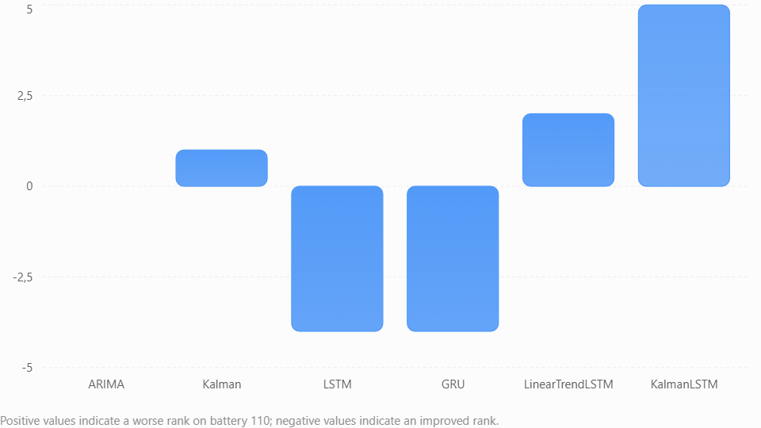

The most striking reversals are:
- KalmanLSTM: rank 1 on 410, rank 6 on 110.
- LSTM: rank 5 on 410, rank 1 on 110.
- GRU: rank 6 on 410, rank 2 on 110.
- ARIMA: rank 3 on both batteries.

These differences are scientifically interesting, but they do not establish that transfer caused the ranking reversals. Battery characteristics, evaluation periods, and optimization protocols also differ.

2. Normalized RMSE comparison
Model | 410 NRMSE | 110 NRMSE
ARIMA | 2.735% | 0.186%
Kalman | 3.026% | 1.064%
LSTM | 4.208% | 0.155%
GRU | 4.493% | 0.161%
LinearTrendLSTM | 2.538% | 0.919%
KalmanLSTM | 2.164% | 3.084%

The normalization scales are 31.060667 µV for 410 and 168.392000 µV for 110.
Five models have lower normalized errors on 110 than on 410. KalmanLSTM is the exception. However, because the normalization denominators differ substantially, these ratios should not be interpreted as direct measurements of transfer degradation.

Sprint 15.4.3 — Ranking Stability and Transferability Diagnostics
I've prepared a separate, read-only module that extends our verified Sprint 15.4.2 analysis engine without modifying it.
The new module calculates pairwise ranking reversals, leave-one-model-out Spearman sensitivity, and top-k overlap. It also includes input validation and independent unit tests.

Preliminary results from your verified rankings

Pairwise ranking reversals
12 / 15
80% of model pairs reverse order
Spearman correlation
−0.771429
Full six-model comparison
Leave-one-out correlation range
−0.903 to −0.600
All six exclusions remain negative
Top-two overlap
0 / 2
No shared model among the two best

These findings suggest that the ranking reversal is not attributable to a single model. They remain descriptive findings, not evidence that transferring configurations caused the reversals.

Sprint 15.4.3 — Verification successful
1. Cross-battery ranking stability

Ranking reversals
12 / 15
80% of model pairs reverse their relative order
Spearman correlation
−0.771429
Strong negative descriptive rank association

Leave-one-out range
−0.902542 to −0.600000
Correlation remains negative for every exclusion
Top-two overlap
0 / 2
No shared model among the two highest-ranked models
2. Leave-one-model-out sensitivity
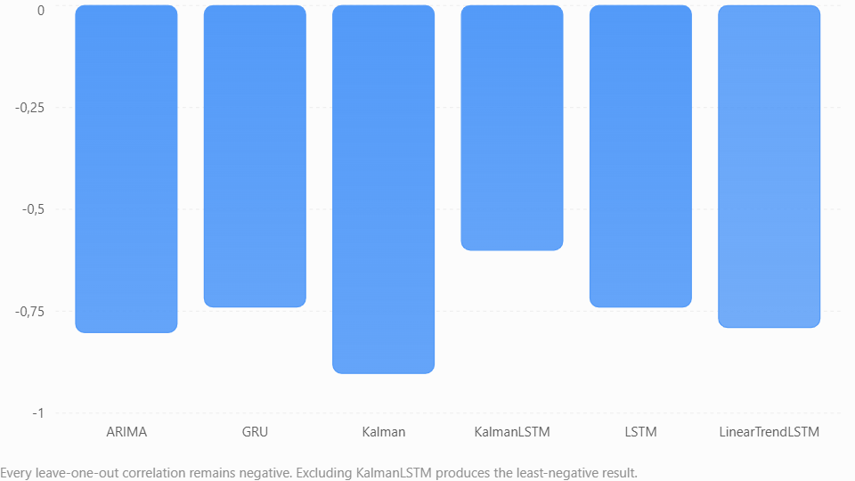
The important finding is that the negative rank association persists regardless of which individual model is excluded. KalmanLSTM contributes substantially to the disagreement, but it is not the sole explanation.
3. Top-k overlap
Top models | Shared models | Overlap
Top 1 | None | 0%
Top 2 | None | 0%
Top 3 | ARIMA | 33.3%

ARIMA is the only model shared between the top-three groups. This is evidence of relative ranking consistency for ARIMA, not proof that its forecasts are inherently more reliable.
4. Scientific interpretation
The results support three descriptive conclusions:
- Model rankings differ substantially between the two batteries.
- The negative ranking relationship is not driven entirely by one model.
- A configuration that performs well on the optimized 410 benchmark is not necessarily highly ranked on the transferred 110 benchmark.
These findings are limited to six models, two batteries, and their respective holdout periods. They do not establish a causal transfer effect or population-level generalization.

Sprint 15.4.4 — Battery 410 RUL verification successful

The results also provide useful information about the behavior of the six forecasting models.

1. RUL results for battery 410
Illustrative upper threshold: 35 µV
0 of 6 models predict a crossing
Forecast horizon: September 2025 – December 2026 (six quarters)
All six models return not_crossed_within_horizon.

This means that none of their saved operational forecasts reaches the illustrative 35 µV threshold within the available six-quarter horizon.

It does not mean that the battery has unlimited remaining life or that failure cannot occur before December 2026. The result is conditional on the models, the assumed threshold, and the saved forecasts.

2. Forecast disagreement decreases over time
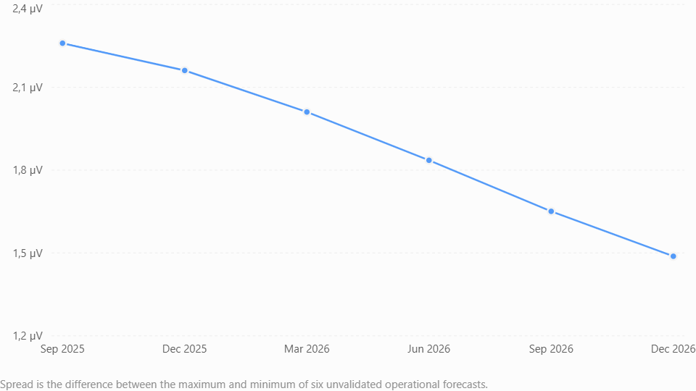
The spread falls from 2.259882 µV to 1.488039 µV, a reduction of approximately 34.2%.
Similarly, the population standard deviation across models falls from 0.704998 µV to 0.571164 µV.
This indicates increasing agreement among the six forecasts over the saved horizon. It does not establish improving predictive accuracy or decreasing physical uncertainty.

3. Median forecast progression
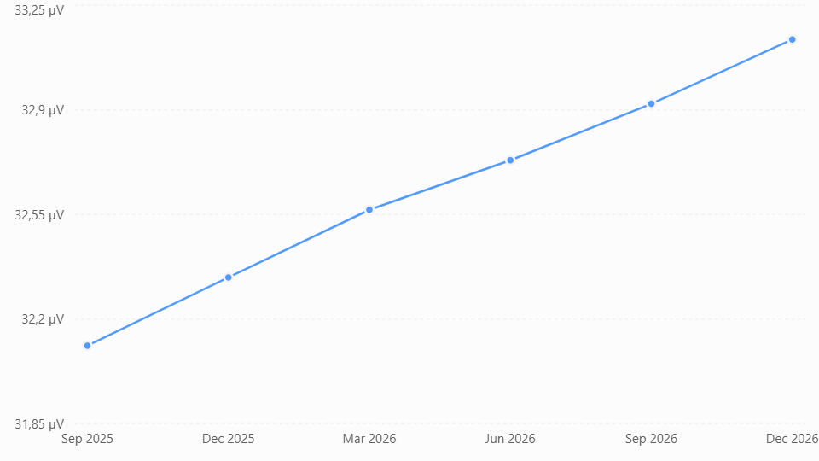

The ensemble median increases from 32.110869 µV to 33.135801 µV. By December 2026, the highest model forecast is 34.144534 µV, still below the illustrative threshold.

4. Important RUL interpretation
Because no model crosses 35 µV, the current engine correctly leaves crossing_date, rul_quarters, and rul_years unset.
For reporting, we can describe these as right-censored at six quarters rather than calculating a numerical failure date. We should also retain the label unvalidated_future_operational_extrapolation in any exported result.

Sprint 15.4.4.2 — Battery 110 RUL verification successful
The results are consistent with the intended threshold-crossing logic. Battery 110 provides a particularly useful diagnostic case because three models predict a crossing of the illustrative 175 µV threshold, while three do not cross within the six-quarter forecast horizon.
The RUL module is therefore distinguishing model-specific outcomes rather than forcing a single failure-date estimate.
1. Model-specific RUL results

Models predicting a crossing
3 / 6
Within the saved horizon
Models without a crossing
3 / 6
Right-censored at six quarters

Model | First crossing | RUL
KalmanLSTM | Jun 2025 | 0.25 yr
LinearTrendLSTM | Dec 2025 | 0.75 yr
Kalman | Mar 2026 | 1.00 yr
ARIMA | Not within horizon | —
LSTM | Not within horizon | —
GRU | Not within horizon | —

175 µV is an illustrative threshold, and all crossing dates come from unvalidated operational forecasts.
An important observation is that KalmanLSTM predicts the earliest crossing, just one quarter after the last measurement. This model also ranked sixth on battery 110's transferred holdout benchmark, so its operational crossing estimate deserves particular caution.
We should not average these three RUL values into a single expected battery lifetime.

2. Forecast disagreement grows over time
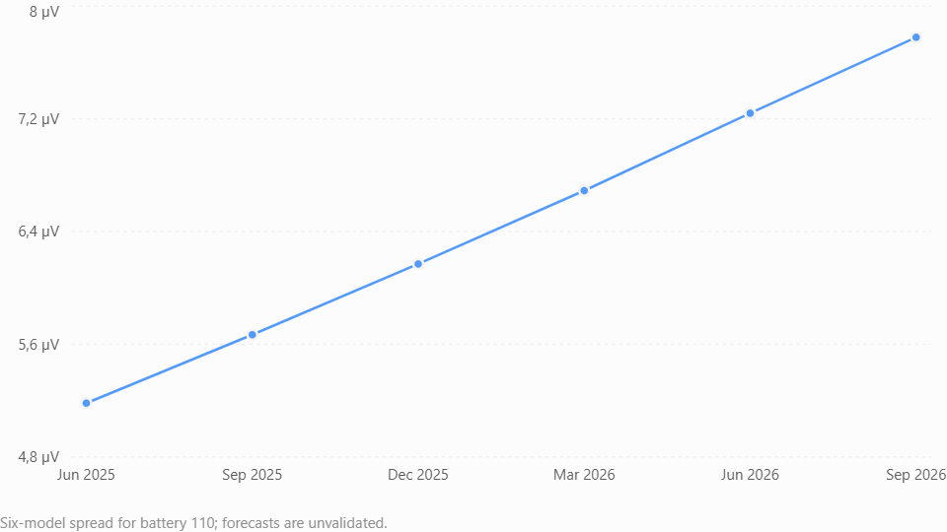

The spread increases from 5.181348 µV to 7.778758 µV, approximately 50.1% growth. The population standard deviation similarly increases from 1.793432 to 2.747450 µV.
This contrasts with battery 410, where model disagreement decreased over the forecast horizon.

3. Battery 410 versus battery 110
Diagnostic | Battery 410 | Battery 110
Illustrative threshold | 35 µV | 175 µV
Models forecasting crossing | 0/6 | 3/6
Horizon | 6 quarters | 6 quarters
Initial normalized spread | 7.06% | 3.02%
Final normalized spread | 4.65% | 4.53%
Spread change | −34.2% | +50.1%
Model disagreement trend | Decreasing | Increasing

These results highlight different forecast behaviors: battery 410 shows increasing agreement among models, whereas battery 110 shows increasing disagreement.
Neither behavior establishes forecast accuracy, physical battery stability, or a calibrated failure probability.

4. One useful distinction: median forecast versus model-specific crossings
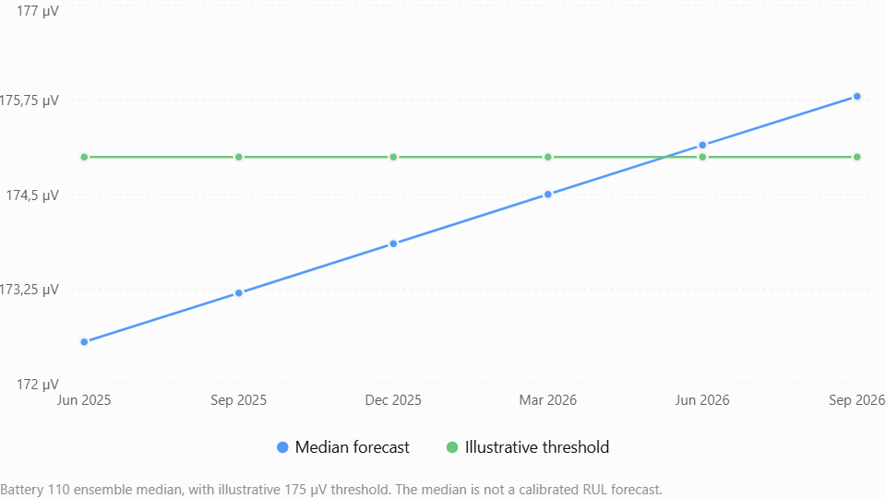

Although KalmanLSTM crosses the threshold in June 2025, the six-model median does not exceed 175 µV until June 2026, the fifth forecast quarter. This illustrates why reporting only one model's RUL can obscure substantial model disagreement.

Nihai denetim süreci boyunca, örnek niteliğindeki eşik senaryoları ile bilimsel olarak doğrulanmış kalan faydalı ömür tahminleri arasındaki ayrımı açık bir şekilde korumalıyız.

Sprint 16: Development Milestones

Milestone 16.1 — Contract and manifest foundation
Audit the existing evaluation API, define the manifest schema, validate manifests, and test serialization and dataset fingerprints. No neural training.
Milestone 16.2 — Reproducible neural runner
Implement architecture construction, preprocessing boundaries, seed management, training, prediction, and execution records.
Milestone 16.3 — Optimization engine
Introduce controlled searches, validation-based ranking, early stopping, trial persistence, and safe experiment resumption.
Milestone 16.4 — Scientific benchmarking
Compare LSTM, GRU, and hybrid architectures across seeds and datasets, with uncertainty and stability diagnostics.
Milestone 16.5 — Reproduction and release audit
Verify manifest-driven reruns, checksum validation, documentation, regression tests, and GitHub-ready packaging.

Initial architectural inventory

Subsystem | Files identified | Audit objective
Evaluation contract | evaluation/evaluator.py, result.py | Verify temporal splits, metrics, and holdout isolation
Neural forecasting | neural/base.py, lstm.py, gru.py | Inspect model configuration, fitting, prediction, and seeds
Neural preprocessing | neural/scaler.py, windows.py, utils.py | Verify scaling and window construction without leakage
Optimization engine | optimization/search.py, candidate.py, spaces.py | Determine how hyperparameter candidates are generated and selected
Optimization validation | optimization/boundary.py, fold.py, validation.py | Inspect training/validation boundaries and rolling-origin support
Optimization stability | optimization/stability.py, stability_evaluator.py | Identify existing repeated-run and stability capabilities
Artifact and provenance | optimization/artifact.py, provenance.py, evidence.py | Determine which reproducibility metadata is already recorded
Experiment management | experiment.py, experiment/experiment.py | Identify the appropriate orchestration layer

The test inventory is also encouraging. It includes LSTM, GRU, hybrid optimization, parameter-space, integration, artifact-persistence, and stability tests. However, file names alone do not establish which capabilities are implemented or scientifically validated. We need to inspect their actual interfaces before deciding what Sprint 16 must add.
Source-code Inventory:

Component | Confirmed interface | Sprint 16 relevance
ForecastEvaluator | evaluate, evaluate_with_forecast, split_dataset | Existing evaluation contract
EvaluationResult | Frozen dataclass, summary, to_dict | Standardized evaluation records
GenericOptimizer | optimize, _select_best | Candidate search and selection
OptimizationEvaluator | evaluate, _aggregate_metrics | Candidate assessment
ExpandingWindowSplitter | split | Temporal cross-validation
BenchmarkBoundary | development_dataset, benchmark_data | Development/holdout separation
TemporalFold | Frozen dataclass | Explicit temporal partitions
OptimizationResult | Frozen dataclass, to_dict | Optimization outcome serialization

This suggests the following existing architecture:

BatteryDataset
BenchmarkBoundary
Development data / final benchmark holdout
ExpandingWindowSplitter + TemporalFold
Training and validation folds
OptimizationEvaluator + ForecastEvaluator
Candidate evaluation
GenericOptimizer
Candidate ranking and selection
OptimizationResult

This is an inferred relationship based on the identified interfaces, not yet a verified execution trace.

Milestone 16.1 assessment :

Section | Deliverable | Status
A | Shared forecast alignment validator | Complete
B | Forecast and optimization evaluator integration | Complete
C | Positional integrity in ForecastResult serialization | Complete
D | Compatibility corrections and full regression testing | Complete
E | Single consolidated Git commit | Complete

Milestone 16.2 assessment :

Section | Scope | Status
16.2-A | Forecast alignment evidence | Passed
16.2-B | Evaluator traceability | Passed
16.2-B1 | Optimization artifact compatibility | Passed
16.2-C1 | Strict alignment opt-in | Passed
16.2-C2 | Structured failure diagnostics | Passed
16.2-C3 | End-to-end optimization integrity | Passed
16.2-D | Complete regression suite | Passed

The full suite includes tests for forecasting, neural architectures, evaluation, optimization, and benchmark integration.

Recommended implementation sequence :

Step | Work | Scope
16.2-D | Final alignment and reproducibility acceptance | Run C3 tests, broader regression suite, verify strict neural entry-point behavior
16.2-E1 | Unified experiment manifest contract | Define required fields, schema version and validation rules
16.2-E2 | Dataset identity and environment provenance | Record dataset fingerprint, dependencies, seed and execution configuration
16.2-E3 | Neural determinism controls | Strengthen seeding, add deterministic-operation support and reproducibility tests
16.3-A | Controlled neural training | Configurable early stopping and explicit training controls
16.3-B | Trial persistence | Save candidate-level results and failures safely
16.3-C | Safe optimization resumption | Validate run identity and resume without silently mixing experiments

The proposed E sections are a way of organizing the remaining original-roadmap requirements, not a claim that those sections have already been approved or implemented.

Questions the audit must resolve
Review | Question
E2-A2-A1 | Does ExpandingWindowSplitter select rows by position, timestamp, or both?
E2-A2-A2 | Are training and validation partitions constructed before preprocessing?
E2-A2-A3 | Can the partition identity be computed without mutating BatteryDataset?
E2-A2-A4 | Does the current workflow preserve observed-versus-inserted flags?
E2-A2-A5 | Can the same fingerprint contract support ARIMA, Kalman, LSTM and GRU?
E2-A2-A6 | How can fold boundaries and selected data be represented without changing manifest schema 1.0?

Proposed acceptance tests
After inspecting the source, we will implement tests for these behaviors:
Scenario | Expected behavior
Same training partition, repeated execution | Identical fingerprint
Different training cutoff | Different fingerprint
Same rows, different row ordering | Identical fingerprint
Changed training measurement | Different fingerprint
Changed validation-only measurement | Same training fingerprint
Validation rows accidentally included | Different fingerprint
Duplicate timestamps | Explicit rejection
Missing observation flags | Explicit rejection for processed-data mode
Interpolated training values | Separately identified from canonical observations
Input dataset | Remains unchanged
The validation-only change test is especially important. It establishes that the training identity depends on training data rather than information from the validation partition.

Confirmed execution behavior
‘ExpandingWindowSplitter’ uses positional slicing to construct expanding training windows and consecutive validation blocks.
For a dataset containing N rows, F folds and V validation rows per fold :
T₀ = N - FV
For fold i :
Train_{i} = D[0 : T₀ + iV]
Validation_{i} = D[T₀ + iV : T₀ + (i + 1)V]

For example, with 100 rows, 3 folds and 4 validation steps :
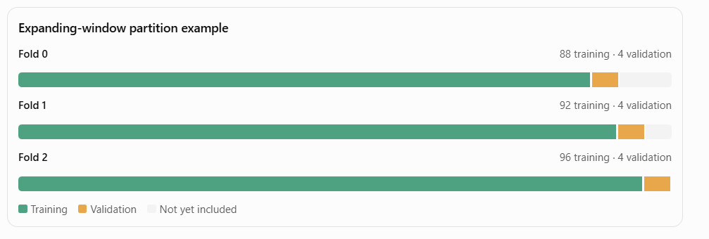
The splitter does not sort the dataset before slicing. Consequently, correct chronological ordering is an important precondition.
2. Two safeguards identified
Safeguard A — Verify the complete temporal ordering.
‘TemporalFold’ currently verifies that the final training timestamp precedes the first validation timestamp. It does not independently verify that every timestamp within each partition is strictly increasing.
For example, an unsorted training partition could satisfy the endpoint comparison while containing out-of-order observations.
The new fingerprint utility should reject duplicate or nonchronological partitions rather than silently repair them.
Safeguard B — Preserve explicit observation provenance.
The splitter constructs each training partition using:
train_dataset = BatteryDataset(train_df)
This creates a new dataset object without preserving the processed-source marker from the original dataset.
Consequently, the E2-A1 ‘fingerprint_dataset()’ function cannot directly fingerprint ‘fold.train’ as a processed ‘BatteryDataset’, even when its DataFrame contains valid ‘is_observed’ flags.
Fortunately, E2-A1 already supports explicit DataFrames.
We can use the validated training DataFrame without changing BatteryDataset or the splitter.

Updated Milestone 16.2-E status
Section | Description | Status
E1 | Unified Experiment Manifest Contract | Accepted
E2-A1 | Canonical Dataset Fingerprinting | Accepted
E2-A2 | Training-Partition Fingerprinting | Accepted
E2-B | Environment and Dependency Provenance | Next
E2-C | Manifest Integration and Persistence

Milestone 16.2-E2 status
Stage | Description | Status
E1 | Experiment Manifest Contract | Accepted
E2-A1 | Canonical Dataset Fingerprinting | Accepted
E2-A2 | Training-Partition Fingerprinting | Accepted
E2-B | Environment and Dependency Provenance | Accepted
E2-C1 | Manifest Integration Audit | Accepted
E2-C2 | Provenance-Aware Manifest Assembly | Accepted
E2-C3 | Persistence and End-to-End Verification | Accepted

Decision: Milestone 16.2-E2 is functionally complete within its defined scope.
The implementation now supports versioned manifest creation, dataset and training-partition fingerprints, environment provenance, JSON persistence and subsequent verification against supplied inputs.
It does not yet automatically capture provenance during historical optimization execution. That remains a separate integration concern.

Proposed implementation stages
Stage | Deliverable | Acceptance requirement
16.3-A | Existing optimizer contract audit | Identify reusable classes and compatibility constraints
16.3-B | Search-space and candidate specification | Deterministic, validated candidate generation
16.3-C | Optimization orchestration | Trial execution, failure isolation and objective ranking
16.3-D | Model integration | ARIMA, Kalman, LSTM, GRU and hybrid compatibility
16.3-E | Provenance and artifact integration | Persist search configuration, trial evidence and selected candidate
16.3-F | End-to-end regression | Determinism, leakage safety, alignment and compatibility tests

The objective should be to reuse ‘OptimizationEvaluator’, the existing generic optimizer and model-specific search infrastructure wherever possible. We should avoid replacing working implementations merely to establish a new abstraction.

What D2 introduces
Two optional controls in the existing GenericOptimizer:
Parameter | Purpose
max_candidates | Maximum number of candidate configurations evaluated
max_epoch_folds | Maximum planned training epochs summed across temporal folds

Both default to None, preserving the existing optimization behavior.
For example:
optimizer = GenericOptimizer(
evaluator,
model="LSTM",
max_candidates=8,
max_epoch_folds=1200,
)

The planned computational budget is calculated as:
B = ∑_{i=1}^{Nevaluated} E_{i} F
where E_{i} is the requested epoch count for candidate i, and F is the number of temporal validation folds.
A candidate is not evaluated if adding its planned epoch-fold cost would exceed the budget. Candidate order remains deterministic, and the search stops at the first budget boundary.
Important: This is a planned training-work budget, not a wall-clock timeout. The epoch budget requires an explicit positive integer epochs in every candidate, and hybrid model factories must forward that value to their neural component.

Proposed Workflow :
- Demo run — neural optimization
Execute the established LSTM, GRU and neural hybrid optimizers with temporal validation. Record training loss, learning onset, convergence diagnostics, candidate scores and training budgets.
- Final model selection and forecasting
Select each model using internal validation only, refit using the eligible historical dataset and produce future forecasts. Retain the forecast dates and alignment evidence.
- Final accuracy evaluation
Compare predictions against the separately held measured future values. Calculate RMSE, MAE, first-step absolute error and forecast bias for every eligible model.
- Dashboard integration
Extend the existing dashboard with optimization comparisons, learning curves, forecast accuracy tables and provenance status.

The essential scientific rule is that measured future values must not influence hyperparameter selection, training budgets, early stopping or model selection. They should be used only for the final external accuracy evaluation.

Existing dashboard confirmed
Previously developed Streamlit + Plotly Cross-Battery Benchmark Explorer, including its saved-evidence comparison, model-ranking charts, numerical reconciliation and provenance components.

It already recognizes these six models:
Statistical models | Neural models
ARIMA | LSTM
Kalman | GRU
 | LinearTrendLSTM
 | KalmanLSTM

The existing dashboard is designed to read saved evidence without retraining models. We should preserve that architecture by running optimization separately and importing verified result files into the dashboard.
Proposed dashboard additions

Training and learning
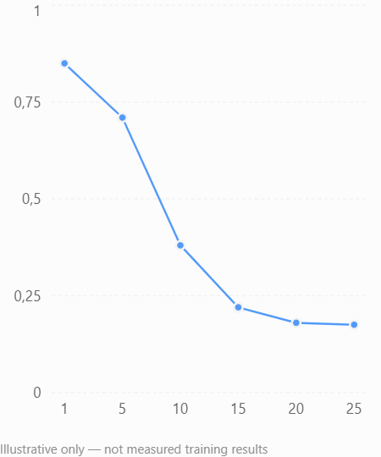
Loss curves, learning onset and convergence markers
Candidate optimization
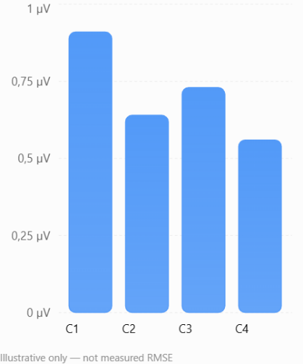
Candidate validation scores and selected parameters

The charts above illustrate the intended dashboard layout. They are not actual ZenerEstimation optimization results.
The final accuracy section should distinguish the optimized 410 benchmark from the frozen transferred 110 benchmark. A newly optimized 110 result must not silently replace its existing frozen-transfer evidence.

Your observations are consistent with the distinction we have maintained throughout ZenerEstimation: training convergence, historical fitting accuracy, and future forecasting accuracy are three different properties of a model.

1. Training loss convergence
If the neural models' training losses approach zero after approximately 20 epochs, this indicates that they can reproduce the training patterns effectively under the current loss definition and scaling.
However, near-zero training loss does not necessarily imply that the models will produce accurate future forecasts. This is particularly important for recursive multi-quarter prediction, where errors can accumulate.

2. Why hybrid models may have relatively poor validation RMSE
A hybrid model can reproduce historical measurements closely while generating comparatively inaccurate forecasts. For example, a trend-plus-residual model might fit the historical trend and short-term fluctuations extremely well, but its residual forecasting component may extrapolate poorly.
Similarly, KalmanLSTM may reconstruct the historical voltage trajectory accurately without necessarily outperforming simpler models over unseen quarters.
Consequently, we should avoid judging either hybrid architecture solely by its internal validation RMSE.

Accuracy Optimization architecture

Experimental workflow:
- Optimization configuration
- Battery · model family · number of runs · search budget · random seeds
- Background execution
- Independent runs with progress, logs, failure tracking, and cancellation
- Statistical evaluation
- RMSE / MAE distributions / Accuracy score · mean · median · std dev · confidence intervals
- Model selection and forecasting
- Select a model using validation evidence, then generate its future forecast
- Three-way comparison: Historical evidence vs Model performance vs Accuracy Optimization

One important scientific consideration: repeating optimization runs provides a distribution of optimization outcomes, but does not by itself establish future forecasting accuracy. We should use consistent temporal validation folds for model selection and preserve an independent holdout for final assessment. Otherwise, repeatedly selecting the lowest holdout error would introduce selection bias.
I would also distinguish the best individual run from the most consistently accurate model family. These can lead to different choices.
For the first implementation, a reasonable experimental default would be 10 independent runs per neural model, with configurable seeds and a shared validation protocol. The number of runs and optimization trials per run should be separate controls.

Next milestone scope

Priority | Development item
1 | Remove unnecessary blank spaces and separators below the source-integrity audit
2 | Add the 110 Battery dataset to Model performance and forecasts
3 | Design the Accuracy Optimization section
4 | Implement configurable background optimization runs
5 | Evaluate run-to-run accuracy statistics and select the best forecasting models
6 | Compare forecasts across the three dashboard sections

