# **KARŞILAŞTIRMA: ARIMA – Regression**

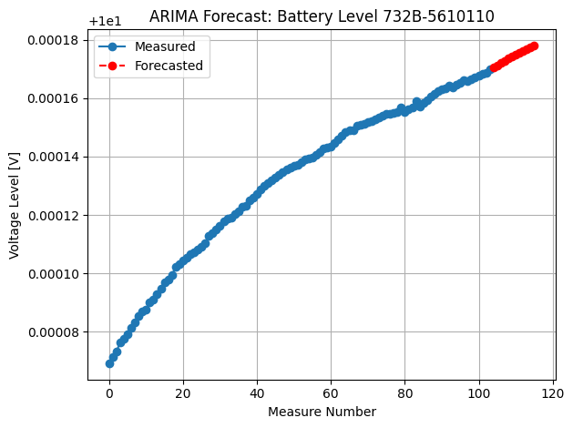

Forecasted Measure Number = 104, prediction is 10.00017064 V

Forecasted Measure Number = 105, prediction is 10.00017136 V

Forecasted Measure Number = 106, prediction is 10.00017215 V

Forecasted Measure Number = 107, prediction is 10.00017293 V

Forecasted Measure Number = 108, prediction is 10.00017363 V

Forecasted Measure Number = 109, prediction is 10.00017431 V

Forecasted Measure Number = 110, prediction is 10.00017500 V

Forecasted Measure Number = 111, prediction is 10.00017568 V

Forecasted Measure Number = 112, prediction is 10.00017632 V

Forecasted Measure Number = 113, prediction is 10.00017694 V

Forecasted Measure Number = 114, prediction is 10.00017756 V

Forecasted Measure Number = 115, prediction is 10.00017816 V

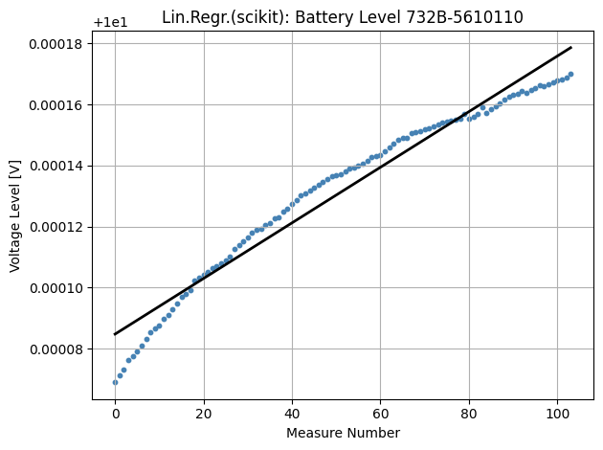

Predicted Measure Number = 104, prediction is 10.00017949 V

Predicted Measure Number = 105, prediction is 10.00018040 V

Predicted Measure Number = 106, prediction is 10.00018131 V

Predicted Measure Number = 107, prediction is 10.00018222 V

Predicted Measure Number = 108, prediction is 10.00018313 V

Predicted Measure Number = 109, prediction is 10.00018404 V

Predicted Measure Number = 110, prediction is 10.00018496 V

Predicted Measure Number = 111, prediction is 10.00018587 V

Predicted Measure Number = 112, prediction is 10.00018678 V

Predicted Measure Number = 113, prediction is 10.00018769 V

Predicted Measure Number = 114, prediction is 10.00018860 V

Predicted Measure Number = 115, prediction is 10.00018951 V

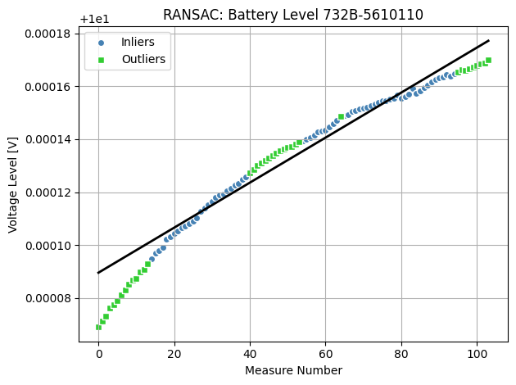

NOT: “Outliers” ölçülen değerler 5ppm den yüksek! (kod satırında: “residual_threshold=5*1e-6, # 5 ppm error”)

Predicted Measure Number = 104, prediction is 10.00017802 V

Predicted Measure Number = 105, prediction is 10.00017887 V

Predicted Measure Number = 106, prediction is 10.00017972 V

Predicted Measure Number = 107, prediction is 10.00018057 V

Predicted Measure Number = 108, prediction is 10.00018142 V

Predicted Measure Number = 109, prediction is 10.00018227 V

Predicted Measure Number = 110, prediction is 10.00018312 V

Predicted Measure Number = 111, prediction is 10.00018397 V

Predicted Measure Number = 112, prediction is 10.00018483 V

Predicted Measure Number = 113, prediction is 10.00018568 V

Predicted Measure Number = 114, prediction is 10.00018653 V

Predicted Measure Number = 115, prediction is 10.00018738 V

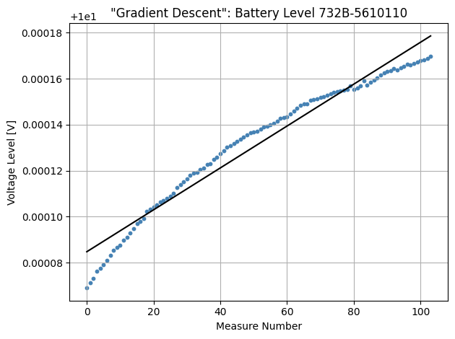

Predicted Measure Number = 104, prediction is 10.00017950 V

Predicted Measure Number = 105, prediction is 10.00018041 V

Predicted Measure Number = 106, prediction is 10.00018132 V

Predicted Measure Number = 107, prediction is 10.00018223 V

Predicted Measure Number = 108, prediction is 10.00018314 V

Predicted Measure Number = 109, prediction is 10.00018405 V

Predicted Measure Number = 110, prediction is 10.00018496 V

Predicted Measure Number = 111, prediction is 10.00018587 V

Predicted Measure Number = 112, prediction is 10.00018678 V

Predicted Measure Number = 113, prediction is 10.00018769 V

Predicted Measure Number = 114, prediction is 10.00018861 V

Predicted Measure Number = 115, prediction is 10.00018952 V

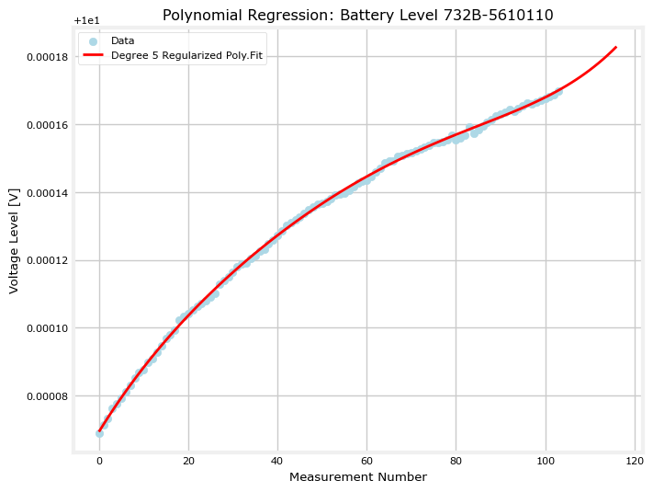

For predicted Measure Number = 104, prediction is 10.00017150 V

For predicted Measure Number = 105, prediction is 10.00017232 V

For predicted Measure Number = 106, prediction is 10.00017317 V

For predicted Measure Number = 107, prediction is 10.00017406 V

For predicted Measure Number = 108, prediction is 10.00017500 V

For predicted Measure Number = 109, prediction is 10.00017597 V

For predicted Measure Number = 110, prediction is 10.00017700 V

For predicted Measure Number = 111, prediction is 10.00017808 V

For predicted Measure Number = 112, prediction is 10.00017921 V

For predicted Measure Number = 113, prediction is 10.00018039 V

For predicted Measure Number = 114, prediction is 10.00018164 V

For predicted Measure Number = 115, prediction is 10.00018295 V

|  |  |  |  |  |  |
| --- | --- | --- | --- | --- | --- |
|  | **ARIMA** | **POLYN. REGR.** | **LIN.REGR.(SCIKIT)** | **RANSAC** | **GRAD. DESCENT** |
| Pred. Nr. = 104 | 10.00017064 V | 10.00017150 V | 10.00017949 V | 10.00017802 V | 10.00017950 V |
| Pred. Nr. = 105 | 10.00017136 V | 10.00017232 V | 10.00018040 V | 10.00017887 V | 10.00018041 V |
| Pred. Nr. = 106 | 10.00017215 V | 10.00017317 V | 10.00018131 V | 10.00017972 V | 10.00018132 V |
| Pred. Nr. = 107 | 10.00017293 V | 10.00017406 V | 10.00018222 V | 10.00018057 V | 10.00018223 V |
| Pred. Nr. = 108 | 10.00017363 V | 10.00017500 V | 10.00018313 V | 10.00018142 V | 10.00018314 V |
| Pred. Nr. = 109 | 10.00017431 V | 10.00017597 V | 10.00018404 V | 10.00018227 V | 10.00018405 V |
| Pred. Nr. = 110 | 10.00017500 V | 10.00017700 V | 10.00018496 V | 10.00018312 V | 10.00018496 V |
| Pred. Nr. = 111 | 10.00017568 V | 10.00017808 V | 10.00018587 V | 10.00018397 V | 10.00018587 V |
| Pred. Nr. = 112 | 10.00017632 V | 10.00017921 V | 10.00018678 V | 10.00018483 V | 10.00018678 V |
| Pred. Nr. = 113 | 10.00017694 V | 10.00018039 V | 10.00018769 V | 10.00018568 V | 10.00018769 V |
| Pred. Nr. = 114 | 10.00017756 V | 10.00018164 V | 10.00018860 V | 10.00018653 V | 10.00018861 V |
| Pred. Nr. = 115 | 10.00017816 V | 10.00018295 V | 10.00018951 V | 10.00018738 V | 10.00018952 V |

