# **KARŞILAŞTIRMA: ARIMA – Polynomial Regression**

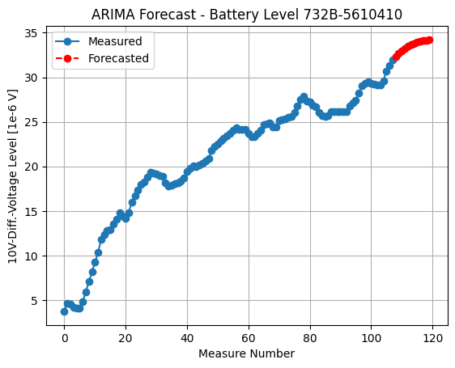

For predicted Measure Number = 108, prediction is 32.31662880 1e-6 V

For predicted Measure Number = 109, prediction is 32.67166999 1e-6 V

For predicted Measure Number = 110, prediction is 32.97085537 1e-6 V

For predicted Measure Number = 111, prediction is 33.23694443 1e-6 V

For predicted Measure Number = 112, prediction is 33.45516479 1e-6 V

For predicted Measure Number = 113, prediction is 33.63408502 1e-6 V

For predicted Measure Number = 114, prediction is 33.78094653 1e-6 V

For predicted Measure Number = 115, prediction is 33.90427722 1e-6 V

For predicted Measure Number = 116, prediction is 34.00816741 1e-6 V

For predicted Measure Number = 117, prediction is 34.09528573 1e-6 V

For predicted Measure Number = 118, prediction is 34.16779575 1e-6 V

For predicted Measure Number = 119, prediction is 34.22808094 1e-6 V

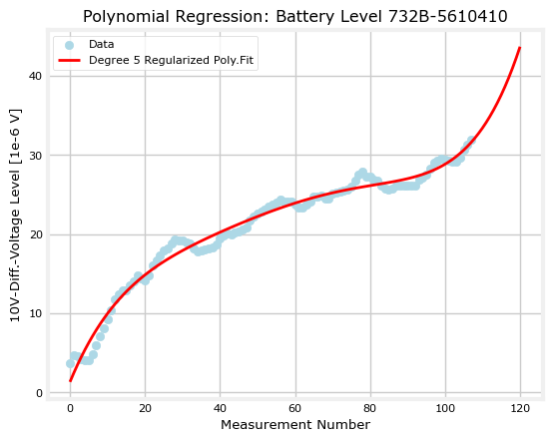

For predicted Measure Number = 108, prediction is 32.69287190 1e-6 V

For predicted Measure Number = 109, prediction is 33.34941599 1e-6 V

For predicted Measure Number = 110, prediction is 34.06221869 1e-6 V

For predicted Measure Number = 111, prediction is 34.83495378 1e-6 V

For predicted Measure Number = 112, prediction is 35.67143646 1e-6 V

For predicted Measure Number = 113, prediction is 36.57562600 1e-6 V

For predicted Measure Number = 114, prediction is 37.55162829 1e-6 V

For predicted Measure Number = 115, prediction is 38.60369842 1e-6 V

For predicted Measure Number = 116, prediction is 39.73624326 1e-6 V

For predicted Measure Number = 117, prediction is 40.95382403 1e-6 V

For predicted Measure Number = 118, prediction is 42.26115892 1e-6 V

For predicted Measure Number = 119, prediction is 43.66312561 1e-6 V

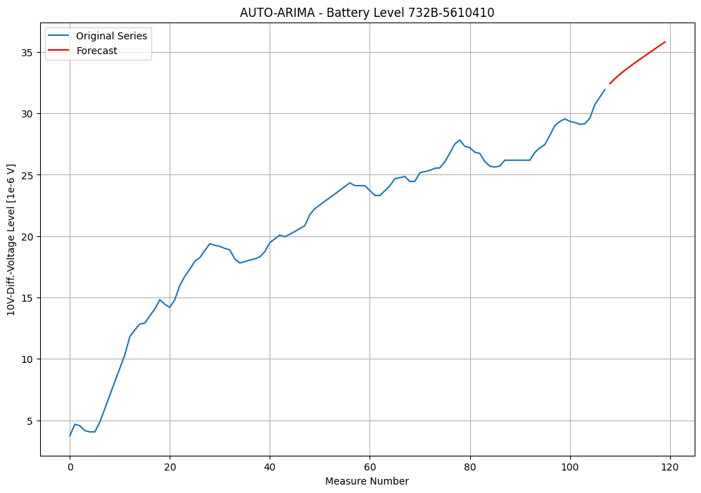

108 32.416131

109 32.821273

110 33.177733

111 33.504214

112 33.812234

113 34.108886

114 34.398536

115 34.683875

116 34.966559

117 35.247608

118 35.527651

119 35.807073

|  |  |  |  |
| --- | --- | --- | --- |
|  | **ARIMA** | **POLYN. REGR.** | **AUTO-ARIMA** |
| Pred. Nr. = 108 | 32.31662880 1e-6 V | 32.69287190 1e-6 V | 108 32.416131 |
| Pred. Nr. = 109 | 32.67166999 1e-6 V | 33.34941599 1e-6 V | 109 32.821273 |
| Pred. Nr. = 110 | 32.97085537 1e-6 V | 34.06221869 1e-6 V | 110 33.177733 |
| Pred. Nr. = 111 | 33.23694443 1e-6 V | 34.83495378 1e-6 V | 111 33.504214 |
| Pred. Nr. = 112 | 33.45516479 1e-6 V | 35.67143646 1e-6 V | 112 33.812234 |
| Pred. Nr. = 113 | 33.63408502 1e-6 V | 36.57562600 1e-6 V | 113 34.108886 |
| Pred. Nr. = 114 | 33.78094653 1e-6 V | 37.55162829 1e-6 V | 114 34.398536 |
| Pred. Nr. = 115 | 33.90427722 1e-6 V | 38.60369842 1e-6 V | 115 34.683875 |
| Pred. Nr. = 116 | 34.00816741 1e-6 V | 39.73624326 1e-6 V | 116 34.966559 |
| Pred. Nr. = 117 | 34.09528573 1e-6 V | 40.95382403 1e-6 V | 117 35.247608 |
| Pred. Nr. = 118 | 34.16779575 1e-6 V | 42.26115892 1e-6 V | 118 35.527651 |
| Pred. Nr. = 119 | 34.22808094 1e-6 V | 43.66312561 1e-6 V | 119 35.807073 |

