

Palm Computing Platform

Installation

Donkie Kung Jr. is designed for the Palm Computing Platform. “dkjr.prc” should be installed into your handheld device using the instructions provided by the manufacturer. The appropriate display mode (black and white, grayscale or color) will be used when the application is started.

How to Play

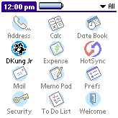
Start Donkie Kung Jr. by tapping on the application icon in the application launcher. After a short while, you will be presented with the main Donkie Kung Jr. screen in which you may select the type of game you wish to play, or setup any configuration options.
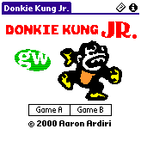
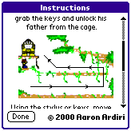
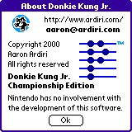
There are two types of game play available, game A and B – your choice depends solely on your confidence and skill level. Game A is for beginners, where Game B requires more skill and co-ordination. You can select the game type by tapping on the “Game A” or “Game B” buttons, or by using a menu command.

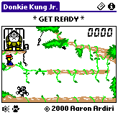
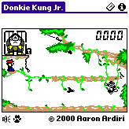
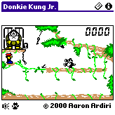
Using the hard keys or the stylus, you must move Donkie Kung Jr. and grab the key that locks the cage Donkie Kung is trapped in. You may configure the key and sound volume on the configuration screen. You get to this by selecting the menu item “Config” in the “Game” menu. Consult your handheld device manual for instructions of selecting a menu item. When a game is active, you may tap the speaker icon at the bottom left of the screen to get to the configuration screen. It is possible to pause the current game in progress by tapping the paw icon.

Registration
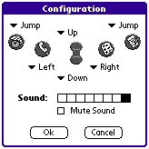
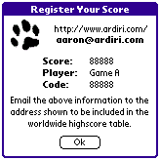
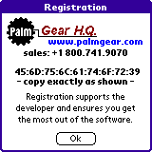
Donkie Kung Jr. is shareware, the demonstration version does not allow player to generate high score codes or the ability to save Donkie Kung more than once. To access these features, a device identification number is required to generate a unique unlocking registration datafile.

You can get to the registration screen by selecting the “Register” menu item in the “Game” menu.

To be included in the global high score table (located at http://www.ardiri.com/), send an email to aaron@ardiri.com with the information shown in the “Register Your Score” dialog. This will only appear if you beat the ‘Internal’ high score for each game type, or if you request it using the menu option under the “Score” menu on the main page.

