

Palm Computing Platform

Installation

Hexxagon is designed for the Palm Computing Platform. “hexxagon.prc” should be installed into your handheld device using the instructions provided by the manufacturer. The appropriate display mode (grayscale or color) will be used when the application is started.

How to Play

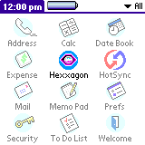Start Hexxagon by tapping on the application icon in the application launcher. After a short while, you will be presented with the main Hexxagon. screen in which you may select the type of game you wish to play, or setup any configuration options.
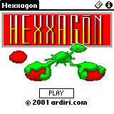
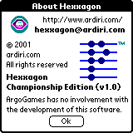
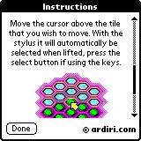
Hexxagon is a variation of the popular board game Othello, where the aim of the game is to fill the board with as many pieces that belong to you as possible. The board is hexagonal in size, with each piece on the board having up to six neighboring pieces. Moving a piece over one space (to neighbor) creates a new piece (a duplicate), while moving over two spaces physically moves the piece.

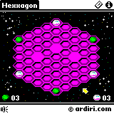
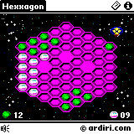
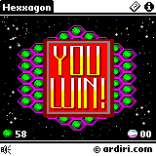
Move the cursor above the piece that you wish to move. With the stylus it will automatically be selected when lifted, press the select button if using the keys. The valid moves are then shown. Tap one, and the move will occur! You may configure the key and sound volume on the configuration screen. You get to this by selecting the menu item “Config” in the “Game” menu. Consult your handheld device manual for instructions of selecting a menu item. When a game is active, you may tap the speaker icon at the bottom left of the screen to get to the configuration screen. It is possible to pause the current game in progress by tapping the paw icon.

Registration

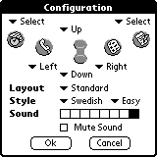

Hexxagon is shareware; the demonstration version brings up a dialog with “please register” at the start/end of each game (annoying, yes). The game is fully playable with the default board layout and positions. In the registered version, ten different board layouts are available and other positioning systems including the unpredictable “random” mode – which makes the game very fun. To access these features, a device identification number is required to generate a unique unlocking registration data file.

You can get to the registration screen by selecting the “Register” menu item in the “Game” menu.

