

Palm Computing Platform

Installation

Hoards of the Deep Realm is designed for the Palm Computing Platform. “hoards.prc” and “lode_original.pdb” should be installed into your handheld device using the instructions provided by the manufacturer. The appropriate display mode (black and white, grayscale or color) will be used when the application is started.

How to Play

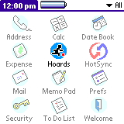
Start Hoards of the Deep Realm by tapping on the application icon in the application launcher. After a short while, you will be presented with the main Hoards of the Deep Realm screen in which you may select a level set to edit (only custom level sets) or to play, and setup any game configuration options.
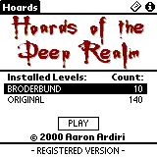
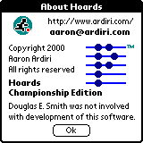
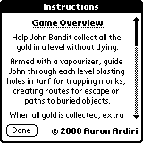
Using the hard keys or the stylus, you must move John Bandit to collect all the gold available in a level. Use your vaporizer to blast holes in turf for trapping monks, creating routes for escapes or paths to buried objects. When all gold is collected, extra routes may be shown. Guide John to the top of the screen to continue to the next level. Monks patrol each level and getting caught by one results in death. They can pick up objects and may drop them or need to be trapped to give them up.

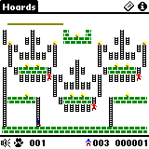
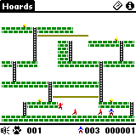
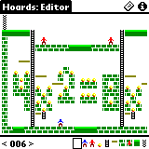
You may configure the key and sound volume on the configuration screen. You get to this by selecting the menu item “Config” in the “Game” menu. Consult your handheld device manual for instructions of selecting a menu item. When a game is active, you may tap the speaker icon at the bottom left of the screen to get to the configuration screen. It is possibe to pause the current game in progress by tapping the paw icon.

Registration
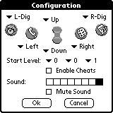

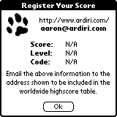
Hoards of the Deep Realm is shareware, the demonstration version does not allow player to generate high score codes or allow more than five levels be played in succession. To access these features, a device identification number is required to generate a unique unlocking registration datafile.

You can get to the registration screen by selecting the “Register” menu item in the “Game” menu.

To be included in the global high score table (located at http://www.ardiri.com/), send an email to aaron@ardiri.com with the information shown in the “Register Your Score” dialog. This will only appear if you beat the ‘Internal’ high score for each game type, or if you request it using the menu option under the “Score” menu on the main page.

