

Palm Computing Platform

Installation

Liberty is designed for the Palm Computing Platform. “liberty.prc” should be installed into your handheld device using the instructions provided by the manufacturer.

How to Play

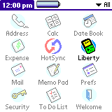
Start Liberty by tapping on the application icon in the application launcher. After a short while, you will be presented with the main Liberty screen in which you may select a game and start emulation, remove it from the device, or setup any configuration options.
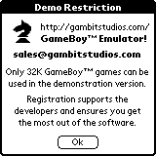
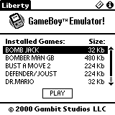
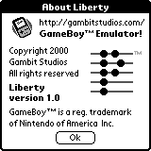
Liberty supports games designed for the original GameBoyTM.

Conversion of GameBoyTM games to the format required on the Palm device is done using a simple utility that is provided with the download. You can get game images anywhere on the Internet, but to get started, go here:

http://www.vintagegaming.com/emulators/gameboyroms.html
http://www.emuunlim.com/ROMs/gameboy.shtml

Gambit Studios does not endorse the illegal use of commercial games. DO NOT request illegal images from us - we don't where you can get them, and will not respond to your requests.

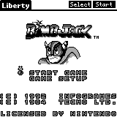
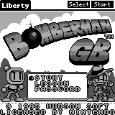
Registration
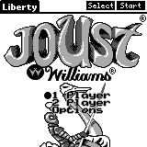
Liberty is shareware, the demonstration version does not allow emulation of GB games that are larger than 32Kb in size. To access these features, a device identification number is required to generate a unique unlocking registration data file.

You can get to the registration screen by selecting the “Register” menu item in the “Game” menu.

Registration is only $16.95 and can be purchased with a credit card at Gambit Studios website. You may also purchase at PalmGearHQ either over the phone or Internet using your credit card. It is also sold with a registered version of the overclocking utility "AfterBurner" at a discounted price of $22.95.

The official website for Liberty, www.gambitstudios.com, handles online registrations and support.

Thank you for downloading and using Liberty!

// Aaron Ardiri
// Michael Ethetton
- the Liberty development team

