

Palm Computing Platform

Installation

Maryo Bros is designed for the Palm Computing Platform. “maryobros.prc” should be installed into your handheld device using the instructions provided by the manufacturer. The appropriate display mode (grayscale or color) will be used when the application is started.

How to Play
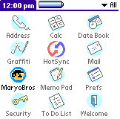
Start Maryo Bros by tapping on the application icon in the application launcher. After a short while, you will be presented with the main Maryo Bros screen in which you may start the game, or setup any configuration options.
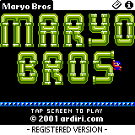
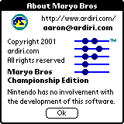
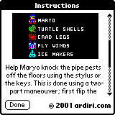
The water pipes in Maryo's house are blocked with crawling creatures. Help Maryo knock the pipe pests (Turtle Shells, Crab Legs, Fly Wings and Ice Makers) off the floors using the hard keys or the stylus – at the same time avoiding firey FireBalls!

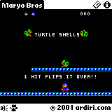
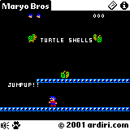
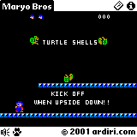
You may configure the key and sound volume on the configuration screen. You get to this by selecting the menu item “Config” in the “Game” menu. Consult your handheld device manual for instructions of selecting a menu item. When a game is active, you may tap the speaker icon at the bottom left of the screen to get to the configuration screen. It is possible to pause the current game in progress by tapping the paw icon.

Registration
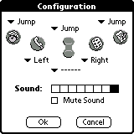
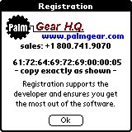
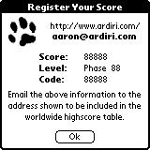
Maryo Bros is shareware, the demonstration version does not allow player to generate high score codes or the advance past the third phase. To access these features, a device identification number is required to generate a unique unlocking registration datafile.

You can get to the registration screen by selecting the “Register” menu item in the “Game” menu.

To be included in the global high score table (located at http://www.ardiri.com/), send an email to aaron@ardiri.com with the information shown in the “Register Your Score” dialog. This will only appear if you beat the ‘Internal’ high score for each game type, or if you request it using the menu option under the “Score” menu on the main page.

