From Mating Gap to Fertility Gap: Decomposition of fertility rate to marriage market conditions in the U.S., 2013 to 2023
Ardis Zhong

Abstract
Background: Fertility rate has declined in the U.S. Existing research has linked marriage rate decline to the fertility rate decline. However, no recent analysis has examined how fertility rate decline is linked to sex ratio changes in marriage markets facing unmarried college-educated women.

Objective: I examine how the sex ratio mismatch has contributed to fertility rate changes. I focus on college-educated women in the U.S. and decompose at the aggregate level from 2013 to 2023.

Methods: I use U.S. Census data from 2013 ACS and 2023 ACS to decompose the change in fertility rate among college-educated women by age group and education level.

Results: Women with a doctorate or professional degree and women in their late 20s were most impacted by the marriage market sex ratio changes. Marriage market sex ratio decline negatively impacts fertility rate. Women adapt to changing marriage market conditions by “marrying down” educationally, which helps stabilize the fertility rate over time. Hypergamy is most evident for women with a Master’s degree.

Conclusions: Marriage market sex ratio can be one factor affecting fertility rate among many other factors. Its effect can be offset by expanding educational preferences of educated women.

Contribution: This study highlights the importance of marriage market sex ratios of equal or higher education level in examining fertility rate changes. This could be an interesting part of future research as marriage becomes deinstitutionalized with changing cultural norms.

Introduction
Fertility rate has been linked to marriage rates, and marriage market conditions have been linked to marriage rates; this study links fertility rate to marriage market conditions among college-educated women in the U.S. from 2013 to 2023 using U.S. Census ACS datasets. Is there an educational mismatch between sexes that affects fertility rates? Would more babies be born if more educated women could find more educated men to partner with?

Literature review
Motherhood on Ice: The Mating Gap by Marcia C. Inhorn (2023) asks why more women are freezing their eggs, perhaps due to career ambitions, the technology being new and available, health considerations such as cancer, or reproductive indecision. Instead, she finds that women are mostly freezing their eggs to buy time because they aren’t finding a suitable male partner in time, and she suggests this is due to the educational mismatch in the dating pool. Since women were allowed to attend college, more women have been getting more education at a rate generally faster than men have, resulting in more college-educated women than men. If every college-educated woman expects to marry and have children with a college-educated man, there may not be enough of them, unless there is systematic divorce and remarriage. Inhorn provides a demographic assessment and suggests that women consider expanding their dating pool to be more realistic, including men with less education than they have. Perhaps this shift in cultural expectations could keep marriage and fertility rates stable. Has this shift happened in the last ten or so years?

Hwang (2023) finds that in South Korea, women are attaining more education, but this is not causing most of the large decline in marriage and fertility; although Hwang doesn’t assess the relative sex ratio between educated men and women. Hwang also finds that there are increases in both single and childless women and married and childless women, which suggests that marriage as an indicator of fertility is not as important since it doesn’t always lead to children, which could make it more interesting to look at earlier stages in the fertility cycle for root causes.

This study uses U.S. Census data and decomposition to examine whether sex ratios in the marriage market account for fertility rate decline among college-educated women from 2013 to 2023. Results are grouped by age group and educational level.

Data and methods
Data used is from the U.S. Census 2013 ACS and 2023 ACS using 20 variables: YEAR, SAMPLE, SERIAL, CBSERIAL, HHWT, CLUSTER, STRATA, GO, PERNUM, PERWT, SEX, AGE, MARST, BIRTHYR, FERTYR, EDUC, EDUCD, SEX_SP, AGE_SP, and EDUCD_SP filtered to ages between 20 and 45 inclusive.

Sex ratios are calculated as a measure of marriage market conditions focusing on unmarried women with at least a college-level education. For unmarried women with a bachelor’s degree, the sex ratio calculates how many unmarried men with at least a college’s degree there are. For unmarried women with a Master’s degree, the sex ratio indicates the number of unmarried men with at least a Master’s degree, and for unmarried women with a doctorate or professional degree, it is the number of unmarried men with at least a doctorate or professional degree.

In this dataset, unmarried is defined as never married, divorced, separated, or widowed and excludes married individuals and individuals who are married but marked spouse as absent, to be conservative, as these could primarily be deployed spouses or spouses temporarily on work assignment.

Fertility rates are calculated as births per 1,000 women regardless of marital status.
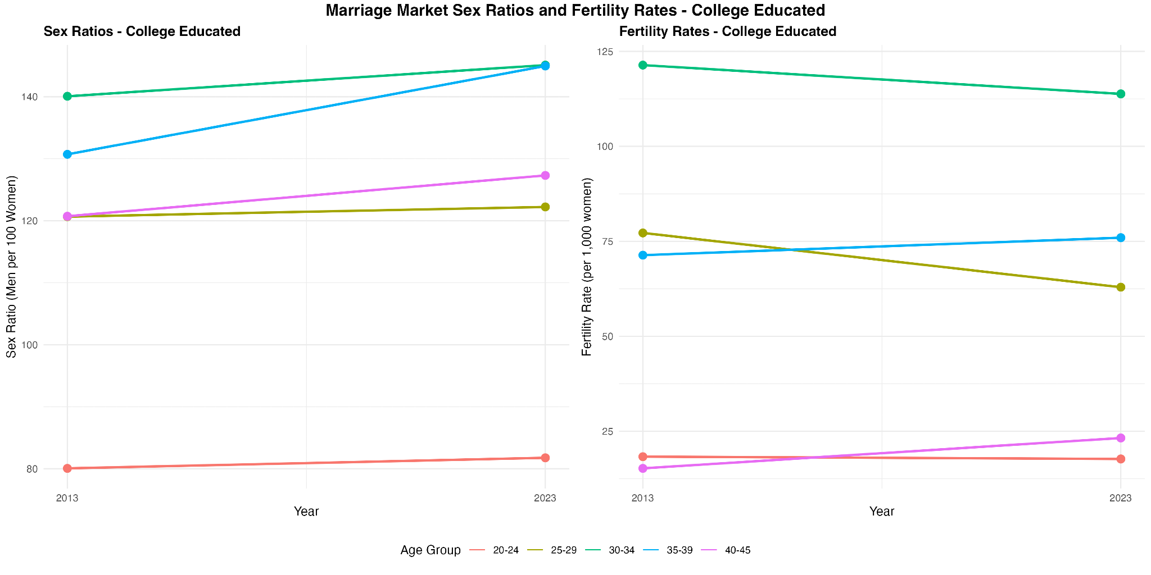
Figure 1: Marriage market sex ratios and fertility rates among women with a bachelor’s degree

There are broad increases in the sex ratio among college-educated women with most age groups except the youngest one showing more men than women. However, while this could be true in the aggregate sense, the geographic distribution may mean that in most marriage markets, the sex ratio is lower for college-educated women. There could be concentrations of college-educated men in the military based in certain locations, so further analysis by geographic region could be helpful. The fertility rate has slightly increased for some age groups but declined for others with no clear correlation. In particular, for the early 30s age group, the sex ratio has increased with even more college-educated men per college-educated woman, but the fertility rate has decreased from 2013 to 2023, indicating many divorces or other factors at play.

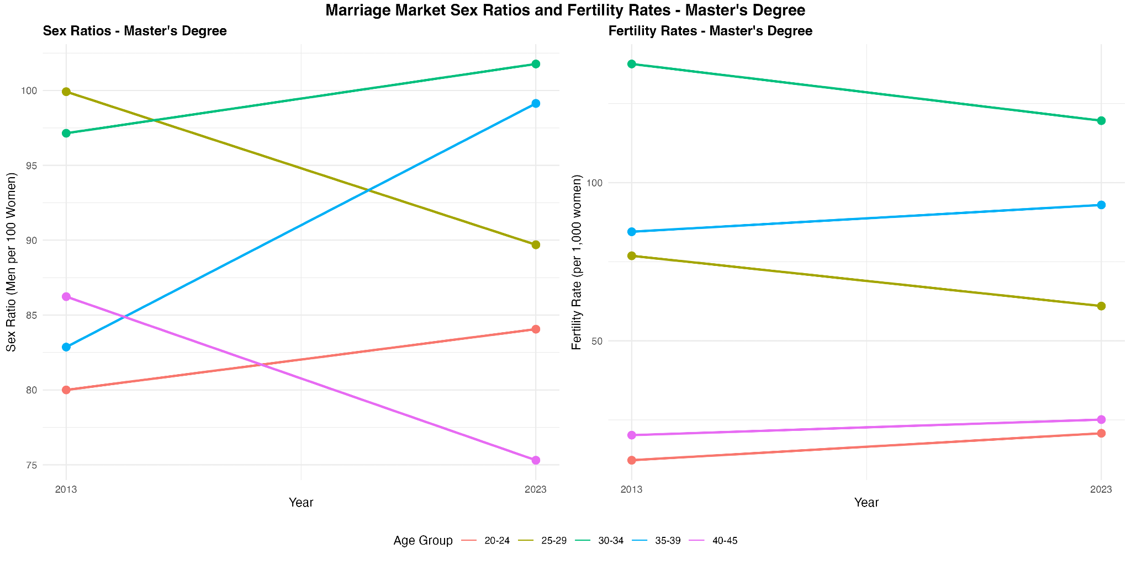
Figure 2: Marriage market sex ratios and fertility rates for women with a Master’s degree

The trends for women with a Master’s degree are the most mixed especially regarding sex ratios. This may reflect how the number and types of Master’s degrees have changed to match the job market, such as newer degrees like Master’s in Data Science and increases in the number of Nurse Practitioners to address rising healthcare costs. The fertility rate among Master’s degree-holders is also mixed with slight declines in some age groups and slight increases in other age groups.

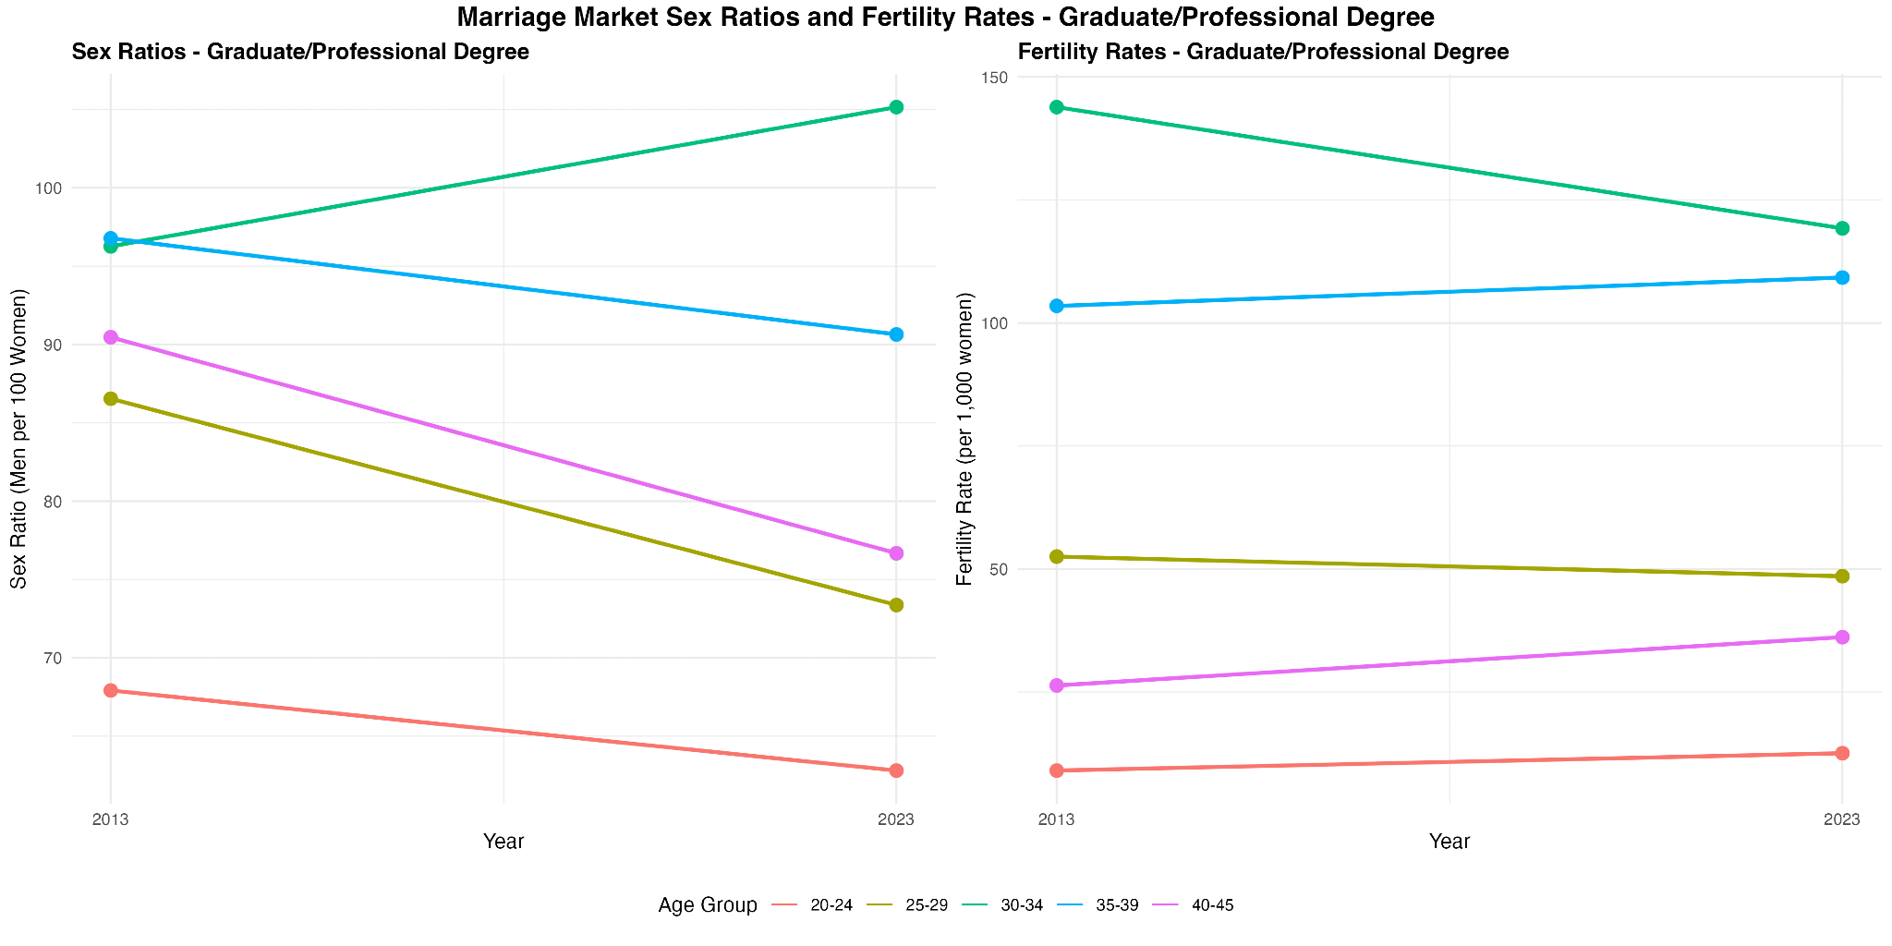
Figure 3: Marriage market sex ratios and fertility rates for women with a doctorate or professional degree

For women with a doctorate or professional degree, sex ratio has generally decreased, except for the early 30s age group, and fertility has stayed broadly the same, although declining for the same early 30s age group. The term professional degree is broad so this could be capturing a labeling change. Currently, the U.S. Census considers degrees such as MD, JD, DDS, DMD, DVM, PharmD, DPT, and OD as professional degrees, while doctorate degrees include PhD, EdD, DBA, and ScD, which are academic research degrees, so it may not make as much sense to combine the two into one educational group.

Women may be adapting to the changing demographic landscape by “marrying down” educationally, also known as hypergamy, as Inhorn (2023) encouraged given the current demographic reality. Women in almost every age group and education level have increased their hypergamy in marriage. By adjusting their marriage preferences, women may be maintaining marriage rates and therefore fertility rates and adapting to the changing marriage market. This indicates that marriage preferences are flexible and respond to marriage market conditions and that fertility rates can be resilient.

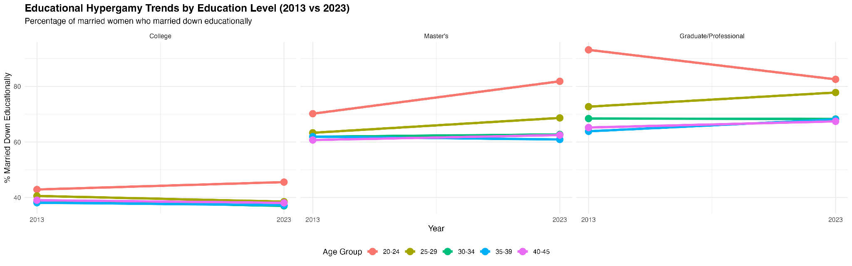
Figure 4: Educational hypergamy trends across educational levels

Results
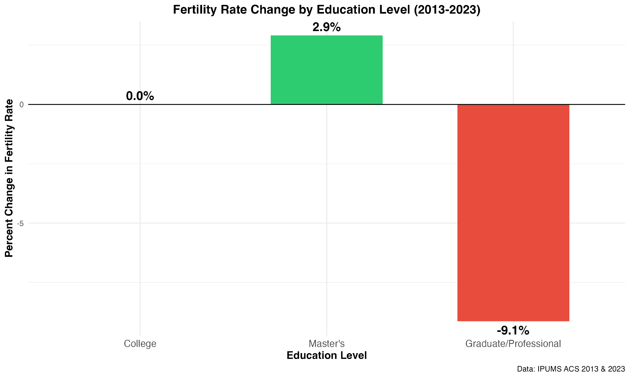
Figure 5: Fertility rate change by education level from 2013 to 2023

Fertility rate for college-educated women, regardless of marital status, was roughly unchanged from 2013 to 2023. However, the fertility rate for women with a Master’s degree increased by 2.9%, but the fertility rate for women with a doctorate or professional degree decreased by 9.1% from 2013 to 2023.

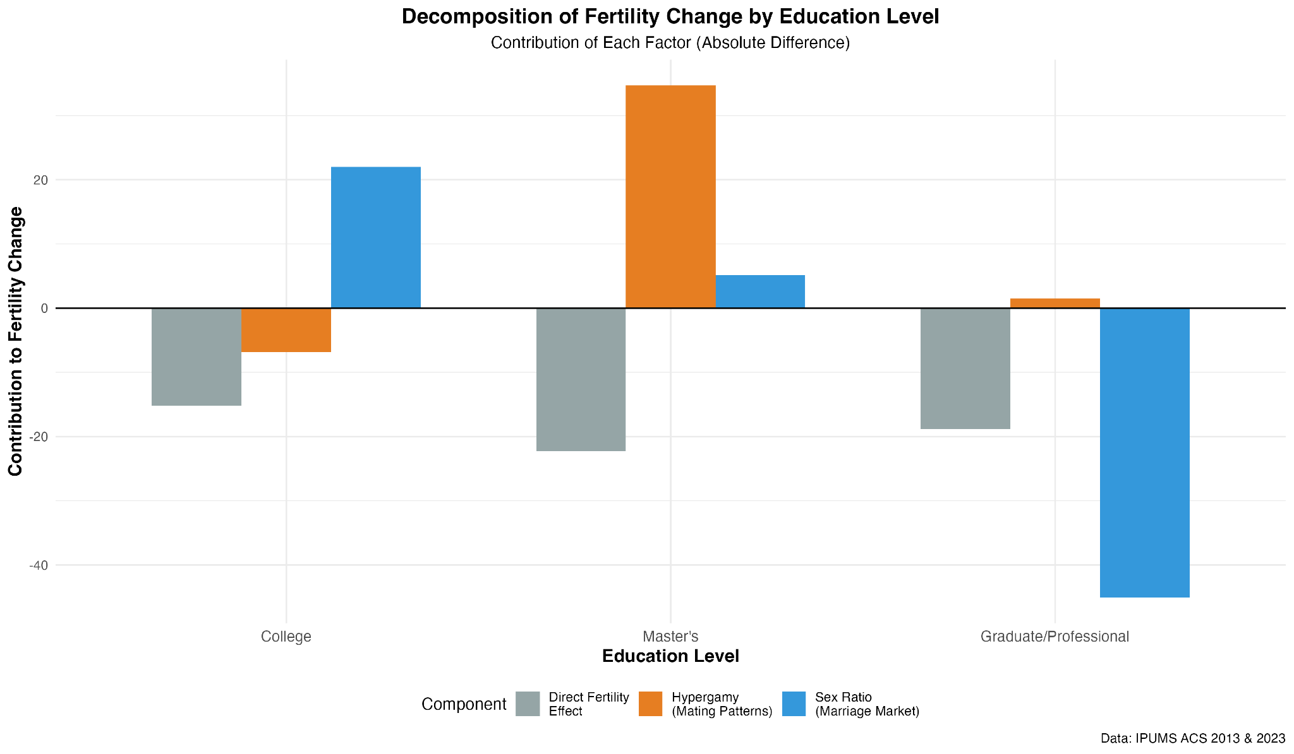
Figure 6: Decomposition of fertility rate change by education level

For college-educated women, the effects of sex ratio changes, hypergamy, and other factors roughly cancel each other out. However, for women with a Master’s degree, the effect from the sex ratio change was positive, but the effect from hypergamy is largest, meaning women with a Master’s degree are “marrying down” educationally, which is resulting in higher fertility rates. The educational mismatch facing women with a doctorate or professional degree is most dramatic, which makes sense since they are the highest-educated. Women with a doctorate or professional degree are impacted by the marriage market sex ratio, resulting in reduced fertility rates.

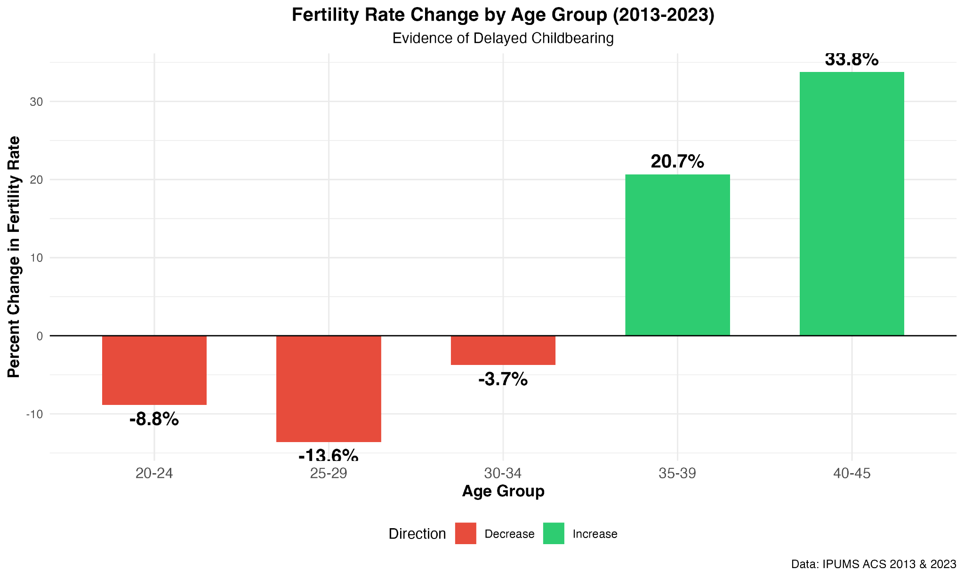
Figure 7: Fertility rate change by age group from 2013 to 2023

Younger women were having fewer children in 2023 than ten years earlier in 2013. However, women in their later 30s and early 40s were having more children in 2023, showing the trend of delayed childbearing.

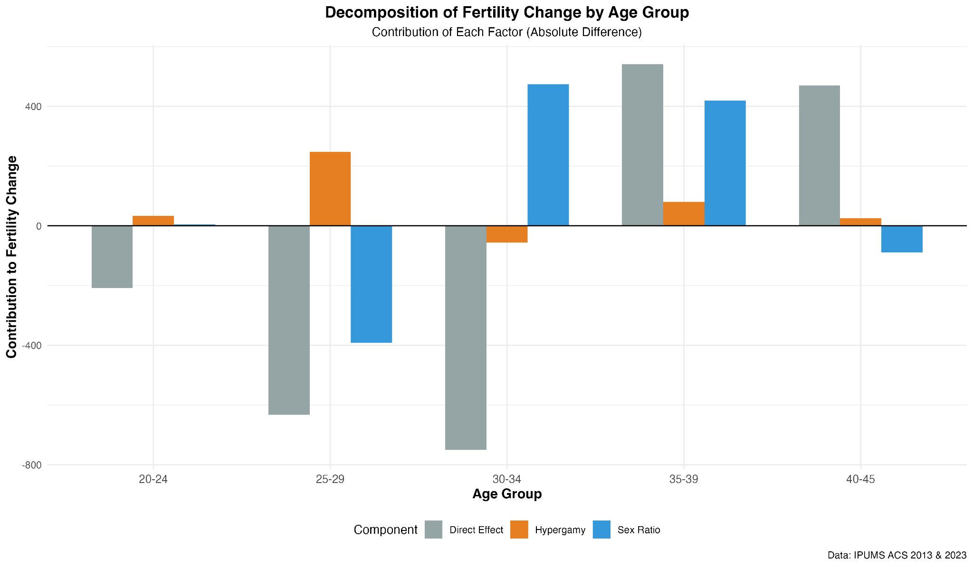
Figure 8: Decomposition of fertility rate change by age group from 2013 to 2023

Within the younger age groups, the largest factors are not hypergamy and marriage market sex ratios. In the late 30s, increased hypergamy and improved sex ratios from 2013 to 2023 contributed to the increase in fertility rate with other factors also significantly contributing. In the early 40s age group, other factors were primarily driving the increase; however, the sex ratio mismatch reduced the fertility rate, but other factors including slight hypergamy, resulted in a net increase.

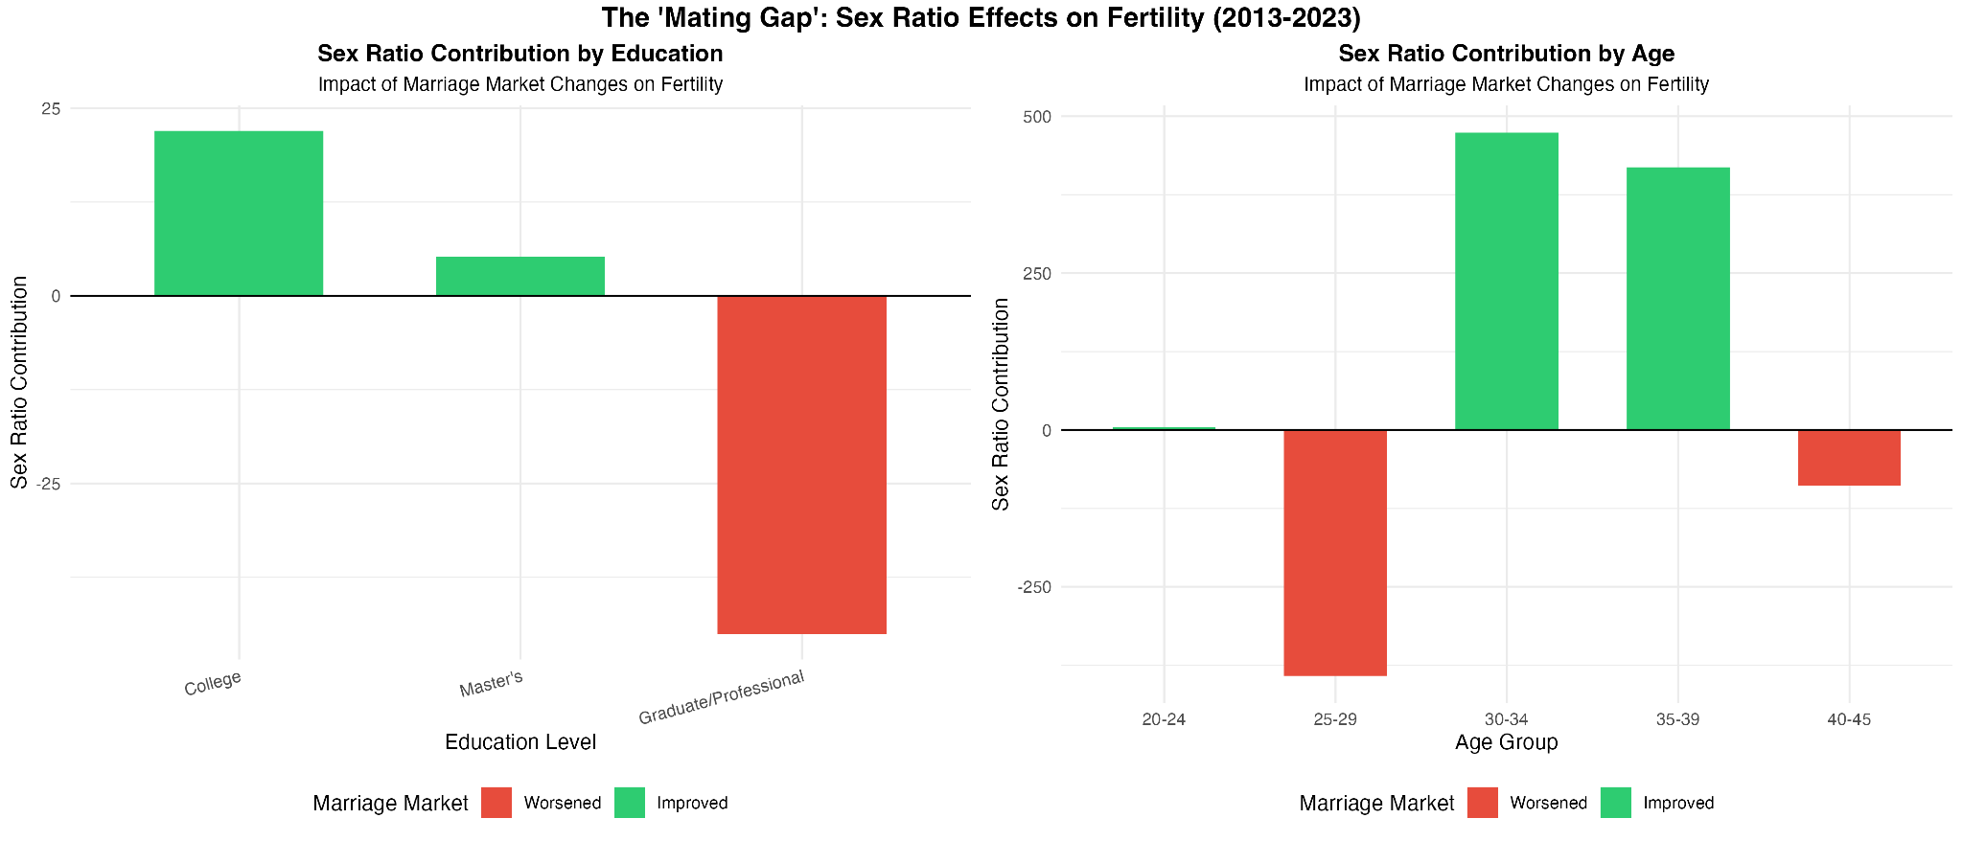
Figure 9: Marriage market sex ratio effects on fertility by education level and age group from 2013 to 2023

The marriage market sex ratios worsened for women with a doctorate or professional degree and for women in their late 20s and early 40s. The sex ratios did improve for college-educated women and women with a Master’s degree as well as the 30s. The improved marriage market sex ratios contributed positively to the fertility rate whereas the worsened sex ratios negatively affected the fertility rate for other education and age groups. The negative effect is largest for women with a doctorate or professional degree and women in their late 20s and smaller for women in their early 40s.

For women with a doctorate or professional degree, the fertility rate decreased from 682 births per 1,000 women to 620 births per 1,000 women, and of the 62 birth decline, about 45 were due to the worsening marriage market, meaning the marriage market sex ratio mismatch accounted for 72% of the fertility rate decline for women with doctoral or professional degrees. For women in the late 20s age group, the fertility rate decreased from 5,708 births per 1,000 women to 4,930 births per 1,000 women, and of the 778 birth decline, about 392 were due to the worsening marriage market, meaning the marriage market sex ratio mismatch accounted for 50% of the fertility rate decline for women in their late 20s. However, other factors are also significant drivers of fertility rate decline.

Conclusion
Hayford and Morgan (2008) find that women who value religion have higher fertility, even controlling for unwanted fertility, age at childbearing, and degree of fertility postponement, which suggests that women can be adaptive in some areas, such as preferences in educational level of their partner, while holding other firmer values like religiosity. Hayford and Morgan also find that religiosity only matters in its correlation with traditional gender and family attitudes, so perhaps women will adapt to their circumstances flexibly in order to maintain their family values.

The change in marriage preferences may be part of a broader cultural change where norms are in flux. Studies have shown that more couples including those with children are choosing not to marry and instead to just cohabit indefinitely. The U.S. Census does not currently specify long-term partnership or civil partnerships in this dataset, so this may make it challenging to accurately estimate sex ratios. If cultural changes mean marriage or even partnership is increasingly not required for or correlated with children, then examining sex ratios directly as precursor to fertility could be valuable, and in this case, could reaffirm that while fertility can be affected by external conditions, there are significant other drivers that are resilient, such as likely inherent fertility desires.

There may also be a lag in how women respond to changing conditions. The marriage market condition or sex ratio demographics in 2013 may not perfectly affect the fertility decisions in 2023 - some women may be responding earlier or later, so there is some noise that is difficult to capture without an individual or cohort analysis. There are also generational differences in this dataset. Women in their 30s and 40s may be interacting with different cultural norms in their age groups than younger women in younger generations are. I think it does bring up interesting questions about how culture is formed and whether sometimes demographic adaptations naturally become part of the culture, not always the other way around.

This study aggregated across the U.S. but further analysis could calculate for individual metropolitan areas to realistically simulate marriage market conditions, but this wouldn’t account for migration. Future research could also focus on smaller groups such as LGBTQIA+ individuals to account for potential differences and characterize cultural shifts within sub-groups.

This could be reassuring or concerning depending on what is considered the ideal fertility rate. It is interesting how resilient fertility rates can be though and how women adapt to their surroundings. This could extend similarly to other factors as well, such as affordability or cost of living, and further research could examine how women or couples adapt to rising costs. Further data improvements could include differentiating between singlehood and civil partnerships or long-term relationships and indicators for single parents by choice.

The results align broadly with existing decomposition research that show many factors contribute to fertility rate decline. Zeman et al. (2018) find that in older generations, women born between 1940 and 1955, the fertility rate decline was mostly due to declines in having more than two children, which would not relate to the marriage market sex ratio factor. However, for women born between 1955 and 1970, in some regions, such as German-speaking countries, Southern Europe, and East Asia, decreases in even having a first child were the main driver of fertility rate decline where it could be interesting to see how the demographics of the marriage markets differ. Similarly, Mugiyama (2025) finds that in Japan, increases in employment instability account for increases in childless individuals, which would be interesting to link to educational and gender demographics as well to add another dimension to our understanding of the structural framework surrounding fertility rate decline.

References
Hayford, S.R. and Morgan, S.P. (2008). Religiosity and Fertility in the United States: The Role of Fertility Intentions. Social Forces 86(3): 1163–1188. doi:10.1353/sof.0.0000.

Hwang, J. (2023). Later, Fewer, None? Recent Trends in Cohort Fertility in South Korea. Demography 60(2): 563–582. doi:10.1215/00703370-10585316.

Inhorn, M.C. (2023). Motherhood on Ice: The Mating Gap and Why Women Freeze Their Eggs. New York: New York University Press.

Mugiyama, R. (2025). Decomposing delayed first marriage and birth across cohorts: The role of increased employment instability among men in Japan. Demographic Research 52(21): 635–688. doi:10.4054/DemRes.2025.52.21.

Zeman, K., Beaujouan, E., Brzozowska, Z., and Sobotka, T. (2018). Cohort fertility decline in low fertility countries: Decomposition using parity progression ratios. Demographic Research 38(25): 651–690. doi:10.4054/DemRes.2018.38.25.

