Weak Prompts:
- Explain regression
- Help me understand SQL
- Create a dataset
Improved prompts: These improved prompts provide clear context, a specific audience, desired topics, and expected output formats. Adding details helps the AI generate more accurate, relevant, and useful results while reducing ambiguity.

- a) Explain regression analysis to a beginner studying data analytics. Include the purpose of regression, the difference between linear and multiple regression, a real-world business example, and how regression is used to make predictions.

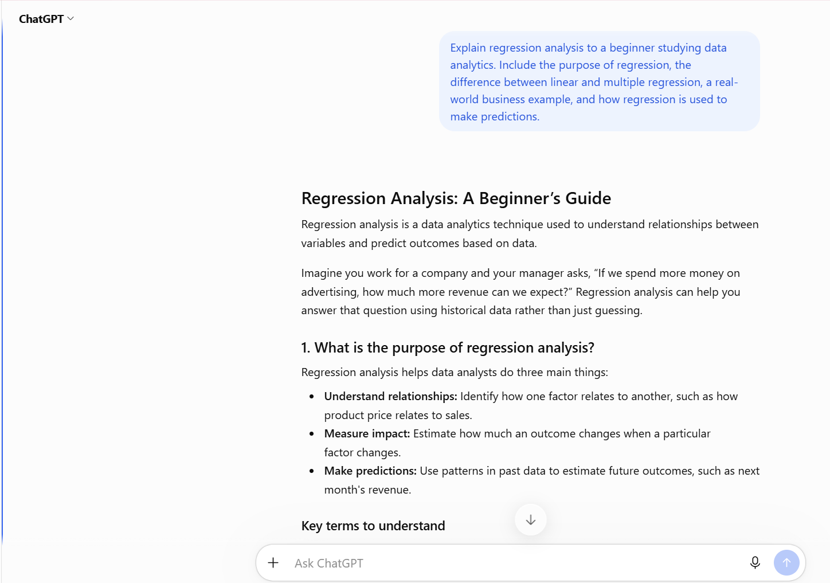

- b) I am a beginner studying data analytics and have no prior experience with SQL. Explain what SQL is, why companies use it, and how it helps data analysts work with data. Use simple language and provide 3 basic examples of SQL queries with explanations.

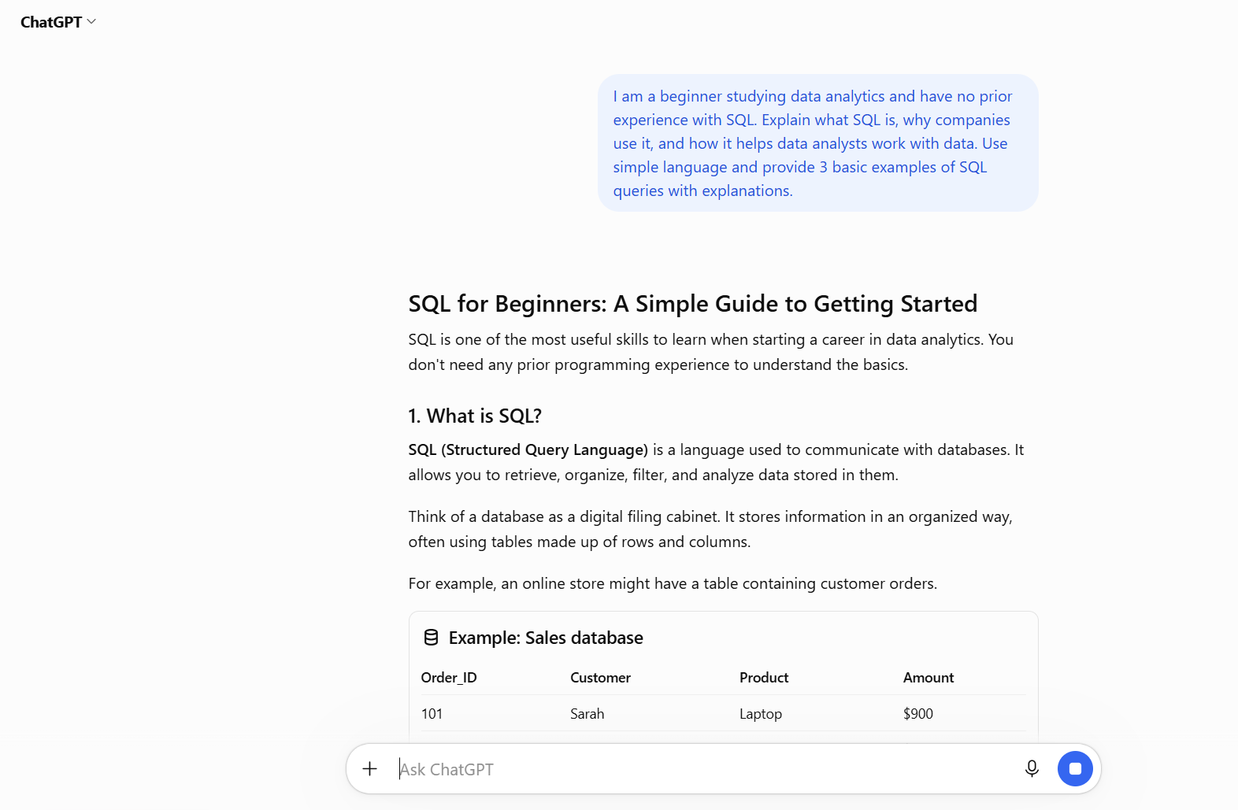

- c) Create a sample dataset with 50 rows for a retail store. Include columns for Customer ID, Product Category, Order Date, Quantity Sold, Unit Price, and Total Sales. Format the data as a table suitable for importing into Excel.
