Assignment 4
Ardak Kazykhan, IT-2510
Forms and Validation with HTML and Bootstrap
I built three responsive forms with Bootstrap and a shared CSS file. The browser checks the input rules using HTML attributes. The pages use no JavaScript.
GitHub repository
https://github.com/ardkzhn0111/assignment4-forms
Task 1 Train ticket form at 1280px
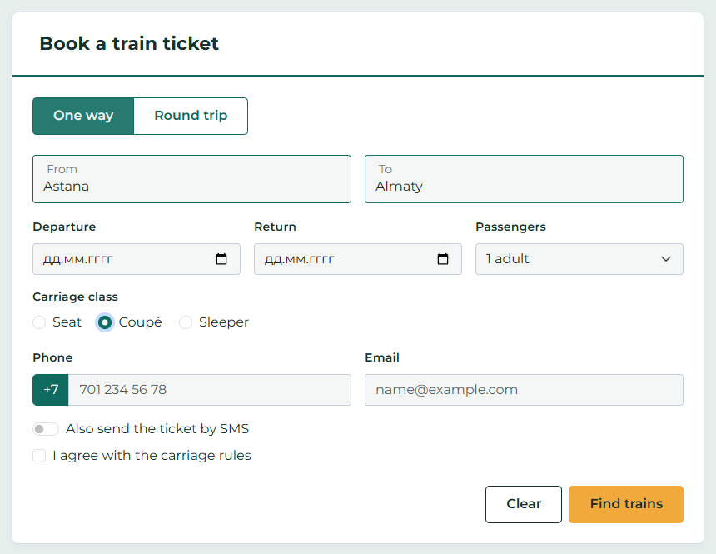
Figure 1. Laptop viewport 1280px. Related fields share a row.
I used floating labels, date inputs, a passenger select, carriage radios, a phone input group and an SMS switch. The updated design uses Montserrat, a white heading, compact corners and a subtle shadow. The ticket keeps the given green and gold colours.
From, To, Departure, Carriage class, Phone, Email and the agreement are required. Passengers can be 1 to 6 adults. The form starts empty; Figure 1 shows entered example values.
Task 1 Train ticket form at 375px
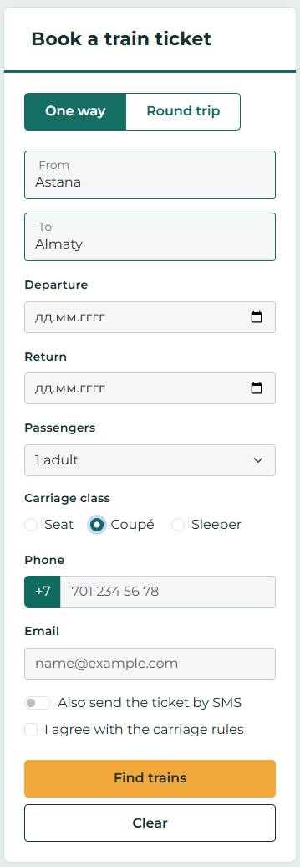
Figure 2. Phone viewport 375px. Find trains appears above Clear.
The HTML order stays Clear then Find trains. On a phone, column-reverse changes their visual order; from 768px, flex-direction becomes row. The reset button restores empty controls and the passenger prompt.
.actions { flex-direction: column-reverse; }
@media (min-width: 768px) {
.actions { flex-direction: row; }
}

Task 2 Hackathon registration
The registration uses blue accents and light grey fields. Each rule uses type, required, min, max, step, minlength or maxlength. No pattern is used. The optional GitHub field accepts an empty value or a full URL.
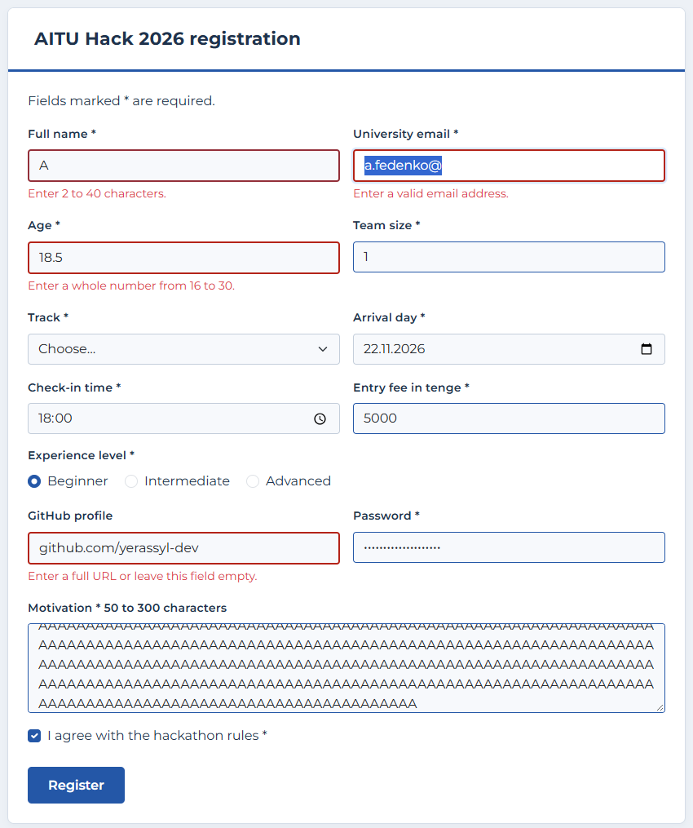
Figure 3. Registration at 1280px after editing. Invalid fields show a red border and a short message.
The initial form has no visible errors. CSS :user-invalid reveals .invalid-feedback after interaction or a submission attempt. Error messages are connected with aria-describedby.
Task 2 Validation results
All values below produced the required result in Chrome. Text lengths were tested through browser input, so minlength and maxlength were checked with actual user edits.
Field | Accepted | Rejected | Result
Full name | Anna-Maria Lee | A | Pass
University email | a.fedenko@  astanait.edu.kz | a.fedenko;  a.fedenko@ | Pass
Age | 18 | 15; 31 | Pass
Team size | 4 | 5; 2.5 | Pass
Track | Web | Choose… | Pass
Arrival day | 21.11.2026 | 25.11.2026 | Pass
Check-in time | 10:30 | 10:15; 19:00 | Pass
Entry fee | 1500 | 1250; 6000 | Pass
Experience | Beginner | Nothing chosen | Pass
GitHub profile | Empty; https://github.com/  yerassyl-dev | github.com/  yerassyl-dev | Pass
Password | Astana2026 | short | Pass
Motivation | 120 characters | 49 characters | Pass
Rules agreement | Checked | Unchecked | Pass

Additional checks
The limits 16 and 30, 1 and 4, 20 and 22 November, 09:00 and 18:00, and 0 and 5000 were accepted. A fractional age was rejected. Text length boundaries passed, and maxlength blocked extra characters.
<input type="time" min="09:00" max="18:00"
step="1800" required>
<input type="number" min="0" max="5000"
step="500" required>

For time, step is measured in seconds: 1800 seconds is 30 minutes. The fee step is 500 tenge. Registration uses POST so its password is not added to the URL; storing registrations requires a server endpoint.
Task 3 Corrected café reservation
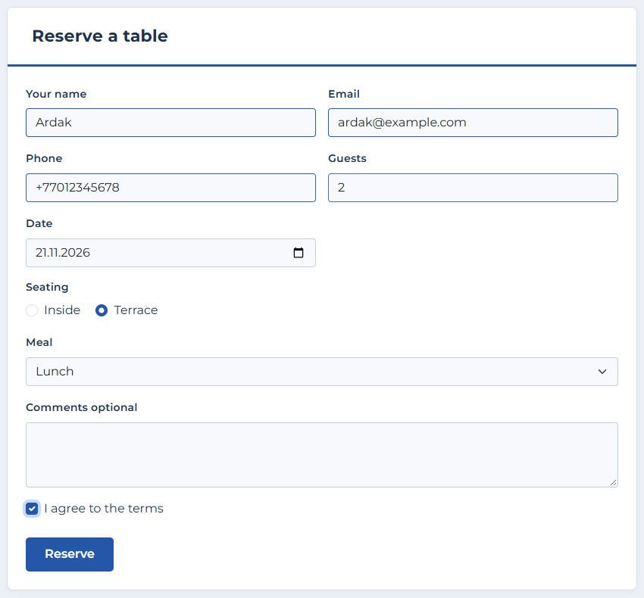
Figure 4. Corrected form at 1280px. Every original field is kept.
The café form uses the same blue accents, white heading and compact corners. I added connected labels and names, appropriate input types, a seating fieldset and a submit button. Seating options share one name and have different values.
W3C Nu Validator returned no errors or warnings for task3.html. Keyboard checks confirmed Tab navigation and arrow selection of the seating radios. FormData included all nine named fields.
Task 3 Problems in the original form
Line numbers refer to the code picture in the assignment, counting the heading as line 1. Several different problems can occur on the same line.
Original line | Problem for the user | Fix in task3.html
3 Your name | Placeholder disappears and provides no persistent label. | Added a visible label linked to id="name".
3 to 10 inputs | Missing name attributes mean most entered data is not sent. | Added a name to each input.
4 Email | Text type does not reject a malformed email. | Used type="email" and required.
5 Phone label | The label is not linked to the phone input. | Added for="phone".
6 Phone input | Text type does not request a phone keypad. | Used type="tel" and autocomplete="tel".
7 and 8 Guests | for="guests" does not match id="people". | Used id="guests" and a matching label.
8 Guests input | Text allows non-numeric guest counts. | Used number, min="1", step="1".
10 Date input | A text date is ambiguous and lacks a calendar. | Used type="date".
10 and 12 date id | Duplicate id makes label targeting ambiguous. | Used unique date and inside ids.
11 to 13 Seating | A paragraph does not name the radio group for assistive tools. | Added fieldset and legend.
12 and 13 radios | Different names allow both seating choices at once. | Both use name="seating" and distinct values.
12 and 13 radio text | Text is not a clickable connected label. | Added a label for each radio.
14 Meal select | There is no label or name; meal selection is not sent. | Added a Meal label, id and name.
18 Comments | Placeholder disappears; no name means comments are lost. | Added label, id and name.
19 Terms | Unlinked text is hard to activate; no required check. | Added linked label, name, value and required.
20 Reserve div | A div is not a native keyboard submit button. | Used button type="submit".

Task 3 Alternative fixes and verification
Alternative for line 3
An aria-label could give the name input an accessible name. I chose a visible connected label because it remains readable after typing and helps both sighted users and screen reader users.
Alternative for line 20
An input type="submit" would also submit through the keyboard. I chose button type="submit" because its visible text is easy to read and edit while keeping native keyboard behaviour.
Verification
All 69 browser checks passed. These included 42 text, number, date, time and URL cases, plus choice controls, length limits, responsive button order, empty reset and keyboard operation. Task 1 was captured at exactly 375px and 1280px with no horizontal overflow.
All three pages use native controls and connected labels. Tab and Shift+Tab move between controls, Space toggles checkboxes, arrow keys change radio choices and Enter activates a submit button. Native validation blocks invalid submission.
Conclusion
I learned how Bootstrap classes arrange forms and how HTML attributes check values without JavaScript. I also learned that connected labels, shared radio names and real buttons make a form easier to use with the keyboard.
Project files
Open index.html to choose a task. Each task has its own HTML file, with one shared style.css. Bootstrap and Montserrat are stored locally. These are front end demonstrations; no real booking or registration is stored.
References
Bootstrap forms documentation
https://getbootstrap.com/docs/5.3/forms/overview/
MDN user invalid selector
https://developer.mozilla.org/en-US/docs/Web/CSS/Reference/Selectors/:user-invalid
W3C Nu HTML Checker
https://validator.w3.org/nu/

