Football Stars
  - Responsive Web Design Report
Assignment 3
Media Queries and Bootstrap Grid
Ardak Kazykhan
Group IT-2510
4 October 2026

Project overview
This report explains how the Football Stars page adapts to phone, tablet and laptop screens. The page introduces six football players in four sections: Home, Football Stars, Football Legends and About the Project.
The stars section uses custom CSS Grid and mobile-first media queries. The other sections use Bootstrap 5.3.8. Both card layouts display one, two and three columns at the required widths of 375px, 768px and 1280px.
https://github.com/ardkzhn0111/football-stars
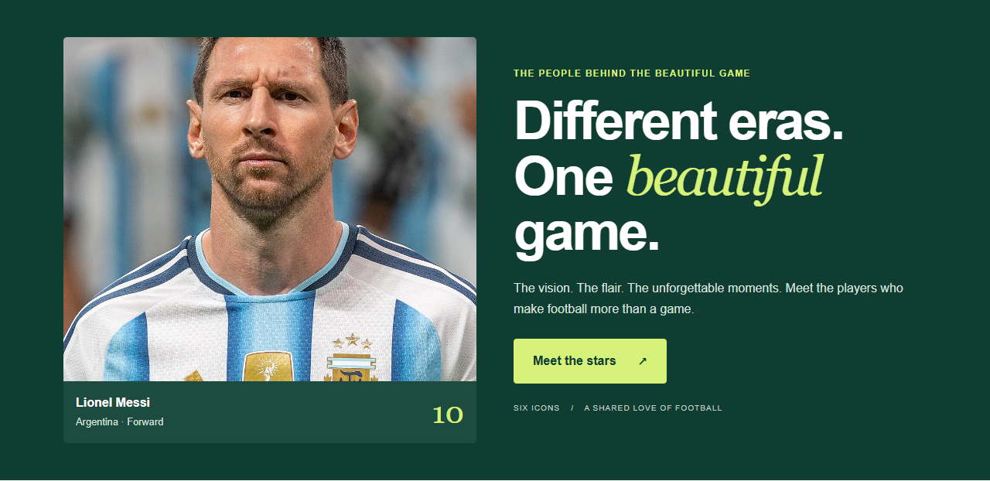
Figure 1. Home section at 1280px. The image is on the left and the introduction is on the right.
The source code, local images and report screenshots are included in the repository. Open index.html in a browser with internet access for the Bootstrap CDN files.

Task 1 Media queries by hand
The Football Stars section contains Messi, Ronaldo and Mbappé. Its HTML uses only custom classes. The .stars-grid rule starts with one column, so the default layout is designed for a phone. No Bootstrap grid or utility classes are used inside this section.
At 768px, a min-width media query changes the grid to two equal columns. At 992px, a second query changes it to three. The section padding and heading size also increase at 768px. At 992px, the heading and its introduction align side by side.
.stars-grid { display: grid; grid-template-columns: 1fr; }
@media (min-width: 768px) {
.stars-grid { grid-template-columns: repeat(2, 1fr); }
}
@media (min-width: 992px) {
.stars-grid { grid-template-columns: repeat(3, 1fr); }
}
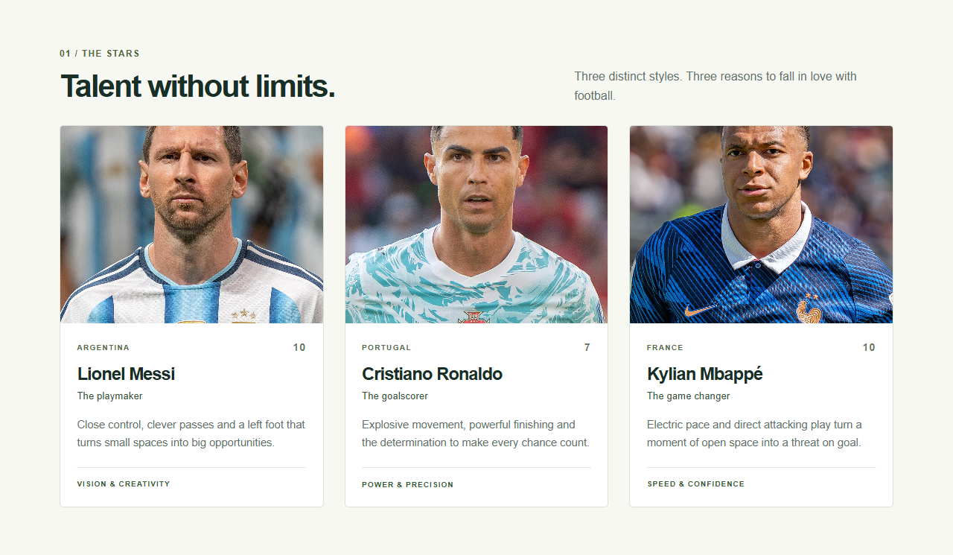
Figure 2. At 1280px, the manual grid has three equal columns. The description sits beside the heading.
Viewport | Columns | Other visible changes
375px | 1 | Smaller heading; introduction below it
768px | 2 | Larger heading and more vertical spacing
1280px | 3 | Heading and introduction share a row

The wrapper uses a percentage width and auto side margins. Images fill their cards with width: 100% and object-fit: cover. The layout does not use fixed widths or absolute positioning.

Task 1 Tablet and phone evidence
At 768px, the first two cards share a row and the third moves to the next row. At 375px, each card occupies its own row. These are layout changes, not only smaller font sizes.
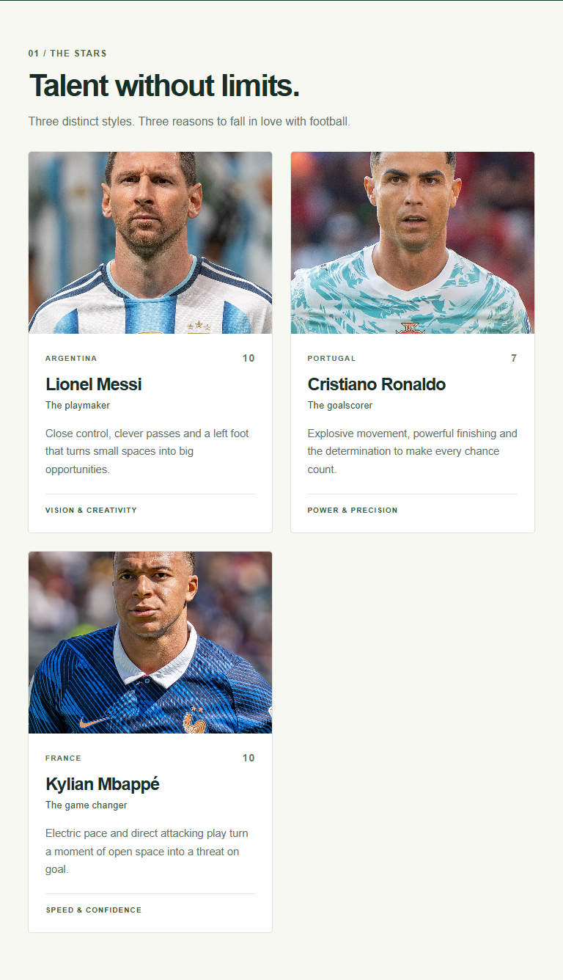
Figure 3. Complete manual section at 768px, showing the two-column layout.
Figure 4 on the following page shows the phone layout at a readable scale. Full-page captures appear after Task 3, and the original PNG files are included in report/screenshots.

Task 1 Phone detail
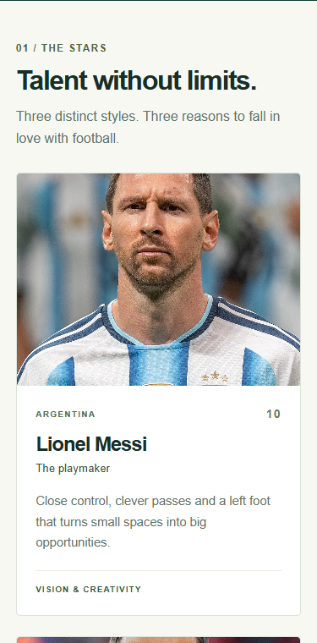
Figure 4. Top of the stars section at 375px. One card fills the row; the next card starts below it.
The phone layout is the base CSS. Wider layouts are added with min-width conditions, so this is a mobile-first implementation. Bootstrap Reboot still applies global HTML defaults, but it does not control this section layout.

Task 2 Bootstrap grid and components
Home, Football Legends and About the Project use Bootstrap containers, rows and columns. The legend cards use col-12 col-md-6 col-lg-4: 12 of 12 grid units on a phone, 6 on a tablet and 4 on a laptop. This produces one, two and three cards per row.
The legends use the card component with card-body, card-title and card-text. Utilities such as p-4, py-5, g-4, text-secondary and h-100 provide spacing, gutters, text colour and equal card heights within a row. Custom CSS supplies the green palette and photograph treatment.
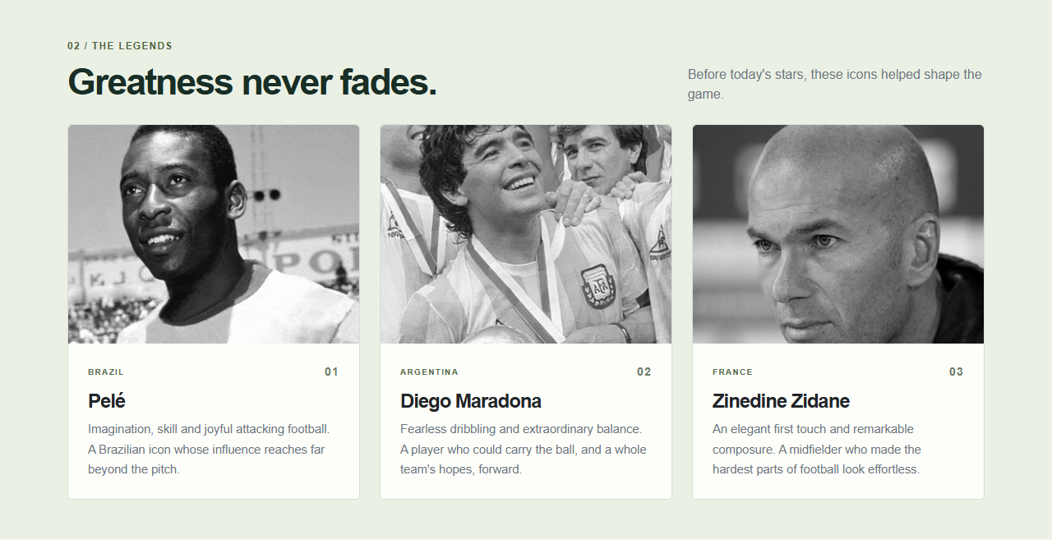
Figure 5. Bootstrap legend cards at 1280px, with three cards per row.

Task 2 Tablet grid detail
At 768px, each col-md-6 wrapper occupies half of the Bootstrap row. Pelé and Maradona share the first row; Zidane starts the second. At the lg breakpoint of 992px, col-lg-4 reduces each wrapper to one third of the row, so all three cards fit beside each other.
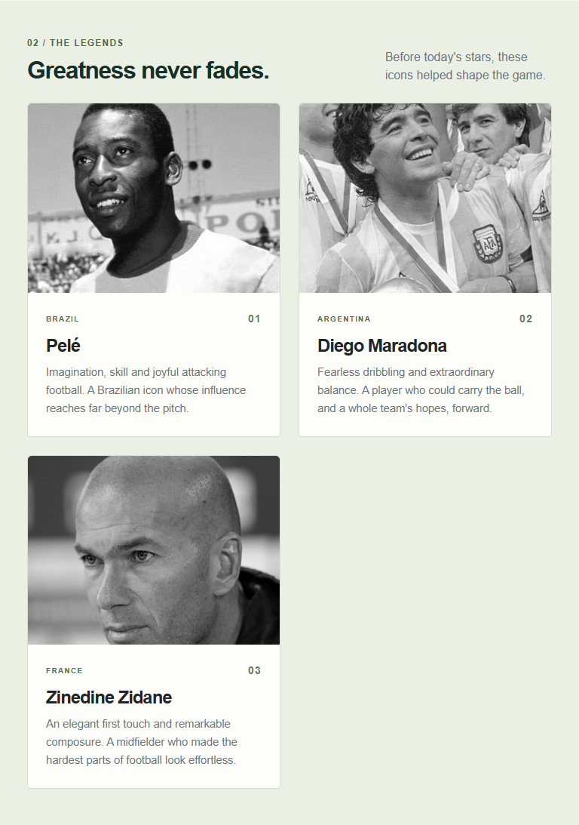
Figure 6. At 768px, col-md-6 gives two cards per row and the third wraps.

Task 2 Ordering visibility and navigation
The Home section has two col-12 col-lg-6 columns. Text uses order-1 order-lg-2; the photograph uses order-2 order-lg-1. Below 992px, the columns stack with the important text first. At 992px and above, the photograph is on the left.
The extra line under the button uses d-none d-md-block. It is hidden on a phone and visible from 768px. The navbar uses navbar-expand-md, so it becomes a menu button below 768px. The button targets #mainNav and Bootstrap JS opens and closes the collapse component. Each navigation link points to a section id.
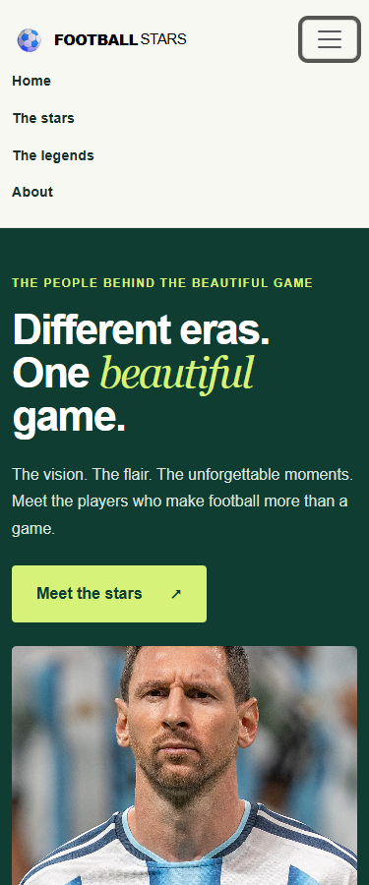
Figure 7. Open navigation menu at 375px. The introduction precedes the image; the extra hero note is hidden.
The HTML head includes the viewport meta tag and the Bootstrap 5.3.8 CDN stylesheet. style.css follows Bootstrap so custom styles can override defaults. The matching JavaScript bundle appears before the closing body tag.

Task 3 Comparison of the two ways
Criterion | Custom media queries | Bootstrap grid
Layout code | Stars needs display: grid, a base column rule and two media queries. | Legends uses col-12 col-md-6 col-lg-4 on each card wrapper.
Design control | The stars heading size, section spacing and heading alignment change in custom queries. | Bootstrap provides md and lg breakpoints; custom CSS still controls colours and images.
Speed of work | The stars layout rules must be written and checked directly. | The legends reuse ready-made card, row, gutter and spacing classes.
Making changes | Changing repeat(3, 1fr) to repeat(2, 1fr) changes the desktop stars grid. | Changing col-lg-4 to col-lg-6 on the wrappers gives two legend cards per row.

I would choose custom media queries when a section needs its own layout and precise breakpoint changes, like the stars heading and grid. I would choose Bootstrap for a familiar page structure with navigation and cards, because its classes provide a quick, consistent starting point. This page combines both approaches without using Bootstrap classes inside the manual section.

Test results
Check | 375px | 768px | 1280px
Stars and legends columns | 1 / 1 | 2 / 2 | 3 / 3
Horizontal scroll | None | None | None
Hero extra note | Hidden | Visible | Visible
Hero order | Text above | Text above | Image left
Images and JS errors | Loaded / 0 | Loaded / 0 | Loaded / 0

Chrome checks also confirmed that the mobile menu opens and closes and that its legends link navigates to #legends. All four section targets exist. The full-page screenshots below were captured with a 900px viewport height and include the entire scrollable page.

Conclusion
This assignment demonstrates how mobile-first rules progressively add columns as the screen gets wider. It also shows how Bootstrap grid, ordering and visibility classes produce responsive behaviour with less layout CSS. The main lesson is to test the actual layout at each required width, including navigation and content overflow.

Whole page at 375px
Complete phone screenshot. The page is tall because all player cards appear in one column. The next two pages reproduce this same capture in readable consecutive strips, without omitting any part of the page.
Figure 8. Entire page at 375px. Original file: report/screenshots/full-375.png.

Phone screenshot details 1
Read the left strip from top to bottom, then the right strip. These are consecutive parts of the full 375px screenshot, enlarged for readability.
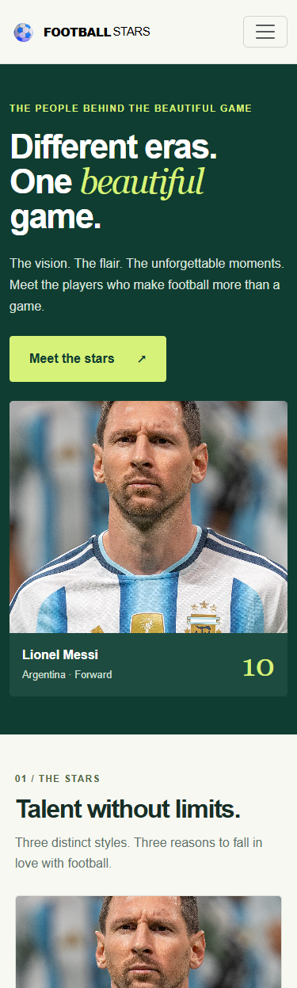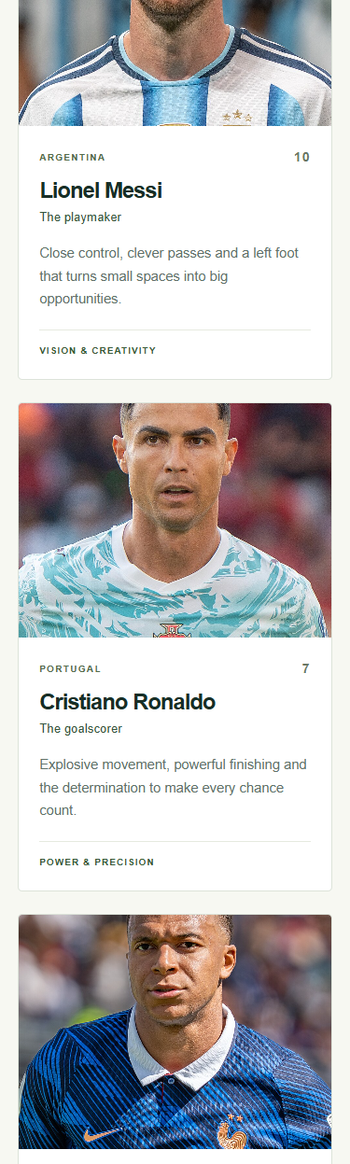
Figure 9. Phone capture parts 1 and 2 of 4.

Phone screenshot details 2
Read the left strip from top to bottom, then the right strip. These are consecutive parts of the full 375px screenshot, enlarged for readability.
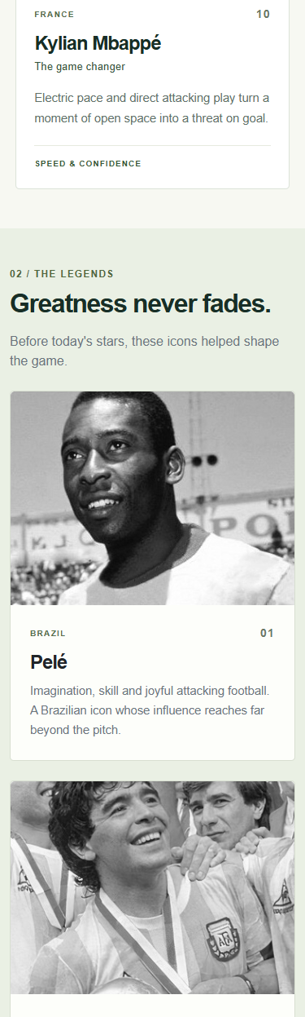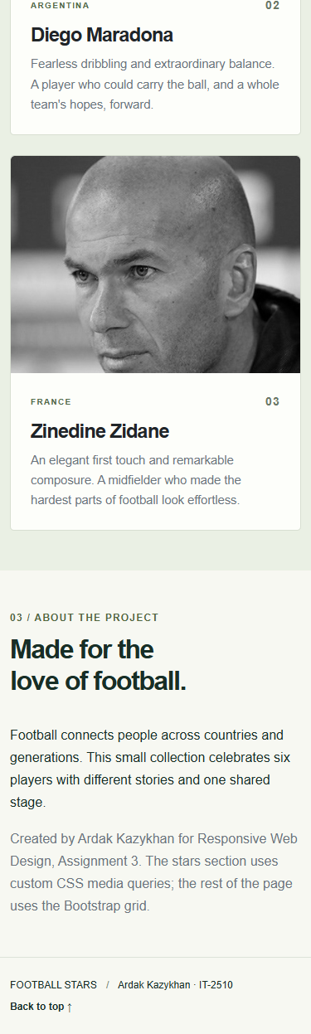
Figure 10. Phone capture parts 3 and 4 of 4.

Whole page at 768px
The manual stars and Bootstrap legends both use two columns. The Home columns remain stacked, while the navbar is expanded and the extra hero note is visible.
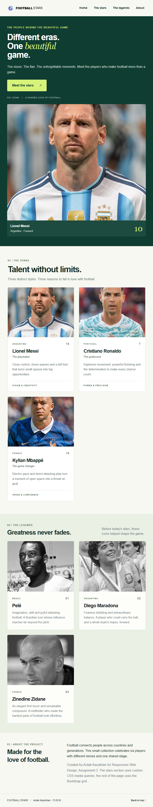
Figure 11. Entire page at 768px. Original file: report/screenshots/full-768.png.

Whole page at 1280px
Both card sections use three columns. Home uses two columns with the photograph on the left. The page fits the viewport without horizontal scrolling.
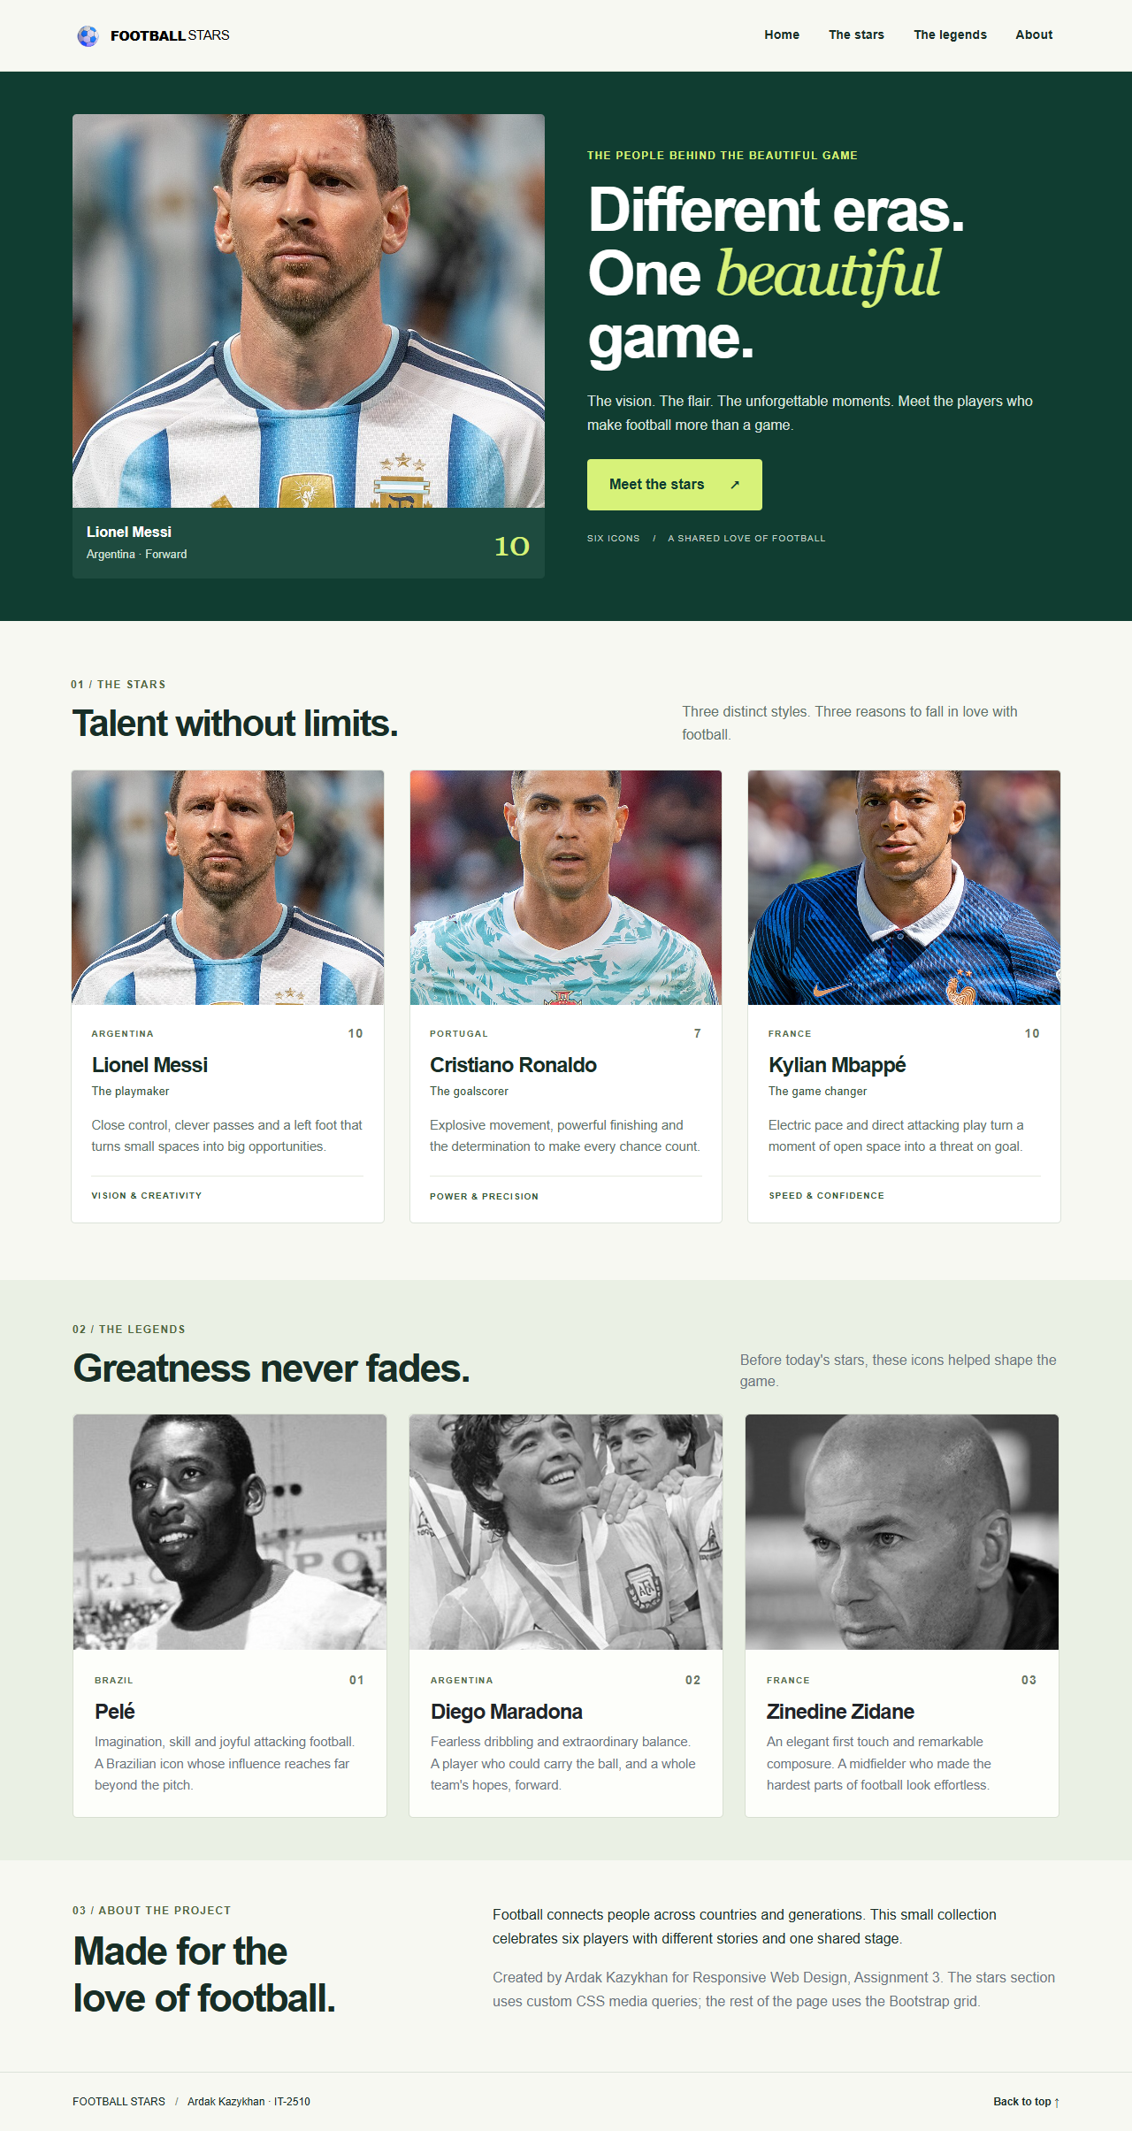
Figure 12. Entire page at 1280px. Original file: report/screenshots/full-1280.png.

References and source files
Assignment requirements: Assignment 3-1.pdf, Responsive Web Design, supplied course brief.
Source code and photo attribution: https://github.com/ardkzhn0111/football-stars
Bootstrap documentation explains the CDN setup, responsive grid and navbar behaviour used in this project.
Bootstrap 5.3 introduction
Bootstrap grid
Bootstrap navbar
MDN media queries

Photographs
Photographs were downloaded from Wikimedia Commons. Bryan Berlin is credited for Messi, Ronaldo and Mbappé under CC BY-SA 4.0. The Pelé and Maradona photographs from El Gráfico are marked public domain on Commons. Hadi Abyar / Tasnim News Agency is credited for Zidane under CC BY 4.0. Exact source links and license links are in README.md.
The website uses CSS cropping and a grayscale filter for the legend photographs. The original downloaded image files remain in assets/images. The screenshot figures reproduce these credited images as displayed on the site.

Project files
index.html contains the page structure. style.css contains the custom design and manual media queries. assets/images contains the photographs. README.md explains how to run the site and maps the implementation to the requirements. report/screenshots contains the original captures at all three widths.

