
Date of publication xxxx 00, 0000, date of current version xxxx 00, 0000.
Digital Object Identifier 10.1109/ACCESS.2017.DOI

An Effective WBC Segmentation and Classification Using MobilenetV3 - ShufflenetV2 Based Deep Learning Framework
BAIRABOINA SAI SAMBASIVA RAO1, BATTULA SRINIVASA RAO2,
¹School of Computer Science & Engineering, VIT-AP University, Amaravati, Andhra Pradesh, India. (e-mail: sambasiva.20phd7016@vitap.ac.in)
²School of Computer Science & Engineering, VIT-AP University, Amaravati, Andhra Pradesh, India. (e-mail: srinivas.battula@vitap.ac.in)
Corresponding author: BATTULA SRINIVASA RAO (e-mail: srinivas.battula@vitap.ac.in).

ABSTRACT White Blood Cells are essential in keeping track of a person’s health. However, the pathologist’s experience will determine how the blood smear is evaluated. Furthermore, it is still challenging to classify WBCs accurately because they have various forms, sizes, and colors due to distinct cell subtypes and labeling methods. As a result, a powerful deep learning system for WBC categorization based on MobilenetV3-ShufflenetV2 is described in this research. Initially, the WBC images are segmented using an efficient Pyramid Scene Parsing Network (PSPNet). Following that, MobilenetV3 and an Artificial Gravitational Cuckoo Search (AGCS)-based technique are used to extract and select the global and local features from the segmented images. Finally, the WBC images are divided into five classes using a ShufflenetV2 model. The proposed approach is evaluated on blood cell count and detection (BCCD) and Raabin-Wbc datasets and achieves 99.19% and 99% accuracy, respectively. Moreover, the results are satisfactory when compared to existing algorithms.

INDEX TERMS white blood cells, deep learning, MobilenetV3, ShufflenetV2

- INTRODUCTION
I
NFECTION illnesses continue to rank as one of the most complex problems in public health after decades of research and effort. As stated by the World Health Organi- zation (WHO), viral infections are currently the deadliest communicable illness in the world and the fourth most significant reason for death in people [1]- [3]. They are some of the biggest global issues, affecting people, society, and the economy everywhere. To address this widespread, potentially fatal problem, it is crucial to build reliable techniques for
early diagnosis and look into the pandemic’s origin.

The peripheral blood smear is a typical laboratory test that

gives much information about a patient’s overall status to
. It offers a statistical and qualitative evaluation of blood constituents, primary cells, and platelets.
the doctor
Human
[4]- [7]. They
blood comprises three types of blood cells
are leukocytes (WBC), erythrocytes (red blood cells), and thrombocytes (platelets). The Hosseinimost prevalent blood cells are erythrocytes, which contain the hemoglobin protein that gives the cell its red color. Leukocytes are agranular, colorless cells with a variable number of nuclei encircled by
a small amount of cytoplasm. There are lots of leukocytes in the lymphatic system. They function as an essential component of the immune system in the blood, guarding the body against communicable diseases and outside invaders [8]- [10]. Thrombocytes, often known as platelets, are com- paratively smaller than erythrocytes and lack a nucleus.

Lymphocytes, neutrophils, eosinophils, basophils, and mono-
cytes are the five different types of nucleated cells that
[11]- [13]. Pathologists will be able to identify a variety of blood illnesses and diseases, such as anemia, leukemia, and malaria, with the correct and exact identification, counting, and categorization of WBC and the variation in percentage between the subtypes [14]- [16]. Better knowledge will aid in treatments, prevent harmful drug interactions, and monitor the patient’s health.
make up leukocytes
Pathologists perform manual WBC identification, which is frequently prone to human error and yield unreliable results. Pathologists may do this procedure differently inside and across classes, which makes it tiresome and time-consuming [17]- [18]. In the traditional WBCs identification system, the classification of WBC from other blood components is

VOLUME 4, 2016 1


Author et al.: Preparation of Papers for IEEE TRANSACTIONS and JOURNALS

difficult due to their similar textures and uneven boundaries. Additionally, WBCs have a complex range of color, structure, form, and intensity [19]- [20]. Different staining and lighting conditions also make it more challenging to identify WBC. Furthermore, the multi-class categorization adds to the com- plexity of the entire system and takes up a lot of processing time. For the reasons listed above, the standard technique fails to capture the accurate pathologist level of knowledge in the detection of WBCs, lacks robustness, and only performs well on small datasets under controlled circumstances.
Motivated by these observations,
this paper presents an effec-

tive deep learning based framework for the recognition and
Specifically, Pyramid Scene Parsing
categorization of WBCs.
most predictable features were then extracted using Scale- Invariant Feature Transform based technique. A convolu- tional neural network (CNN) was implemented to learn con- textual dependencies while maintaining spatial neighborhood dependencies. The authors employed the weighted two-phase test sample sparse representation technique for classification. WBC and LISC datasets were utilized to evaluate the effi- ciency of the suggested approach.
By combining many datasets from different sources, Cheuque et al. [22] presented a multilevel CNN framework to enhance the recognition and categorization of individual WBC. The
Faster R-CNN network was used at the first level

to distinguish between mononuclear and polymorphonuclear

(PSPNet)
Network
incorporates several pooling layers to

maximize the global context and various layers links to have

MobilenetV3 uses a
Moreover,
diverse segmentation layouts.

partial residual design to boost the ability of features to reveal
themselves, and its bottleneck architecture reduces the loss of low-dimensional characteristics. The ShuffleNetV2 based classifier reduces computing costs while retaining accuracy using channel shuffle and pointwise group convolution. Moreover, its efficient feature reuse mode is tremendously advantageous to the proposed framework. These advantages of both PSPNet, MobilenetV3, and ShuffleNetV2 make the proposed model more robust and classify the WBC more efficiently images into monocytes, basophils, eosinophils, neutrophils, and lymphocytes classes.

- OUR CONTRIBUTIONS
  - The
most effective segmentation and classification
to create the WBC classification
techniques are used
To cat-
egorize the subcategories in the second level, two parallel CNN models were implemented. The MobileNet architecture was the foundation for the implementation of the ML-CNN proposal. Additionally, the MobileNet utilized the depthwise separable convolution to fetch pertinent characteristics from every channel, making greater use of the data present in the images for leukocyte categorization. For performance assessment, LISC, KBC, WBC, CBC, and BCD datasets were used.
cells in identifying the region of interest for WBC.
To automatically categorize WBC subclasses based on fo- calized attention mechanism, Wang et al, [23] introduced the Deep CNN with feature fusion techniques called WBC- AMNet. Gather-Excite (GE) and Squeeze-and-Excitation (SE) phases were combined in a focalized attention method

to retrieve the fusion characteristics of the first and last con-
volutional layers of CNN to achieve more targeted attention.
This study examines the effectiveness of classification per- formance using several metrics such as
 |  | F1-score, precision,
specificity, and accuracy on the WBC and BCCD datasets.
Alharbi et al, [24] | suggested a technique that segments

model.
  - An effective
 |  | mobilenetV3 network is implemented to
extract global and local features from the image. |  |  | From
that, the | optimal features are chosen using the Artifi-

cial Gravitational Cuckoo Search (AGCS) algorithm, which improves the classifier’s performance.
  - Many experiments are run on the BCCD and Raabin- WBC datasets using various performance indicators to assess the proposed approach’s performance.
The remaining proportion of the proposed article is organized as follows: Section 2 presents the background information and literature on the suggested model. Section 3 presents the suggested framework model, while Section 4 presents the findings and discussions. The conclusion is shown in Section

leukocytes from blood samples after extracting features from them using the ResNet and UNet networks. Using the se- mantic segmentation method, WBC segmentation was done for blood pictures using the MASK-RCNN network. Feature fusion, feature extraction, and Feature reconstruction were carried out in the U-net. However, due to the deep layer network’s huge layers, gradient descent will occur when extracting features from the network. The authors applied

the ResNet model to resolve these problems. The dice sim-
ilarity coefficient (DSC), intersection-over-union (IoU), and
the mean were utilized to evaluate the effectiveness of the approach.

5.

- LITERATURE REVIEW
It is quite tricky to identify WBC because of its diversity. Numerous researchers have looked into various methods in
Using the
al, [25] demonstrate
images were subjected to contrast-limited adaptive histogram
how to classify WBC data.
4B-AdditionNet CNN architecture,

ResNet50 and EfficientNetB0 networks, a C
NN was built
equalization (CLAHE) during preprocessing.
Shahzad et
The input In addition to

this area. The following discusses a few of them.
To categorize five different types of WBC using microscopic images, Manthouri et al, [21] developed a system for blood samples. To separate the nuclei from the input image, the Gram-Schmidt algorithm was employed in this system. The
and trained specifically for feature extraction. Ant colony optimization was utilized to choose the optimal character- istics. Then it was combined and sent to classifiers such as the quadratic discriminant analysis and support vector machine for categorization. For performance evaluation, the

2 VOLUME 4, 2016

Author et al.: Preparation of Papers for IEEE TRANSACTIONS and JOURNALS

author used several evaluation criteria, including precision, F1 Score, sensitivity, and accuracy.
An approach based on deep learning was presented by Roy and Ameer [26] for segmenting leukocytes from microscopic blood images. The suggested model uses the DeepLabv3+ technique for segmentation and ResNet-50 for feature ex- traction. The following variables were chosen to evalu- ate the effectiveness of the suggested system: relative dis- tance error, overall error rate, under-segmentation rate, over- segmentation rate, Dice similarity coefficient, mean IoU, mean accuracy, and mean BF score.
A system based
on pretrained Alexnet and Googlenet archi-

Preprocess-
by Cinar and Tuncer [27].
tectures was presented

ing, filtering, feature extraction, and classification procedures

were included in the suggested method.
The Support Vector

Machine classifies the feature vector that results from merg-
ing the feature vectors in the final pooling layers of both
Alexnet and Googlenet techniques. This article handled two separate data sets from the LISC database and the Kaggle website to evaluate the proposed approach.
- PROPOSED METHODOLOGY
This study intended to provide a new approach that is lighter, quicker, and more reliable than CNN-based techniques for categorizing white blood cells in peripheral smear pictures. Fig. 1 illustrates the proposed scheme’s structure and stages. The first step is to obtain the appropriate test images from the database and finish the required data preprocessing. Fol- lowing preprocessing, a PSPNet-based framework is used to
reduce model overfitting, lessen data imbalance, increase val- idation accuracy, and improve discriminative performance. In particular, the picture dataset is improved by applying a color jitter modification (0.1) and flipping the image horizontally and vertically.

- PSPNET BASED SEGMENTATION
Following preprocessing, a PSP-net based network is used to separate the WBC nucleus from the picture. The PSPNet network structure is based on the residual network (ResNet) with some modifications. The suggested model has nine iden- tity blocks, one max pooling layer, five convolution layers, three convolution blocks, three attention gates, and three pyramid pooling modules (PPMs). It is possible to incorpo- rate the multiscale contexts by adding PPMs and merging multilayer characteristics by tightly integrating the PPMs in

the decoder with the sub-sampling layers of the encoder. |  | The
performance of the suggested segmentation model is further
enhanced by the application of an attention gate in the soft
attention module.
To create feature maps FM with three distinct pyramid sizes, max pooling is first used, as shown in equation (1), where λ and DWS(.) are the inputs that represent the max pool- ing layer’s strides and downsampling operations correspond- ingly. The sizes of the input and output feature maps, ip and op, are used in equation (2), which is used to calculate the max pooling layer’s strides.
FM_{k} = DWS (FM, λ_{k}) , k = 1, 2, 3 (1)

segment the WBC nucleus from the image. Following that,
λk k
using the MobilenetV3 and AGCS algorithms, the significant characteristics are retrieved, and more prominent features
ip − λk + 1 = op ⇒ λ
IS
^{k} = OS
k
(2)

are chosen, respectively. The shufflenetV2 based network is implemented based on the final features chosen to classify the WBC into five classes: monocytes, basophils, eosinophils, neutrophils, and lymphocytes.

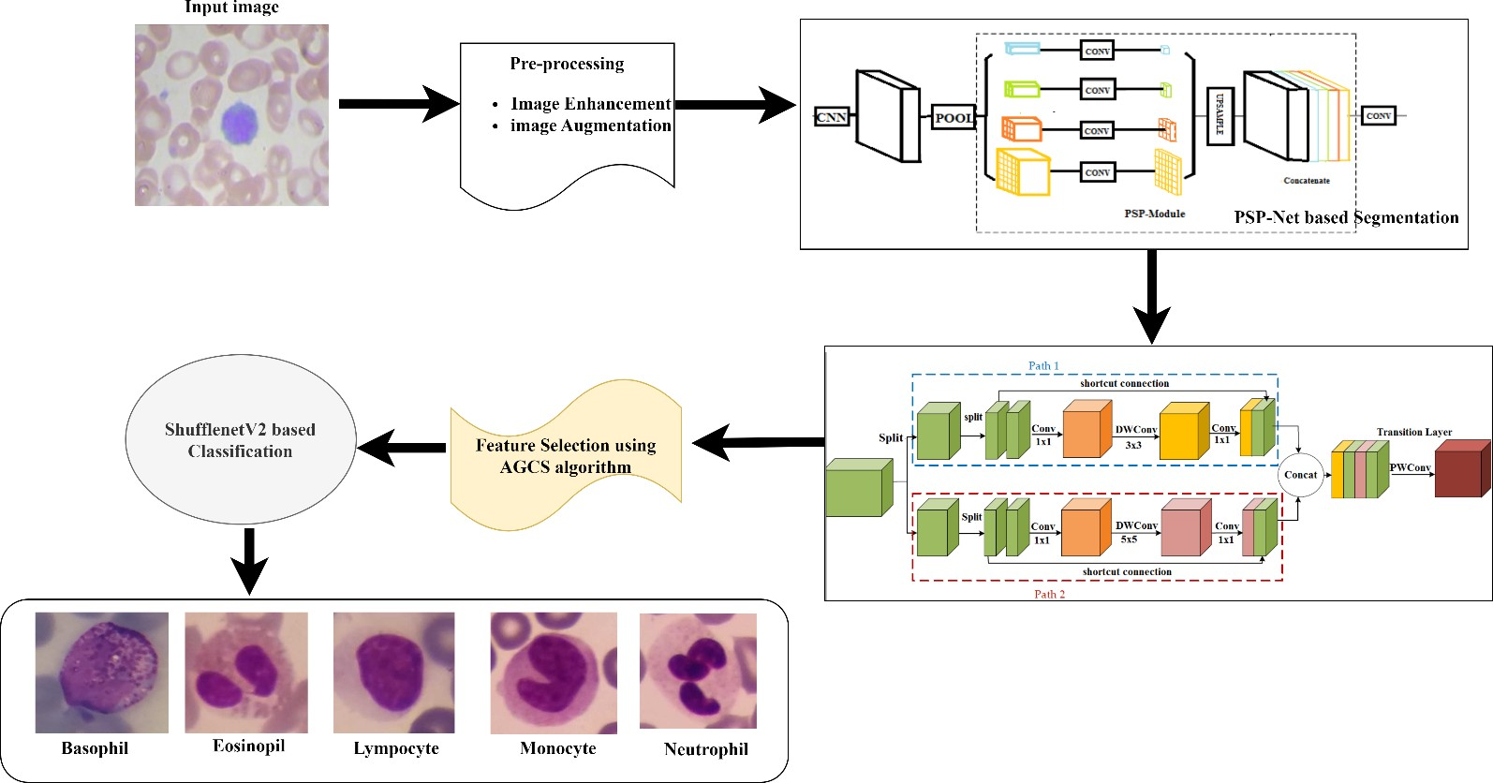
FIGURE 1. System Architecture of the proposed approach.

A. PREPROCESSING
During the preprocessing stage, the input images are resized and CLAHE is utilized on the images to
into 256 × 256,
An image aug- mentation technique was used on these blood cell images to
increase contrast and highlight the cell bodies.
As illustrated in equation (3), bilinear interpolation is applied
to scale the extracted features (OF) after the convolution operation on such multi-scale extracted features, where wt and bs are the weights and biases of the k^{th} 1 1 convolution layer, respectively, and BI(.) is the bilinear interpolation operation.
×
OF_{k} = BI (wt_{k} ⊗ FM_{k} + bs_{k}) , k = 1, 2, 3 (3)
Furthermore, the original input and different pyramid scale’s feature maps are concatenated. To decrease the channel num- ber CH using equation (4), a 1 1 convolution operation is applied.
×
CH = wt_{k} (concat (FM, O_{k})) + bs_{k}, k = 1, 2, 3 (4)
Here, bs_{k} and wt_{k} are bias and weights of the 1 1 convolu- tion layer.
×

the original PPM generates the feature maps
In max pooling,

in four pyramid scales (1,2,3, and 6). In contrast to the origi-
nal PPM, in our network, three pyramid scales feature maps
(1,2, and 6) are produced by max pooling. For dimension reduction, a 1 1 convolution layer is also attached to the concatenation layer. Additionally, the fifth and third identity blocks and the first convolution layer’s attention maps are generated using the first, second, and third attention gates
×

VOLUME 4, 2016 3

Author et al.: Preparation of Papers for IEEE TRANSACTIONS and JOURNALS

correspondingly. Moreover, the outcomes of the attention gates and PPMs are tightly combined to integrate multilevel features. The final pixel-by-pixel prediction outcomes are obtained by feeding these integrated feature maps into a 1 1 convolution layer. In actual use, the PSPNet network has an auxiliary loss function to improve optimization outcomes.
×

- MOBILENETV3 BASED FEATURE EXTRACTION
This section presents detailed information about the imple- mentation of MobileNetV3 used in our framework for WBC feature extraction. The method extracts the characteristics from a segmented image that is provided as input. Several bottleneck blocks make up the structure of MobileNetV3. The residual structure is one of the bottleneck blocks in- cluded in this network.
There is just one path for feature
extraction in the traditional bottleneck blocks which are
replaced by the dual feature extraction paths in our approach
called partial residual structure. This structure is used to
lower the calculation cost of the residual framework.

optimum features straightforwardly and easily. The newly developed cuckoo search algorithm operates in accordance with the required nest parasitism of cuckoo species. The cuckoo laid an egg in its nest; the strongest egg develops into the next generation. At least one egg is laid in the nest by the cuckoo during this phase to create the next generation. However, it can be challenging to select the best egg when the nest has multiple eggs. The best features must also be chosen from the collection of features. The characteristics are initially gathered in the feature space denoted by the expression x = x₁, x₂, . . . x_{d}. Following the collection of all features, each feature is evaluated using the fitness function, which is carried out until the stop condition is reached (maximum number of features or max generation of cuckoo eggs). Before calculating the fitness function, the position of each feature in the feature space and its associated mass value, ms(t), are established using the following equation.

ms (t) = fs(t) − wr(t)
i

(7)

A unique nonlinearity in MobileNetV3 is known as hard swish (hswish) which is a refined version of the sigmoid function.
The h-swish nonlinearity is used to lessen the
amount of training parameters and decrease the complexity of the model and size, which is expressed in Equation (5).
h − swish (x) = x.σ (x) (5)
ReLU 6 (x + 3)
bs(t) − wr(t)
Here, fs(t) represents the fitness value, wr(t) represents the worst features and bs(t) represents the best features. The best and worst features are calculated using equations (8) and (9).
bs(t) = min (fs_{j}(t)) , j ∈ 1....N (8)
wr(t) = max (fs_{j}(t)) , j ∈ 1....N (9)

σ (x) =
6
(6)
Then, the feature direction is calculated as well as the feature mass value as,

Here, the piece-wise linear hard analog function is denoted
as σ (x).
Initially, the input image is given into the network’s base layer that extracts initial features and forwards them into
fd_{j}(t) =
ms_{i}(t)
N
Σ
ms_{i}(t)
j=1
(10)

the bottleneck block. Then the input feature map is evenly split across two sections in the bottleneck block. One portion is utilized as the feature map input for path 1, and another is utilized as the feature map input for path 2. The input feature map is equally split into two portions in path 1. One portion is passed via a 1 1 convolution layer, 3 3 depthwise convolution layer, and 1 1 convolution layer. Through the shortcut connection, another path is straightly linked to the outcome of the residual learning section.
×
× ×
Similarly, in path 2, the input feature map is evenly split into two portions. In this 1 1 convolution layer, 5 5 depthwise convolution layer, and 1 1 convolution layer are all applied to one portion. One element of the output feature also uses the other directly. The output feature maps of two pathways are connected using the concatenation method. Finally, the transition layer is built to fuse the concatenated feature maps using a 1 1 pointwise convolutional kernel with batch normalization layer (BN) and ReLU or hswish activation functions.
×
×
× ×

- FEATURE SELECTION USING AGCS ALGORITHM The artificial gravitational cuckoo search (AGCS) algorithm is used in this work to choose features, which selects
The maximizing function is then used to define the fitness value of a feature. Once the effective features have been calculated based on the direction change and feature mass value, the features are selected to determine which features should be further optimized. The highly ranked characteristic that is selected as the best feature is used to process the classification of WBC. The improved classifier is then given the chosen features to carry out the recognition procedure.

- SHUFFLENET V2 BASED CLASSIFICATION ShuffleNet V2 is CNN based structure that is demonstrated to be quite effective in terms of computing. ResNet’s residual architecture is optimized using channel shuffling and depth-
wise separable convolution, which not only increases the
model’s operational efficiency but also ensures the network’s accuracy. The input feature map is separated into X₁ and X₂ groups in the inverted residual module. In the X₂ path, the input passes through the depthwise separable convolution and two 1 1 convolution layers with the activation function and batch normalization. Afterward, the output of X1 and X2 feature maps are combined through the global pooling in the SE module.
×
There are two steps to it: the squeeze and excitation actions.

4 VOLUME 4, 2016

Author et al.: Preparation of Papers for IEEE TRANSACTIONS and JOURNALS

Each channel’s feature map is compressed by the Squeeze operation using global pooling, and each channel’s weight can be obtained by the Excitation process. Afterward, the original feature map is multiplied by these weights in the Scale operation. To create two feature maps of mixed channel attention at various scales, the two-channel outcomes are multiplied by convolution 1 and convolution 2 in the channel dimension. The two feature maps are then added to create the output features.
A global pooled GP is used to flatten a feature map FE with a size of x y and a total number of channels Cs into a feature vector of (1, 1, C) as shown below.
×
memory, the experimental research for this paper was car- ried out. TensorFlow was used as the backend, and Python 3.7 was used to develop the software. In the experimental investigation, training data accounted for 70% of the data, while testing data made up 30%. All experiments use a batch size of 8, a learning rate of 0.001, a drop rate of 0.01, 100 epochs, an Adam optimizer, and an auxiliary loss function. The accuracy and error loss percentages show significant improvement from the beginning of the training and testing process until the end. The proposed approach’s training and
Ad-
testing accuracies are 83.37% and 85.86%, respectively.
ditionally, the suggested network’s
training and testing losses

x y are 0.004 and 0.007. This training and testing study shows

X = GP (FE
) = 1 Σ Σ FE
(a, b) (11)
how well the proposed method could segment the input and

cs cs
x × y
cs
a=1 b=1
learn features based on the available dataset to categorize the WBC.

To increase the number of nonlinear circumstances and better
account for the intricate channel correlation, the linear map- ping and activation function is added to the feature vector. By dividing the estimated channel features by the original feature map, the channel attention result is then generated. The proposed framework’s pseudocode and the proposed approach’s step-by-step output are given in algorithm 1 and figure 2.

Algorithm 1
Input: BCCD and Raabin-WBC datasets
Initialize global and local/global variables and model param- eters for training
Train the network using the dataset
PSPNet <——– Segment the WBC Nucleus. MobileNetV3 <——– Extract Global and local features. AGCS algorithm <——– Select Important features ShuffleNetV2 <——– Classify WBC subtypes
Return subtypes.

- DATASET DESCRIPTION
In our experiments, two different datasets are used for perfor- mance evaluation, including Raabin-WBC and BCCD.
BCCD dataset: The BCCD dataset is publicly available. In this, 12,453 JPEG photos are available for leukocytes, and cell type labels are included in a CSV file. This dataset contains
images.
and eosinophil - there are 3123, 3107, 3103, and 3120 aug-
mented photos, as opposed to 207, 21, 33, and 88 original
four cell types - neutrophil, monocyte, lymphocyte,

Since basophils typically comprise less than 1% of total leukocytes, they are not included in the dataset.
Raabin-WBC dataset: The Raabin-WBC dataset is vast, and two hematologists have labeled every single row of data in it. It has 14514 WBC images with resolutions of 575

× 575, including 3461 lymphocytes, 8891 neutrophils, 795
There are three sets in this dataset: Train, Test-A, and Test-B. Because the Test-B set has not yet been named, we did not utilize it. Cropped versions of the five abovementioned general categories of WBCs are included in the Train and Test-A sets.
monocytes, 301 basophils, and 1066 eosinophils.

- SEGMENTATION RESULTS
Performance metrics for segmentation: The precision, sensitivity, and dice similarity coefficient (DSC) are mea- sures used to assess the efficacy of the suggested nucleus segmentation algorithm. The following equations offer these metrics, which are generated using the segmentation’s false negative (FsP), true negative (TrN), false positive (FsP), and true positive (TrP) values.

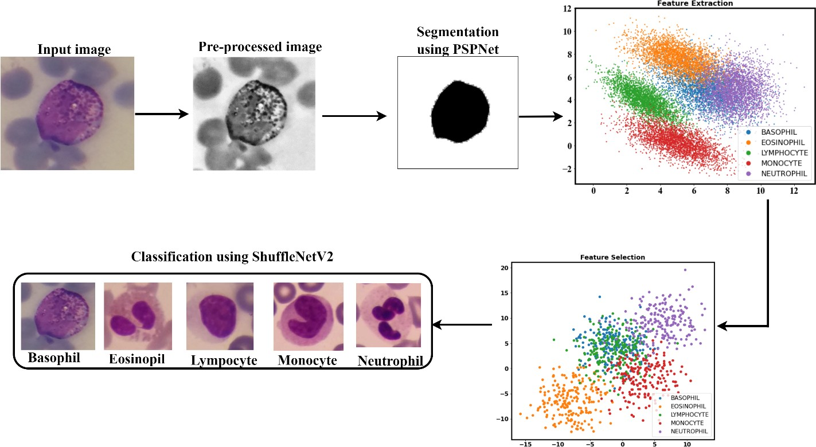
FIGURE 2. Step-by-step output of the proposed approach.

- RESULTS AND DISCUSSION
All of the outcomes from the suggested model are included in this section. On a desktop computer with an Intel Core (i7)
DSC = 2 × TrP
2 × TrP + FsP + FsN
TrP
SEN =
TrP + FsN
TrP
PPV =
TrP + FsP

(12)

(13)

(14)

8700U processor running at 3.20 GHz, NVIDIA GeForce- GTX 1050 Ti graphics totaling 4 GB, and 16 GB of main
We employ both visual and numerical measurements to as- sess our suggested strategy. The results of segmenting the

VOLUME 4, 2016 5

Author et al.: Preparation of Papers for IEEE TRANSACTIONS and JOURNALS

TABLE 1. Segmentation results of WBC classes in the BCCD dataset

WBC cell type | DSC | Precision | Sensitivity
Neutrophils | 98.83 | 99.89 | 99.92
Eosinophils | 99.41 | 99.82 | 99.93
Monocytes | 98.89 | 99.93 | 99.95
Lymphocytes | 98.76 | 99.77 | 99.9

BCCD dataset are shown in Figure 3. The first column lists the input photographs, the second the outcomes of the preprocessing, and the third the segmented images.
The backdrop and the RBCs around the WBCs are erased

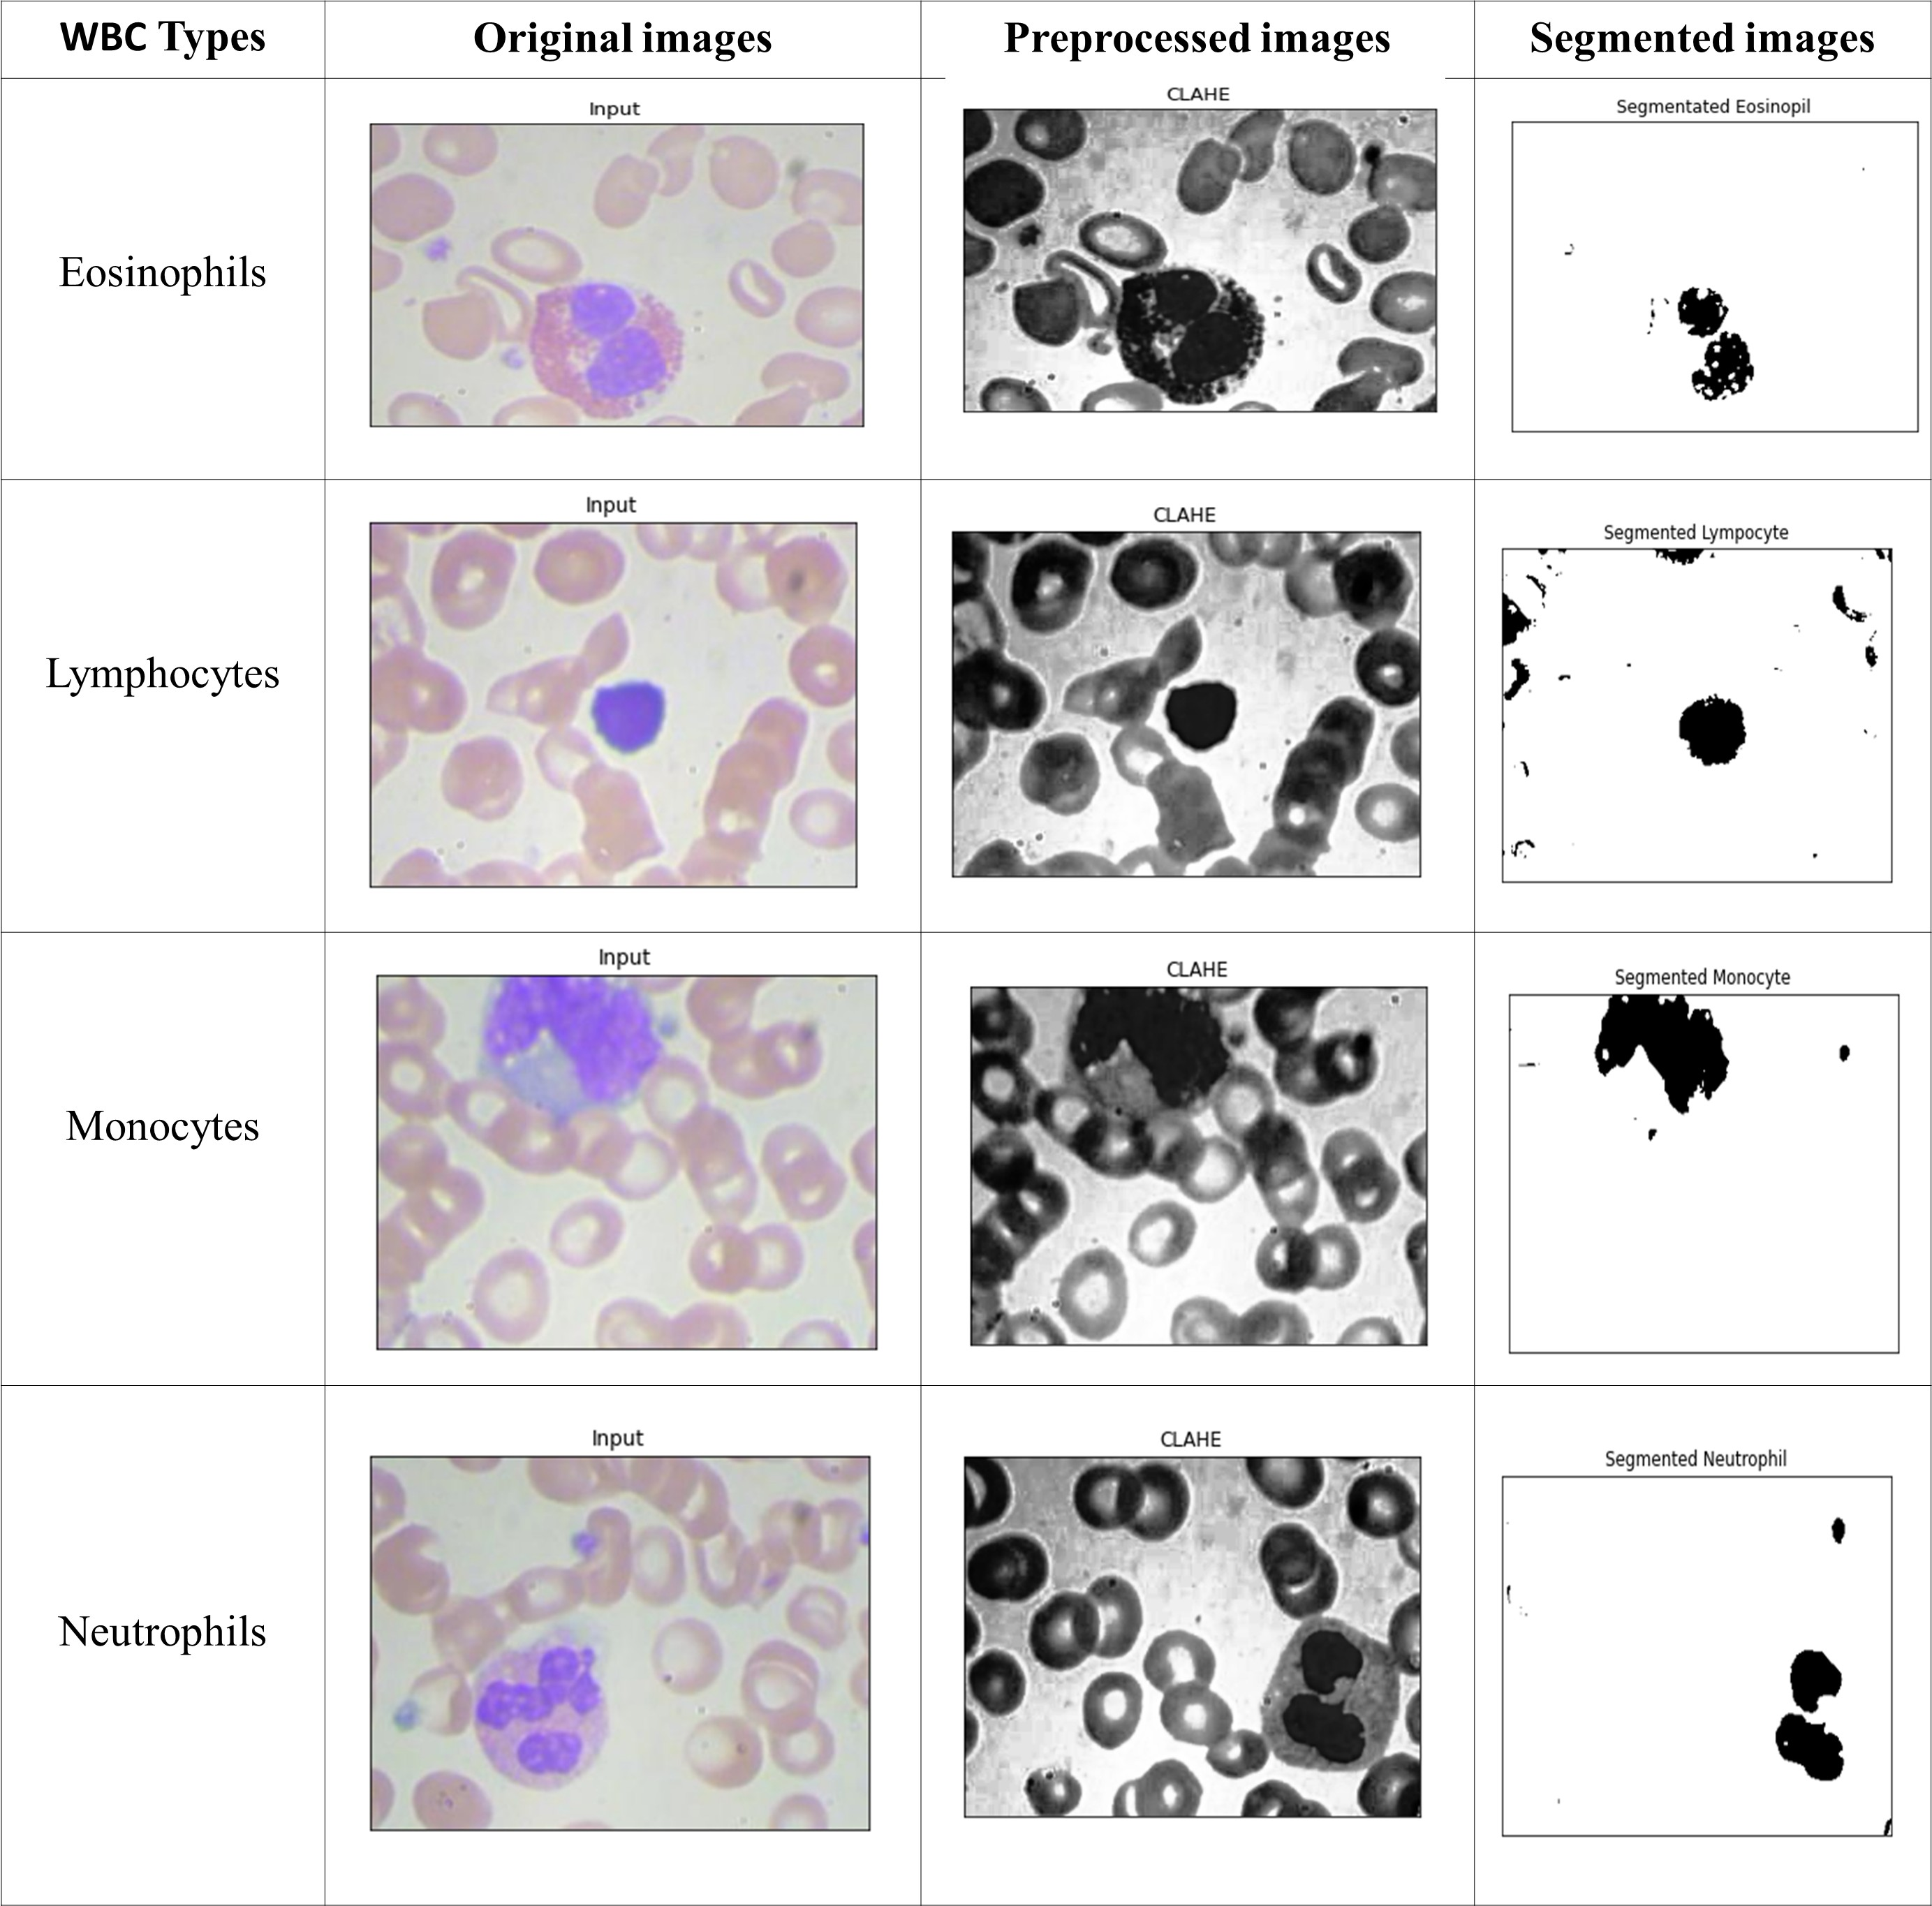
FIGURE 3. Segmented images of the BCCD dataset

from the image by the proposed approach, which performs exceptionally well in the majority of situations. Even when the form borders are unequal, our segmentation accurately isolates the nucleus regions. The four WBC subtypes were successfully segmented and recognized using the suggested approach; it was demonstrated (see Figure 3). Certain cells tightly spaced or situated at the margins could also be de- tected with reasonable accuracy.
Table 1 shows the derived DSC, Precision, and Sensitivity scores for each class in the BCCD dataset. The suggested seg- mentation approach has minimal standard deviation for both DSC and accuracy, indicating that the approach consistently performs very well for different cells in the sample.
Figure 4 shows that the suggested method produces superior segmentation performance on the Rabbin-WBC dataset. The decision boundaries are pushed farther by using the auxiliary loss function to keep the optimization from stopping at a particular margin. This improves segmentation outcomes and enables the network to maintain strong generalization ability. Table 2 provides the quantitative outcomes of the suggested segmentation approach on the Raabin-WBC dataset.
TABLE 2. Segmentation results of WBC classes in the Raabin-WBC dataset.

WBC cell type | DSC | Precision | Sensitivity
Neutrophils | 98.78 | 99.85 | 99.89
Eosinophils | 99.38 | 99.74 | 99.90
Monocytes | 98.86 | 99.89 | 99.92
Lymphocytes | 98.73 | 99.76 | 99.88
Basophils | 98.71 | 99.73 | 99.83

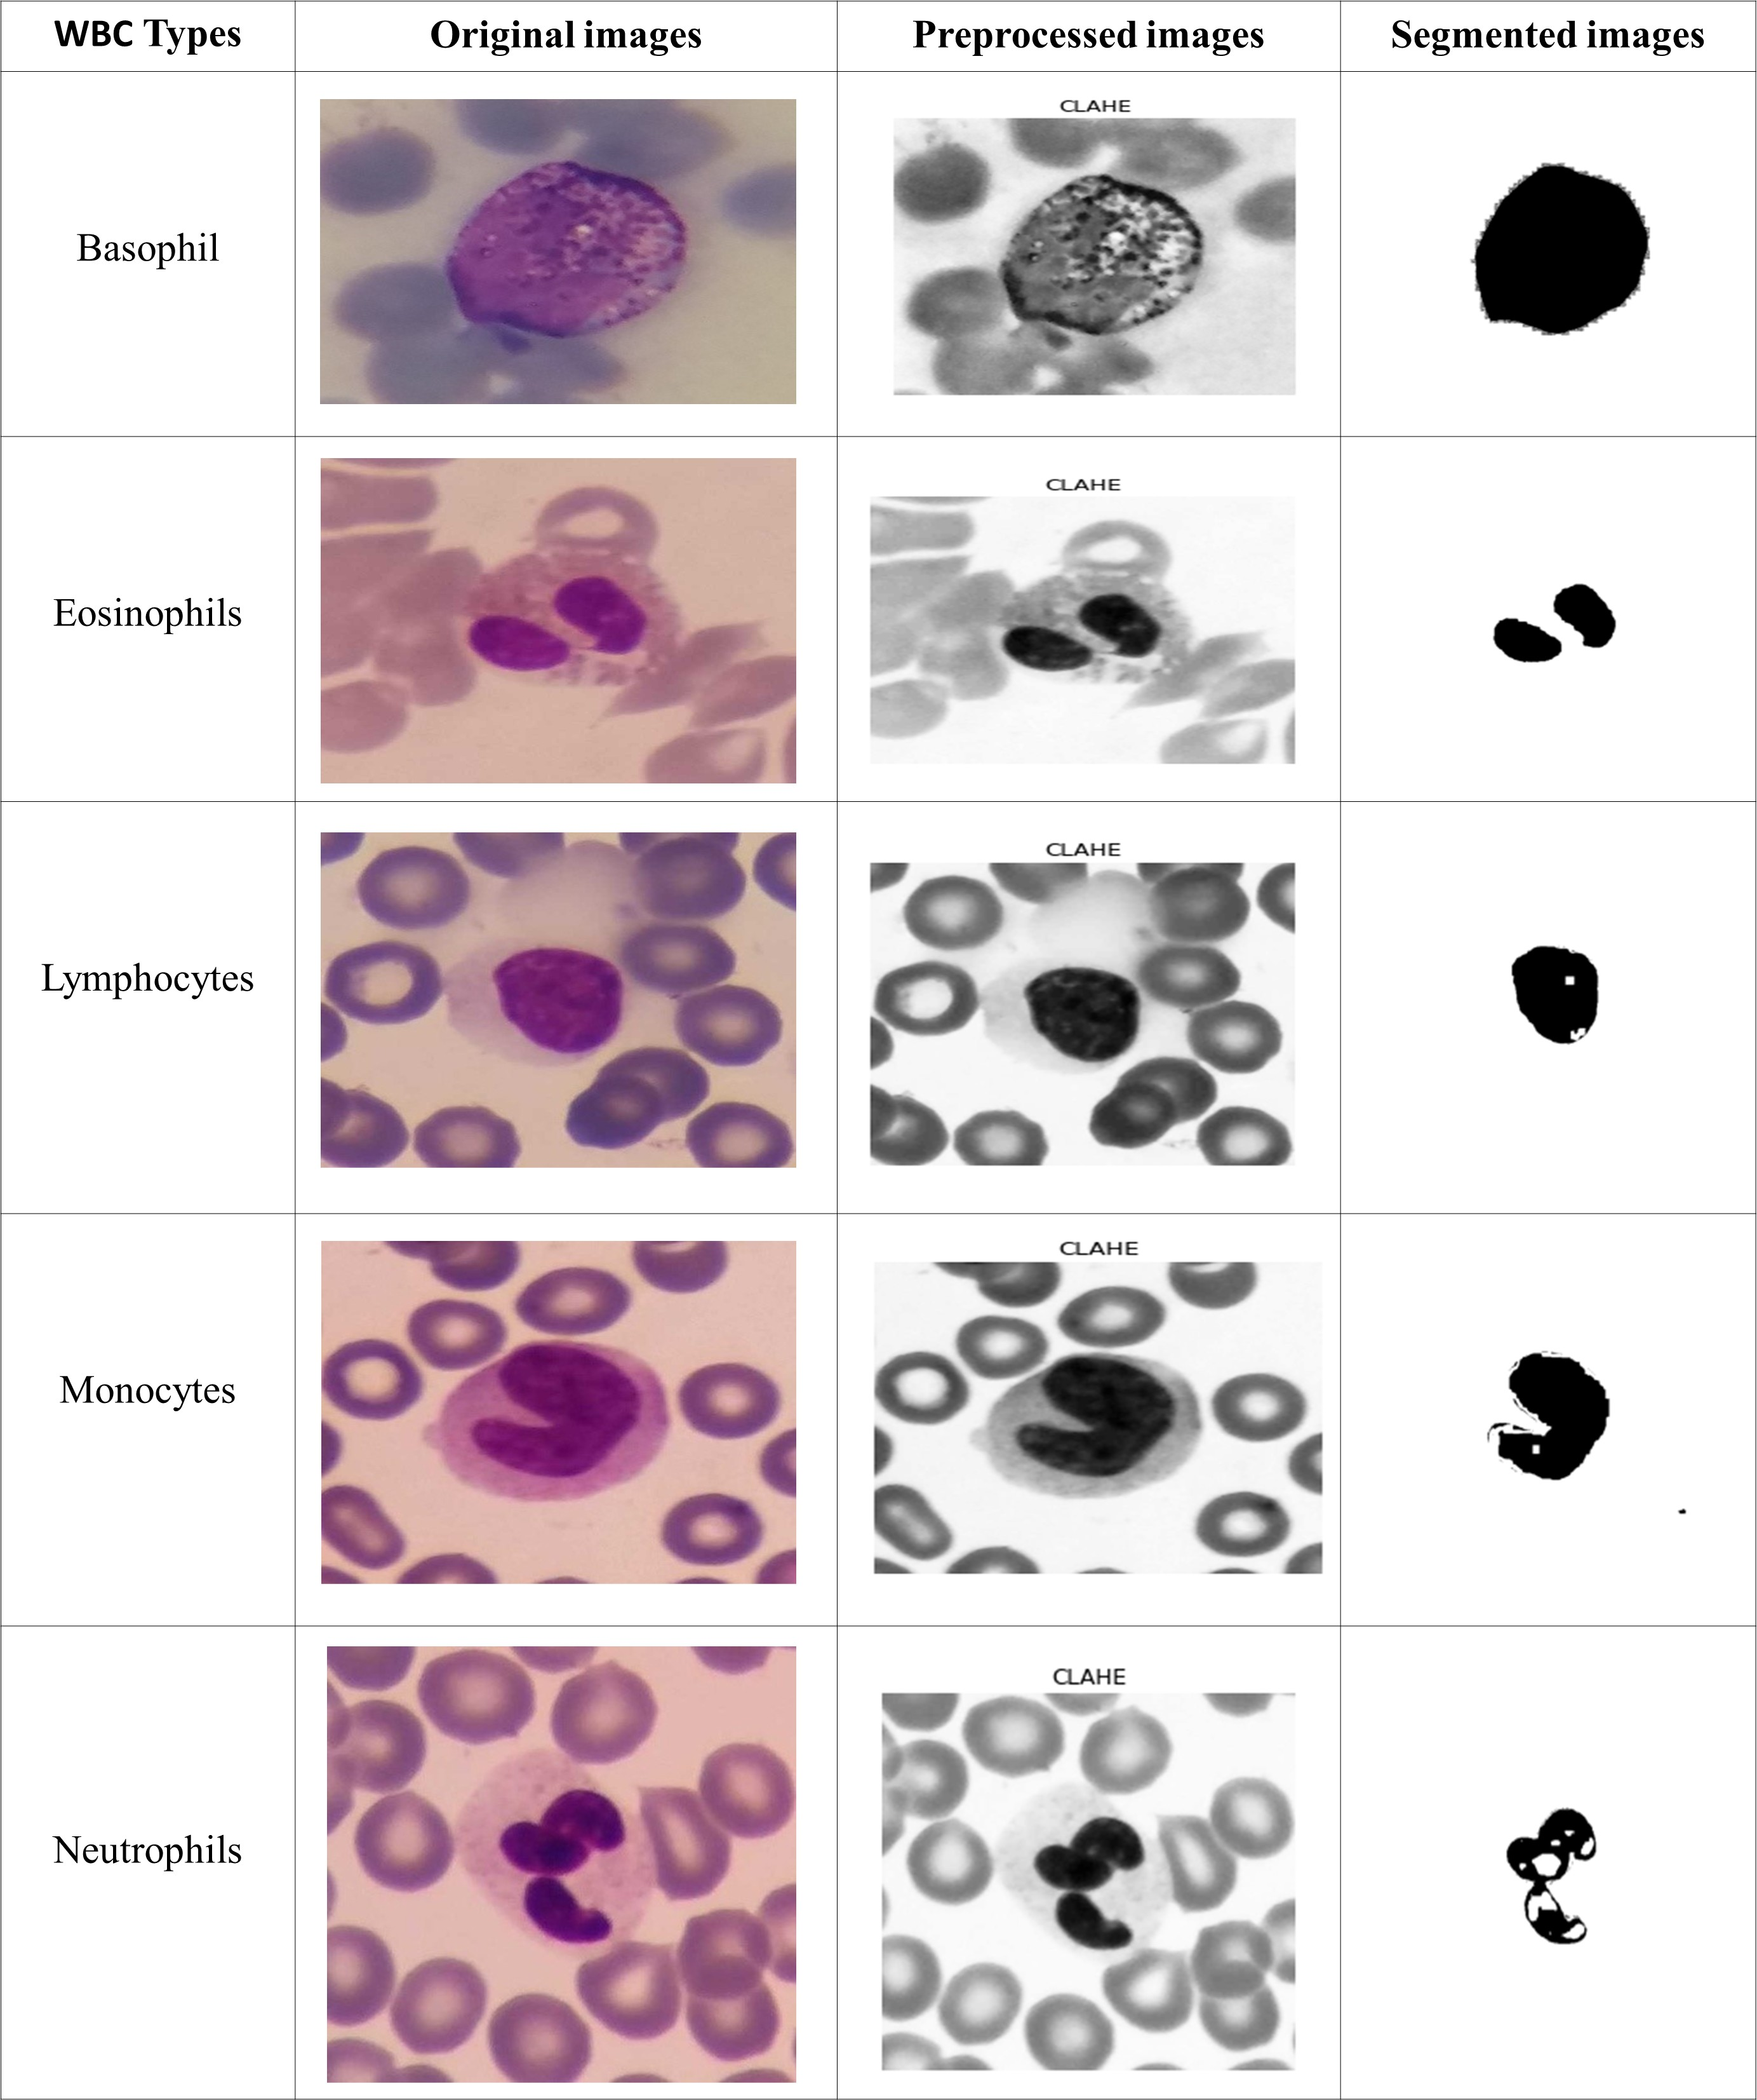

FIGURE 4. Segmented images of the Raabin-WBC dataset

The segmentation result of the suggested approach on the Eosinophils class is more significant than all other classes, with 99.38% DSC, 99.74% accuracy, and 99.9% sensitivity, as seen in Table 2. However, Monocytes achieve greater values than other groups in precision and sensitivity (99.89% precision and 99.92% sensitivity). The Basophils class scored slightly worse than the other classes in each of the five classes. It achieves a DSC of 98.71%, an accuracy of 99.73%, and a sensitivity of 99.83%.

- CLASSIFICATION RESULTS
Performance metrics for classification: An essential step in creating a reliable classifier is assessing the effectiveness of a classification system. The most widely used evaluation met- rics, including F 1 Score, specificity, sensitivity, precision, and accuracy, are used in this work. Below is a list of the mathematical equations used in these techniques.
TrP + TrN
Accuracy = (15)
TrP + TrN + FsP + FsN

6 VOLUME 4, 2016

Author et al.: Preparation of Papers for IEEE TRANSACTIONS and JOURNALS

TABLE 3. Classification results of four classes on the BCCD dataset TABLE 4. Comparison of the proposed approach on the BCCD dataset
WBC  subtypes | DSC | Precision | Sensitivity | Specificity | F1-score
Monocytes | 98.82 | 98.86 | 98.73 | 98.80 | 98.82
Eosinophils | 98.69 | 98.75 | 98.65 | 98.69 | 98.70
Neutrophils | 99.48 | 99.56 | 99.41 | 99.49 | 99.52
Lymphocytes | 99.78 | 99.74 | 99.62 | 99.70 | 99.71

Techniques | DSC | Precision | Sensitivity | Specificity | F1-score
CSVM [28] | 97.58 | 94.85 | 96.56 | 98.24 | 95.69
WBC-AMNet[29] | 89.22 | 90.72 | - | 89.22 | 89.47
DenseNet121[30] | 94 | 94.22 | 93.74 | - | 93.81
CNN[31] | 97 | 95 | 94 | - | 95
FIAL[32] | 93.22 | 93 | 93 | 98 | 93.5
Proposed | 99.19 | 99.22 | 99.10 | 99.17 | 99.18

Precision =
TrP TrP + FsP
(16)

it can be seen from the figure that monocytes outperform

TrP
Sensitivity =
TrP + FsN
TrN
(17)
eosinophils. In general, the suggested method minimizes the overall false- and leak-detection percentages, and the tracked bounds of the suggested method are highly accurate.

Specificity = (18)
TrN + FsP
The proposed approach achieves 99.19% accuracy, 99.22%
99.10% sensitivity, 99.17% specificity, and
precision,

F 1 Score = 2 × Precision × recall
−
Precision × recall
(19)
99.18% f1-score, according to table 4. The findings of this study demonstrate that, in comparison to previous deeper

Here, False Negative (FsN) indicates the number of blood
cell types that were improperly identified, while True Positive (TrP) indicates the number of blood cell types that were correctly separated. The number of cells correctly detected as not being the target blood cell types is known as True Negative (TrN); False Positive (FsP) counts the number of cells mistakenly classified as the wrong type of blood cell.

- Classification results on the BCCD dataset
The categorization outcomes of the suggested approach uti- lizing the BCCD Dataset are reported in this section. It is clear from a careful examination of the
F1-score crite-
networks, the suggested technique can be both sufficient and more successful in the WBC classification problem. Densenet-121’s extensive connections increase the risk of overfitting by making networks more susceptible to com- putation and parameter inefficiency. When compared to the proposed method, Densenet-121 only achieves 94% accu- racy. The performance of WBC-AMNet is relatively poor in comparison to all other networks. Only 89.22% accuracy and 90.72% precision are achieved. In contrast, Densenet-121 performs slightly better and achieves outcomes comparable to Fine-grained Interactive Attention Learning (FIAL). The graphical representation of this table is shown in figure 6.

rion, which considers both precision and sensitivity, that

our suggested approach has delivered the best results in

most classes, as shown in Table 3. Overall, lymphocytes
and neutrophils had the best classification impacts, while eosinophils displayed the worst ones. Since granulocytes such as neutrophils and eosinophils share a similar nucleus structure with other WBC categories, this difference was not statistically significant. Figure 5 shows a visual depiction of
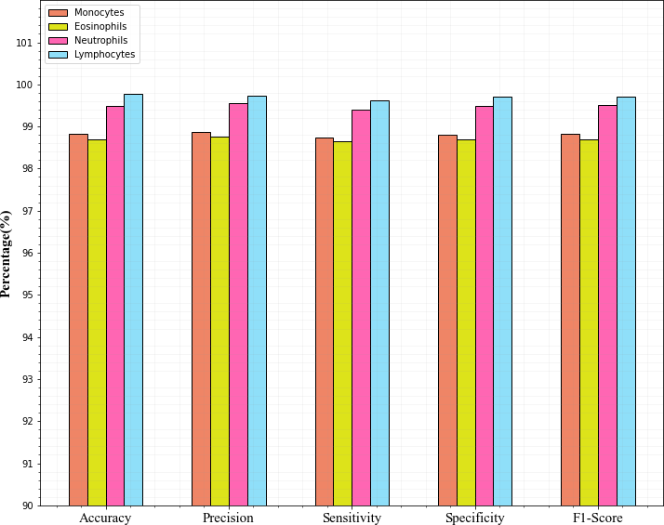
FIGURE 5. Graphical representation of four class classifications on the BCCD dataset
table 3 in a format. Based on every performance indicator,

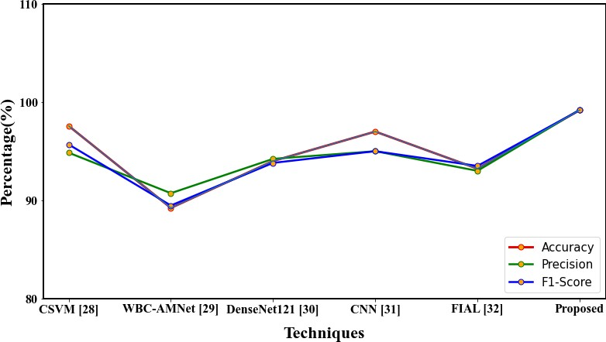

FIGURE 6. Comparison of classification results on the BCCD dataset

- Classification results on the Rabbin-WBC dataset
The categorization outcomes of the suggested approach uti- lizing the Rabbin-WBC Dataset are reported in this sec- tion. The results of WBC’s five class classifications are shown in table 5. The suggested method successfully rec- ognized each class and produced improved results across the board. Our suggested method explicitly has a high f1- score (99.63%), sensitivity (99.55%), specificity (99.65%), and accuracy (99.69%) when classifying lymphocytes. The developed model more precisely extracts the characteristics of lymphocytes as contrasted to other categories. Eosinophils

VOLUME 4, 2016 7

Author et al.: Preparation of Papers for IEEE TRANSACTIONS and JOURNALS

TABLE 5. Classification results of five classes on the Raabin-WBC dataset

WBC subtypes | DSC | Precision | Sensitivity | Specificity | F1-score
Monocytes | 98.75 | 98.93 | 98.67 | 98.72 | 98.73
Eosinophils | 98.61 | 98.72 | 98.59 | 98.61 | 98.68
Neutrophils | 99.43 | 99.52 | 99.35 | 99.43 | 99.45
Lymphocytes | 99.69 | 99.71 | 99.55 | 99.65 | 99.63
Basophils | 98.54 | 98.69 | 98.47 | 98.56 | 98.62

and Basophils have slightly lower accuracy than other classes due to a small percentage of them being incorrectly classified. A summary of the outcomes for the various models-namely,
TABLE 6. Comparison of the proposed approach on the Raabin-WBC dataset

Techniques | DSC | Precision | Sensitivity | Specificity | F1-score
DRFA-Net[33] | 95.17 | 90.43 | 93.40 | - | 91.89
ResNet-DenseNet-SCAM[34] | 98.71 | 97.18 | 98.42 | - | 97.78
SVM [35] | 94.65 | 97.23 | 95.07 | - | 96.14
CNN [36] | 93.97 | - | - | - | -
Proposed | 99 | 99.11 | 98.92 | 98.99 | 99

TABLE 7. Comparison of with and without feature selection technique

With Feature selection
Dataset | Accuracy | Precision | Sensitivity | Specificity | F1-score
BCCD  Raabin-wbc | 99.19  99 | 99.22  99.11 | 99.10  98.92 | 99.17  98.99 | 99.18  99
Without Feature selection
Dataset | Accuracy | Precision | Sensitivity | Specificity | F1-score
BCCD  Raabin-wbc | 99.03  98.91 | 99.13  98.99 | 98.98  98.81 | 99  98.87 | 99  98.89

suggested method achieves 99% accuracy, 99.11% precision, 98.92% sensitivity, and 98.99% specificity. Figure 7 displays this table’s graphical depiction.
Figure 8 shows that standard MID-YOLO and SVM perform

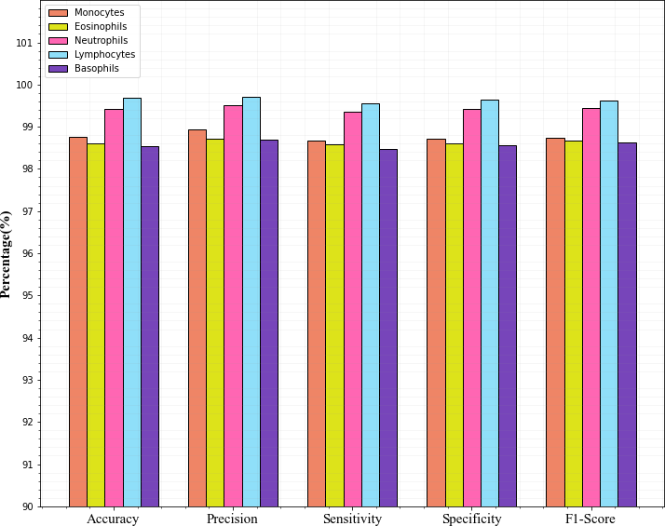
FIGURE 7. Graphical representation of five class classifications on the Raabin-WBC dataset

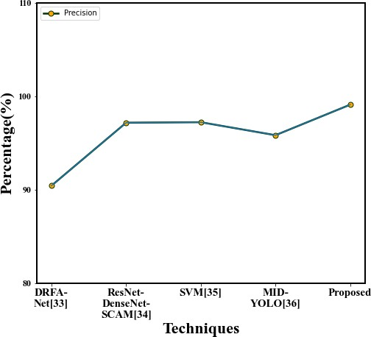

FIGURE 8. Accuracy comparison of the proposed approach on the Raabin-WBC dataset
Discriminative region detection assisted feature aggregation (DRFA-Net), Resnet-Densenet-SCAM, support vector ma- chine (SVM), MID-YOLO, and our suggested method using Raabin-WBC dataset-is presented in Table 6. The findings are the sum of various measures, including F1-score, sensi- tivity, sensitivity, accuracy, and precision. In this dataset, our
quite poorly compared to alternative methods. Extensive WBC data make SVM unsuitable for handling them. When identifying eosinophils and monocytes, Yolo has significant misclassification issues, which leads to lower accuracy than other networks. The conclusion drawn from the preceding discussion is that the proposed technique can reliably and accurately carry out the process of WBC categorization.

- Impact of feature selection
As was already noted, choosing the most robust features and training the learning algorithm with them can considerably minimize the size of the training, which significantly de- creases the time and space complexity of the system. Because the feature selection approach enhances the classifier’s per- formance, we examine its effectiveness in this section. Table 7 shows how feature selection has an impact.
This approach’s performance has been significantly im- proved by the feature selection method based on the AGCS algorithm. It only achieves 99.03% accuracy for the BCCD dataset without feature selection and 98.91% accuracy for the raabin-WBC dataset. For complex classification tasks, using optimization techniques for feature selection shows significant promise. In addition to improving performance, this strategy can reduce power and resource usage.

- Statistical Analysis
The primary objective of this statistical analysis is to estab- lish a specific degree of confidence in the suggested method.

To verify whether the outcomes are statistically significant,

we compare the means of a number of distributions using the
analysis of variance (ANOVA) method.
Table 8 displays the statistical findings from the ANOVA test, including the degree of freedom (df), F-statistics, mean squared error (MSE), and p-value. It was considered to be significant when the probability value fell below 0.05. From

8 VOLUME 4, 2016

Author et al.: Preparation of Papers for IEEE TRANSACTIONS and JOURNALS

TABLE 8. Result of ANOVA Test

 |  | df | Sum square | Mean square | f-value | p-value
Accuracy | Between groups | 1 | 0.07896 | 0.07896 | 0.29 | 0.6069
Accuracy | Within groups | 7 | 1.9062 | 0.2723
Accuracy | Total | 8 | 1.9852 | 0.2481
Precision | Between groups | 1 | 0.02863 | 0.02863 | 0.1233 | 0.7358
Precision | Within groups | 7 | 1.6252 | 0.2322
Precision | Total | 8 | 1.6538 | 0.2067
Sensitivity | Between groups | 1 | 0.06923 | 0.06923 | 0.2917 | 0.6059
Sensitivity | Within groups | 7 | 1.6614 | 0.2373
Sensitivity | Total | 8 | 1.7306 | 0.2163

the table, it is observed that p-value > α. Therefore, all group averages are taken to be equal. In other words, there is not a substantial enough statistical difference between the averages of all groups.

- Limitations of the proposed framework
One of the shortcomings of the proposed structure is that we missed suppressing image noise. However, it did not significantly affect the performance of our proposed method. It is possible to remove image noise using techniques such as conservative smoothing, gaussian smoothing, unsharp filters, mean, a median, frequency filter, and others, which could improve the algorithm’s performance. Moreover, to improve the classifier’s performance, various optimization techniques like heuristics, metaheuristics, and Bayesian optimization

may fine-tune the suggested technique’s hyperparameters.

- CONCLUSION
To help medical practitioners classify WBCs, this study aimed to employ a deep learning technique based on MobileNetV3-ShufflenetV2. Our framework is greatly im- proved by the partial residual structure of mobilenetV3, fea- ture selection using the AGCS method, channel shuffle, and pointwise group convolution of shufflenetV3 networks and reach 99.19% and 99% accuracy for the BCCD and Raabin- wbc datasets, respectively. The suggested technique also has equally good segmentation ability and yields the best results. Moreover, the proposed approach outperforms the existing approaches in terms of performance on both datasets.
In future research, our suggested framework will also be tested in other areas, such as blood group identification, malaria parasite detection, anemia detection, leukemia de- tection, and RBC count with microscopic images. We can also concentrate on boosting the system’s stability, reducing noise, and overall performance with effective preprocessing and post-processing phases.

REFERENCES
- Girdhar. A, Kapur. H, & Kumar. V, “Classification of White blood cell using Convolution Neural Network," Biomedical Signal Processing and Control, 71, 103156, 2022.
- Ha. Y, Du. Z, & Tian. J, “Fine-grained interactive attention learning for semi-supervised white blood cell classification. Biomedical Signal Processing and Control, 75, 103611, 2022.
- Dong. N, Feng. Q, Zhai. M, Chang. J, & Mai. X, “A novel feature fusion based deep learning framework for white blood cell classification," Journal of Ambient Intelligence and Humanized Computing, 1-13, 2022.
- Zhai. Q, Fan. B, Zhang. B, Li. J. H, & Liu. J. Z, “Automatic White Blood Cell Classification Based on Whole-Slide Images with a Deeply Aggre- gated Neural Network," Journal of Medical and Biological Engineering, 42(1), 126-137, 2022.
- Meenakshi. A, Ruth. J. A, Kanagavalli. V. R, & Uma. R, “Automatic classification of white blood cells using deep features based convolutional neural network. Multimedia Tools and Applications, 1-22, 2022.
- Al-Qudah. R, & Suen. C. Y, “Improving blood cells classification in peripheral blood smears using enhanced incremental training," Computers in Biology and Medicine, 131, 104265, 2021.
- Ryu. D, Kim. J, Lim. D, Min. H. S, Yoo. I. Y, Cho. D, & Park. Y, “Label- free white blood cell classification using refractive index tomography and deep learning," BME Frontiers, 2021.
- Wu. J, Zheng. X, Liu. D, Ai. L, Tang. P, Wang. B, & Wang. Y, “WBC Image Segmentation Based on Residual Networks and Attentional Mech- anisms," Computational Intelligence and Neuroscience, 2022.
- Zhao. M, Yang. H, Shi. F, Zhang. X, Zhang. Y, Sun. X, & Wang. H, “MSS- WISN: Multiscale Multistaining WBCs Instance Segmentation Network," IEEE Access, 10, 65598-65610, 2022.
- Cengil. E, Cinar. A, & Muhammed. Y, “A hybrid approach for efficient multiâA˘ Rˇ classification of white blood cells based on transfer learning
techniques and traditional machine learning methods," Concurrency and Computation: Practice and Experience, 34(6), e6756, 2021.
- Khan. A, Eker. A, Chefranov. A, & Demirel. H “White blood cell type identification using multi-layer convolutional features with an extreme- learning machine," Biomedical Signal Processing and Control, 69, 102932, 2021.
- Wang. Q, Wang. J, Zhou. M, Li. Q, Wen. Y, & Chu. J, “A 3D attention networks for classification of white blood cells from microscopy hyper- spectral images," Optics & Laser Technology, 139, 106931, 2021.
- Makem. M, Tiedeu. A, Kom. G, & Nkandeu. Y. P. K, “A robust algorithm for white blood cell nuclei segmentation. Multimedia Tools and Applica- tions, 81(13), 17849-17874, 2022.
- Haider. A, Arsalan. M, Lee. Y. W, & Park. K. R, “Deep features aggregation-based joint segmentation of cytoplasm and nuclei in white blood cells," IEEE Journal of Biomedical and Health Informatics, vol. 26, no. 8, pp. 3685-3696, Aug. 2022.
- Roy. R. M, & Ameer. P. M, “Segmentation of leukocyte by semantic segmentation model: A deep learning approach," Biomedical Signal Pro- cessing and Control, 65, 102385, 2021.
- Baby. D, Devaraj. S. J, & Hemanth. J, “Leukocyte classification based on feature selection using extra trees classifier: atransfer learning approach," Turkish Journal of Electrical Engineering and Computer Sciences, 29(8), 2742-2757, 2021.
- Zheng. X, Tang. P, Ai. L, Liu. D, Zhang. Y, & Wang. B, “White blood cell detection using saliency detection and CenterNet: A twoâA˘ Rˇ stage approach," Journal of Biophotonics, e202200174.
- Yang. D, Zhao. H, Han. T, Kang. Q, Ma. J, & Lu. H, “Leukocyte subtypes identification using bilinear self-attention convolutional neural network," Measurement, 173, 108643, 2021.
- Hosseini. M, Bani-Hani,. D, & Lam. S. S, “Leukocytes Image Classifi- cation Using Optimized Convolutional Neural Networks," Expert Systems with Applications, 117672, 2022.
- Dong. N, Zhai. M. D, Chang. J. F, & Wu. C. H, “A self-adaptive approach for white blood cell classification towards point-of-care testing," Applied Soft Computing, 111, 107709, 2022.
- Manthouri. M, Aghajari. Z, & Safary. S, “Computational Intelligence Method for Detection of White Blood Cells Using Hybrid of Convolutional Deep Learning and SIFT," Computational and Mathematical Methods in Medicine, 2022.

VOLUME 4, 2016 9

Author et al.: Preparation of Papers for IEEE TRANSACTIONS and JOURNALS

- Cheuque. C, Querales. M, Leon. R, Salas. R, & Torres. R, “An Efficient Multi-Level Convolutional Neural Network Approach for White Blood Cells Classification," Diagnostics, 12(2), 248, 2022.
- Wang. Z, Xiao. J, Li. J, Li. H, & Wang. L, “WBC-AMNet: Automatic classification of WBC images using deep feature fusion network based on focalized attention mechanism," Plos one, 17(1), e0261848, 2022.
- Alharbi. A. H, Aravinda. C. V, Lin. M, Venugopala. P. S, Reddicherla. P, & Shah. M. A, “Segmentation and Classification of White Blood Cells Using the UNet," Contrast Media & Molecular Imaging, 2022.
- Shahzad. A, Raza. M, Shah. J. H, Sharif. M, & Nayak. R. S, “Categorizing white blood cells by utilizing deep features of proposed 4B-AdditionNet- based CNN network with ant colony optimization," Complex & Intelligent Systems, 8(4), 3143-3159, 2022.
- Roy. R. M, & Ameer. P. M, “Segmentation of leukocyte by semantic segmentation model: A deep learning approach," Biomedical Signal Pro- cessing and Control, 65, 102385, 2022.
- Cinar. A, & Tuncer. S. A, “Classification of lymphocytes, monocytes, eosinophils, and neutrophils on white blood cells using hybrid Alexnet- GoogleNet-SVM," SN Applied Sciences, 3(4), 1-11, 2021.
- Shahzad. A, Raza. M, Shah. J. H, Sharif. M, & Nayak. R. S, “Categorizing white blood cells by utilizing deep features of proposed 4B-AdditionNet- based CNN network with ant colony optimization," Complex & Intelligent Systems, 8(4), 3143-3159, 2022.
- Wang. Z, Xiao. J, Li. J, Li. H, & Wang. L, “WBC-AMNet: Automatic classification of WBC images using deep feature fusion network based on focalized attention mechanism," Plos one, 17(1), e0261848, 2022.
- BOZKURT. F, “Classification of Blood Cells from Blood Cell Images Using Dense Convolutional Network," Journal of Science, Technology and Engineering Research, 2(2), 81-88, 2021.
- Hosseini, M, Bani-Hani, D, & Lam, S. S, “Leukocytes Image Classifica- tion Using Optimized Convolutional Neural Networks," Expert Systems with Applications, 205, 117672, 2022.
- Ha, Y, Du, Z, & Tian, J, “Fine-grained interactive attention learning for semi-supervised white blood cell classification," Biomedical Signal Processing and Control, 75, 103611, 2022.
- Jiang. L, Tang. C, & Zhou. H, “White blood cell classification via a discriminative region detection assisted feature aggregation network," Biomedical Optics Express, 13(10), 5246-5260, 2022.
- Chen. H, Liu. J, Hua. C, Feng. J, Pang. B, Cao. D, & Li. C, “Accurate classification of white blood cells by coupling pre-trained ResNet and DenseNet with SCAM mechanism," BMC bioinformatics, 23(1), 1-20, 2022.
- Tavakoli. S, Ghaffari. A, Kouzehkanan. Z. M, & Hosseini. R, “New segmentation and feature extraction algorithm for classification of white blood cells in peripheral smear images," Scientific Reports, 11(1), 1-13, 2021.
- Han Z, Huang H, Lu D, Fan Q, Ma C, Chen X, Gu Q, Chen Q, “One-stage and lightweight CNN detection approach with attention: Application to WBC detection of microscopic images," Computers in Biology and Medicine, 2023 Jan 23, 154:106606. doi: 10.1016/j.compbiomed.2023.106606. Epub ahead of print. PMID: 36706565.

DR. BATTULA SRINIVASA RAO working as

Associate professor in School of CSE, Vel- lore Institute of Technology, VIT-AP. His re- search interests are soft computing, image pro- cessing, machine learning and deep learning. He can be reached at sreenivas.battula@gmail.com https://orcid.org/0000-0003-2242-3656


BAIRABOINA SAI SAMBASIVA RAO working
as Research Scholar in School of CSE, Vellore Institute of Technology, VIT-AP. His research in- terest includes digital image processing, pattern recognition and deep learning. He can be reached at bsssr3@gmail.com

10 VOLUME 4, 2016

