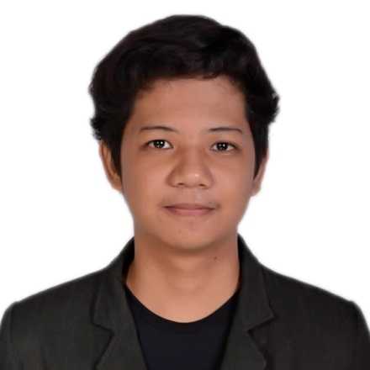**ARDRIAN LOIS HINGADA ENRIQUEZ**

#292 San Isidro 1st, Paombong, Bulacan

09161146511

[ard.lois00@live.com](mailto:ard.lois00@live.com)

https://ardrinizer.github.io/ardrian-portfolio/

**CAREER OBJECTIVE**

To apply my skills, knowledge and abilities acquired in the field of Information Technology. To be trained in actual work setting, be highly competent through quality trainings and be an asset in the organization by providing the best service I can give.

**EDUCATIONAL ATTAINMENT**

**Bachelor of Science in Information Technology**

Bulacan State University, College of Information and Communication Technology

City of Malolos, Bulacan

2012 – 2016

**SEMINARS AND WORKSHOPS ATTENDED**

**Annual IT Congress Seminar for Information Technology**

Bulacan State University, City of Malolos, Bulacan

December 2015

**Abacus Distribution Systems**

Leviste Street, Makati, 1227 Metro Manila

March 2015

**PLDT Innolab**

Session Rd, Baguio, Benguet

March 2015

**Certificates**

**Microsoft Certified Professional**

Date of achievement – 03/25/2014

**Microsoft Technology Associate**

Date of achievement – 03/25/2014

**On-The-Job Training**

Brighttank Inc., Ortigas Center, Pasig City

From November 10, 2015 to March 18, 2016

In Web Department

**SKILLS AND QUALIFICATION**

•Databases

* MySQL
* XML
* JSON

•Web Development and design.

* HTML
* CSS
* AJAX
* PHP
* JavaScript
* JQuery
* Twitter Bootstrap

•Skilled in using Photoshop.

•Ability to work under pressure and independently or willing to work under pressure.

•Can easily adapt to a new working environment

•I am willing to learn new technologies and attend trainings or boot camps.

**CHARACTER REFERENCES**

**Engr. Angelo Adriano**

Software Engineer, Accenture

09178993484

**Engr. Michael Christian Sagun**

Marine Engineer, Wallem Ship

Management

sagunmichaelchristian@ymail.com

I hereby certify that the above information is true and correct according to the best of my knowledge.

Ardrian Lois H. Enriquez