RT-Thread getting started guide for Bouffalo Lab RISC-V AIoT MCU series
Original post: https://zhuanlan.zhihu.com/p/627481115
The bouffalo_lab BSP under rt-thread is
The BSP for Bouffalo Lab's AIoT chips is located in rt-thread/bsp/bouffalo_lab (https://github.com/RT-Thread/rt-thread/tree/master/bsp/bouffalo_lab). It currently has 4 subdirectories including:
Chip model | Core
bl60x (BL602/BL604) | SiFive E24
bl70x (BL702/BL704/BL706) | SiFive E24
bl61x (BL616/BL618) | T-Head E907
bl808 | T-Head E902 (lp) + E907 (m0) + C906 (d0)
The latest chips such as BL616/BL618 that support WiFi 6, and the three-core heterogeneous multimedia chip BL808 all use T-Head RISC-V cores.
Chip-related information can be downloaded at https://github.com/bouffalolab/bl_docs, the information is very detailed, with all register-level instructions.

1. rt-thread driver adaptation
The current BSP uses the latest LHAL driver library of bouffalo_lab, which is the same as https://github.com/bouffalolab/bouffalo_sdk.
LHAL is a driver library designed by Bouffalo Lab to unify the general peripheral interface. The code is refined and supports all series of Bouffalo Lab chips.
With the support of many small partners, the basic peripheral driver adaptation has been completed, including UART/GPIO/I2C/SPI/PWM/RTC/ADC/WDT/HWTIMER/FLASH, and the RT-Thread driver is also a set of codes to support all the above chips. Other drivers are also being adapted. Interested partners can also participate in submitting PR together, or contact me directly (WeChat: flyingcys).
- UART: supported (default baud rate 2000000)
- GPIO: supported
- I2C: supported
- SPI: supported (supports DMA)
- PWM: supported
- ADC: supported
- RTC: supported
- WDT: supported
- HWTIMER: supported
- FLASH: supported
Friends interested in the Open Source Promotion Plan summer program can also pay attention to Bouffalo Lab BSP, one of the high-level projects of the Summer of Open Source rt-thread community, "RT-thread uses BL602/BL702 chips to support WiFi, BLE, and Thread functions". To complete "BL60X/BL70X's IoT communication capabilities, BL602's WiFi and BLE capabilities, and BL702's BLE and Thread communication capabilities", click this link: https://summer-ospp.ac.cn/org/prodetail/238bc0129?list=org&navpage=org

2. Compile

2.1. Cross-compiler download
Please download the toolchain matching your chip and platform:
BL60x/BL70x
- Bouffalo Lab's developer zone:
https://dev.bouffalolab.com/download
- or Bouffalo Lab's Gitee:
https://gitee.com/bouffalolab/toolchain_gcc_sifive_linux
https://gitee.com/bouffalolab/toolchain_gcc_sifive_windows
BL61x/BL808
- T-Head official website:
https://occ.t-head.cn/community/download?id=4073475960903634944
- or Bouffalo Lab's GitHub:
https://github.com/bouffalolab/toolchain_gcc_t-head_linux
https://github.com/bouffalolab/toolchain_gcc_t-head_windows

2.2. Settings
Under Windows, please use [env tool][1], use the command tar -xvf Xuantie-900-gcc-elf-newlib-mingw-V2.6.1-20220906.tar.gz to decompress the cross-compiler. Direct decompression using Windows' decompression tool may cause compilation errors.
Add the local path of the RISC-V toolchain to EXEC_PATH in rtconfig.py or specify the path through the RTT_EXEC_PATH environment variable
Windows:
set RTT_EXEC_PATH=C:\Users\xxxx\Downloads\Xuantie-900-gcc-elf-newlib-x86_64-V2.6.1\bin
Linux:
export RTT_EXEC_PATH=/opt/Xuantie-900-gcc-elf-newlib-x86_64-V2.6.1/bin

2.3. Compiling
It is recommended to use [env tool][1] under Windows. Execute:
cd bsp/bouffalo_lab/bl61x
menuconfig
pkgs --update
If you are on the Linux platform, you can first execute:
scons --menuconfig
It will automatically download env related scripts to the ~/.env directory. Then execute:
source ~/.env/env.sh
cd bsp/bouffalo_lab/bl61x
pkgs --update
After updating the package, execute scons -j10 or scons -j10 --verbose to compile the board support package. Or use the scons –exec-path="<GCC toolchain path>" command to compile directly while specifying the toolchain location.
If the compilation is correct, rtthread.elf and rtthread.bin files will be generated.
After compiling, it will automatically call libraries/bl_mcu_sdk/tools/bflb_tools/bflb_fw_post_proc to package rtthread.bin for subsequent burning of bouffalo_flash_cube tool.
The script will automatically use the curl command line to download bflb_fw_post_proc. If the automatic download fails, you can manually download the corresponding operating system file from the URL below and save it to libraries/bl_mcu_sdk/tools/bflb_tools/bflb_fw_post_proc:
Linux: https://github.com/bouffalolab/bouffalo_sdk/raw/master/tools/bflb_tools/bflb_fw_post_proc/bflb_fw_post_proc-ubuntu
Windows: https://github.com/bouffalolab/bouffalo_sdk/raw/master/tools/bflb_tools/bflb_fw_post_proc/bflb_fw_post_proc.exe
MacOS: https://github.com/bouffalolab/bouffalo_sdk/raw/master/tools/bflb_tools/bflb_fw_post_proc/bflb_fw_post_proc-macos

3. Download and burn

3.1. Burning tool download
The current BSP must be burned using the bouffalo_flash_cube tool, and it cannot run normally with other tasks.
Linux: https://github.com/bouffalolab/bouffalo_sdk/raw/master/tools/bflb_tools/bouffalo_flash_cube/BLFlashCube-ubuntu
Windows: https://github.com/bouffalolab/bouffalo_sdk/raw/master/tools/bflb_tools/bouffalo_flash_cube/BLFlashCube.exe
MacOS: https://github.com/bouffalolab/bouffalo_sdk/raw/master/tools/bflb_tools/bouffalo_flash_cube/BLFlashCube-macos

3.2. GUI download
- Connect the serial port and select the corresponding serial port number on the tool
- Open the flash_prog_cfg.ini file under the corresponding chip folder
- Press and hold the boot button on the development board and then power on again to enter the download state
- Click "Download" to start downloading
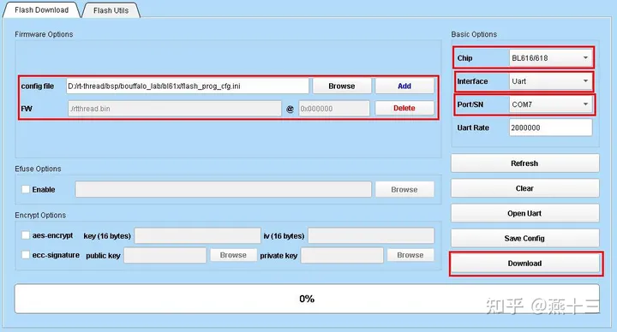

3.3. Command line download
The command line download can use the bouffalo_flash_cube.sh script in the bsp/bouffalo_lab directory, enter ./bouffalo_flash_cube.sh bl616 /dev/ttyUSB1, the script will automatically use the curl command line to download bouffalo_flash_cube.
Arguments:
bl616: chip name
/dev/ttyUSB1: download serial port number, /dev/ttyUSBx or /dev/ttyACMx under Linux, COMx under Windows
If the automatic download fails, you can manually download the corresponding operating system files and save them to the libraries/bl_mcu_sdk/tools/bflb_tools/bouffalo_flash_cube directory.

4. Execution
If the compilation and programming are correct, after resetting the device, you will see the RT-Thread startup logo information on the serial port:
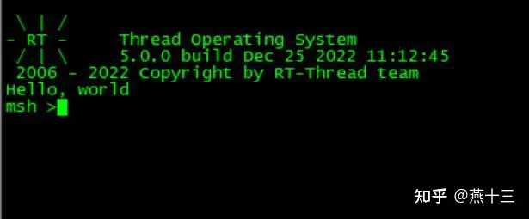

5. List of supported development boards
BL602: BL602-IoT-3S/BL-HWC-G1
BL702: Maix Zero Sense
BL616/BL618: M0S Dock/M0P Dock
BL808: M1s Dock

6. Follow-up promotion plan
Include:
- WiFi driver adaptation
- SD card driver adaptation
- USB driver adaptation
- I2S driver adaptation
- display driver adaptation
- BLE driver adaptation
- Heterogeneous inter-core communication
Wait;
I hope that more friends will participate together, learn RISC-V together, and learn IoT together;
Anyone who is interested in rt-thread, RISC-V, rt-smart, and Bouffalo Lab BSP can add me on WeChat (flyingcys).

