Detailed explanation of WCH TMOS usage
Original post: https://www.cnblogs.com/debugdabiaoge/p/15775521.html
In order to connect with multiple devices and achieve multi-function and multi-tasking, Bluetooth has a scheduling problem. Although the software and protocol stack can be expanded, after all, there is only one bottom-level execution department. In order to realize multi-event and multi-task switching, it is necessary to correspond events and tasks, and a TMOS name operating system abstraction layer is set up for this application.
TMOS is the scheduling core, and the BLE protocol stack, profile definition, and all applications are implemented around it. TMOS is not the traditional operating system that everyone uses, but a cycle that allows software to create and execute events.
In the multi-task management mode, only one task is actually running, but multiple tasks can be scheduled using the task scheduling strategy, and each task takes a certain amount of time (exclusive, exit after executing the current task, and continue to query other executable tasks) , all tasks are processed by time slicing.
The TMOS system clock unit is 625us, and all the required system time is obtained based on the RTC.
Software functions are realized by task events. Creating a task event requires the following work:

1. Create task identifier task ID
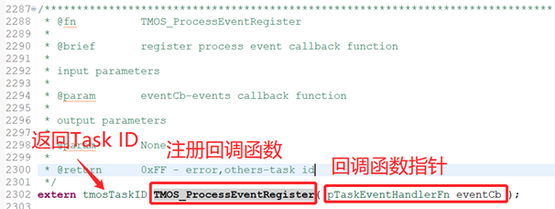
For example:
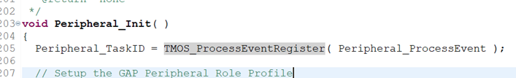

2. Write a task initialization routine process and add it to the TMOS initialization process
Which means that the function cannot be dynamically added after the system starts (new Task ID).
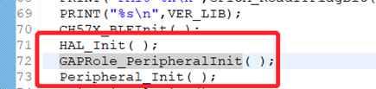

3. Write a task handler
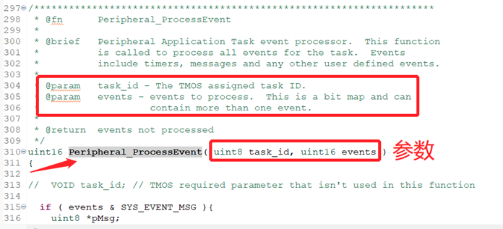

4. Define task events and write user function codes
The event name is defined by bit, each taskID contains at most 1 message event and 15 task events (total 16 bits). For example:
Define EVT task events bit by bit, as shown in the figure below:
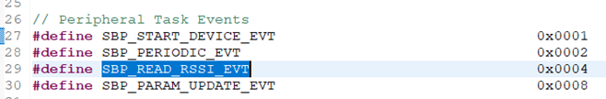
There are two ways to start the task event (the task is only executed once after the task is started, if it is executed repeatedly, the task needs to be restarted):
1) The task is started immediately, and the event time is executed immediately after the call
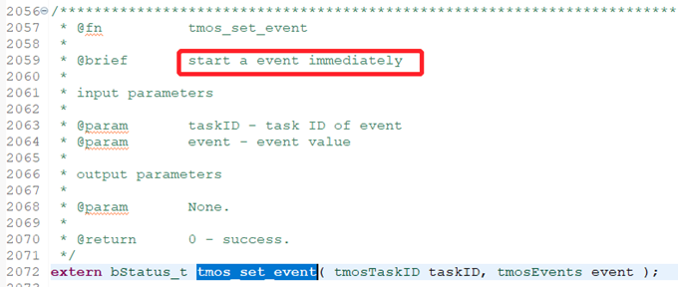
For example:
2) Set a delay to start a task, and start timing after the setting is completed
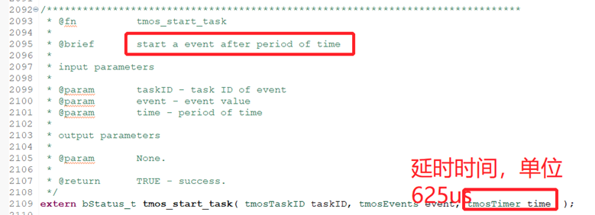
For example: the custom SBP_PERIODIC_EVT task under the Peripheral_TaskID function runs after a delay of (SBP_READ_RSSI_EVT_PERIOD*625)us.
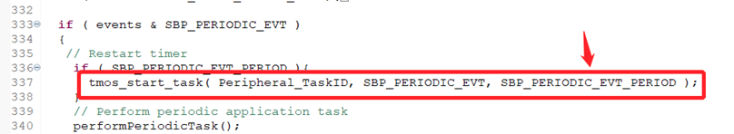
User code function. When generating TaskID, you need to register the EVT processing function pointer with TMOS. After the EVT execution conditions are met, TMOS will automatically call this function, as shown in the following figure:
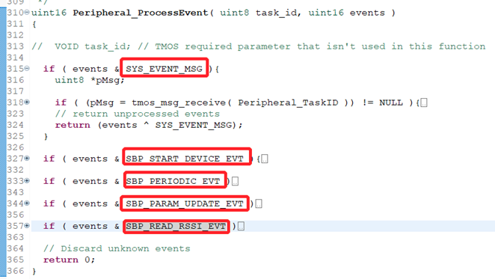
externbStatus_ttmos_stop_task(tmosTaskIDtaskID, tmosEvents event);
This function will stop a task named event that will take effect at the taskID layer. After calling this function, the event task will not take effect.

5. The main loop calls TMOS_SystemProcess continuously to query executable events
If HAL_SLEEP starts, the chip turns on low-power sleep mode, TMOS will turn on the RTC wake-up function, and it will automatically wake up before the event is executed, and run the event code.
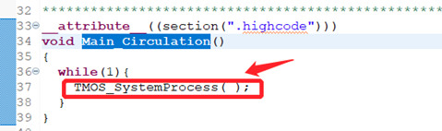
Precautions for using the task scheduling function:
- It is forbidden to call in interrupt
- It is recommended not to execute tasks that exceed half the connection interval in a single task, otherwise it will affect Bluetooth communication
- In the same way, it is recommended not to perform tasks that exceed half the connection interval during the interruption, otherwise it will affect the Bluetooth communication
- When the delayed execution function is called in the code executed by the event, the delay time is offset from the current event effective time point, so there is no requirement for the position of the delayed execution function called in the executed code.
- Tasks have priority, which is determined according to the sequence of judgments in the xxx_ProcessEvent function. Tasks that are effective at the same time are executed first and judged first, and then judged after execution. Note that after executing the first-judgment event task, the last-judgment event task will not be executed until the task scheduling system takes turns.
- The event name is defined by bit. Each taskID contains at most 1 message event and 15 task events (total 16 bits)
I talked about the application of a Task ID earlier. In order to reduce the coupling between C files or functions, it is generally better to put the same function or similar events under the same Task ID, which creates a problem; different Task IDs may have data that needs to be interacted with, and TMOS provides functions for data interaction between different Task IDs.
For example: Take two of the Task IDs in the peripheral as examples, halTaskID and Peripheral_TaskID, assuming that data interaction between these two Tasks is required.
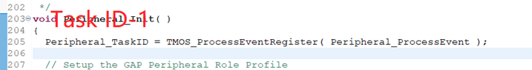
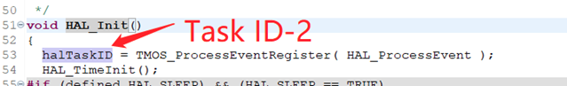
It was said before that each Task ID has 1 message event
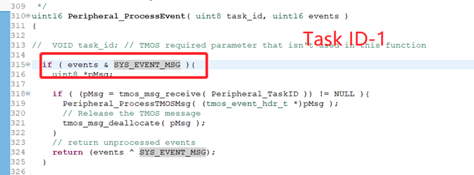
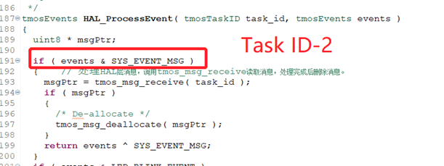
The above figure demonstrates receiving messages, which mainly use 2 functions
