Appendix M. Use STC's IAP series MCU to develop your own ISP program
The continuous development of IAP (In-Application-Programming) technology in the field of microcontrollers brings great convenience to the application system program code upgrade. STC's serial port ISP (In-System-Programming) program uses the IAP function to upgrade the user's program online, but for the sake of the safety of the user code, neither the underlying code nor the upper-level application program is open source, so STC launched the IAP series microcontrollers, that is, the Flash space of the entire MCU, can be rewritten by users in their own programs, so that the idea that some users need to develop their own ISP programs can be realized.
All the models of STC8H series microcontrollers that can be user-defined EEPROM size during ISP download are IAP series microcontrollers. At present, the STC8H series has the following models of microcontrollers as the IAP series: STC8H1K12, STC8H1K17, STC8H1K28, STC8H1K33, STC8H3K64S2, STC8H3K64S4, STC8H8K64U. This article takes STC8H8K64U as an example to describe in detail how to use STC's IAP microcontroller to develop the user's own ISP program, and gives the assembly and C source code based on the Keil environment.

Step 1: Internal FLASH planning
Since the EEPROM of the STC8H series IAP MCU is set by the user when the ISP is downloaded, if the user needs to implement his own ISP, then when downloading the user’s own ISP program, he needs to follow the method shown in the figure below to set all 64K as EEPROM, so that the user program space and EEPROM space completely overlap, so that the user can modify and update his own program space.
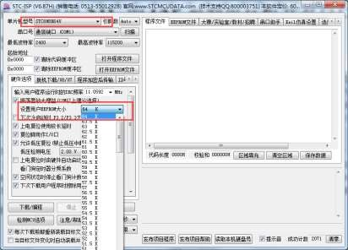
The following assumes that the user has set the entire 64K program space as EEPROM, and now the entire 64K program space is divided as follows:
FA00
F9FF
0000
User parameter area

(cannot run code)

User ISP area

User program area

0.5K
0.5K
62.5K
Reset Entry
Mapping area
0.5K
FC00
FBFF
FDFF
FE00
FFFF
In the FLASH space, the continuous 62.5K byte space starting from address 0000H is the user program area. When the specific download conditions are met, the user needs to jump the PC to the user ISP program area. At this time, the user program area can be erased and rewritten to achieve the purpose of updating the user program.

Step 2: Basic framework of the program
MCU reset

Are system upgrade
requirements met?
Execute user
function module

Y
N
Update user code

Soft reset

POST module

Is the system
normal?
Y

N
Exception handling

Step 3: Firmware of the lower computer
The firmware of the lower computer includes two parts: ISP (ISP code) and AP (user code).

ISP code (assembly code)
UARTBAUD EQU 0FFE8H ; Serial port baud rate (65536-11059200/4/115200)

AUXR DATA 08EH ; Additional function control register
WDT_CONTR DATA 0C1H ; Watchdog control register
IAP_DATA DATA 0C2H ; IAP data register
IAP_ADDRH DATA 0C3H ; IAP high address register
IAP_ADDRL DATA 0C4H ; IAP low address register
IAP_CMD DATA 0C5H ; IAP command register
IAP_TRIG DATA 0C6H ; IAP command trigger register
IAP_CONTR DATA 0C7H ; IAP control register
IAP_TPS DATA 0F5H ; IAP wait time control register

ISPCODE EQU 0FA00H ; ISP module entry address (1 page),
; also the external interface address
APENTRY EQU 0FC00H ; Application entry address data (1 page)

ORG 0000H

LJMP ISP_ENTRY ; System reset entry

MOV SCON,#50H ; Set serial port mode (8 data bits, no parity bit)
MOV AUXR,#40H ; Timer 1 is in 1T mode
MOV TMOD,#00H ; Timer 1 works in mode 0 (16-bit reload)
MOV TH1,#HIGH UARTBAUD ; Set reload value
MOV TL1,#LOW UARTBAUD
SETB TR1 ; Start timer 1
NEXT1:
MOV R0,#16
NEXT2:
JNB RI,$ ; Wait for serial port data
CLR RI
MOV A,SBUF
CJNE A,#7FH,NEXT1 ; Determine whether it is 7F
DJNZ R0,NEXT2
LJMP ISP_DOWNLOAD ; Jump to the download interface

ORG ISPCODE

ISP_DOWNLOAD:
CLR A
MOV PSW,A ; ISP module uses register 0
MOV IE,A ; Disable all interrupts
CLR RI ; Clear the serial port receiving flag
SETB TI ; Set the serial port to send flag
CLR TR0
MOV SP,#5FH ; Set stack pointer
RESET:
MOV A,#5AH ; Return 5A 55 to PC, indicating the ISP erase module is ready
LCALL ISP_SENDUART
MOV A,#055H
LCALL ISP_SENDUART
LCALL ISP_RECVACK ; Receive response data
MOV IAP_ADDRL,#0 ; First write "LJMP ISP_ENTRY" command at the start address
; of page 2
MOV IAP_ADDRH,#02H
LCALL ISP_ERASEIAP
MOV A,#02H
LCALL ISP_PROGRAMIAP ; Program user code reset vector code
MOV A,#HIGH ISP_ENTRY
LCALL ISP_PROGRAMIAP
MOV A,#LOW ISP_ENTRY
LCALL ISP_PROGRAMIAP
MOV IAP_ADDRL,#0
MOV IAP_ADDRH,#0
LCALL ISP_ERASEIAP ; User code address starts from 0
MOV A,#02H
LCALL ISP_PROGRAMIAP
MOV A,#HIGH ISP_ENTRY
LCALL ISP_PROGRAMIAP
MOV A,#LOW ISP_ENTRY
LCALL ISP_PROGRAMIAP
MOV IAP_ADDRL,#0 ; New code buffer address
MOV IAP_ADDRH,#02H
MOV R7,#124 ; Erase 62.5K bytes
ISP_ERASEAP:
LCALL ISP_ERASEIAP
INC IAP_ADDRH ; Target address +512
INC IAP_ADDRH
DJNZ R7,ISP_ERASEAP ; Determine whether the erase is complete

MOV IAP_ADDRL,#LOW APENTRY
MOV IAP_ADDRH,#HIGH APENTRY
LCALL ISP_ERASEIAP

MOV A,#5AH ; Return 5A A5 to PC, indicating that the ISP programming
; module is ready
LCALL ISP_SENDUART
MOV A,#0A5H
LCALL ISP_SENDUART
LCALL ISP_RECVACK ; Receive response data

LCALL ISP_RECVUART ; Receive length high byte
MOV R0,A
LCALL ISP_RECVUART ; Receive length low byte
MOV R1,A
CLR C ; Set total length to -3
MOV A,#03H
SUBB A,R1
MOV DPL,A
CLR A
SUBB A,R0
MOV DPH,A ; Total length complement stored in DPTR

LCALL ISP_RECVUART ; Map user code reset entry code to mapped area
LCALL ISP_PROGRAMIAP ; 0000
LCALL ISP_RECVUART
LCALL ISP_PROGRAMIAP ; 0001
LCALL ISP_RECVUART
LCALL ISP_PROGRAMIAP ; 0002

MOV IAP_ADDRL,#03H ; User code start address
MOV IAP_ADDRH,#00H
ISP_PROGRAMNEXT:
LCALL ISP_RECVUART ; Receive code data
LCALL ISP_PROGRAMIAP ; Program to user code area
INC DPTR
MOV A,DPL
ORL A,DPH
JNZ ISP_PROGRAMNEXT ; Length detection

ISP_SOFTRESET:
MOV IAP_CONTR,#20H ; Software reset system
SJMP $

ISP_ENTRY:
MOV WDT_CONTR,#17H ; Clear watchdog
MOV IAP_CONTR,#80H ; Enable IAP function
MOV IAP_TPS,#11 ; Set IAP waiting time parameter
MOV IAP_ADDRL,#LOW ISP_DOWNLOAD
MOV IAP_ADDRH,#HIGH ISP_DOWNLOAD
MOV IAP_DATA,#00H ; Test data 1
MOV IAP_CMD,#1 ; Read command
MOV IAP_TRIG,#5AH ; Trigger ISP command
MOV IAP_TRIG,#0A5H
MOV A,IAP_DATA
CJNE A,#0E4H,ISP_ENTRY ; If the data cannot be read, wait for the voltage to stabilize
INC IAP_ADDRL ; Test address FC01H
MOV IAP_DATA,#45H ; Test data 2
MOV IAP_CMD,#1 ; Read command
MOV IAP_TRIG,#5AH ; Trigger ISP command
MOV IAP_TRIG,#0A5H
MOV A,IAP_DATA
CJNE A,#0F5H,ISP_ENTRY ; If the data cannot be read, wait for the voltage to stabilize

MOV SCON,#50H ; Set serial port mode (8 data bits, no parity bit)
MOV AUXR,#40H ; Timer 1 is in 1T mode
MOV TMOD,#00H ; Timer 1 works in mode 0 (16-bit reload)
MOV TH1,#HIGH UARTBAUD ; Set reload value
MOV TL1,#LOW UARTBAUD
SETB TR1 ; Start timer 1
SETB TR0

LCALL ISP_RECVUART ; Check whether there is serial data
JC GOTOAP
MOV R0,#16
ISP_CHECKNEXT:
LCALL ISP_RECVUART ; Receive synchronous data
JC GOTOAP
CJNE A,#7FH,GOTOAP ; Determine whether it is 7F
DJNZ R0,ISP_CHECKNEXT
MOV A,#5AH ; Return 5A 69 to PC, indicating that the ISP module is ready
LCALL ISP_SENDUART
MOV A,#69H
LCALL ISP_SENDUART
LCALL ISP_RECVACK ; Receive response data
LJMP ISP_DOWNLOAD ; Jump to the download interface
GOTOAP:
CLR A ; Restore SFR to reset value
MOV TCON,A
MOV TMOD,A
MOV TL0,A
MOV TH0,A
MOV TL1,A
MOV TH1,A
MOV SCON,A
MOV AUXR,A
LJMP APENTRY ; Run user program normally

ISP_RECVACK:
LCALL ISP_RECVUART
JC GOTOAP
XRL A,#7FH
JZ ISP_RECVACK ; Skip synchronous data
CJNE A,#25H,GOTOAP ; Response data 1 detection
LCALL ISP_RECVUART
JC GOTOAP
CJNE A,#69H,GOTOAP ; Response data 2 detection
RET

ISP_RECVUART:
CLR A
MOV TL0,A ; Initialize timeout timer
MOV TH0,A
CLR TF0
MOV WDT_CONTR,#17H ; Clear watchdog
ISP_RECVWAIT:
JBC TF0,ISP_RECVTIMEOUT; Timeout detection
JNB RI,ISP_RECVWAIT ; Wait for receiving to complete
MOV A,SBUF ; Read serial port data
CLR RI ; Clear flag
CLR C ; Receive serial data correctly
RET
ISP_RECVTIMEOUT:
SETB C ; Timeout exit
RET

ISP_SENDUART:
MOV WDT_CONTR,#17H ; Clear watchdog
JNB TI,ISP_SENDUART ; Wait for the previous data sending to complete
CLR TI ; Clear flag
MOV SBUF,A ; Send current data
RET

ISP_ERASEIAP:
MOV WDT_CONTR,#17H ; Clear watchdog
MOV IAP_CMD,#3 ; Erase command
MOV IAP_TRIG,#5AH ; Trigger ISP command
MOV IAP_TRIG,#0A5H
NOP
NOP
NOP
NOP
RET

ISP_PROGRAMIAP:
MOV WDT_CONTR,#17H ; Clear watchdog
MOV IAP_CMD,#2 ; Programming command
MOV IAP_DATA,A ; Send current data to IAP data register
MOV IAP_TRIG,#5AH ; Trigger ISP command
MOV IAP_TRIG,#0A5H
NOP
NOP
NOP
NOP
MOV A,IAP_ADDRL ; IAP address+1
ADD A,#01H
MOV IAP_ADDRL,A
MOV A,IAP_ADDRH
ADDC A,#00H
MOV IAP_ADDRH,A
RET

ORG APENTRY
LJMP RESET

END
The ISP code includes the following external interface modules:
ISP_DOWNLOAD: program download entry address, absolute address FA00H
ISP_ENTRY: Power-on system self-test program (automatically called by the system)
For the user program, the user only needs to jump the PC value to ISPPROGRAM (that is, the absolute address of FA00H) when the download condition is met, and then the code can be updated.

User code (C code)

User code (assembly code)

User code can be written in C or assembly language, but one thing needs to be paid attention to for assembly code: the instruction at the reset entry address at 0000H must be a long jump statement (similar to LJMP START). In the user code, the serial port needs to be set up, and when the download condition is satisfied, the PC value is jumped to ISPPROGRAM (that is, the absolute address of FA00H) to realize the code update. For assembly code, we can use the "LJMP 0FA00H" instruction to call, as shown below:
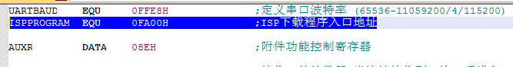
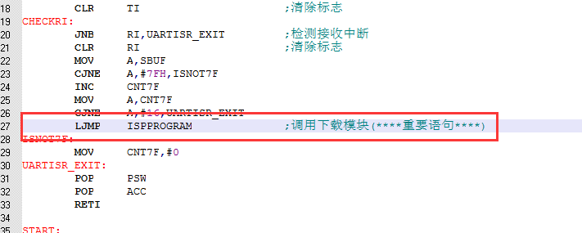
In the C code, a function pointer variable must be defined, and this variable is assigned a value of 0xFA00, and then called, as shown in the figure below:
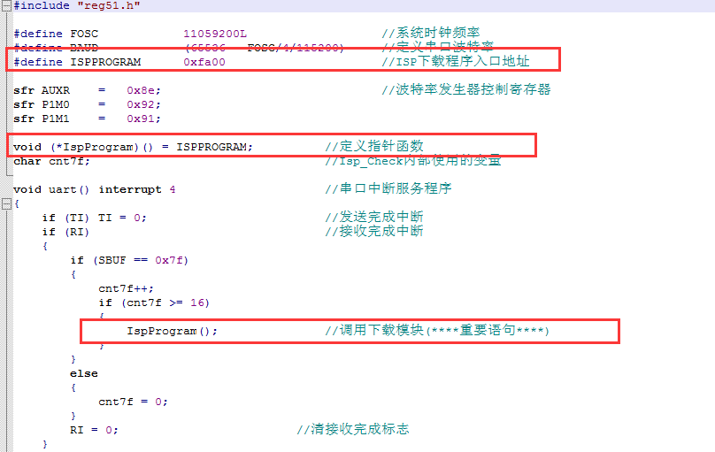

Step 4: PC application description
The program of the upper computer is based on the MFC dialog box project, and the access to the serial port is to directly call the API function of Windows, instead of using the serial port control, so as to save the registration of the control and many problems of incompatibility of the system version. The interface is relatively simple, and it only provides a framework for the realization of this function, and other functions and requirements can be added to it.
The core module of the upper computer program is based on a friend function "UINT Download(LPVOID pParam);" of the CISPDlg class. This function is responsible for communicating with the lower computer and sending various communication commands to complete the update of the user program. Users can add commands according to their different needs.

Step 5: How to use the upper computer application program
- Open the upper computer interface, as shown below:
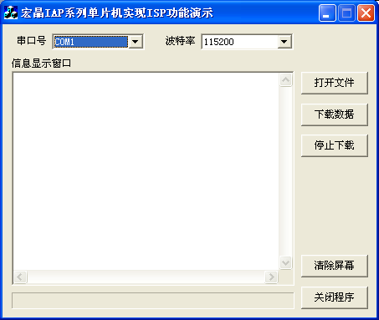
- Select the serial port number and set the same serial port baud rate as the lower computer
- Open the source data file to be downloaded, either in Bin or Intel hex format
- Click the "Download Data" button to start downloading data

Step 6: How to use the firmware of the lower computer
The target file of the lower computer has two "IAPISP.hex" and "AP.hex". For a new MCU, you must use the ISP download tool to write "IAPISP.hex" into the chip for the first time, as shown in the figure below. After updating, it is no longer necessary to write the "IAPISP.hex" file. The "AP.hex" in the attachment is just a template of the user program. When the download condition is met, the user only needs to jump the PC value to the address of FA00H , the code can be updated.
