Using an STC Auto Programmer with STCGAL

Copying
This document is (c) 2022 Vincent DEFERT and is licensed under the Creative Commons Attribution 4.0 International License. Information about the license can be found at: http://creativecommons.org/licenses/by/4.0/

The STC Auto Programmer
A cool thing with STC's MCU is you only need a USB-to-serial adapter to program them. However, as the MCU programming procedure requires to power cycle it, you may find much more convenient to buy, in the same low price range, an "STC Auto Programmer USB-TTL". You can easily find it on AliExpress, for instance. Here's what it looks like:
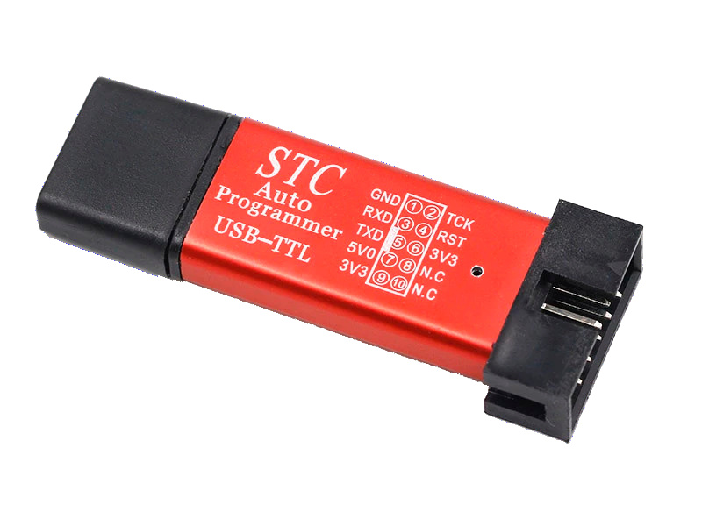
However, this adapter was designed for use with STC-ISP and the way STCGAL power cycles the MCU is a little different, which will require a little modification.

Hardware modification for use with STCGAL
Apparently, STC-ISP wiggles RTS to power cycle the MCU, whereas STCGAL just asserts DTR low for 0.5 second, so the required modification is pretty straightforward, as shown on the schematic below:
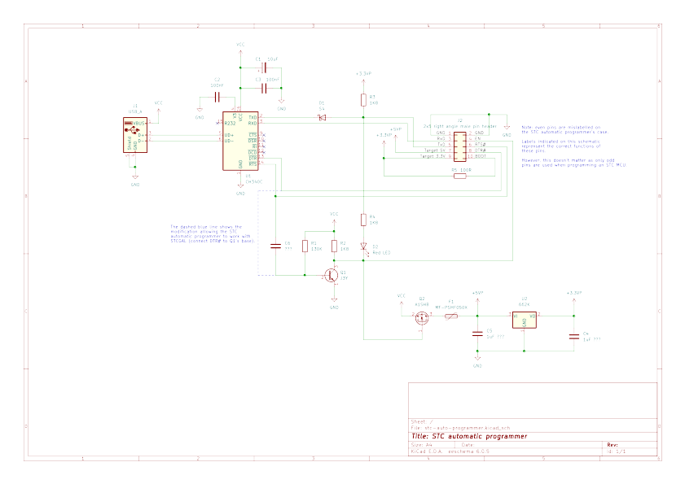
Here are also the board layout and connector pinout for reference:
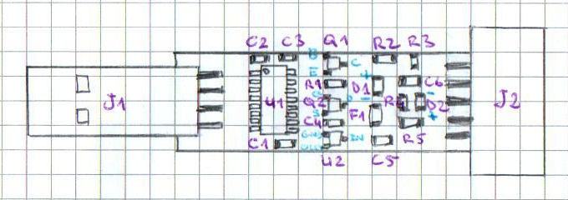 |  | 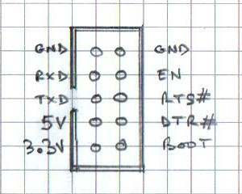
As you can see, the modification is as easy as a piece of wire and 2 drops of solder:
