Firmware flashing on WCH's CH57x and CH58x MCU series
Original URL: https://www.cnblogs.com/iot-fan/p/13498088.html

Tool description
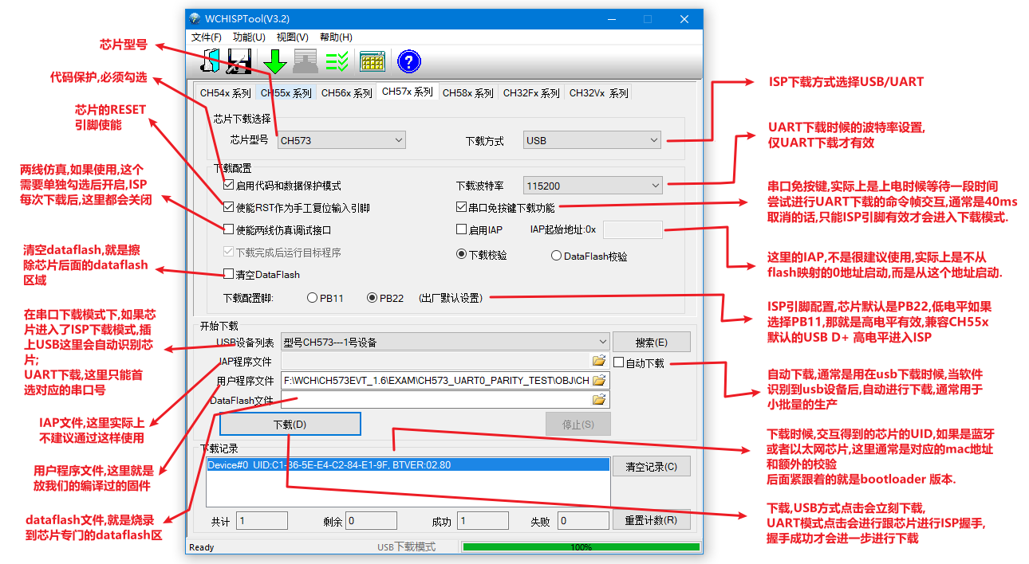

Download steps

USB download connection and steps
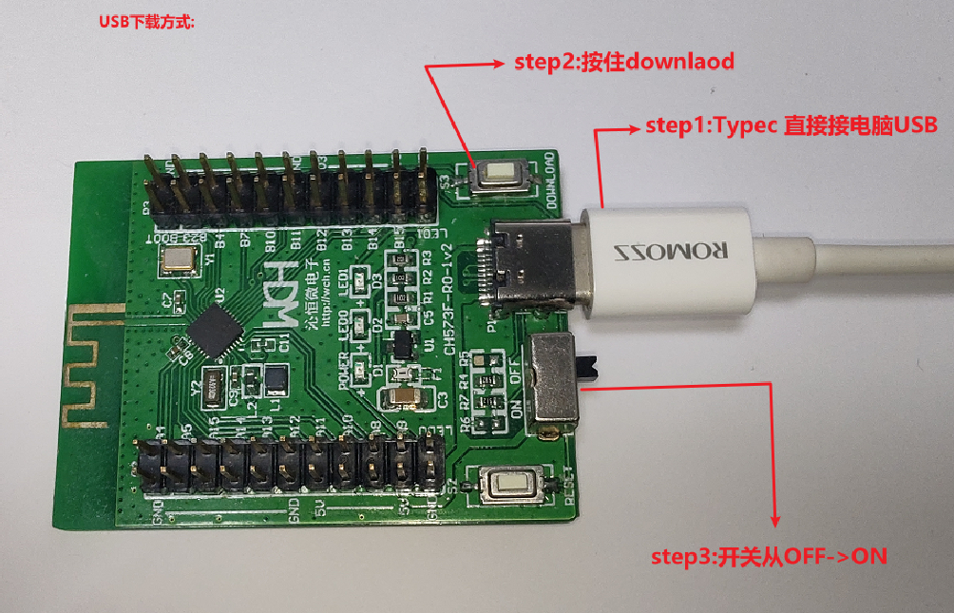

ISP download mode Download via USB
- The driver needs to be installed for USB recognition. The driver of CH372 is used. When installing WCHISPTool_Setup_exe, the driver will be installed automatically. After the isp recognition, a USB Module device will usually appear in the device manager.
- Using USB for ISP is the WCH recommended way, including mass production.

Does the host computer not recognize the USB download?
- Device Manager has no "USB Module" device: Reinstall the wchisptool tool, the corresponding driver will be installed during the installation process, or the driver of CH372 will be installed directly.
- Device Manager has "USB Module" device, but with exclamation mark: Under win7, there may be a yellow exclamation mark in the device manager. This is usually caused by the fact that win7 does not have a new version of Microsoft's digital signature patch. You can download the relevant patch to install: win7_64bit_update_KB3033929, or turn off the digital signature;
- Bad descriptor/unrecognized USB device: Check the hardware design, such as whether the USB has a short circuit, short circuit phenomenon, and whether it is designed according to the official schematic diagram.
- Device Manager is silent:
1. The ISP does not detect a valid flag to enter ISP mode when powered on.
2. The data cable may only be used for charging and cannot be used as a data cable. For some inferior "data cables", only the power supply cannot be used to transmit data;
3. The hardware must be able to meet the conditions for bootloader download. For example, in the case of CH577/578/579 bootloader>=2.8, the capacitance of the external reset pin cannot be greater than 10nF, and the CH573/CH583 series must be welded with a high-frequency 32M crystal. Can refer to ch579/ch573/ch57x hardware design

Serial download connection and steps
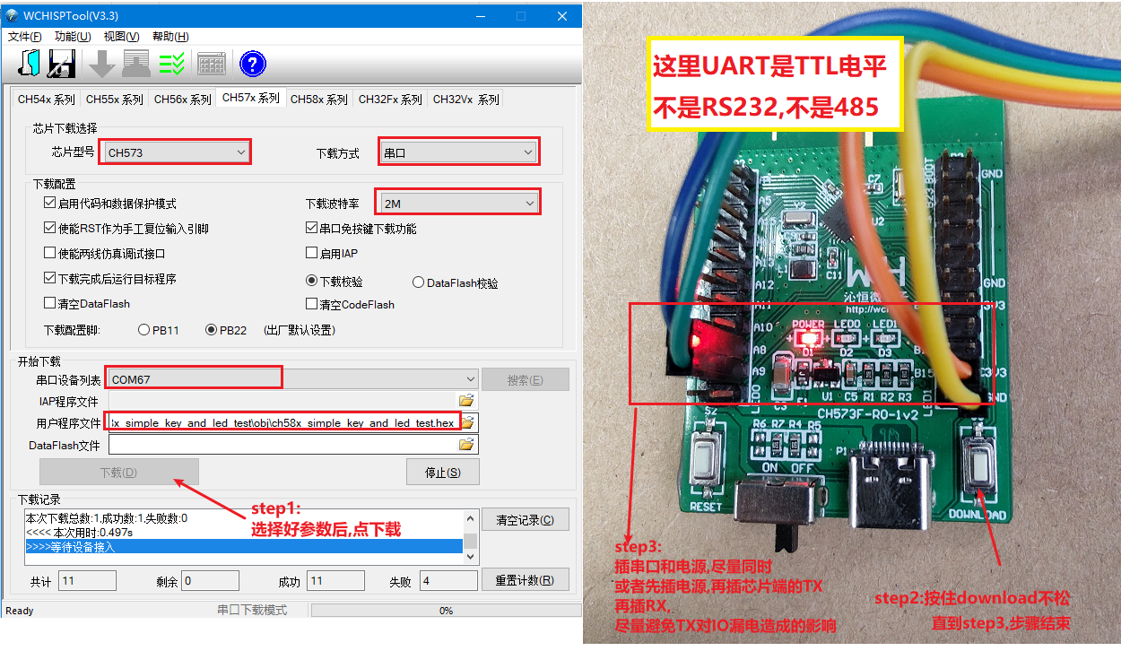

ISP download mode Download via UART
- The default baud rate is 115200
  - CH577/CH578/CH579 starting from bootloader 2.8 support 1M and 2M baud rate downloads
  - The new version of CH571/CH573 also supports 1M and 2M baud rate download
- If "Serial port free button download" is selected, when the chip is powered on, it will wait for an additional 40ms to wait for the serial port download handshake. If the handshake is successful, it will continue to wait for the download

UART download host computer does not recognize?
- Like usb download, it needs to be triggered when power on, such as CH573F, the default is power-on detection PB22, low level is active, other chips see above: power on and enter the ISP upgrade method
- When the TX of UART has no data, it is high level, which is usually push-pull output, which may supply power to external devices, and the chip enters isp mode and is detected when it is powered on. If the serial port TX is powered, it will cause The chip is not effectively powered off to generate a power-on reset, which will lead to inability to enter the ISP download mode. In this case, a 2K resistor can be temporarily connected to the TX and RX terminals in series, which greatly reduces this risk.
- UART must be at ttl level, remember not to use RS232, although this is a matter of common sense, write here as a word count, although you will not make such a low-level mistake.

High baud rate programming failed
- The chip of the low version bootloader does not support high baud rate, only 115200
- The actual selected serial port does not support high baud rate. For example, cp2102 sets a baud rate of 1Mbps, which is actually 921600bps.

The principle of ISP
- ISP programming means that the chip enters the ISP upgrade program preset inside the chip in some ways, turns on the upgrade function, then communicates with the outside world, and then completes the erasing, writing, and checksum of the program area through related protocols. The process of configuration and other series of operations.
- The chip of wch, after power-on reset, will enter the ISP by default, and check whether it enters the ISP.

Power on and enter the ISP upgrade method
Chip | USB Download IO | Serial download IO (Note 1) | Enter ISP mode by default IO | Time to enter ISP detection | Optional ISP IO (selected when programming) | Remark
CH577F/579F/573F/571F/582F | PB10_D- /PB11_D+ | PA8_RX/PA9_TX | PB22 low level | when powered on | PB11 high level
CH578F | not supported | PA8_RX/PA9_TX | PB22 low level | when powered on | PB11 high level
CH578M/579M/582M/583M | PB10_D- /PB11_D+ | PA8_RX/PA9_TX | PB22 low level | when powered on | PB11 high level | USB2 of CH58x also supports USB ISP
CH573X | PB10_D- /PB11_D+ | PA8_RX/PA9_TX | PB22 low level | when powered on | PB11 high level
CH571D | PB10_D- /PB11_D+ | PA8_RX/PA9_TX | PB22 low level | when powered on | PB11 high level
CH571K | not supported | PA15_RX/PA14_TX | not supported | not supported | not supported | Serial port free button download, wait 40ms by default when power on, wait for download handshake
Note 1: The chip also supports command detection through the serial port during ISP detection (the so-called "serial port key-free download"), but this process is very short, usually only tens of ms.
Note 2: For the WCH chip, when the 0 address of the flash is 0xffffffff (usually a blank chip), the power-on will stay in the ISP instead of jumping, so the new chip will enter the bootloader for the first time after power-on, even if No control over ISP io.

WCHISP Tool Considerations
- Processing problems of HEX files and bin files:
- The wchisptool tool can download bin files and hex files, but they are ultimately converted to bin files for download
- When it comes to hex to bin, there is a problem of data filling when the content described by hex is discontinuous. For ch57x/ch58x series chips, the processing method of wchisptool is: the hex to bin is filled with 0x00 when it is discontinuous. It may not be the same as most hex to bin implementations.
- It is still the problem of wchisptool's hex to bin download. If hex does not start from 0 address, the logic of wchisp is to fill in 0x00 from 0 address and convert it to bin before downloading.
- In view of the above two methods, it is recommended that customers use their own tools to convert to bin files starting from 0 address for downloading when doing ota or distributing firmware, so as to avoid possible verification problems caused by different filling methods.

