
The E-corporation
Antalink G2V4.4
Test Plan
Management Module



DOCUMENT IDENTIFICATION

Document reference: | TP_Management.doc
Version: | 6.0
Date of the version: | 01/07/2007
Status: | FINAL

Technical approval: | Kristof Vereecke  Luc De Kesel | Date:
Commercial approval: | Jos Vaes | Date:

Revision History

Date | Version | Description | By
17/7/2003 | 0.1 | Initial version | David Van den Brande
26/05/2003 | 1.1 | Final version | Kris Aelterman
10/11/2004 | 1.2 | Updated for v3 | Peter Averens
21/04/2005 | 2.0 | Updated for BE | Kristof Vereecke
06/02/2006 | 3.0 | Updated for V3.1 | Kristof Vereecke
21/08/2006 | 4.0 | Updated for V4.2 | Kristof Vereecke
01/07/2007 | 6.0 | Updated for V4.4 | Kristof Vereecke

Table of Contents

1 Introduction 6
1.1 Scope 6
1.2 Purpose 6
1.3 Approach 6
1.3.1 Test Objective 6
1.3.2 Technique 6
1.3.3 Completion Criteria 6
1.4 References 6
2 Test setup 8
2.1 Precondition Deliverables 8
2.2 Test Preparation Tasks 8
2.3 Test Environment 8
2.3.1 Hardware setup 8
2.3.2 Software Setup 8
3 Test Cases 10
3.1 Test Case 4010: Manage Product Cards 10
3.1.1 Brief Description 10
3.1.2 Use Case Parameters 10
3.1.3 Main Test Flow 10
3.2 Test Case 4020: Manage Product Keywords 15
3.2.1 Brief Description 15
3.2.2 Use Case Parameters 15
3.2.3 Main Test Flow 15
3.3 Test Case 4030: Manage Marketing Campaign (Highlights, Brands & Bargains) 17
3.3.1 Brief Description 17
3.3.2 Use Case Parameters 17
3.3.3 Main Test Flow 17
3.4 Test Case 4040: Manage “Tip of the day” 26
3.4.1 Brief Description 26
3.4.2 Use Case Parameters 26
3.4.3 Main Test Flow 26
3.5 Test Case 4050: Manage Users’ Spend Limit 29
3.5.1 Brief Description 29
3.5.2 Use Case Parameters 29
3.5.3 Main Test Flow 29
3.6 Test Case 4060: Manage Users’ Catalogue Filters 32
3.6.1 Brief Description 32
3.6.2 Use Case Parameters 32
3.6.3 Main Test Flow 32
3.7 Test Case 4070: Manage My Profile 35
3.7.1 Brief Description 35
3.7.2 Use Case Parameters 35
3.7.3 Main Test Flow 35
3.8 Test Case 4080: Manage forwarded orders 38
3.8.1 Brief Description 38
3.8.2 Use Case Parameters 38
3.8.3 Main Test Flow 38
3.9 Test Case 4090: Manage Members sample requests 40
3.9.1 Brief Description 40
3.9.2 Use Case Parameters 40
3.9.3 Main Test Flow 40
3.10 Test Case 4100: Manage Holidays 42
3.10.1 Brief Description 42
3.10.2 Use Case Parameters 42
3.10.3 Main Test Flow 42
3.11 Test Case 4110: Manage Sample frequency 44
3.11.1 Brief Description 44
3.11.2 Use Case Parameters 44
3.11.3 Main Test Flow 44
3.12 Test Case 4120: Manage Matrix window 47
3.12.1 Brief Description 47
3.12.2 Use Case Parameters 47
3.12.3 Main Test Flow 47
3.13 Test Case 4130: Manage email Marketing Campaign 49
3.13.1 Brief Description 49
3.13.2 Use Case Parameters 49
3.13.3 Main Test Flow 49

Introduction

Scope
This document covers all test cases and test environment setup for the System.

Purpose
The acceptance Test Plan Document defines and describes the test cases and the procedures to be followed. These test cases will ensure that all functional requirements are fully met.

Approach

Test Objective
Ensure proper target-of-test functionality, including navigation, data entry, processing, and retrieval.

Technique
Execute each test case (composed of use case, use-case flow, or function) using valid and invalid data, to verify the following:
• The expected results occur when valid data is used.
• The appropriate error or warning messages are displayed when invalid data is used.
• Each business rule is properly applied.

Completion Criteria
• All planned tests have been executed.
• All identified defects have been addressed.

References
Title | Version | Date | Author
SRS V4.2 | 1.1 | 11/07/2006 | Kristof Vereecke
SRS V4.1 | 1.1 | 11/05/2006 | Kristof Vereecke
SRS V3 | 1.0 | 04/08/2004 | Luc De Kesel
SRS V2 | 1.0 | 14/07/2004 | Vereecke Kristof
SRS V1 | 2.3 | 26/05/2004 | David Van den Brande

Test setup

Precondition Deliverables
To be defined.

Test Preparation Tasks
Product card id’s have to be created in the back-end.

Test Environment

Hardware setup
To be defined.

Software Setup
To be defined.

Test Cases

Test Case 4010: Manage Product Cards

Brief Description
Use templates to create, modify and delete product fiches for products available in the back-end database.

Use Case Parameters
Actors: Product Manager
Precondition: Logged in as an Antalis Product Manager

Main Test Flow

Step | Action performed by tester |  Expected System Response | Passed / Failed (+description)
1 | Click on the “Manage Product Cards” link on the Antalis homepage | Display all existing product card codes (dropdown) and language selection.  The language selection box contains all needed languages for this country.
1b | Select a product card (code and language) and Click on the “Manage” button. | Display the product card management tool for the selected item code and in the selected language with all form fields pre-filled with previously saved data if any.
2 | Enter an item code, select a language and Click on the “Manage” button. | An error is shown if this item code does not exist.  If it does exist: display the product card management tool for the selected item code and in the selected language with all form fields pre-filled with previously saved data if any.  In the overview section, a shortcut menu to all sections is shown.  Read only sections as “Technical details” (static HTML) and “Range” (dynamically rendered) are shown as they appear in the final product card.
3 | Repeat step 2 until a correct item code is given.  Write down the product card code and go back to the previous screen
4 | Select the product card code to which previous item code belongs to, select a language and Click on the “Manage” button | Display the product card management tool for the selected item code and in the selected language with all form fields pre-filled with previously saved data if any.  On top of this page, a shortcut menu to all sections is showed.  Read only sections as “Technical details” (static HTML) and “Range” (dynamically rendered) are shown as they appear in the final product card.
5 | Check in back-end if the item code drop down contains the correct item codes for this product card

6 | For any section (except links):  - Add some text  - Add a picture:  - Enter picture display name (alt tag)  - Enter ”browse” file upload path  - Specify that this section may not be published
7 | Save All Data | Page refreshes and shows the newly entered content again.
8 | Use Antalink Catalogue (item code) search to get an item code in the result list that belongs to the altered product card. | The item description is a hyperlink.
9 | Click on the item description hyperlink | The correct product card pops up with the same data as filled in step 6.
10 | Display another product card via the product card management tool.
11 | For any section (except links):  - Add some text  - Add a picture:  - Enter picture display name (alt tag)  - Enter ”browse” file upload path  Specify whether or not this section may be published
12 | Cancel | You go back to the previoius page.
13 | Check via the catalogue search whether the product card hasen’t changed.

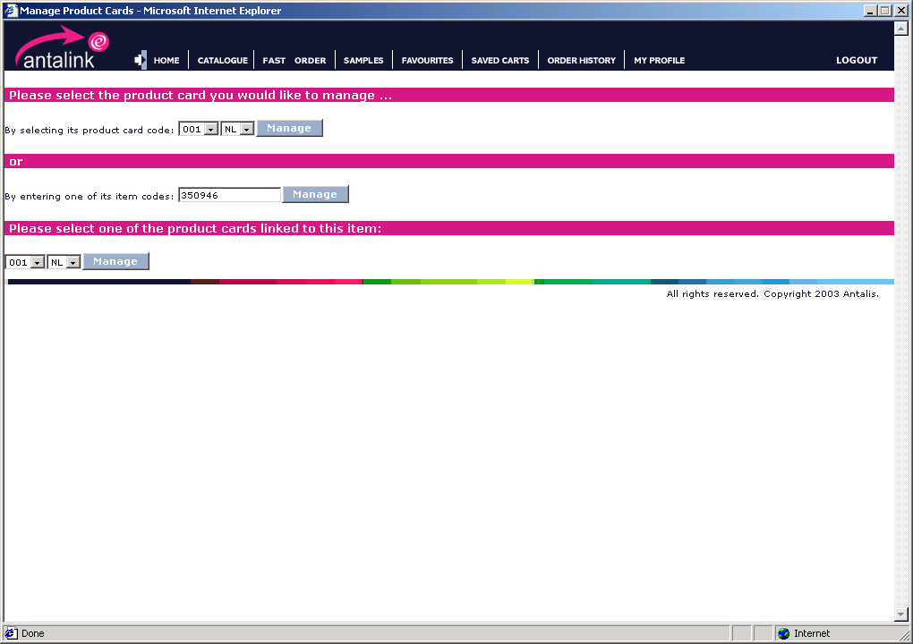

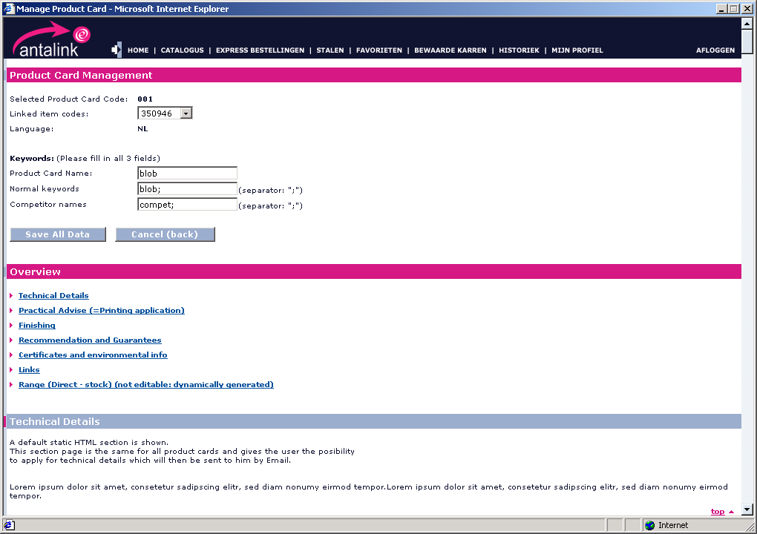

Test Case 4020: Manage Product Keywords

Brief Description
Add, modify or delete product keywords. These keywords are used in the free text field search.

Use Case Parameters
Actors: Product Manager
Precondition: UC 4010 until step 3

Main Test Flow
Step | Action performed by tester |  Expected System Response | Passed / Failed (+description)
0 | Pre-condition | The keyword section is shown on top of the product card. Both input fields (normal & competitor) are pre-filled with previously saved keywords. | TODO
1 | Add a normal keyword, save and check if a keyword search with this new keyword returns this item code.
2 | Add a competitor name and, save and check if a keyword search with this new keyword returns this item code with the warning that the shown product is an alternative.
3 | Delete a normal keyword and, save and check if a keyword search with this new keyword does not return this item code.
4 | Delete a competitor name and, save and check if a keyword search with this new keyword does not return this item code.

Test Case 4030: Manage Marketing Campaign (Highlights, Brands & Bargains)

Brief Description
Create, modify and delete country specific Marketing campaigns (promotions), bargains and Brands (email marketing campaigns) that will be shown on the Antalink homepage.

Use Case Parameters
Actors: Marketing Manager
Precondition: Marketing Manager logged in for a specific country

Main Test Flow

Step | Action performed by tester |  Expected System Response | Passed / Failed (+description)
1 | Click on “Manage Marketing Campaign & Bargains” | Show “Current Highlights & Bargains” page
2 | Click on “Add a new Highlight or Promotion” | Show create form/page
3 | Fill in all fields and save. | Show “Current Highlights & Bargains” page containing the newly added one on.
4 | Check the Antalink home page if the newly added item is shown.
5 | Again in the “Current Highlights & Bargains” page: change visibility of the new item to “Hide”
6 | Check the Antalink home page if the newly added item is not shown.
7 | Delete the item | Page is refreshed without deleted item.
8 | Check the Antalink home page if the newly added item is not shown.
9 | Create at least 4 items and arrange their order.
10 | Check on the homepage if the items appear in the correct order.
11 | Repeat steps 3 until 10 but for member homepages | Members homepage includes only the first 2 items
12 | Repeat steps 3 until 10 but for user homepages
13 | Click on View Details for an existing item that will be shown on the homepage | The details of the selected item are shown. All information is editable except for linked applications (Bargains)
14 | Change some fields and click on “update” | Show “Current Highlights & Bargains” page
15 | Check the Antalink home page whether the changes are implemented.
16 | Make 2 marketing campaigns the default ones (can only be a highlight) and make sure the user can see at least 1 MC which is not one of the default ones | The default MC’s should not be visible
17 | Make 2 marketing campaigns the default ones (can only be a highlight) and make sure the user can see 0 MC | The default MC’s should be visible

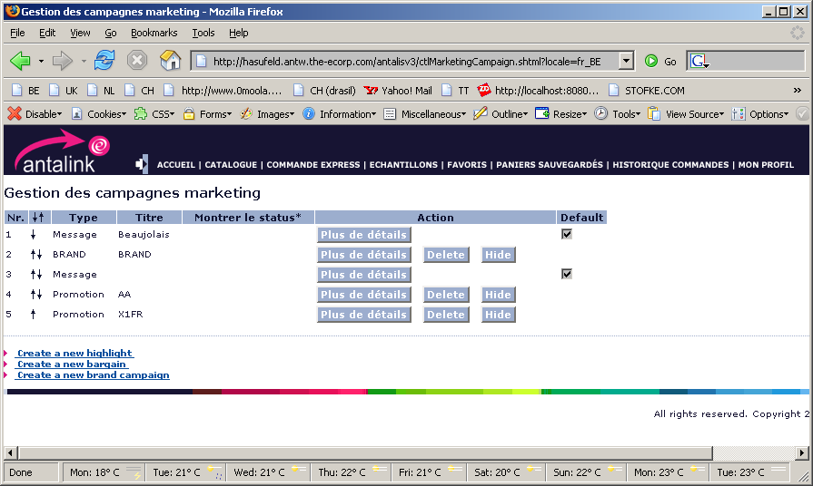

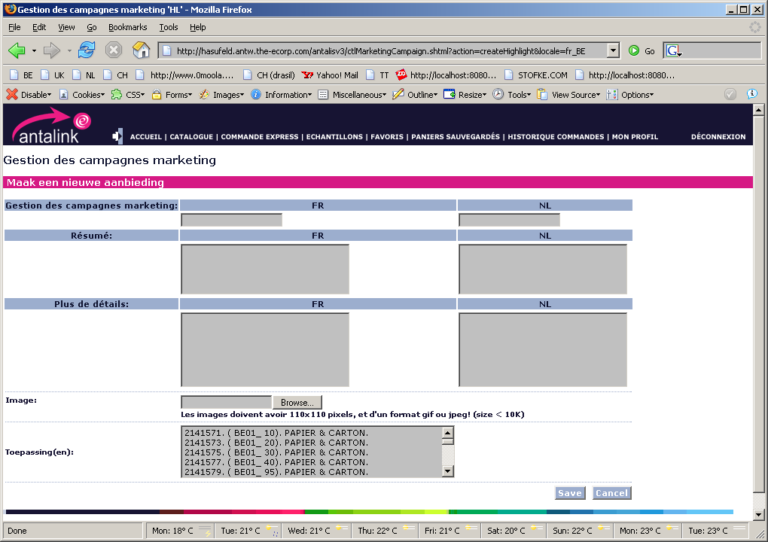
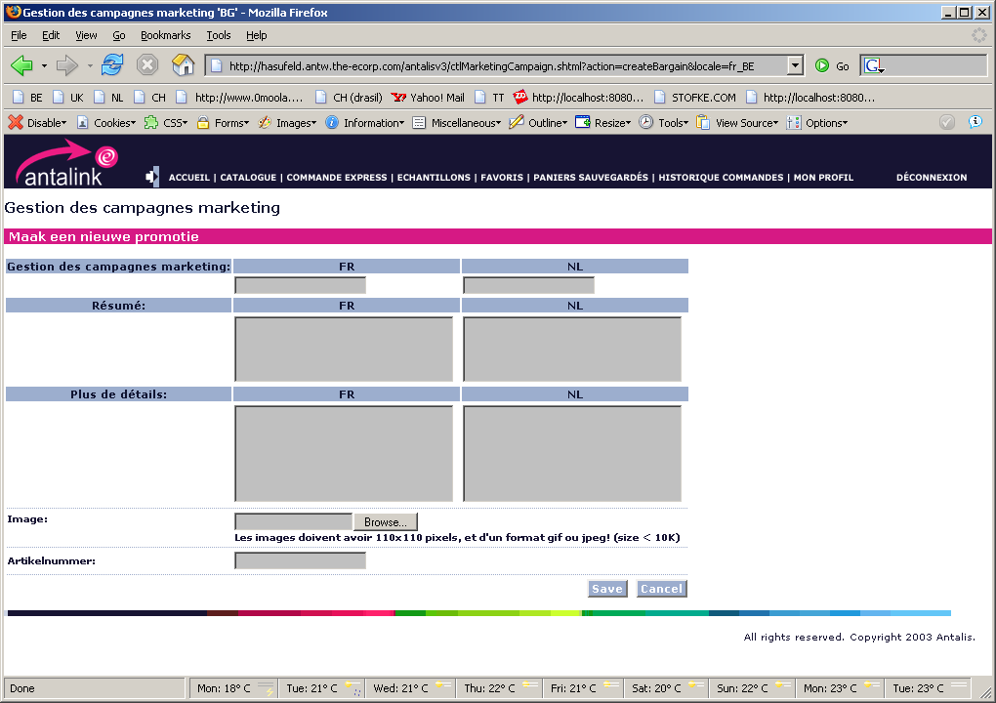
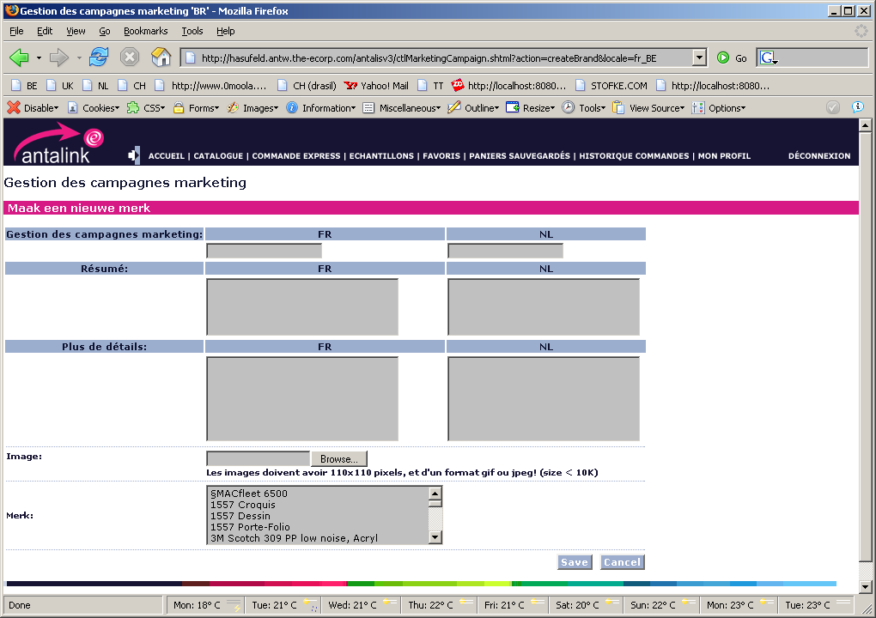

Test Case 4040: Manage “Tip of the day”

Brief Description
Create, modify or delete tips

Use Case Parameters
Actors: Administrator
Precondition: Administrator logged in for a specific country

Main Test Flow

Step | Action performed by tester |  Expected System Response | Passed / Failed (+description)
1 | Click on “Manage Tips” on the home page | A form to select a “tip of the day” language containing one drop down list with all possible languages
2 | Select a language | Display “Tip of the day management console” with all current available tips in the selected language
3 | Add New Tip (for members and users): tip title, description. Add also a [shortcut, link] section as described on the page.  Click on “create” | The new tip is added in the “current tips” overview
4 | Go to the home page and click on “show all tips” | All current tips including the new one are shown.
5 | Repeat step 3 and 4 for members only items
6 | Repeat step 3 and 4 for user only items
7 | Repeat step 1 and 2, change some text (title, description) and click the “modify” button of that tip. | All current tips including the changed one are shown.
8 | Go to the home page and click on “show all tips” | All current tips including the changed one are shown.
9 | Repeat step 1 and 2, change the target group(s) of a tip and click the “modify” button of that tip. | All current tips including the changed one are shown.
10 | Check if the tip is only shown to the selected target group(s)
11 | Repeat step 1 and 2, and delete a Tip: Click on the delete link next to the tip description | JavaScript confirm box
12 | Confirm | All current tips without the deleted one are shown.
13 | Check on the homepage if this tip is not shown anymore

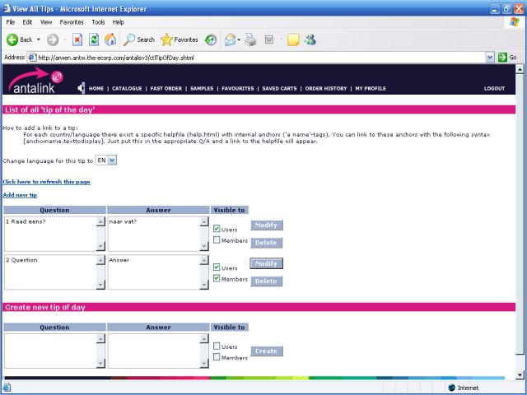

Test Case 4050: Manage Users’ Spend Limit

Brief Description
Create, modify or delete users spend limit

Use Case Parameters
Actors: Authorizer
Precondition: Authorizer logged in.

Main Test Flow

Step | Action performed by tester |  Expected System Response | Passed / Failed (+description)
1 | Click on “Manage users Spend Limit”  (Home page) | Show Manage users Spend Limit page
2 | Change periodical spend limit check: enter new amount and submit | See step 1 (new period shown)
3 | Select user | Display page as specified in the user interface prototype below
4 | Modify spend limit per order amount  (if necessary enable by clicking the checkbox) | Display page as specified in the user interface prototype below with the modified value
5 | Modify spend limit per period amount  (if necessary enable by clicking the checkbox) | Display page as specified in the user interface prototype below with the modified value
6 | Enable/disable spend limit per order  (un/check checkbox) | Display page as specified in the user interface prototype below with(out) value
7 | Enable/disable spend limit per period amount  (un/check checkbox) | Display page as specified in the user interface prototype below with(out) value

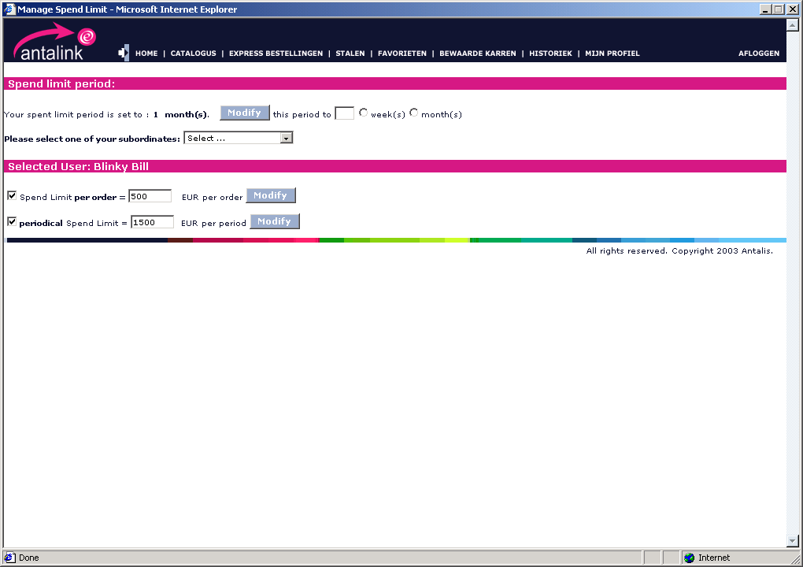

Test Case 4060: Manage Users’ Catalogue Filters

Brief Description
Create, modify or delete Catalogue filters

Use Case Parameters
Actors: User manager
Precondition: User manager logged in.

Main Test Flow
!After changing a filter for a user or cost center, the tester needs to use the catalogue search tool of Antalink to determine whether the updated filter is applied or not!
Step | Action performed by tester |  Expected System Response | Passed / Failed (+description)
1 | Show Management console for the management of the Catalogue filters  Check if all data on this page is correct. | Show the initial management screen:  - Show all product filters of this company  - Show all users of this company in the dropdown  - Show all cost centers of this company in the drop down
5 | Create new filter: enter name, select parent application and click on “proceed” | Show product filter form step 1.  (Error message if a product filter with the same name already exists.)
6 | Select product filter attribute | Show product filter form step 2.
7 | Enter value and click on “create” | See step 1 (product filter added)
8 | Go to Step 1
9 | Manage filters of users: select user and submit | The product filters for this user are shown.
10 | Add a filter for this user: select filter and click on “Add” | The product filters for this user are shown including the added one.
11 | Remove a filter for this user | The product filters for this user are shown without the removed one.
12 | Go to Step 1
13 | Manage filters of cost centers: select cost centre and submit | The product filters for this cost center are shown. | TODO
14 | Remove a filter from this CC | The product filters for this cost center are shown without the removed one.
15 | Add a filter for this CC: select filter and click on “Add” | The product filters for this cost center are shown including the added one.

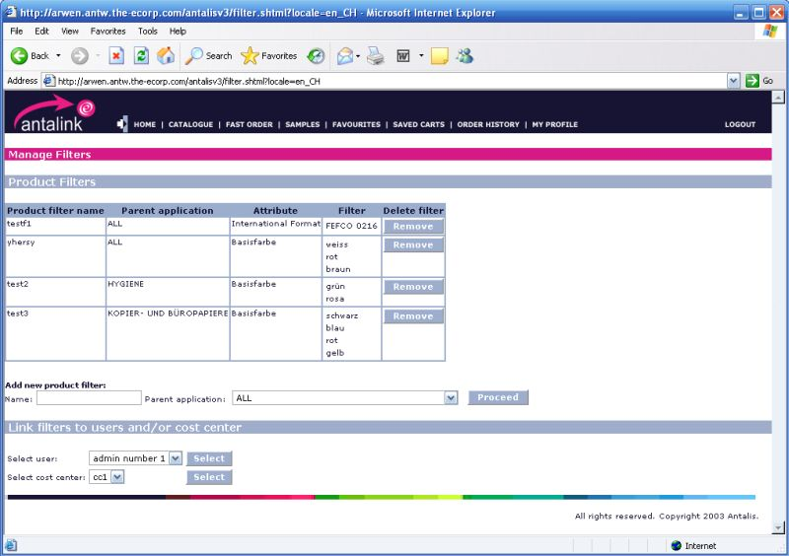

Test Case 4070: Manage My Profile

Brief Description
Change password or email, ask for new delivery address, choose default delivery address, …

Use Case Parameters
Actors: User
Precondition: User is logged in

Main Test Flow
Change/update any entry and check if the application acts correctly.
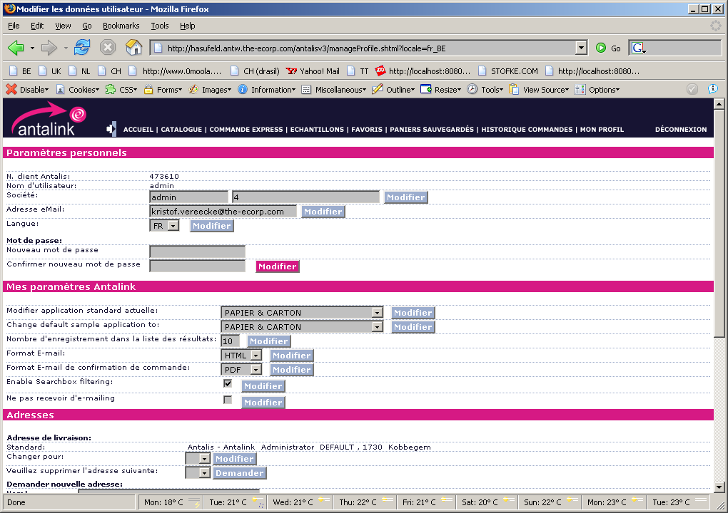
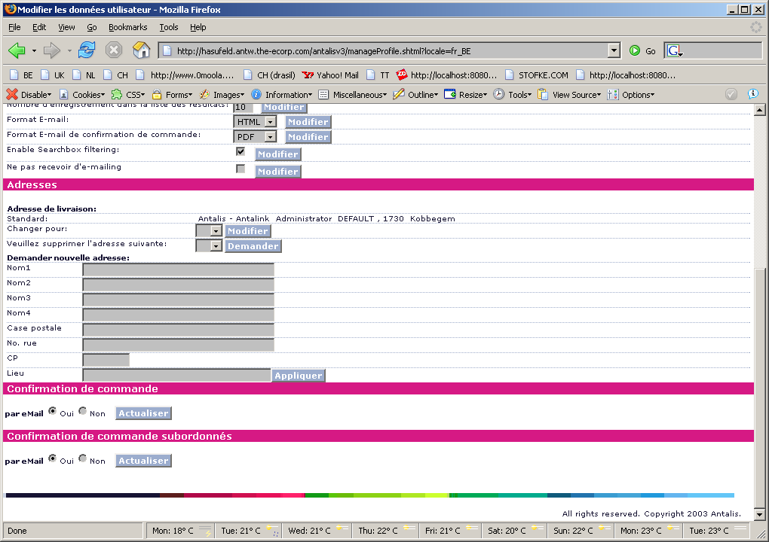

Test Case 4080: Manage forwarded orders

Brief Description
Approve or reject orders of users of a certain customer who exceeded their spend limit

Use Case Parameters
Actors: Authorizer
Precondition: Authorizer logged in., Some users of this customer have forwarded orders.

Main Test Flow

Step | Action performed by tester |  Expected System Response | Passed / Failed (+description)
1 | Show Management console for the management of the forwarded orders | Show the initial management screen:  - Show all orders awaiting authorization
2 | Select the Reject button | - A popup appears where the authorizer can enter a reason.  - Check that the order of the user is saved as a shopping basket of that user
3 | Select the approve button | - A confirmation screen appears
3.2 | Select the approve button of the selected order | - Check that the order was actually placed

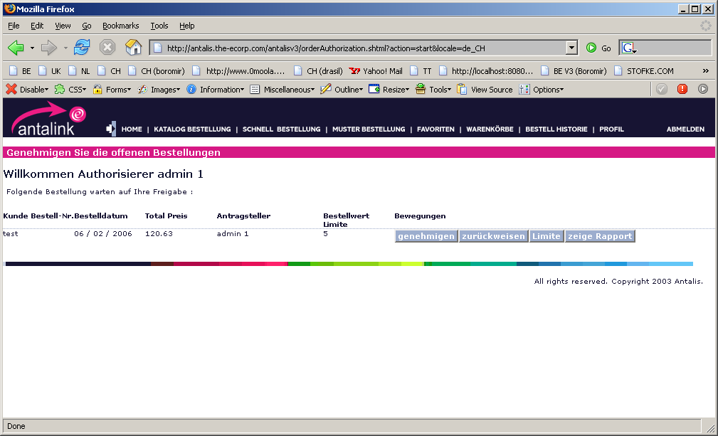

Test Case 4090: Manage Members sample requests

Brief Description
Approve or reject the ability for members to order samples

Use Case Parameters
Actors: Administrator
Precondition: Administrator logged in., Some members have requested the ordering of samples

Main Test Flow

Step | Action performed by tester |  Expected System Response | Passed / Failed (+description)
1 | Show Management console for the management of member samples orders | Show the initial management screen:  - Show all members with their state of sample orders:  - Pending  - Rejected  - Accepted
2 | Change a state of one of the members and press submit | The revised list is shown  Check that the affected customer sees the changes

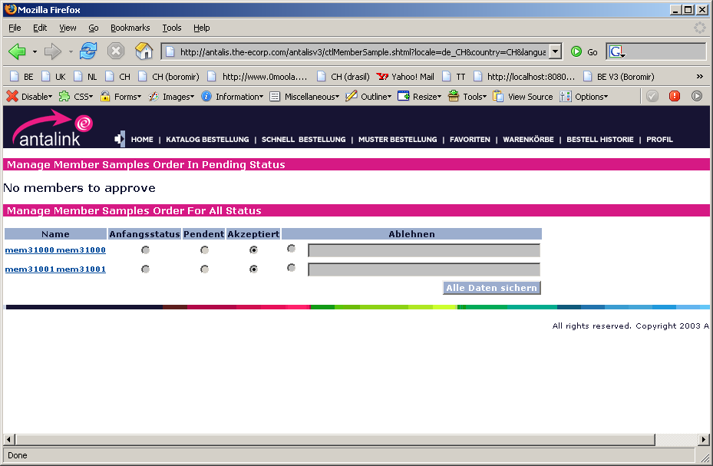

Test Case 4100: Manage Holidays

Brief Description
Manage the holidays of the country. These dates will not be proposed as default delivery date

Use Case Parameters
Actors: Administrator
Precondition: Administrator logged in.

Main Test Flow

Step | Action performed by tester |  Expected System Response | Passed / Failed (+description)
1 | Show Management console for the management of holidays | - A calendar is shown  - The list of all holidays is shown
2 | Select a date, enter a subscription and press enter | - The date is added to the holiday list  - Make sure this date is not proposed as a default delivery date

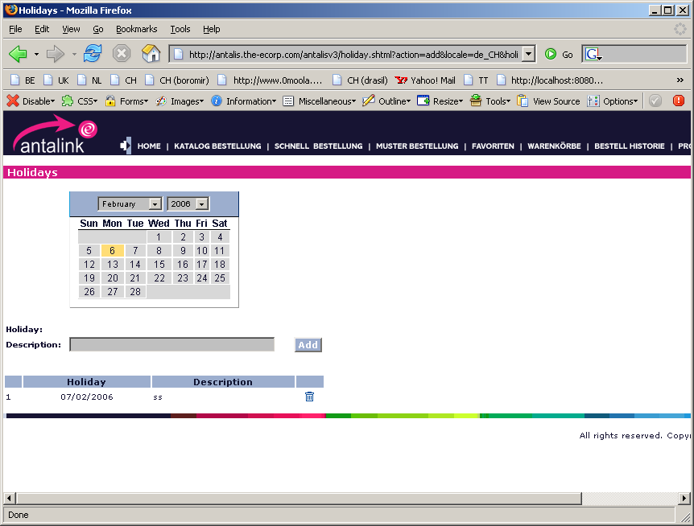

Test Case 4110: Manage Sample frequency

Brief Description
Manage the settings that can be used for sample ordering by users and/or members

Use Case Parameters
Actors: Administrator
Precondition: Administrator logged in.

Main Test Flow

Step | Action performed by tester |  Expected System Response | Passed / Failed (+description)
1 | Show Management console for the management of sample frequencies | The following is shown  - The default settings for all users (if any)  - A box to search for customers  - The default settings for members
2 | Enter some data for ‘All users’ and press the submit button | The system refreshes the screen  Make sure that the users can not order beyond those limits
3.1 | Search for a certain customer | The system shows the details for this customer
3.2 | Add some data for the selected customer | The system refreshes the screen  Make sure that the users of this customer can not order beyond those limits of this customer.
4 | Enter some data for Members and press the submit button | The system refreshes the screen  Make sure that the members can not order beyond those limits

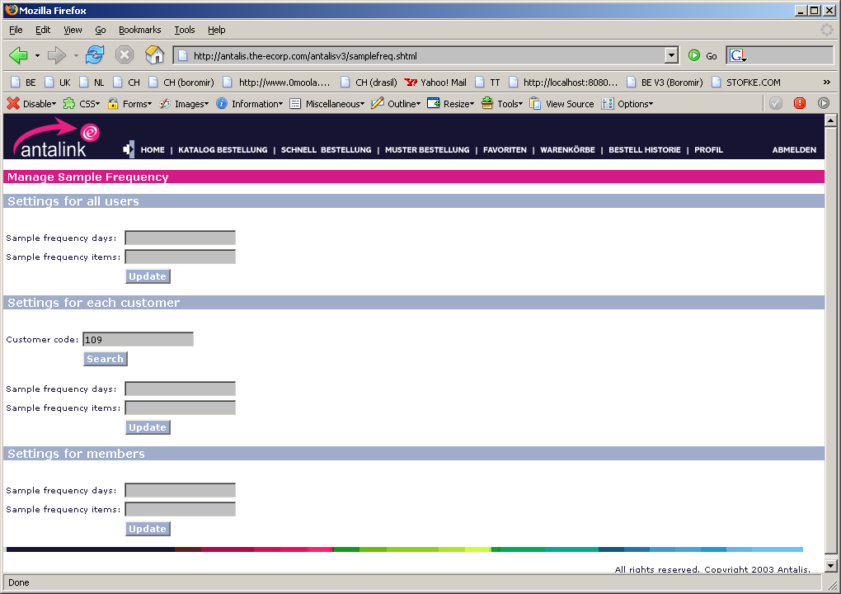

Test Case 4120: Manage Matrix window

Brief Description
Manage the order and size of the search boxes in the catalogue screen

Use Case Parameters
Actors: Administrator
Precondition: Administrator logged in.

Main Test Flow

Step | Action performed by tester |  Expected System Response | Passed / Failed (+description)
1 | Show Management console for the management of the matrix | A management screen appears with all applications for all sales area’s
2 | Select an application and press the manage button | a screen is shown with:  - All search boxes of this application  - The position of the boxes (99999999=default)  - The size of the boxes in pixels
3 | Change the order of the boxes and the size and press modify | The screen is refreshed
4 | Log in as a user of the chosen sales area and the chosen application | Check that the catalog screen reflects the changes for the selected application

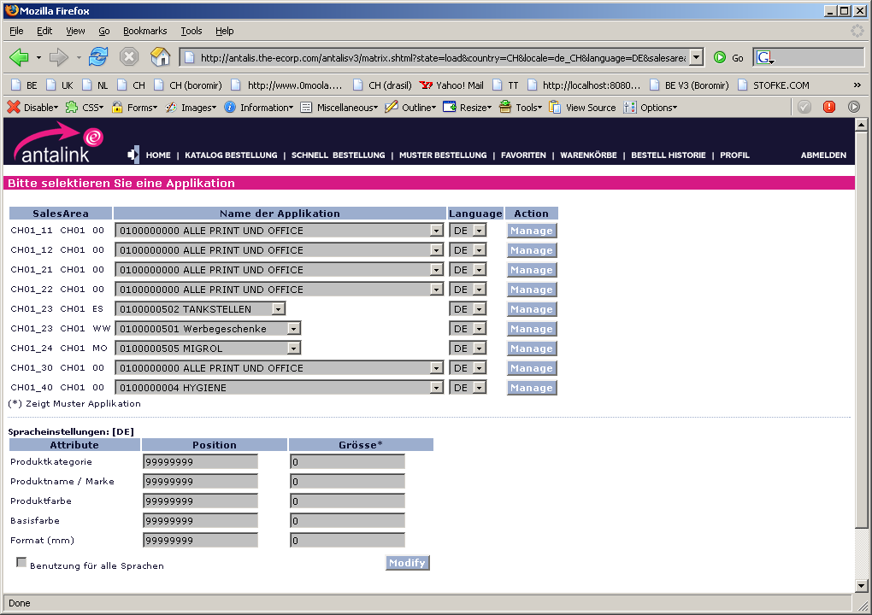

Test Case 4130: Manage email Marketing Campaign

Brief Description
Management of the email marketing campaigns

Use Case Parameters
Actors: Administrator
Precondition: Administrator logged in.

Main Test Flow

Step | Action performed by tester |  Expected System Response | Passed / Failed (+description)
1 | Select the email marketing campaign link | A management screen appears with all current email marketing campaigns (EMC)
2 | Create a new EMC | The screen is updated with the new EMC
3 | Remove an EMC | The screen is updated and the EMC is deleted
4 | Select download CSV file | A popup is shown asking the user where to store the CSV file containing all users able to see this EMC

