
The E-corporation
Antalink G2V4.4
Test Plan
Search Module



DOCUMENT IDENTIFICATION

Document reference: | TP_Search.doc
Version: | 6.0
Date of the version: | 01/07/2007
Status: | FINAL

Technical approval: | Kristof Vereecke  Luc De Kesel | Date:
Commercial approval: | Paul Poelmans | Date:

Revision History

Date | Version | Description | By
17/7/2003 | 0.1 | Initial version | David Van den Brande
26/05/2003 | 1.1 | Final version | Kris Aelterman
10/11/2004 | 1.2 | Updated for v3 | Peter Averens
21/04/2005 | 2.0 | Updated for BE | Kristof Vereecke
06/02/2006 | 3.0 | Updated for V3.1 | Kristof Vereecke
21/08/2006 | 4.0 | Updated for V4.2 | Kristof Vereecke
11/01/2007 | 5.0 | Updated for V4.3 (NSP) | Kristof Vereecke
01/07/2007 | 6.0 | Updated for V4.4 | Kristof Vereecke

Table of Contents

1 Introduction 6
1.1 Scope 6
1.2 Purpose 6
1.3 Approach 6
1.3.1 Test Objective 6
1.3.2 Technique 6
1.3.3 Completion Criteria 6
1.4 References 6
2 Test setup 8
2.1 Precondition Deliverables 8
2.2 Test Preparation Tasks 8
2.3 Test Environment 8
2.3.1 Hardware setup 8
2.3.2 Software Setup 8
3 Test Cases 10
3.1 Test Case 2010: Search Catalogue 10
3.1.1 Brief Description 10
3.1.2 Use Case Parameters 10
3.1.3 Main Test Flow 10
3.2 Test Case 2020: Matrix Search 13
3.2.1 Brief Description 13
3.2.2 Use Case Parameters 13
3.2.3 Main Test Flow 13
3.3 Test Case 2030: Item code search 14
3.3.1 Brief Description 14
3.3.2 Use Case Parameters 14
3.3.3 Main Test Flow 14
3.4 Test Case 2040: Free Text Field search 15
3.4.1 Brief Description 15
3.4.2 Use Case Parameters 15
3.4.3 Main Test Flow 15
3.5 Test Case 2050: Consult Bookmarked Products 16
3.5.1 Brief Description 16
3.5.2 Use Case Parameters 16
3.5.3 Main Test Flow 16
3.6 Test Case 2060: Show Product Fiche and Product Card 17
3.6.1 Brief Description 17
3.6.2 Use Case Parameters 17
3.6.3 Main Test Flow 17
3.7 Test Case 2070: Bookmark product 19
3.7.1 Brief Description 19
3.7.2 Use Case Parameters 19
3.7.3 Main Test Flow 19
3.8 Test Case 2080: Delete Book mark 20
3.8.1 Brief Description 20
3.8.2 Use Case Parameters 20
3.8.3 Test Flow A 20
3.8.4 Test Flow B 20
3.9 Test Case 2090: Launch Cutting Tool 22
3.9.1 Brief Description 22
3.9.2 Use Case Parameters 22
3.9.3 Main Test Flow 22

Introduction

Scope
This document covers all test cases and test environment setup for the System.

Purpose
The acceptance Test Plan Document defines and describes the test cases and the procedures to be followed. These test cases will ensure that all functional requirements are fully met.

Approach

Test Objective
Ensure proper target-of-test functionality, including navigation, data entry, processing, and retrieval.

Technique
Execute each test case (composed of use case, use-case flow, or function) using valid and invalid data, to verify the following:
• The expected results occur when valid data is used.
• The appropriate error or warning messages are displayed when invalid data is used.
• Each business rule is properly applied.

Completion Criteria
• All planned tests have been executed.
• All identified defects have been addressed.

References
Title | Version | Date | Author
SRS V4.2 | 1.1 | 11/07/2006 | Kristof Vereecke
SRS V4.1 | 1.1 | 11/05/2006 | Kristof Vereecke
SRS V3 | 1.0 | 04/08/2004 | Luc De Kesel
SRS V2 | 1.0 | 14/07/2004 | Vereecke Kristof
SRS V1 | 2.3 | 26/05/2004 | David Van den Brande

Test setup

Precondition Deliverables
To be defined.

Test Preparation Tasks
Product card id’s have to be created in the back-end.

Test Environment

Hardware setup
To be defined.

Software Setup
To be defined.

Test Cases

Test Case 2010: Search Catalogue
This test has to be performed with a user account and with a member account.

Brief Description
Search the catalogue for products

Use Case Parameters
Actors: Member, User
Precondition: Search link clicked on homepage
Post condition: searched items displayed in result list

Main Test Flow

Step | Action performed by tester |  Expected System Response | Passed / Failed (+description)
1 | Click “Catalogue” on homepage or “Catalogue” tab in the top navigation  Check that all applications granted to this user are available in the application drop down | Search screen is displayed:  - Application list drop down with the default application on top and selected.  - Filled list boxes for every search criterion  - Checkboxes with values “Bargains Only” and “Own Brand”  - Reset button  - Drop down box with values “Item Code(s)” and “free text”, input field and find button.
2 | Search: See one of the children Test Cases: Matrix Search, Item code search or Free Text Field search  (Check with the SRS if all mandatory columns are showed) | See one of the children Test Cases: Matrix Search, Item code search or Free Text Field search.  - If no results found: message “no results found” is displayed.  - If more than x (configurable per country) results found: message “Found … items, please refine your search is displayed.  - Results are by default sorted on item code  - Calculate Price button is shown (not for members!)  - In case of an NSP material the packet and pallet qty columns show the following info:  - (pallet qty – NSP margin down) – (pallet qty + NSP margin up)  - (weight – NSP margin down) – (weight + NSP margin up)  - Only the Pallet unit is selectable

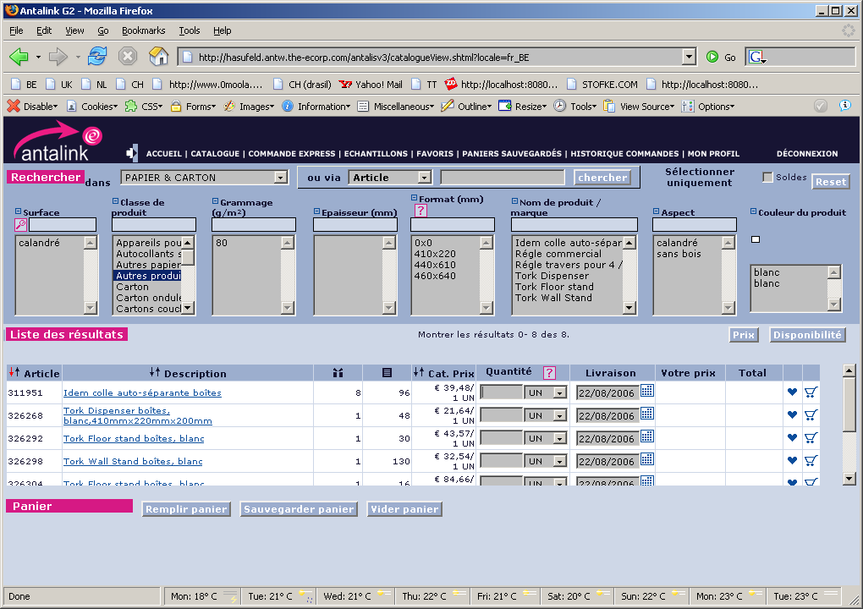

Test Case 2020: Matrix Search
This test has to be performed with a user account and with a member account.

Brief Description
Search on different criteria with multiple criteria selection possibilities.

Use Case Parameters
Actors: Member, User
Precondition: Step 1 and 2 of UC 2010: Search Catalogue

Main Test Flow

Step | Action performed by tester |  Expected System Response | Passed / Failed (+description)
1 | Set Filter on bargains or dedicated stock. | Result list is adapted
2 | Change application (if more than one is available) | The search boxes for the selected application replace the current search boxes.
3 | Select one or more entries in a choosing box. | All entries that don’t map with the selected entries disappear from the search boxes (the choose box in which the user made his selection remains unchanged)
4 | Reset | All search boxes are re-filled with all search criteria values of all items of the selected application.

Test Case 2030: Item code search
This test has to be performed with a user account and with a member account as well as with a wrong item code

Brief Description
“starts with”-search on Item Code(s)

Use Case Parameters
Actors: Member, User
Precondition: Step 1 and 2 of UC 2010: Search Catalogue

Main Test Flow

Step | Action performed by tester |  Expected System Response | Passed / Failed (+description)
1 | Search: Enter one or more (‘;’ separated) item codes and click on “Find” | The correct items are shown in the result list

Test Case 2040: Free Text Field search
This test has to be performed with a user account and with a member account as well as with irrelevant free text

Brief Description
Free Text field “contains” search on product description and keywords

Use Case Parameters
Actors: Member, User
Precondition: Step 1 and 2 of UC 2010: Search Catalogue

Main Test Flow

Step | Action performed by tester |  Expected System Response | Passed / Failed (+description)
1 | Enter some keywords and click on find | Show all items in the result list that map the “contains” search on all product descriptions and keywords.

Test Case 2050: Consult Bookmarked Products

Brief Description
Search in the book marked products to select a product

Use Case Parameters
Actors: User
Precondition: Home page or 3-part screen showed
Post condition: Bookmarked items displayed

Main Test Flow

Step | Action performed by tester |  Expected System Response | Passed / Failed (+description)
1 | Click on the “Book marked products” on homepage or “Favourites” tab in the top navigation | All Bookmarked items are shown in the same way as the result list is displayed.

Test Case 2060: Show Product Fiche and Product Card

Brief Description
The requested product fiche pops-up in a new window

Use Case Parameters
Actors: User, Member

Main Test Flow

Step | Action performed by tester |  Expected System Response | Passed / Failed (+description)
1 | Search an item which has a product card | Item displayed in result list. Item description is link to product fiche
2 | Click on the item description to open its product fiche | Product fiche is displayed in a new screen
3 | Click on the link at the bottom to show the product card | The Product Card is displayed
4 | Fill in the form and submit | Question is sent by mail to the Antalis product manager.

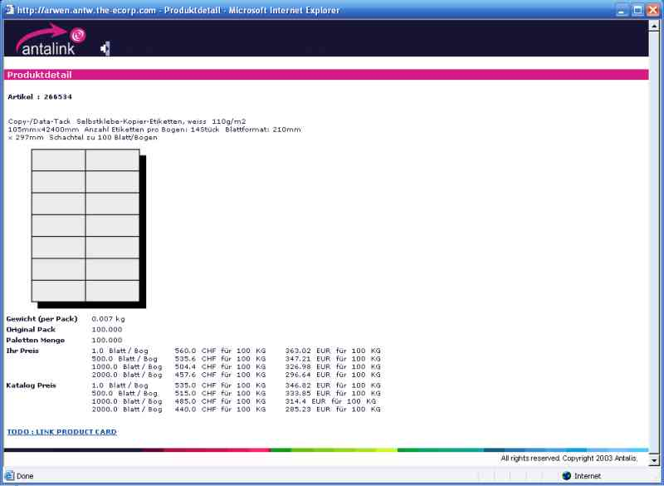

Test Case 2070: Bookmark product

Brief Description
Bookmark a product for later retrieval

Use Case Parameters
Actors: User
Precondition: Result list shown with minimum one item line
Post condition: Item bookmarked

Main Test Flow

Step | Action performed by tester |  Expected System Response | Passed / Failed (+description)
1 | Click on the favorite/bookmark icon to bookmark the item line | The same result list is shown with the indication that this item is Bookmarked

Test Case 2080: Delete Book mark

Brief Description
Delete a bookmarked product from the book marked product list

Use Case Parameters
Actors: User
Precondition: Result list shown with minimum one item line that is indicated as a Bookmarked or bookmarked item list showed
Post condition: Item no longer bookmarked

Test Flow A

Step | Action performed by tester |  Expected System Response | Passed / Failed (+description)
0 | Precondition | Result list shown with minimum one item line that is indicated as a Bookmarked.
1 | Click on the favorite/bookmark icon to delete the bookmark | The same result list is shown with the indication that this item is no longer Bookmarked

Test Flow B

Step | Action performed by tester |  Expected System Response | Passed / Failed (+description)
0 | Precondition | Homepage or 3-part screen shown
1 | Click on the My favorites link | Bookmarked items are displayed in the same way as the result list is displayed but without cutting tool icon.
2 | Click on the favorite/bookmark icon to delete the bookmark | The favorites list is shown without this item.

Test Case 2090: Launch Cutting Tool

Brief Description
In case a format the user is looking for is not available, an item can be cut into the desired format.

Use Case Parameters
Actors: User
Precondition: Search performed
Post condition: Item cut and added to cart

Main Test Flow
Step | Action performed by tester |  Expected System Response | Passed / Failed (+description)
0 | Perform search until “cutting button” is shown in result list | Display cutting button in result list if all the items can be cut.
1 | Launch cutting tool via the button on result list | Cutting tool applet with following input fields:  - Dimension: width and height of the coupon in cm  - Total number of coupons  - Wrapping quantity  - Grain direction  - Square Cut, Center Cut  - Remarks
2 | Specify how the item must be cut and click on calculate | Line up all cut items and their respective costs sorted by price.  Show Cutting (graphically) for the first listed item
3 | Chose an alternative | Show Cutting (graphically) for chosen alternative
4 | Print cutting plan | Print job started on your printer
5 | Add selected item (preferred or alternative) to cart | Show cart with selected item and cutting icon indicating this item is cut.
6 | Put the mouse on the cutting icon of the cut item | A text description appears beneath the cutting icon indicating the cutting settings.
7 | Launch cutting tool for a dedicated “cut enabled” item in the cart. | Cutting tool applet with following input fields:  - Format: width and height of the coupon in mm  - Total number of coupons  - Coupon packaging quantity  - Checkbox: Respect fibre direction  - Checkbox: Square Cut  - Remark (free text input filed)
8 | Repeat steps 2 until 6 | See steps 2 - 6

