
The E-corporation
Antalink G2V4.4
Test Plan
Security Module



DOCUMENT IDENTIFICATION

Document reference: | TP_Security.doc
Version: | 6.0
Date of the version: | 01/07/2007
Status: | FINAL

Technical approval: | Kristof Vereecke  Luc De Kesel | Date:
Commercial approval: | Jos Vaes | Date:

Revision History

Date | Version | Description | By
17/7/2003 | 0.1 | Initial version | David Van den Brande
26/05/2003 | 1.1 | Final version | Kris Aelterman
10/11/2004 | 1.2 | Updated for v3 | Peter Averens
21/04/2005 | 2.0 | Updated for BE | Kristof Vereecke
06/02/2006 | 3.0 | Updated for V3.1 | Kristof Vereecke
21/08/2006 | 4.0 | Updated for V4.2 | Kristof Vereecke
01/07/2007 | 6.0 | Updated for V4.4 | Kristof Vereecke

Table of Contents

1 Introduction 6
1.1 Scope 6
1.2 Purpose 6
1.3 Approach 6
1.3.1 Test Objective 6
1.3.2 Technique 6
1.3.3 Completion Criteria 6
1.4 References 6
2 Test setup 8
2.1 Precondition Deliverables 8
2.2 Test Preparation Tasks 8
2.3 Test Environment 8
2.3.1 Hardware setup 8
2.3.2 Software Setup 8
3 Test Cases 10
3.1 Test Case 1010: Create Member Account 10
3.1.1 Brief Description 10
3.1.2 Use Case Parameters 10
3.1.3 Main Test Flow 11
3.1.4 Test form input fields 11
3.1.5 Confirm member registration” window 11
3.2 Test Case 1020: Request User Account 14
3.2.1 Brief Description 14
3.2.2 Use Case Parameters 14
3.2.3 Main Test Flow 14
3.3 Test Case 1030: Login 17
3.3.1 Brief Description 17
3.3.2 Use Case Parameters 17
3.3.3 Main Test Flow 17
3.4 Test Case 1040: Reset Password 20
3.4.1 Brief Description 20
3.4.2 Use Case Parameters 20
3.4.3 Main Test Flow 20
3.5 Test Case 1050: Manage User Account(s) 23
3.5.1 Brief Description 23
3.5.2 Use Case Parameters 23
3.5.3 Main Test Flow 23
3.6 Test Case 1060: Manage Authorizer Account(s) 28
3.7 Test Case 1070: Manage User Manager Account 29
3.7.1 Brief Description 29
3.7.2 Use Case Parameters 29
3.7.3 Main Test Flow 29

Introduction

Scope
This document covers all test cases and test environment setup for the System.

Purpose
The acceptance Test Plan Document defines and describes the test cases and the procedures to be followed. These test cases will ensure that all functional requirements are fully met.

Approach

Test Objective
Ensure proper target-of-test functionality, including navigation, data entry, processing, and retrieval.

Technique
Execute each test case (composed of use case, use-case flow, or function) using valid and invalid data, to verify the following:
• The expected results occur when valid data is used.
• The appropriate error or warning messages are displayed when invalid data is used.
• Each business rule is properly applied.

Completion Criteria
• All planned tests have been executed.
• All identified defects have been addressed.

References
Title | Version | Date | Author
SRS V4.2 | 1.1 | 11/07/2006 | Kristof Vereecke
SRS V4.1 | 1.1 | 11/05/2006 | Kristof Vereecke
SRS V3 | 1.0 | 04/08/2004 | Luc De Kesel
SRS V2 | 1.0 | 14/07/2004 | Vereecke Kristof
SRS V1 | 2.3 | 26/05/2004 | David Van den Brande

Test setup

Precondition Deliverables
To be defined.

Test Preparation Tasks
Product card id’s have to be created in the back-end.

Test Environment

Hardware setup
To be defined.

Software Setup
To be defined.

Test Cases

Test Case 1010: Create Member Account
! All described tests should be executed in the correct order.

Brief Description
A Website visitor uses a form to create a member account online without interaction with the Antalis Back-end.

Use Case Parameters
Actors: Website Visitor
Precondition: The Antalink login page with the member registration link is shown:
Post condition: member account created

Main Test Flow

Step | Action performed by tester |  Expected System Response | Passed / Failed (+description)
1 | Check if all available Antalink languages are listed in the language drop down.
2 | Check if the default selected language of the drop down is the same as the language of the form.

Test form input fields
Step | Action performed by tester |  Expected System Response | Passed / Failed (+description)
1 | Try to submit the form without filling in anything | The name of all mandatory empty fields appear in red.
2 | Fill in an incorrect email address (correct=*@*.*) | An error message appears to indicate that the given email address is not correct
3 | Fill in a correct email address and submit | The name of all mandatory empty fields appear in red.
4 | Fill in all mandatory fields (all shown input fields are mandatory) | If everything is filled in, a new window appears. This is the “Confirm member registration” window.

Confirm member registration” window
Step | Action performed by tester |  Expected System Response | Passed / Failed (+description)
0 | See previous test | “Confirm member registration” window is shown.

1 | Check if all fields that where filled and selected on the form on the informational website do now appear again but are read only.
2 | Confirm the creation of the member account | System displays confirmation message that the member account has been created and that an email with the initial password is sent to “the given email address”.
4 | Check if the displayed email address is the same as the one you filled in.
5 | Check (after 5 minutes) if you received a mail with welcome message, your chosen login, the initial password and a message that tells you how to log in (URL) and how to change the initial password
6 | Repeat previous test with  - The same username | Result:  - Error message indicates that the login is already taken.

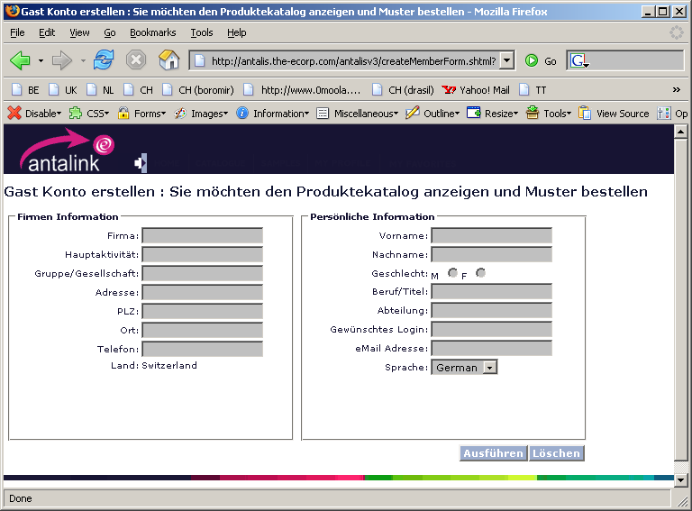

Test Case 1020: Request User Account

Brief Description
Use a form to send a user account registration request to Antalis.

Use Case Parameters
Actors: Website Visitor
Precondition: The Antalink login page with the user registration link is shown.
Post condition: Account request is made persistent and sent by email to the Antalis Administrator.

Main Test Flow

Step | Action performed by tester |  Expected System Response | Passed / Failed (+description)
1 | Check if the language drop down holds the correct supported languages for the country.
2 | Check that the form cannot be submit without all fields (except Customer ID or VAT) filled in. | Appropriate error message beside the concerned input field(s)
3 | Check that the form cannot be submit with an invalid email address (correct=*@*.*) | appropriate error message beside the email address input field
4 | Fill out the complete registration form and click on the “Proceed” button.  Check that the shown pop-up window appears in the correct language and that all parameters are filled in correctly. |  Confirm registration form pop-up window in correct language
4 | Click on the Cancel button | Pop-up window is closed
5 | Repeat step 4 and Click on the Change button |  Registration form is shown with all values filled in and editable. ‘Confirm and cancel’ buttons appear at the bottom.
6 | Repeat step 5, change some fields and click on ‘confirm’ |  Registration form is shown with all values filled in read only. ‘Confirm, cancel and change’ buttons appear at the bottom.
7 | Click on the Confirm button.  - Check if the user manager or administrator received an email | If the comp ID is known and this company has already a User Manager:   System displays message that the request is forwarded to the User Manager ( name + email address) of the applicants company and that he will receive a notification and initial password when his request has been approved.  Else   System displays message that the request is forwarded to the Antalis administrator and that the user will receive a notification and initial password when his request has been approved.

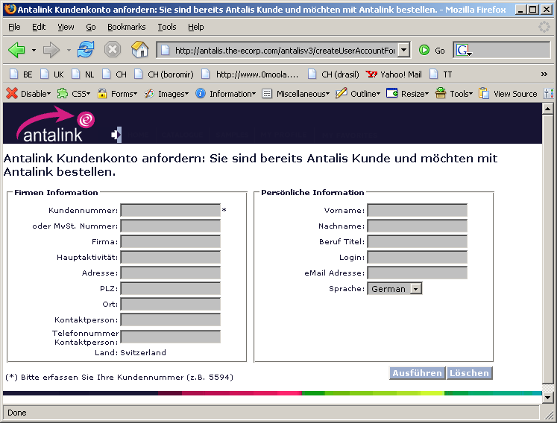

Test Case 1030: Login

Brief Description
Authenticate a Website Visitor by submitting their login credentials. An authenticated Website visitor can be one of the following: Member, User, Authorizer, User Manager, Administrator or Product Manager.

Use Case Parameters
Actors: Website Visitor
Precondition: The Antalink login page is shown.
Post condition: Website visitor is logged in as Member, User, Authorizer, User Manager, Administrator or Sales Representative and the specific homepage is shown in a new window.

Main Test Flow

Step | Action performed by tester |  Expected System Response | Passed / Failed (+description)
1 | Go to the login page | A pop-up window shows the login form in the correct language with tree form fields: Customer ID, User name and password. Submit and cancel buttons are shown at the bottom along with following links: “Lost password”; “Create member account” and “create user account”

2 | Check if the correct screens are behind the provided links
3 | Try to log in with wrong credentials |  Display appropriate error message
3 | Login as a member with the member account you created in Test Case 1010. | The Member home page is shown with  - Member Navigation  - Member “Tip of the day”  - Promotion/news highlights  - The last 4 posted sample orders, if available (maximum 2 months old)
4 | Log out | You are redirected to the logout page (blanco when logging out as Member ?)
5 | Login as a user with the user account you created in Test Case 1020 (after it has been approved). | The user home page is showed with  - User Navigation  - User “Tip of the day”  - Promotion/news highlights and bargains  The last 4 posted orders, if available (maximum 2 months old)
6 | Log out | You are redirected to the logout page

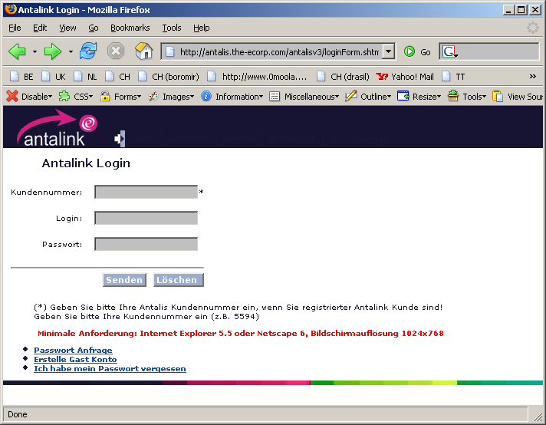

Test Case 1040: Reset Password

Brief Description
A website visitor who forgot his Antalink password can ask Antalink to create a new password and send it to his known email address.

Use Case Parameters
Actors: Website Visitor
Precondition: The Antalis Informational website page with the login form is shown.
Post condition: Website visitor received a new password via email.

Main Test Flow

Step | Action performed by tester |  Expected System Response | Passed / Failed (+description)
1 | Click on the “forgot password” link located on the login form and click appropriate radio-button (user/member) | Display “Forgot login credentials” form
2a | Member account:  Fill in  email address  and submit  => Check if a mail with new login credentials is received on the correct email address |  Notify the applicant that his new login credentials are sent to his email address ()

2 | User account:  Fill in  Customer ID & email address  OR  Customer ID & login  and submit  => Check if a mail with new login credentials is received on the correct email address |  Notify the applicant that his new login credentials are sent to his email address ()
3 | Try to login with the old login credentials | Error message if test was performed more than 10 minutes after change. Success if test was performed less than 10 minutes after change.
4 | Login with the new login credentials | Homepage shown

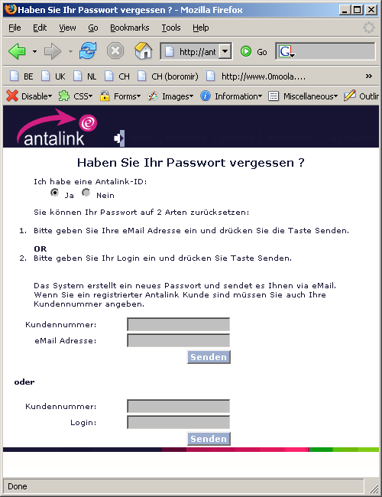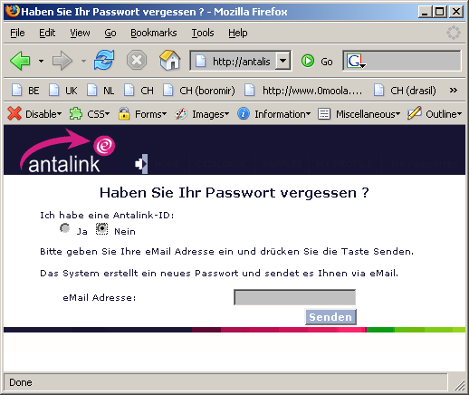

Test Case 1050: Manage User Account(s)

Brief Description
The User Manager can create, modify or delete an Antalink user of his company and manage his cost centers.

Use Case Parameters
Actors: User Manager
Precondition: Homepage shown

Main Test Flow

Step | Action performed by tester |  Expected System Response | Passed / Failed (+description)
1 | Login as a user manager | Home page is shown with the “Manage My Users” link (Your special task links).

2 | Click on the “Manage My Users” link |  Display the User Manager Page with following sections:  - list of employees of this user managers company who applied for an Antalink user account, if any.  - list of current Antalink users of this user managers company, if any.  - ‘Manage/Change Authorizer’ section  - ‘Add New User” section  - ‘Manage cost centers’ section
3 | Log-out and apply for a new user account for the same country (See Test Case 1020: Request User Account)
4 | Repeat step 1 and 2 | The new applicant appears in the first section  If it doesn’t then there are multiple sales areas for the customer. In this case go to the Manage User Manager Page on the Home page and accept the user in the first section there. The user should now appear in the first section of the Manage My Users page.
5 | Decline the applicant |  Ask to enter a “decline reason” in a form
6 | Fill in the box and click OK.  Check if the applicant receives a mail with the decline reason. | The new applicant disappears from the first table
7 | Repeat step 3 and 4 and accept the applicant | The new applicant disappears from the first table and appears as an Antalink user of the company in the second table
8 | Make this new user an authorizer
9 | Delete a normal user.  Check if that user received a notification mail | This user is removed from the “Current Antalink users in your company” table.
11 | Change authorizer to “nobody” and delete than the former authorizer.  Check if that user received a notification mail | This user is removed from the “Current Antalink users in your company” table and the authorizer of the company is “Nobody”.
13 | Add new user :  Fill in the credentials (name, login, email)  Check if this user received a mail with his login and password and check if he can login. | New User is shown in the “Current Antalink users” table.
15 | Manage Cost Center :  Create new Cost Center: enter a name for the new cost center and click ‘Create’ | The new cost center is added in that section (obviously without any user linked to it yet)
16 | Try to create a “new” Cost Center that has the same name as an existing cost center. | Error message
17 | Delete a cost centre: click on the “delete cc” link next to the cost centre name | - cost center is removed from the table
18 | Add a user to a cost centre: For a given cost centre, select a user in the drop down box (which contains all users of this company except those who are already linked to this cost centre) and click ‘add’ | The selected user is added to the member column of this cost centre and removed from the dropdown box in the “Add User” column of this cost centre.
19 | Remove a user from a cost centre by clicking on the ‘delete’ button next to the name | This user is removed from the member column of this cost centre and added in the dropdown box of the “Add User” column of this cost centre.
20 | Pick a user and Deselect the ‘prices visible’ checkbox. Try to log in into antalink with that user | The user should not see personal prices anymore, nowhere in antalink at all, not even in order emails

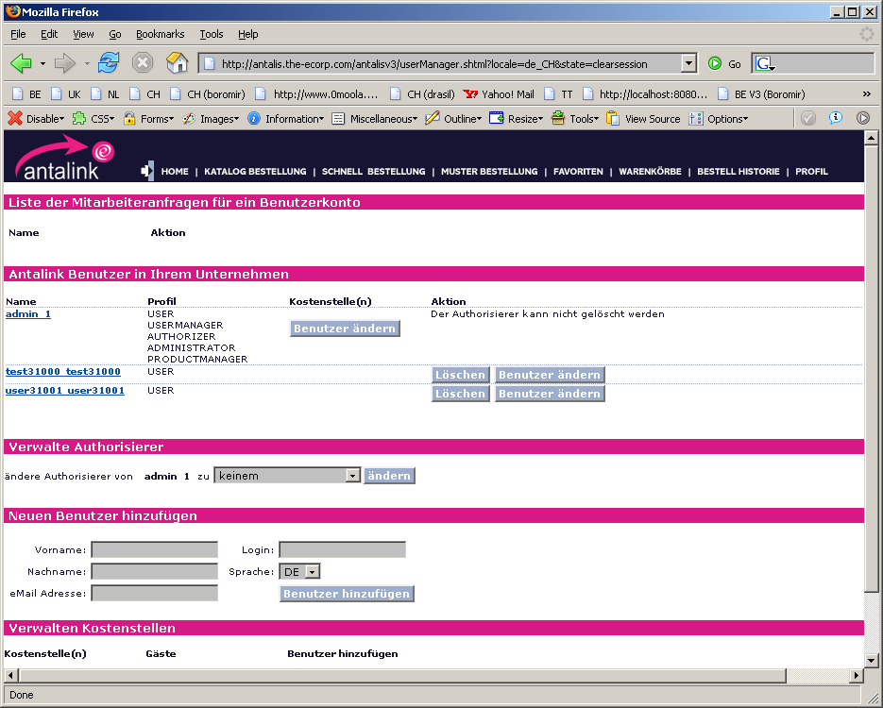

Test Case 1060: Manage Authorizer Account(s)
Part of paragraph 3.5 “Test Case 1050: Manage User Account(s)”

Test Case 1070: Manage User Manager Account
Create, modify or delete the unique User Manager Account of a customer. This User Manager Account is the unique link with the back-ends company account.

Brief Description

Use Case Parameters
Actors: Administrator
Precondition: Homepage shown

Main Test Flow

Step | Action performed by tester |  Expected System Response | Passed / Failed (+description)
1 | Click on the “Manage User Manager” link on the homepage (Your special task links). | User Manager Page is showed with 3 sections:  - The first with the list of website visitors who applied for an Antalink user account of the selected country, if any.  - The second with the list of all current Antalink customers of the selected country.  - The third with a list of all Antalink product managers.  - The 4th part with an option to extract user/member data in CSV file

2 | Accept an applicant  If Comp ID is not known or wrong:  add or change comp ID  In case the company has already a user manager: check whether he received a notification mail  If the applicant filled in a Customer ID for a Customer that is coupled to more than 1 Sales Area, select the correct Sales Area/ | The applicant is removed from the “Website visitors who applied for a user account”  .
2 | In case there is no user manager | This applicant is removed from the “Website visitors who applied for a user account”  .
3 | Decline an applicant (+ enter the decline reason)  Check whether the applicant received a notification mail | This applicant is removed from the “Website visitors who applied for a user account”  .
4 | Disable all users of a company | The “disable” link is changed into an “enable” link
5 | Try to login with an account of a disabled company | Error message
6 | Enable all users of a company | The “enable” link is changed into an “disable” link
7 | Login with the account of step 5 | Homepage is shown
8 | Change The UseManager to another user | Page is refreshed and the selected user is set as UserManager.  The old UserManager (if present) receives a mail message that his UserManager status is removed. The new UserManager receives a mail that he Is UserManager
9 | Log in as the old UserManager | The Manage My Users link is no longer shown
10 | Log in as the new UserManager | The Manage My Users link is shown.
11 | Delete all Antalink users of this company: ONLY POSSIBLE if the customer ID does not exist any more | Client side confirmation pop-up for confirmation + Remove this company from the overview.
12 | Change User Manager  Check if old and new user manager received a notification mail | Display the new User Manager in the table and update the dropdown list in the action column to reflect this change.
13 | Add new User Manager | Display the “Add new User Manager” form
14 | Fill in form and click on “Proceed”  Check if notification email is sent | New User Manager is added in the “All Antalink customers” table
15 | Try to repeat step 13 & 14 with the same parameters | Error message (This company has already a user manager)
16 | Add new Product Manager
17 | Fill in form and click on “Proceed”  Check if notification email was sent | New Product Manager is added in the “All Antalink customers” table.
18 | Extract User/Member data
19 | Select the appropriate button | A popup box should appear with a question to save the csv file or to open it in Excell (windows)

