MODULO “MATEMATICAS APLICADAS, ESTADISTICA Y PROBABILIDAD”

UNIDAD FINAL

PROYECTO FINAL

**DIANA MARIA SALAS**

CC 52816047

ALUMNO VITUAL

**DORIS STELLA ORDUY RUIZ**

TUTORA

FUNDACION UNIVERSITARIA SAN MATEO

PROFESIONAL EN GASTRONOMIA

2018

|  |  |  |  |  |  |  |  |
| --- | --- | --- | --- | --- | --- | --- | --- |
| FECHA | CANTIDAD DE VENTA | FECHA | CANTIDAD DE VENTA | FECHA | CANTIDAD DE VENTA | FECHA | CANTIDAD DE VENTA |
| 01/01/17 | 25 | 26/01/17 | 30 | 20/02/17 | 45 | 17/03/17 | 37 |
| 02/01/17 | 26 | 27/01/17 | 27 | 21/02/17 | 35 | 18/03/17 | 27 |
| 03/01/17 | 26 | 28/01/17 | 32 | 22/02/17 | 41 | 19/03/17 | 36 |
| 04/01/17 | 35 | 29/01/17 | 29 | 23/02/17 | 26 | 20/03/17 | 29 |
| 05/01/17 | 27 | 30/01/17 | 25 | 24/02/17 | 29 | 21/03/17 | 44 |
| 06/01/17 | 29 | 31/01/17 | 31 | 25/02/17 | 45 | 22/03/17 | 31 |
| 07/01/17 | 25 | 01/02/17 | 34 | 26/02/17 | 31 | 23/03/17 | 45 |
| 08/01/17 | 30 | 02/02/17 | 28 | 27/02/17 | 29 | 24/03/17 | 27 |
| 09/01/17 | 33 | 03/02/17 | 37 | 28/02/17 | 42 | 25/03/17 | 29 |
| 10/01/17 | 25 | 04/02/17 | 30 | 01/03/17 | 30 | 26/03/17 | 36 |
| 11/01/17 | 33 | 05/02/17 | 26 | 02/03/17 | 34 | 27/03/17 | 35 |
| 12/01/17 | 35 | 06/02/17 | 31 | 03/03/17 | 27 | 28/03/17 | 34 |
| 13/01/17 | 28 | 07/02/17 | 35 | 04/03/17 | 32 | 29/03/17 | 38 |
| 14/01/17 | 31 | 08/02/17 | 36 | 05/03/17 | 29 | 30/03/17 | 27 |
| 15/01/17 | 26 | 09/02/17 | 33 | 06/03/17 | 28 | 31/03/17 | 34 |
| 16/01/17 | 34 | 10/02/17 | 35 | 07/03/17 | 43 | 01/04/17 | 43 |
| 17/01/17 | 35 | 11/02/17 | 41 | 08/03/17 | 32 | 02/04/17 | 28 |
| 18/01/17 | 27 | 12/02/17 | 44 | 09/03/17 | 28 | 03/04/17 | 33 |
| 19/01/17 | 30 | 13/02/17 | 27 | 10/03/17 | 33 | 04/04/17 | 34 |
| 20/01/17 | 35 | 14/02/17 | 32 | 11/03/17 | 40 | 05/04/17 | 27 |
| 21/01/17 | 25 | 15/02/17 | 34 | 12/03/17 | 28 | 06/04/17 | 29 |
| 22/01/17 | 31 | 16/02/17 | 35 | 13/03/17 | 35 | 07/04/17 | 31 |
| 23/01/17 | 31 | 17/02/17 | 28 | 14/03/17 | 38 | 08/04/17 | 35 |
| 24/01/17 | 27 | 18/02/17 | 42 | 15/03/17 | 39 | 09/04/17 | 32 |
| 25/01/17 | 38 | 19/02/17 | 29 | 16/03/17 | 32 | 10/04/17 | 28 |

|  |  |  |  |  |  |  |  |  |
| --- | --- | --- | --- | --- | --- | --- | --- | --- |
| DATO MAYOR | | 45 | | |  | | | |
| DATO MENOR | | 25 | | |  | | | |
| RANGO | | 20 | | |  | | | |
| K=1+3,32*LOG(n) | | 7,64 | | | Aprox. A 8 | | | |
| AMPLITUD | | 2,5 | | | Aprox a 3 | | | |
| Ajustar Rango | | 4 | | |  | | | |
| A*Num Intervalos -R | |  | | | |
| Límite inferior | | 23 | | |  | | | |
| Liminte Superior | | 47 | | |  | | | |
|  | |  | | |  | | | |
| TABULACION DE DE ATOS AGRUPADOS | | | | | | | | | |
| **Intervalos** | **f** | | **fr** | **%** | | **Σf** | **Σfr** | **%Σr** | |
| [23 - 26) | 10 | | 0,1 | 10 | | 10 | 0,1 | 10 | |
| [26 - 29) | 27 | | 0,27 | 27 | | 27 | 0,37 | 37 | |
| [29 - 32) | 19 | | 0,19 | 19 | | 46 | 0,56 | 56 | |
| [32 - 35) | 23 | | 0,23 | 23 | | 69 | 0,79 | 79 | |
| [35 - 38) | 8 | | 0,08 | 8 | | 77 | 0,87 | 87 | |
| [38 - 41) | 4 | | 0,04 | 4 | | 81 | 0,91 | 91 | |
| [41 - 44) | 6 | | 0,06 | 6 | | 87 | 0,97 | 97 | |
| [44 - 47) | 3 | | 0,03 | 3 | | 90 | 1 | 100 | |

Avances del proyecto por Unidades

Unidad 1

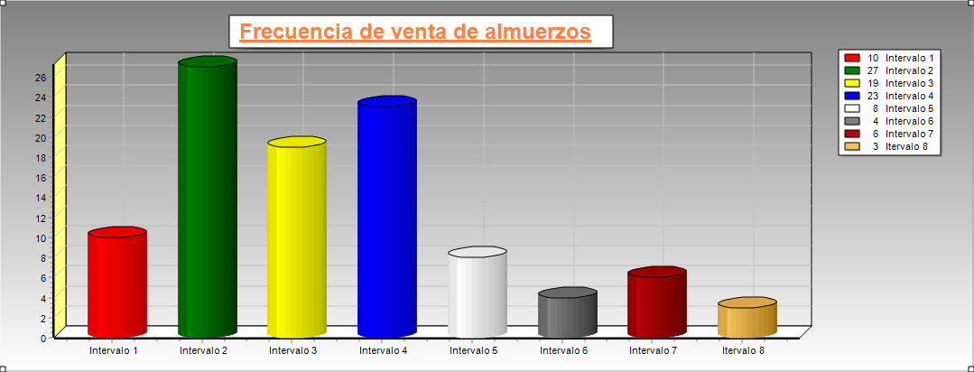

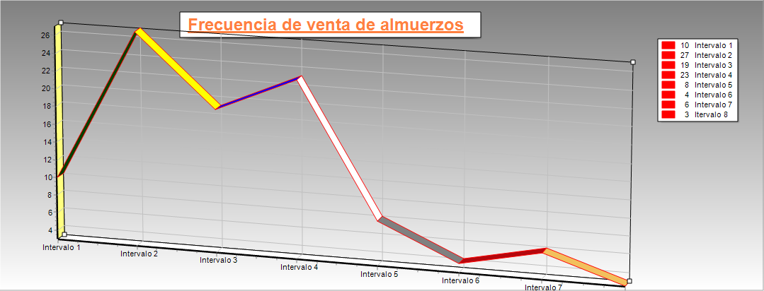

UNIDAD 2

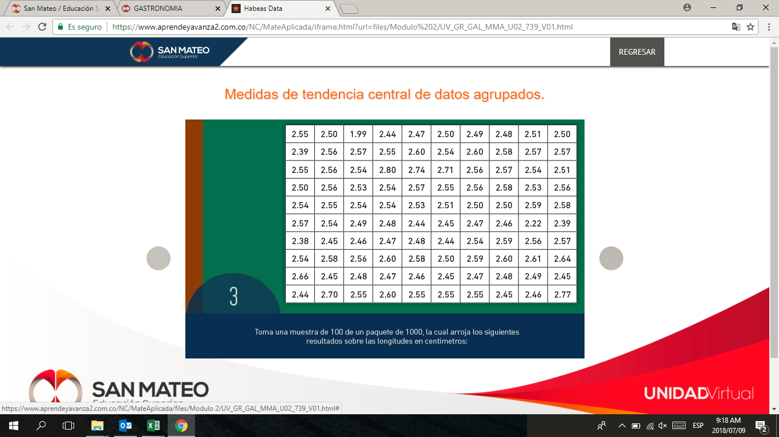

Tabla de longitud de tornillos

|  |  |  |  |  |
| --- | --- | --- | --- | --- |
| DATOS ORDENADOS | | | | |
| 1,99 | 2,47 | 2,51 | 2,55 | 2,58 |
| 2,22 | 2,47 | 2,51 | 2,55 | 2,58 |
| 2,38 | 2,47 | 2,53 | 2,55 | 2,58 |
| 2,39 | 2,47 | 2,53 | 2,55 | 2,58 |
| 2,39 | 2,48 | 2,53 | 2,56 | 2,59 |
| 2,44 | 2,48 | 2,54 | 2,56 | 2,59 |
| 2,44 | 2,48 | 2,54 | 2,56 | 2,59 |
| 2,44 | 2,48 | 2,54 | 2,56 | 2,6 |
| 2,44 | 2,48 | 2,54 | 2,56 | 2,6 |
| 2,45 | 2,49 | 2,54 | 2,56 | 2,6 |
| 2,45 | 2,49 | 2,54 | 2,56 | 2,6 |
| 2,45 | 2,49 | 2,54 | 2,56 | 2,6 |
| 2,45 | 2,5 | 2,54 | 2,57 | 2,61 |
| 2,45 | 2,5 | 2,54 | 2,57 | 2,64 |
| 2,45 | 2,5 | 2,54 | 2,57 | 2,66 |
| 2,46 | 2,5 | 2,55 | 2,57 | 2,7 |
| 2,46 | 2,5 | 2,55 | 2,57 | 2,71 |
| 2,46 | 2,5 | 2,55 | 2,57 | 2,74 |
| 2,46 | 2,5 | 2,55 | 2,57 | 2,77 |
| 2,47 | 2,51 | 2,55 | 2,58 | 2,8 |

|  |  |  |  |  |
| --- | --- | --- | --- | --- |
| Datos para tabulación | |  |  |  |
| Dato mayor | 2,80 |  |  |  |
| Dato menor | 1,99 |  |  |  |
| Rango | 0,81 |  |  |  |
| Intervalos | 7,66 | 8 |  |  |
| Amplitud | 0,11 |  |  |  |
|  |  |  |  |  |
| Tabla de frecuencias | | | | |
| Intervalos de clase [ ) | f | fr | F | Fr |
| 1,99 - 2,10 | 1,00 | 0,01 | 1 | 0,01 |
| 2,10 - 2,21 | 0,00 | 0 | 1,00 | 0,01 |
| 2,21 - 2,32 | 1,00 | 0,01 | 2,00 | 0,02 |
| 2,32- 2,43 | 3,00 | 0,03 | 5,00 | 0,05 |
| 2,43 - 2,54 | 40,00 | 0,4 | 45,00 | 0,45 |
| 2,54 - 2,65 | 49,00 | 0,49 | 94,00 | 0,94 |
| 2,65 - 2,76 | 4,00 | 0,04 | 98,00 | 0,98 |
| 2,76 - 2,87 | 2,00 | 0,02 | 100,00 | 1,00 |
| N | 100,00 |  |  |  |

|  |
| --- |
| MEDIDAS DE TENDENCIA CENTRAL, DISPERSION Y POSICION |
|

|  |  |  |  |  |  |  |  |
| --- | --- | --- | --- | --- | --- | --- | --- |
| |  | | --- | |  | |  |  |  |  |  |  |
| MODA |  |  |  |  | 2,54 |  |
|  |  |  |  |  |  |  |
|  |  |  |  |  |  |  |
| |  | | --- | |  | |  |  |  |  |  |  |
| MEDIANA |  |  |  |  | 2,54 |  |
|  |  |  |  |  |  |  |
|  |  |  |  |  |  |  |
| |  | | --- | |  | |  |  |  |  |  |  |
|  |  |  |  |  |  |  |
| MEDIA |  |  |  |  | 2,53 |  |
|  |  |  |  |  |  |  |
|  |  |  |  |  |  |  |
| |  | | --- | |  | |  |  |  |  |  |  |
|  |  |  |  |  |  |  |
| VARIANZA |  |  |  |  | 0,00923331 |  |
|  |  |  |  |  |  |  |
|  |  |  |  |  |  |  |
|  | |  | | --- | |  | |  |  |  |  |  |
| DESV. ESTANDAR | |  |  |  | 0,0965742 |  |
|  |  |  |  |  |  |  |
|  |  |  |  |  |  |  |

UNIDAD 3

|  |  |  |  |
| --- | --- | --- | --- |
| Informacion del contexto para el ejercicio   |  | | --- | |  | |  |  |
|  |  |  |
| **ASOCIADO** | **PRESTAMO** | **TIEMPO** |
| Acevedo Diego | 4000000 | 1 a;o |
| Buitrgado Claudia | 4000000 | 6 meses |
| Casas Javier | 2000000 | 2 a;os |
| Gomez Esperanza | 2500000 | 3 meses |
| Vega Jose Maria | 1250000 | 10 meses |
| Tinjaca Nelson | 3500000 | 15 meses |
| Zarate Yulieth | 3500000 | 18 meses |
| Zuluaga Tomas | 5500000 | 20 meses |

|  |  |  |  |  |  |  |
| --- | --- | --- | --- | --- | --- | --- |
| Posicion | |  |  |  | Posicion | |
| Cuartil 1 | 25 |  |  |  | Decil 4 | 40 |
| Q1 = | 2,485 | |  | | --- | |  | |  |  | D4 = | 2,52625 |
| Cuartil 2 | 50 |  |  |  | Decil 5 | 50 |
| Q2 = | 2,55122449 |  |  |  | D5 = | 2,55122449 |
| Cuartil 3 | 75 |  |  |  | Decil 6 | 60 |
| Q3 = | 2,607346939 |  |  |  | D6 = | 2,57367347 |
|  |  |  |  |  |  |  |

Los préstamos se manejan a un interés compuesto de 2,2% Annual

Antes de realizar el estudio de cada persona, debemos tomar en cuenta que los tiempos   
de algunos asociados son en meses y de otros en a;os.

|  |  |
| --- | --- |
| |  | | --- | | FORMULA PARA INTERES MENSUAL | |

**TABLA DE RESUMEN DE PRESTAMOS**

|  |  |  |  |  |  |
| --- | --- | --- | --- | --- | --- |
| **ASOCIADO** | **PRESTAMO** | **TIEMPO** | **INTERES** | **MONTO** |  |
| Acevedo Diego | 4000000 | 1 a;o | 2,20% | 4088000 | **M = C(1+i)n**   |  | | --- | |  | | |
| Buitrgado Claudia | 4000000 | 6 meses | 0,182% | 4043760,63 |
| Casas Javier | 2000000 | 2 a;os | 2,200% | 2088968 |
| Gomez Esperanza | 2500000 | 3 meses | 0,182% | 2513638 |
| Vega Jose Maria | 1250000 | 10 meses | 0,182% | 1272875,01 |
| Tinjaca Nelson | 3500000 | 15 meses | 0,182% | 3596513,25 |
| Zarate Yulieth | 3500000 | 18 meses | 0,182% | 3616132,94 |
| Zuluaga Tomas | 5500000 | 20 meses | 0,182% | 5703141,97 |

|  |  |  |
| --- | --- | --- |
| Total prestado | 26250000 | CAPITAL |
| Total recolectado luego de interes | 26923029,78 | MONTO |
| Total ganacias | 673029,7826 |  |
| %GANANCIA | 2,50% |  |
|  | 24 MESES | TIEMPO |

Luego, para encontrar la tasa de interes manejada por la cooperativa tenemos lo siguiente:

|  |  |  |  |  |  |  |
| --- | --- | --- | --- | --- | --- | --- |
| $t.interés=\sqrt[24]{(\frac{26923029,78}{26250000}}$) -1   |  | | --- | |  | |  |  |  |  |  |
|  |  |  |  |  |  |
|  |  |  | 0,01% |  |
|  |  |  |  |  |
|  |  |  |  |  |  |

UNIDAD 4

El video fue enviado por medio de Google drive, pues el tamaño impidió otra forma de envío