Maths at University Interview Questions
Below is a list of questions that have been asked at interviews (mainly at Oxford/Cambridge, but also other universities too).
Sometimes the interviewer will gently ask such things as:
- Tell us about some maths books that you have been reading.
- Why do you want to study maths?
- What areas of maths do you like? (this is a prompt for the next question which will be on that topic!)
Mainly (particularly at Oxford/Cambridge) there is little or no gentle chit chat, and straight into the fun stuff like:
- Which is bigger 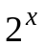 or 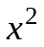?
- Draw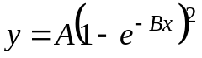
- Differentiate 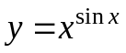
- Find an approximation to 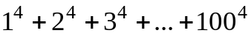
- Draw 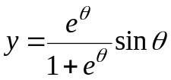 and 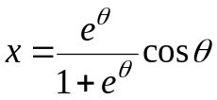
- Draw 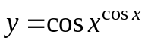
- Prove 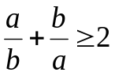
- Draw: 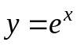, 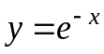, 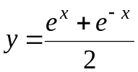
- Draw 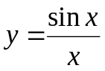
- Prove 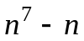 is always divisible by 42.
- Which is larger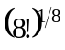 or 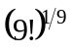 ?
- Which is greater 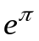 or 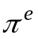 ?
- What is the last digit of 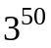?
- What is the last digit of 36! How many zeros are on the end of 36!?
- How many zeros does 371! Have on the end of it?
- How many possible subsets are there of the set: {1, 2, 3, 4, ,5, 6, 7, 8}?
- A teacher gives plain cards to a class and tells each student to draw a number on one side and a letter on the other. The rule is that if the number is even, then the letter must be a vowel.
Which of these cards must be checked (by turning over) to see if the rule was followed?
A | B | 2 | 3
- What is the value of 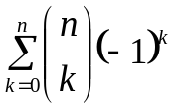?
- Imagine you are in a lift travelling from the bottom of a building to the top.
Sketch the velocity time graph for this situation.
Imagine a person in the lift standing on scales, sketch a graph of the reading on the scales.
What forces are acting?
Do you notice anything interesting about the bumps?

- Can you show why this number is so close to an integer?
- On a plane each individual point can be either red, white or blue. Prove that at some point on the plane two points will be at a distance of one unit apart and the same colour.
- Draw 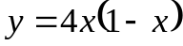 and sketch 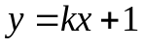.
For which values of k do these lines cross twice?
- Sketch 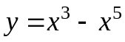, hence sketch 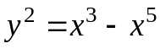.
- Is 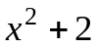 ever divisible by 5?
- Sketch 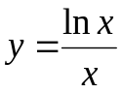 and find its maximum.
- Draw 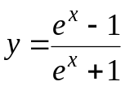
- Integrate 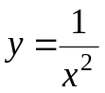
- By drawing a graph of 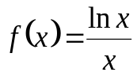, find out which is greater 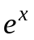or 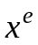?
- Draw 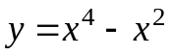. What does it look like when you zoom in at the origin?
Draw 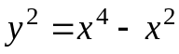.
- There are three children, at least one of them is a girl, what is the probability that they are all girls?
- Solve: 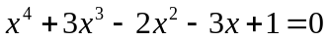.
- Draw the graph of 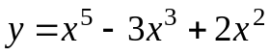
- Draw the graph of 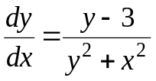 given that it passes through 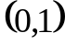
- Draw the graph of 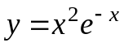.
- Draw 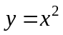, 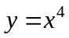and 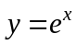 on the same axes, as which is bigger?
- Sketch 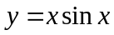
- Prove 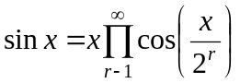
- What do you know about differentiation?
Looking for 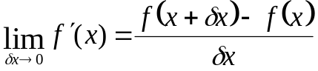
Then, use this to work out:
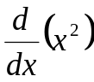, 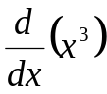 and 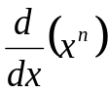
- Two trains are moving, so that the first train with mass 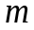 is moving at ms⁻¹, and the second train with mass 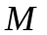is stationary. The first train collides with and sticks to the second train.
What is the speed of the train after the collision?
What other forms of energy is the Kinetic Energy converted into on impact?
Work out the energy loss and simplify it.
- If I bet £5 on you getting a heads when you flip a coin, what is a fair bet?
If I bet £100 on rolling a six, with a six sided die, what is a fair bet?
- N people are in a room, what is the probability that any two of them share a birthday?
- How many subsets of 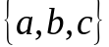 are there?
How many subsets of 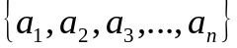 are there?
- Sketch 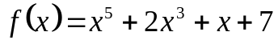 and 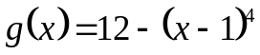 on the same graph.
Can you find any points of intersection?
- What does 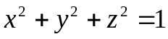 represent on a 3D graph?
If a plane 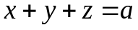 intersects the above what 2D shapes are made?
Find the equation of the plane which makes each shape.
- Particle moving at ms⁻¹ , with ms⁻² acceleration, and time, , travelling from rest. Please give an equation linking it all.
Use this equation with 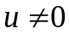 to find the distance.
- Solve 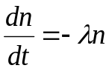 then give in terms of 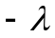. If 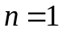 and 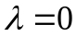 find the constant of integration.
- Sketch 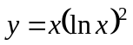
- Sketch 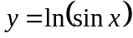 highlighting any maxima or minima.
- (a) Sketch 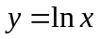- then discuss the graph, eg. What happens as gets big? What happens near 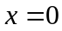?
(b) Sketch 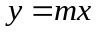 for some other - What do you notice about the graph? How many intersections are there? How could you distinguish between the times when there are 0 intersections/1 intersection/2 intersections?
Looking for 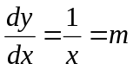and 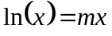and solve to find that if 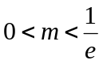there are two solutions, but if 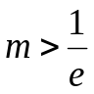there are no solutions and if 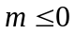then there will only be one solution.
- 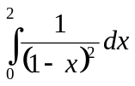
More questions…
1. Differentiate
2. Integrate
3. What is the square root of i?
4. If I had a cube and six colours and painted each side a different colour, how many (different) ways could I paint the cube? What about if I had n colours instead of 6?
6. Integrate ln x.
7. Sketch the curve .
8. 3 girls and 4 boys were standing in a circle. What is the probability that two girls are together but one is not with them?
9. Prove that 1+1/2+1/3+...+1/1000<10
10. Is there such number N that 7 divided 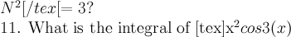?
12. How many squares can be made from a grid of ten by ten dots (ignore diagonal squares)?
13. Integrate tan x.
14. Pascal's triangle (prove that every number in the triangle is the sum of the two above it)
15. Integrate 1/(1-lnx)
16. sketch
17. Prove 4n - 1 is a multiple of 3
18. How many ways there are of getting from one vertex of a cube to the opposite vertex without going over the same edge twice?
19. What shape there would be if the cube was cut in half from diagonally opposite vertices?
20. Draw x ln(x).
21. Integrate and differentiate xln(x).
22. Draw sin(1/X).
23. Differentiate
24. What do you know about triangles?
25. Find a series of consecutive integers such that the sum of the series is a power of 2.
26. Prove Ptolemy's Theorem.
27. Find roots of the equation mx=sin x considering different values of m.
28. Integrate |sinn(x)+cosn(x)| between 0 and 2 & (pi) for cases n=1,2
29. . Prove xyz is a multiple of 60
30. Two people are playing a game which involves taking it in turns to eat chillies. There are 5 mild chillies and 1 hot chilli. Assuming the game is over when the hot chilli is eaten (and that I don't like hot chillies), is it a disadvantage to go first? What is the probability that I will eat the chilli if I go first? How about if there are 6 mild and 2 hot?
31. kx4=x3-x Find the real roots when k=0. Sketch the graph when k is small and then when k is large, and find approximations of the real roots in both cases. When else does x have 3 real roots?
32. Sketch f(x) = (x - R(x))2, where R(x) is x rounded up or down in the usual way. then sketch g(x) = f(1/x)
33. (a+b)/2 is an integer, is the relationship transitive? (a+b)/3?
34. Differentiate 1/1+(1/1+(1/1+1/(1 + x))))
35. Sketch graph of 1/x, 1/x2, 1/(1+x2)
36. Integrate 1/(1+x2)
37. Integrate ex x2 between limits of 1 and 0. Draw that graph.
38. Integrate x -2 between limits of 1 and -1. Draw the graph. Why is it -2 and not infinity, as it appears to be on the graph?
39. Write down 3 digits, and then write the number again next to itself, eg: 145145. Why is it divisible by 13?
40. You are given a triangle with a fixed perimeter but you want to maximise the area. What shape will it be? Prove it.
41. Next you are given a quadrilateral with fixed perimeter and you want to maximise the area. What shape will it be? Prove it.
42. Integrate (1)/(x+x3), (1)/(1+x3), (1)/(1+xn)
43. How many 0's are in 100!
44. Prove that the angle at the centre of a circle is twice that at the circumference.
45. How many ways are there in which you can colour three equal portions of a disc?
46. Integrate 1/(9 +x2)
47. Draw y=ex, then draw y=kx, then draw a graph of the numbers of solutions of x against x for ex=kx, and then find the value of k where there is only 1 solution.
48. Rubik's cube and held it by two diagonally opposite vertices and rotated it till it reached the same position, by how many degrees did it take a turn?
49. Solve ab=ba for all real a and b.
50. There is a game with 2 players (A&B) who take turns to roll a die and have to roll a six to win. What is the probability of person A winning?
51. Sketch y=x3 and y=x5 on the same axis.
52. What the 2 sides of a rectangle (a and b) would be to maximise the area if a+b=2C (where C is a constant).
53. Can 1000003 be written as the sum of 2 square numbers?
54. Show that when you square an odd number, you always get one more than a multiple of 8.
55. Prove that 1 + 1/2 + 1/3 + 1/4 + ... equals infinity
56. Prove that for n E Z ,n>2, n(n+1)>(n+1)n
57. Prove that sqrt(3) is irrational
58. What are the possible unit digits for perfect squares?
59. What are the possible remainders when a cube is divided by 9?
60. Prove that 801,279,386,104 can't be written as the sum of 3 cubes
61. Sketch y=ln(x)/x and find the maximum.
62. What's the probability of flipping n consecutive heads on a fair coin? What about an even number of consecutive heads?
63. Two trains starting 30km apart and travelling towards each other. They meet after 20 mins. If the faster train chases the slower train (starting 30km apart) they meet after 50mins. How fast are the trains moving?
64. A 10 digit number is made up of only 5s and 0s. It's also divisible by 9. How many possibilities are there for the number?
65. There is a set of numbers whose sum is equal to the sum of the elements squared. What's bigger: the sum of the cubes or the sum of the fourth powers?
66. Draw e(-x^2)
67. Draw cos(x^2)
68. What are the last two digits of the number which is formed by multiplying all the odd numbers from 1 to 1000000?
69. Prove that 1!+ 2!+ 3!+... has no square values for n>3
70. How many zeros in 365!
71. Integrate x sin2x
72. Draw ex , ln x, y=x what does show you. As x tends infinity, what does lnx/x tend to?
73. Define the term 'prime number'
74. Find method to find if a number is prime.
75. Prove for a2 + b2 = c2 a and b can't both be odd.
76. What are the conditions for which a cubic equation has two, one or no solutions?
77. What is the area between two circles, radius one, that go through each other's centres?
78. If every term in a sequence S is defined by the sum of every item before it, give a formula for the nth term
79. Is 0.9 recurring = 1? Why? Prove it
80. Why are there no Pythagorean triples in which both x and y are odd?
81. draw a graph of sinx, sin2x, sin3x
82. prove infinity of primes, prove infinity of primes of form 4n+1
83. differentiate cos3(x)
84. Show (x-a)2 - (x-b)2 = 0 has no real roots if a does not equal b in as many ways as you can.
85. Hence show: i) (x-a)3 + (x-b)3 = 0 has 1 real root ii) (x-a)4 + (x-b)4 = 0 has no real roots iii) (x-a)4 + (x-b)4 = (b-a)4 has 2 real roots
86. Find the values of all the derivatives of e(-1/x^2) at x=0
87. Show that n5-n3 is divisible by 12
88. If I have a chance p of winning a point in tennis, what's the chance of winning a game
89. Explain what integration is.
90. If n is a perfect square and its second last digit is 7, what are the possibilities for the last digit of n and can you show this will always be the case?
91. How many subsets can you form from a set of n numbers?
92. Prove that (a+b)/2 > sq.root of ab where a>0, b>0 and a does not equal b ie prove that arithmetic mean > geometric mean
93. What is 00 (i.e is it 0 or1), and solve it by drawing xx
94. If f(x+y)=f(x)f(y) show that f(0) = 1,
95. Suggest prime factors of 612612503503
96. How many faces are there on an icosahedron
97. integrate 1/(1+sin x)
98. What is the greatest value of n for which 20 factorial is divisible by 2n?
99. Prove that the product of four consecutive integers is divisible by 24.

