**SQL - Assignment**

**Question-1:**

1.Here is the Dataset for the below questions.

**Gold members Data Set**--Column names : (userid integer, signup_date)

('John','09-22-2017'), ('Mary','04-21-2017')

values

**Users Data Set**--Column names : (userid integer, signup_date)

('John','09-02-2014'), ('Michel','01-15-2015'), ('Mary','04-11-2014')

**Sales Data Set**-- Column names : (userid,created_date,product_id)

('John','04-19-2017',2), ('Mary','12-18-2019',1), ('Michel','07-20-2020',3), ('John','10-23-2019',2), ('John','03-19-2018',3), ('Mary','12-20-2016',2), ('John','11-09-2016',1), ('John','05-20-2016',3), ('Michel','09-24-2017',1), ('John','03-11-2017',2), ('John','03-11-2016',1), ('Mary','11-10-2016',1), ('Mary','12-07-2017',2)

**Product Data Set**--Column names : (product_id,product_name,price)

(1,'Mobile',980), (2,'Ipad',870), (3,'Laptop',330)

1. Create Database as ecommerce:  
   A close-up of a computer screen

   AI-generated content may be incorrect.
2. Create 4 tables (gold_member_users, users, sales, product) under the above database(ecommerce)

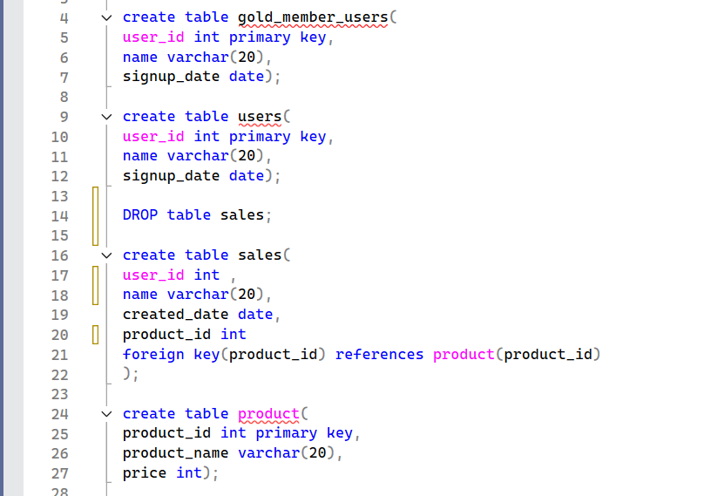

1. Insert the values provided above with respective datatypes:

1. Show all the tables in the same database(ecommerce):



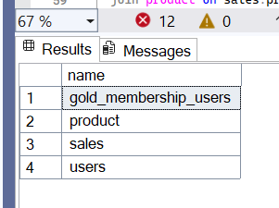

1. Count all the records of all four tables using single query:

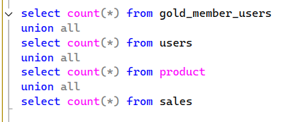

6. What is the total amount each customer spent on ecommerce company :

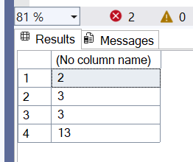

7. Find the distinct dates of each customer visited the website: output should have 2 columns date and customer name :

8. Find the first product purchased by each customer using 3 tables(users, sales, product) :

9. What is the most purchased item of each customer and how many times the customer has purchased it: output should have 2 columns count of the items as item_count and customer name

10. Find out the customer who is not the gold_member_user :

11. What is the amount spent by each customer when he was the gold_memberorder by user :

\

12. Find the Customers names whose name starts with M

13. Find the Distinct customer Id of each customer

16.

17

18

19.

14. Change the Column name from product table as price_value from price :

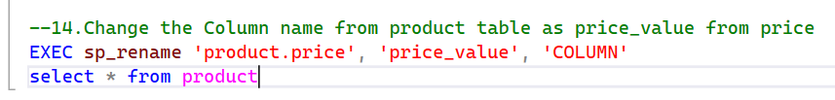

15. Change the Column value product_name – **Ipad to Iphone** from product table :

16. Change the table name of gold_member_users to gold_membership_users

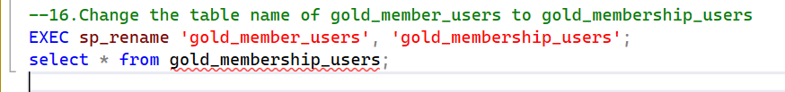

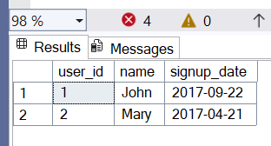

17. Create a new column as **Status** in the table crate above **gold_membership_users** the Status values should be 2 Yes and No if the user is gold member, then status should be Yes else No:

18. Delete the users_ids 1,2 from users table and roll the back changes once both the rows are deleted one by one mention the result when performed roll back

19. Insert one more record as same (3,'Laptop',330) as product table

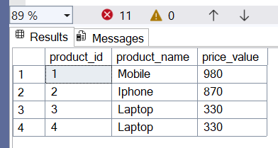

20. Write a query to find the duplicates in product table

**Question-2 :** Write a query to find for each date the number of different products sold and their names.   
Column names: (sell_date, product)

Data: ('2020-05-30', 'Headphones'),  
('2020-06-01','Pencil'),  
('2020-06-02','Mask'),  
('2020-05-30','Basketball'),  
('2020-06-01','Book'),  
('2020-06-02', ' Mask '),  
('2020-05-30','T-Shirt')

* Create table product_details with above data and find the above result
* Output:

|  |  |  |
| --- | --- | --- |
| sell_date | num_sold | product_list |
| 2020-05-30 | 3 | Basketball, Headphones, T-Shirt |
| 2020-06-01 | 2 | Book, Pencil |
| 2020-06-02 | 1 | Mask |

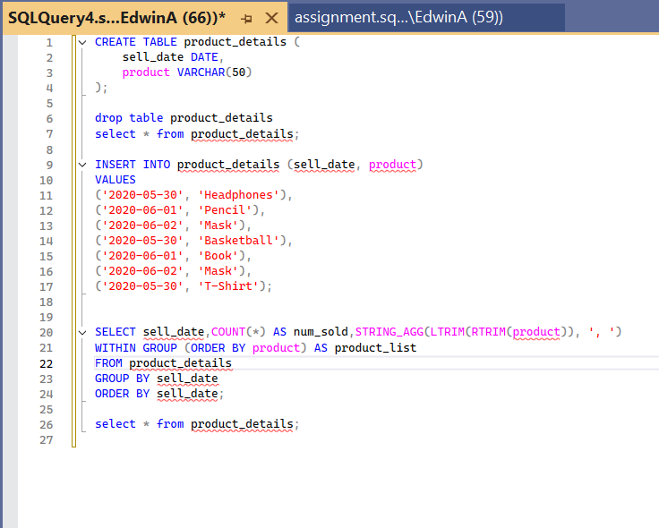

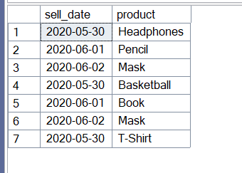

Final Output Table:

**Question-3 :** Find the total salary of each department

Column names:(id_deptname, emp_name, salary)

Data:   
('1111-MATH', 'RAHUL', 10000),  
('1111-MATH', 'RAKESH', 20000),  
('2222-SCIENCE', 'AKASH', 10000),  
('222-SCIENCE', 'ANDREW', 10000),  
('22-CHEM', 'ANKIT', 25000),  
('3333-CHEM', 'SONIKA', 12000),  
('4444-BIO', 'HITESH', 2300),  
('44-BIO', 'AKSHAY', 10000)

* Create table dept_tbl with above data

Output:

|  |  |
| --- | --- |
| dept_name | total_salary |
| BIO | 12300 |
| CHEM | 37000 |
| Math | 30000 |
| Science | 20000 |

**Question-4 :** Write a query to find gmail accounts with latest and first signup date and difference between both the dates and also write the query to replace null value with ‘1970-01-01’

Column names: (id, email_id, signup_date)

Data:

(1, '[Rajesh@Gmail.com](mailto:Rajesh@Gmail.com)', '2022-02-01'),  
(2, '[Rakesh_gmail@rediffmail.com](mailto:Rakesh_gmail@rediffmail.com)', '2023-01-22'),  
(3, '[Hitest@Gmail.com](mailto:Hitest@Gmail.com)', '2020-09-08'),  
(4, '[Salil@Gmmail.com](mailto:Salil@Gmmail.com)', '2019-07-05'),  
(5, '[Himanshu@Yahoo.com](mailto:Himanshu@Yahoo.com)', '2023-05-09'),  
(6, '[Hitesh@Twitter.com](mailto:Hitesh@Twitter.com)', '2015-01-01'),  
(7, '[Rakesh@facebook.com](mailto:Rakesh@facebook.com)', null);

Create table email_signup with above data

Output:

|  |  |  |  |
| --- | --- | --- | --- |
| count_gmail_account | latest_signup_date | first_signup_date | diff_in_days |
| 2 | 2022-02-01 | 2020-09-08 | 511 |

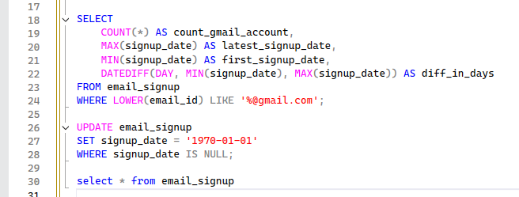

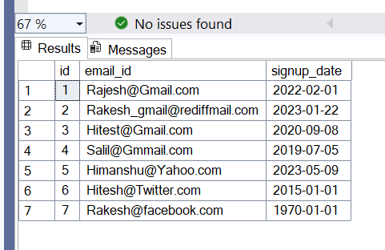

**Question -5 :** Solve the below questions by creating below mentioned tables and adding the given dataset.

Hint: Solve using the Window Functions

1. create a table named **sales_data** with columns: **product_id**, **sale_date**, and  **quantity_sold**.
2. insert some sample data into the table:

dataset:

(1, '2022-01-01', 20),

(2, '2022-01-01', 15),

(1, '2022-01-02', 10),

(2, '2022-01-02', 25),

(1, '2022-01-03', 30),

(2, '2022-01-03', 18),

(1, '2022-01-04', 12),

(2, '2022-01-04', 22)

1. Assign rank by partition based on product_id and find the latest product_id sold
2. Retrieve the **quantity_sold** value from a previous row and compare the **quantity_sold**.
3. Partition based on product_id and return the first and last values in ordered set.



