**Topics in Software Engineering I**

**CSE 350**

**GROUP NAME: ALPHA IMPACT**

**NAME: DURR-E-SABEEH, HUMA, AQSA, AREEB AHMED**

**REG. NO: FA19-BSE-062, FA19-BSE-068, FA19-BSE-036, FA19-BSE-022**

**Assignment: 1**

1. Enable the project using any IDE for code review. It would be better to use Eclipse or Netbeans. You may use VS Code too.

Explore your project and find all options discussed in lecture 2 from Chapter 2. You need to prepare a google doc that highlights the potential issue that your code has. You may identify these issues with the help of

i) Identify deprecated technology or APIs. Just report the diagram.

ii) Potential issues missing in the documentation but available in the code

iii) missing of technical documentation (if applicable)

**Answer:**

These are the highlighted potential issue that our code has, and we identify these issues with the help of

deprecated technology or APIs:

* Not Understanding the User.
* Debugging.
* Keeping up with Technology.
* Communication.
* Time Estimation.
* Sitting for Hours.
* Security Threats.
* Working with Another Person’s Code.
* Group task issue.

b) Use PMD to help identify potential coding errors and customize the rules you use to make sure only pertinent rules are applied to your source code.

1. Create & view code issues directly from your editor
2. Track & prioritize code improvements like technical debt
3. Check your code quality
4. Apply at least 3 PMD rules with the help of tool
5. Generate the Abstract Syntax Tree of your source code suing PMD.

**Answer:**

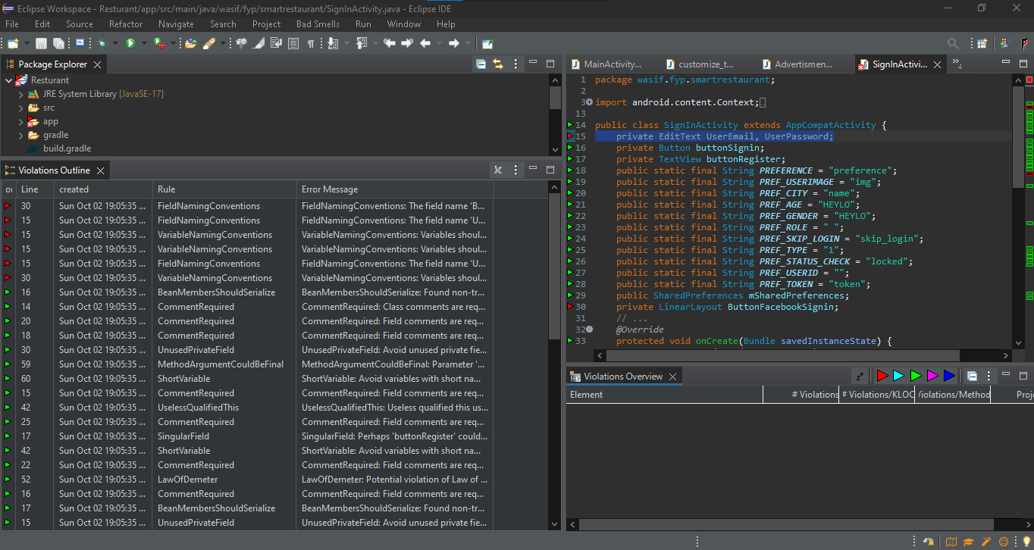

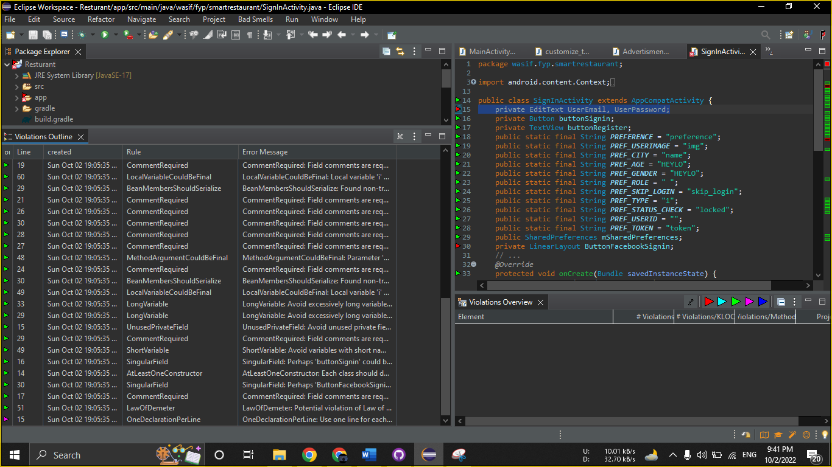

* According to PMD rules, **blocker violation** occurs in this java file naming **FieldNamingConventions.**
* According to PMD rules, **urgent violation** occurs in this java file naming **UnusedPrivateField.**
* According to PMD rules, **Important violation** occurs in this java file naming **OneDeclarationPerLine.**

C) Use the Check Style tool to review your code. At least apply 2 rules on your code using CHeckStyle.

**Answer:**

* Abbreviation in name 'isGPSEnabled' must contain no more than '1' consecutive capital letters.
* Location cannot be resolved to a type
* Member name 'mContext' must match pattern '^[a-z][a-z0-9][a-zA-Z0-9]*$'.

