**COMSATS University Islamabad, Lahore Campus**



**Sessional II Examination (Lab) – Semester Spring 2021**

|  |  |  |  |  |  |  |  |  |  |  |
| --- | --- | --- | --- | --- | --- | --- | --- | --- | --- | --- |
| Course Title: | Database Systems | | | | Course Code: | | CSC371 | | Credit Hours: | 4(3,1) |
| Course Instructor/s: | Zeenat Afzal | | | | Programme Name: | | BSE | | | |
| Semester: | SP21 | Batch: | FA19-BSE | Section: | B | | Date: | 01-05-2021 | | |
| **Time Allowed:** | **90mins(solve) + 10 mins(upload)** | | | | **Maximum Marks:** | | | **30 marks** | | |
| Student’s Name: | **Areeb Ahmed** | | | | Reg. No. | FA19-BSE-022 | | | | |
| **Important Instructions / Guidelines:** | | | | | | | | | | |
| * Need to submit one Word/PDF file for all questions that must have all the relevant information. Picture/files sent after submission time will NOT be entertained. * Make sure you attach screenshots of all questions you have attempted. | | | | | | | | | | |

**Download the file named InputData.txt.**

1. Take the data from given file. You need to remove the errors, create tables and insert data. No need to add any additional constraint on data. Paste the complete corrected data in your submission file.[7 marks]

**Note: you need to name the database as per your roll number. So change it accordingly.**

create database fa19_bse_022;

use fa19_bse_022;

CREATE TABLE agents

(

AGENT_CODE varchar(50) PRIMARY KEY,

AGENT_NAME varchar(50) NOT NULL,

WORKING_AREA varchar(100),

COMMISSION int,

PHONE_NO varchar(15),

COUNTRY varchar(50)

);

DROP TABLE agent1

CREATE TABLE agent1

(

AGENT_CODE varchar(50) PRIMARY KEY,

AGENT_NAME varchar(50) NOT NULL,

WORKING_AREA varchar(100),

COMMISSION int,

PHONE_NO varchar(50),

COUNTRY varchar(50)

);

DROP TABLE customer;

CREATE TABLE customer

(

CUST_CODE varchar(50) PRIMARY KEY,

CUST_NAME varchar(50) NOT NULL,

CUST_CITY varchar(50),

WORKING_AREA varchar(100),

CUST_COUNTRY varchar(50),

GRADE int,

OPENING_AMT int,

RECEIVE_AMT int,

PAYMENT_AMT int,

OUTSTANDING_AMT int,

PHONE_NO varchar(50),

AGENT_CODE varchar(50) FOREIGN KEY REFERENCES agents(AGENT_CODE)

);

CREATE TABLE customer1

(

CUST_CODE varchar(50) PRIMARY KEY,

CUST_NAME varchar(50) NOT NULL,

CUST_CITY varchar(50),

WORKING_AREA varchar(100),

CUST_COUNTRY varchar(50),

GRADE int,

OPENING_AMT int,

RECEIVE_AMT int,

PAYMENT_AMT int,

OUTSTANDING_AMT int,

PHONE_NO varchar(50),

AGENT_CODE varchar(50) FOREIGN KEY REFERENCES agents(AGENT_CODE)

);

INSERT INTO agents VALUES

('A007','Ahmad','Bangalore',15,'0321-4578456','Australia'),

('A003','Sara','London',13,'0322-4512756','Canada'),

('A008','Ali','New York',12,'0323-4512476','Australia'),

('A011','Rehan','Bangalore',15,'0322-4248416','Pakistan'),

('A010','Saima','Chennai',14,'0324-4578486','UK'),

('A012','Iqra','San Jose',12,'0311-4545426','USA'),

('A005','Nouman','Brisban',13,'0331-4588410','USA'),

('A001','Sajid','Bangalore',14,'0341-4508050','UK'),

('A002','Alia','Mumbai',11,'0315-4078151','Australia'),

('A006','Saud','London',15,'0334-4504421','Pakistan'),

('A004','Anas','Torento',15,'0320-4551124','Pakistan'),

('A009','Zohaib','Hampshair',15,'0320-4152167','Pakistan')

INSERT INTO customer VALUES

('C00013','Mohsin','LONDON','LONDON','UK',2,6000,5000,7000,4000,'BBBBBBB','A003'),

('C00001','Raza','New York','New York','USA',2,3000,5000,2000,6000,'CCCCCCC','A008'),

('C00020','Shoaib','New York','New York','USA',3,5000,7000,6000,6000,'BBBBSBB','A008'),

('C00025','Irfan','Bangalore','Bangalore','India',2,5000,7000,4000,8000,'AVAVAVA','A011'),

('C00024','Haris','LONDON','LONDON','UK',2,4000,9000,7000,6000,'FSDDSDF','A006'),

('C00015','Afaq','LONDON','LONDON','UK',1,6000,8000,3000,11000,'GFSGERS','A003'),

('C00002','Anam','New York','New York','USA',3,5000,7000,9000,3000,'DDNRDRH','A008'),

('C00018','Sana','Brisban','Brisban','Australia',2,7000,7000,9000,5000,'NHBGVFC','A005'),

('C00021','Komal','Brisban','Brisban','Australia',1,7000,7000,7000,7000,'WERTGDF','A005'),

('C00019','Kashif','Islamabad','Islamabad','Pakistan',1,8000,7000,7000,8000,'ZZZZBFV','A010'),

('C00005','Salman','Lahore','Lahore','Pakistan',1,7000,11000,7000,11000,'147-25896312','A002'),

('C00007','Adnan','Islamabad','Islamabad','Pakistan',1,7000,11000,9000,9000,'GHRDWSD','A010'),

('C00022','Farhan','Lahore','lahore','Pakistan',2,7000,11000,9000,9000,'113-12345678','A002'),

('C00004','Umar','Brisban','Brisban','Australia',1,5000,8000,7000,6000,'AAAAAAA','A005'),

('C00023','Muzammil','London','London','UK',0,4000,6000,7000,3000,'AAAABAA','A006'),

('C00006','Qaiser','Torento','Torento','Canada',1,10000,7000,6000,11000,'DDDDDDD','A004'),

('C00010','Hasnain','Hampshair','Hampshair','Canada',3,6000,4000,5000,5000,'MMMMMMM','A009'),

('C00017','Intizar','Karachi','Karachi','Pakistan',2,8000,4000,3000,9000,'AAAAAAB','A007'),

('C00012','Saba','San Jose','San Jose','USA',1,5000,7000,9000,3000,'KRFYGJK','A012'),

('C00008','Sadia','Torento','Torento','Canada',1,7000,7000,9000,5000,'HJKORED','A004'),

('C00003','Sania','Torento','Torento','Canada',2,8000,7000,7000,8000,'MJYURFD','A004'),

('C00009','Rabia','Karachi','Karachi','Pakistan',3,8000,7000,3000,12000,'Phone No','A002'),

('C00014','Shazia','Lahore','Lahore','Pakistan',2,8000,11000,7000,12000,'AAAATGF','A001'),

('C00016','Fiaz','Lahore','Lahore','Pakistan',2,8000,11000,7000,12000,'JRTVFDD','A007'),

('C00011','Shakil','Islamabad','Islamabad','Pakistan',3,7000,11000,7000,11000,'PPHGRTS','A010')

INSERT INTO customer1 SELECT * FROM customer;

INSERT INTO agent1 SELECT * FROM agents

SELECT*

FROM agents;

SELECT*

FROM customer;

Once you are done with insertion of data, write SQL queries to answer the following question.

1. List all those customers whose opening amount is less than the average of each customer opening amount. [4 marks]

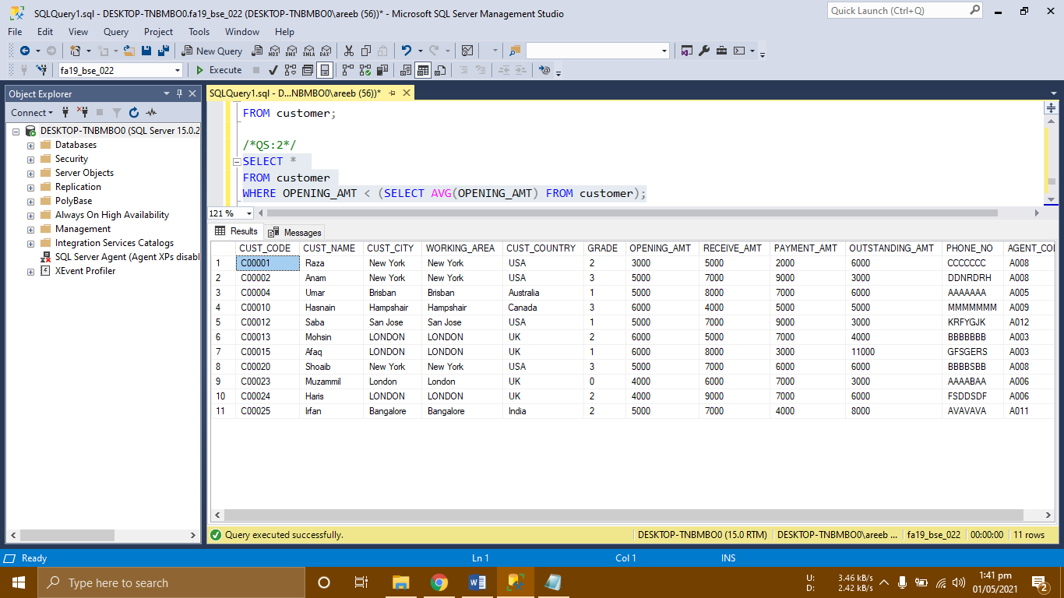

1. List all agents whose clients have total payment amount greater than 15000. [4 marks]

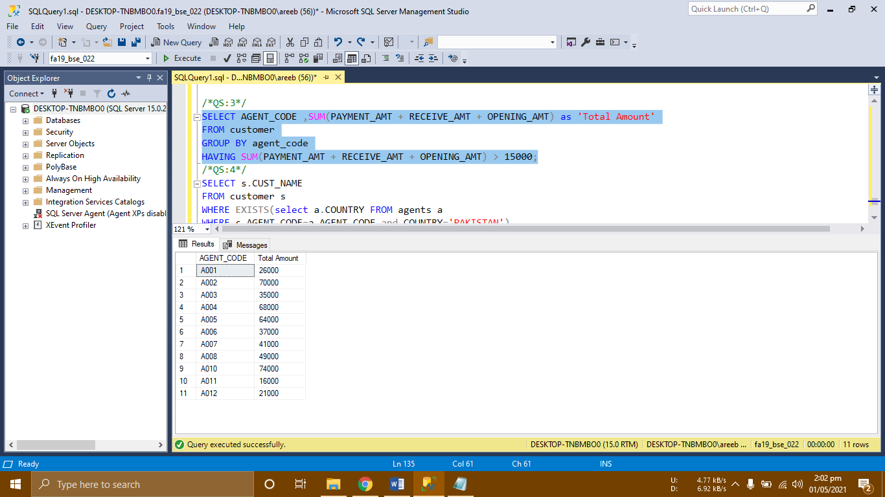

1. Show the details of the customer whose agents belong to Pakistan. [4 marks]

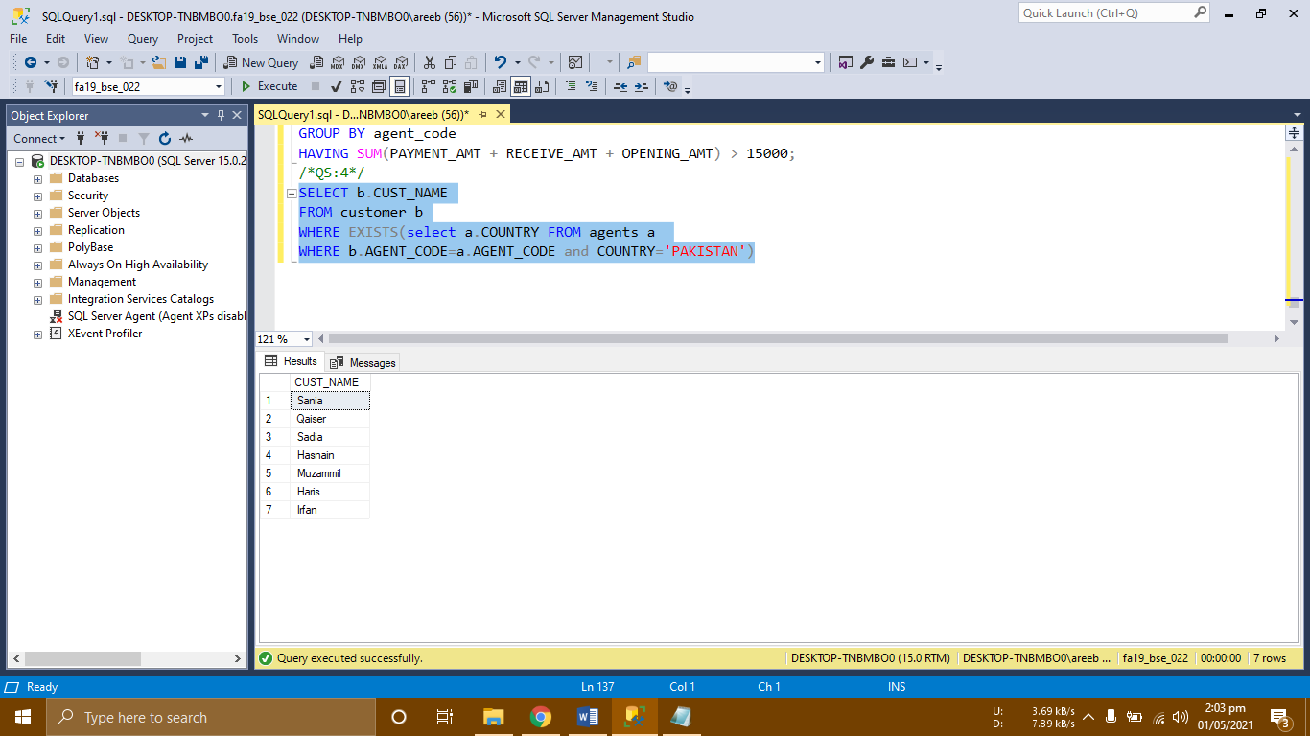

1. Write a query to see how many customers do each agent handles in every country.[4 marks]

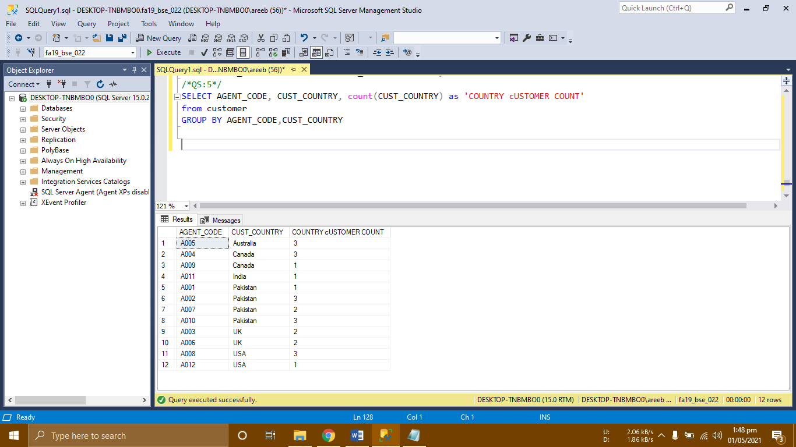

1. List all those agents who have phone number starting with “0321” or "0322".[3 marks]

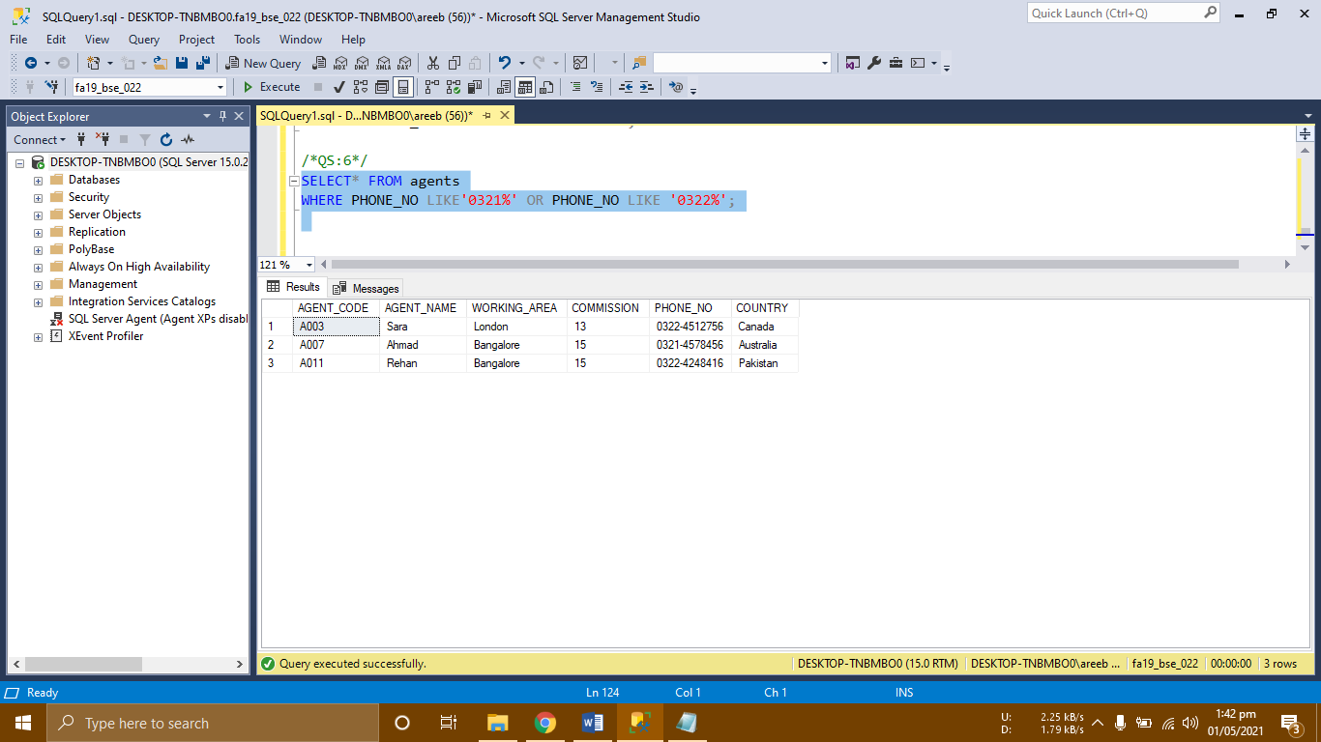

1. List the customer count for each grade, Also display the max outstanding amount for each grade. [2 marks]

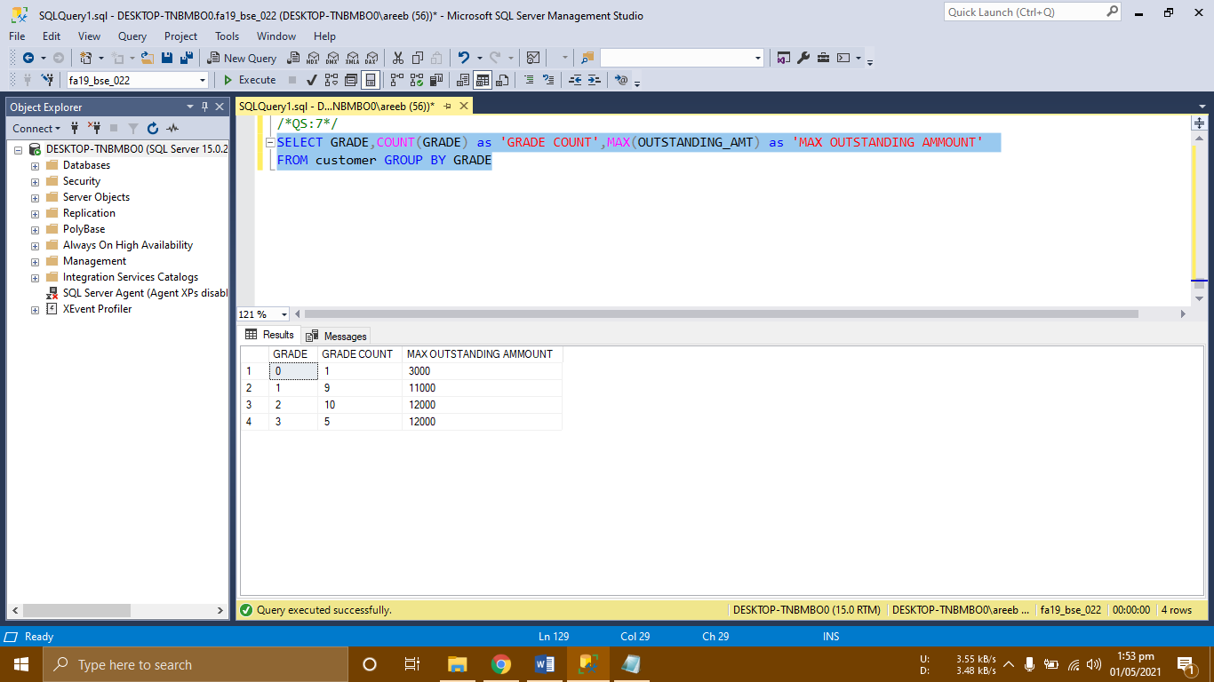

1. Show all the customers who have opening amount balance in the range of 2000 and 5000. [2 marks]

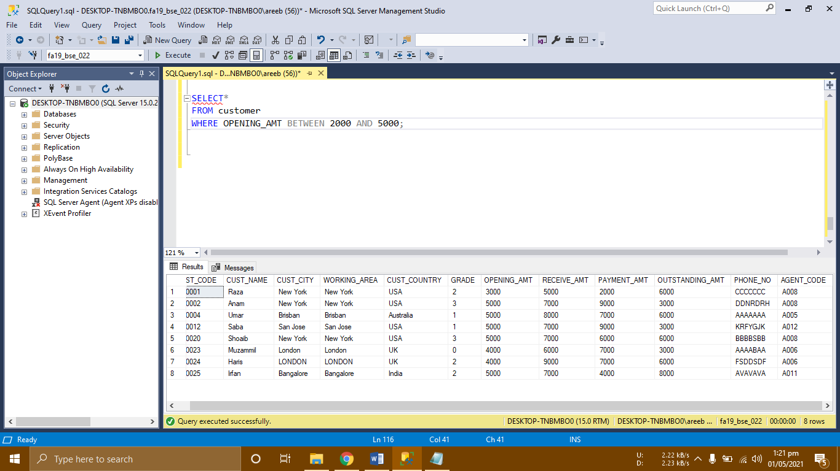

**Instructions for Submission**

* For every part you need to show code, resultant data and the name of database you are working in. You can take a single screenshot.
* Clearly mention the question to which you are attaching that screenshot for.
* You need to submit one word/PDF file renamed as your registration number.

Page **1**