** COMSATS University Islamabad, Lahore Campus**

***Lab 7***

|  |  |  |  |  |  |  |  |  |  |
| --- | --- | --- | --- | --- | --- | --- | --- | --- | --- |
| Course Title: | Object Oriented Software Engineering | | | | Course Code: | CSC 304 | Credit Hours: | | 3(2,1) |
| Course Instructor IndhsdjsIInstructorInstructor/s: | Yella Mehroze | | | | Theory/Lab Name: | Lab | | | |
| Semester: | 4th | Batch: | Fa19-BSE | Section: | B | Semester | | Spring 2021 | |

Student Name – AREEB AHMED

Registration ID- FA19-BSE-022

Section -  **B**

**Outline**

* **Representation of Inheritance**
  + **Graphical Representation**
  + **Hierarchical Representation**
* **Identification of Good Superclass-Subclass pairs**
* **Implementation of isa rule**

**[Write your solutions in this document]**

# **Task 1**

Consider the different types of bank accounts (as illustrated in class / given below) and show inheritance hierarchies existing in them. Before making a solution for this Task, you need to learn the difference between these account types else you won’t be able to identify the relations correctly. You can explore them on Book at page 39 and on the links given by the end of this task.

**Account Names:**

Account,SavingsAccount,CheckingAccount,MortageAccount,StudentAccount,SalaryAccount,FixDepsoitAccount, RecurringDepositAccount,CurrentAccount

***Graphical Representation [Draw class diagram in MS Visio/Visual Paradigm and paste the screen shot here]***

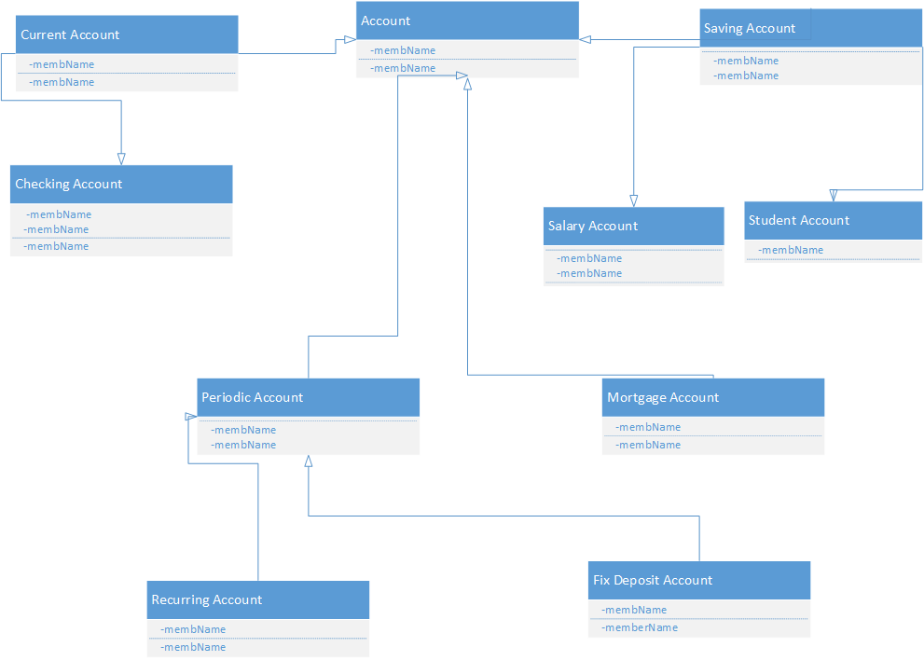

***Indentation Representation [Write in MS Word and use bullets]***

* Account
* Saving Account
* Salary Account
* Student Account
* Periodic Account
* Recurring Account
* Fixed Deposit account
* Current Account
* Checking Account
* Mortgage Account

***Links for Task 3:***

[***https://affairscloud.com/different-types-bank-accounts/***](https://affairscloud.com/different-types-bank-accounts/)

[***https://www.thebalance.com/types-of-bank-accounts-315458***](https://www.thebalance.com/types-of-bank-accounts-315458)

[***https://www.creditkarma.com/advice/i/types-of-accounts***](https://www.creditkarma.com/advice/i/types-of-accounts)

# **Task 2**

Which of the following would not form good superclass–subclass pairs (generalizations), and why? Hint: look for violations of the isa rule, poor naming, and other problems.

1. Money – CanadianDollars

Canadian dollars are not money and we can’t we plural name in classes.

1. Bank – Account

Account is not a bank

1. OrganizationUnit – Division

It is correct.

1. SavingsAccount – CheckingAccount

CheckingAccount is not a subclass of SavingsAccount

1. Account – Account12876

Account12876 is an instance but it is not a class

1. People – Customer

Customer is not a people

1. Student – GraduateStudent

It is correct

1. Continent – Country

Country is not a continent

1. Municipality – Neighborhood

Neighborhood is not a Municipality.

***For any queries***

[***yellamehroze@cuilahore.edu.pk***](mailto:yellamehroze@cuilahore.edu.pk)

***Office: H-Block – Room 23 (H – 23)***