**COMSATS University Islamabad, Lahore Campus**



**Sessional I Examination (Lab) – Semester Spring 2021**

|  |  |  |  |  |  |  |  |  |  |  |
| --- | --- | --- | --- | --- | --- | --- | --- | --- | --- | --- |
| Course Title: | Database Systems | | | | Course Code: | | CSC371 | | Credit Hours: | 4(3,1) |
| Course Instructor/s: | Zeenat Afzal | | | | Programme Name: | | BSE | | | |
| Semester: | SP21 | Batch: | FA19-BSE | Section: | B | | Date: | 10-04-2021 | | |
| **Time Allowed:** | **60mins(solve) + 10 mins(upload)** | | | | **Maximum Marks:** | | | **25 marks** | | |
| Student’s Name: | **Areeb Ahmed** | | | | Reg. No. | FA19-BSE-022 | | | | |
| **Important Instructions / Guidelines:** | | | | | | | | | | |
| * Need to submit one Word/PDF file for all questions that must have all the relevant information. Picture/files sent after submission time will NOT be entertained. * Make sure you attach screenshots of all questions you have attempted. | | | | | | | | | | |

1. Create a database named as your registration number e.g. fa19bse000. Do not use hyphens(-). All the working must be done in this database. [2 marks]
2. Write DDL commands to create following tables. You need to identify all the relevant and essential **constraints and keys.** [8 marks]
3. Write DML commands to enter the following data in your tables. If any record is not valid, state the reason. [3 marks]

Answer: Yes, There is a CourseID(PK) has duplicate value so it will be terminated and second in Teacher table Course(EE323) does not exist in Course table.

1. Write a query to show all the data present in these tables. [1 mark]

|  |  |  |  |  |  |  |  |  |  |  |  |  |  |  |  |  |  |  |  |  |  |  |  |  |  |  |  |  |  |  |  |  |  |  |  |  |  |  |  |  |  |  |  |  |  |  |  |  |  |  |  |  |  |  |  |  |  |  |  |  |  |  |  |  |  |  |  |  |  |
| --- | --- | --- | --- | --- | --- | --- | --- | --- | --- | --- | --- | --- | --- | --- | --- | --- | --- | --- | --- | --- | --- | --- | --- | --- | --- | --- | --- | --- | --- | --- | --- | --- | --- | --- | --- | --- | --- | --- | --- | --- | --- | --- | --- | --- | --- | --- | --- | --- | --- | --- | --- | --- | --- | --- | --- | --- | --- | --- | --- | --- | --- | --- | --- | --- | --- | --- | --- | --- | --- |
| |  |  |  |  | | --- | --- | --- | --- | |  | Teacher | |  | | ID | Name | Course | Department | | LHR201 | Huma | CS005 | CS | | LHR206 | Ahsan | EE321 | EE | | LHR589 | Hira | CS056 | CS | | ISB453 | Shafaq | CS456 | CS | | ISB786 | Abdullah | EE323 | EE | | ISB985 | Arshia | CS005 | CS | | KHI432 | Aahid | CS456 | CS | | KHI789 | Mohid | EE321 | EE | | |  |  |  |  | | --- | --- | --- | --- | |  | Course |  |  | | CourseID | Name | CH | Students | | CS005 | Game Dev | 4 | 54 | | CS056 | Algorithms | 3 | 36 | | CS456 | OOP | 4 | 28 | | EE321 | Circuits | 4 | 97 | | EE321 | Algebra | 3 | 105 | |

Once you are done entering this data, write SQL queries to answer the following questions.

1. List teachers’ details who are teaching in CS department. [1 mark]
2. List all the courses with 4 credit hours that have student strength less than 40. [2 marks]
3. List the teachers’ name who are teaching either course CS456 or EE321. [2 marks]
4. List the course details for Algorithms course. [1 mark]

1. Code Execution, Submission File, Viva [5 marks]

**Instructions for Submission**

* For every part you need to show code, resultant data and the name of database you are working in. You can take a single screenshot.
* Clearly mention the question to which you are attaching that screenshot for.

Page **1**

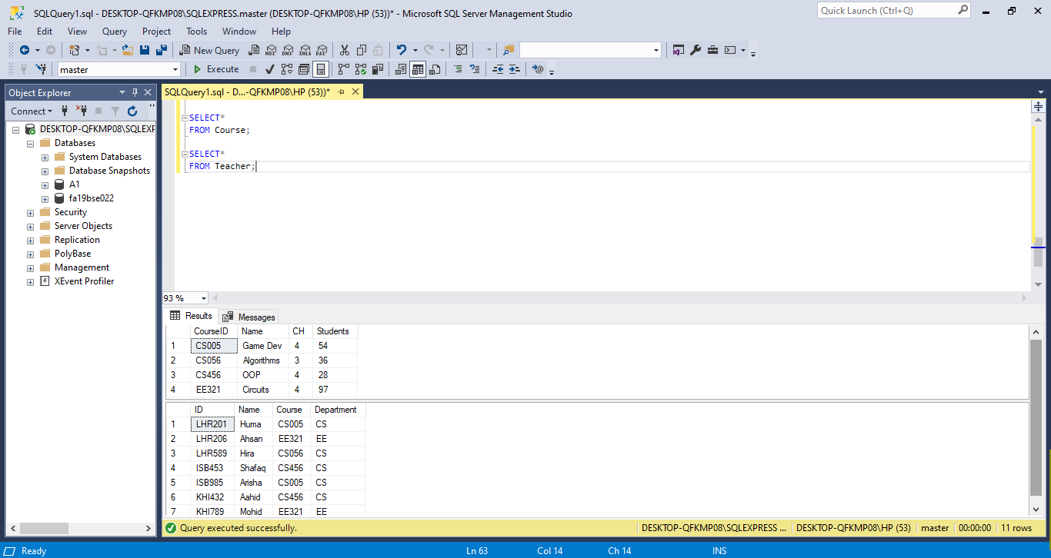

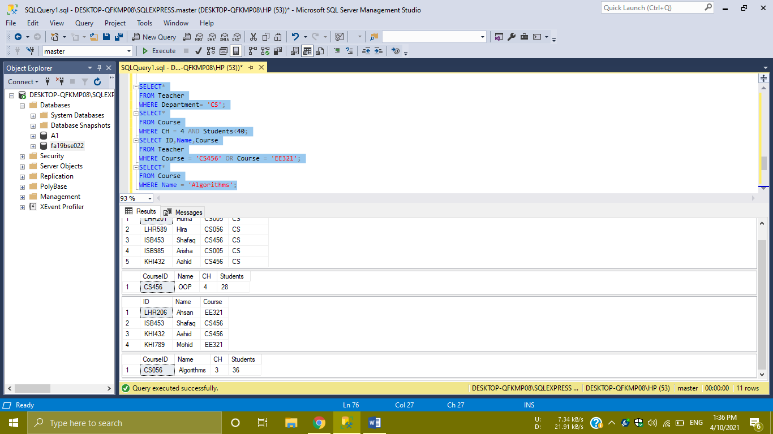

**CODE:**

CREATE DATABASE fa19bse022

CREATE TABLE Course

(

CourseID varchar(5) PRIMARY KEY,

Name varchar(12) NOT NULL,

CH int ,

Students int NOT NULL

)

INSERT INTO Course

VALUES('CS005','Game Dev',4,54);

INSERT INTO Course

VALUES('CS056','Algorithms',3,36);

INSERT INTO Course

VALUES('CS456','OOP',4,28);

INSERT INTO Course

VALUES('EE321','Circuits',4,97);

INSERT INTO Course

VALUES('EE321','Algebra',3,105);

CREATE TABLE Teacher

(

ID varchar(6) NOT NULL,

Name varchar(8) NOT NULL,

Course varchar(5) FOREIGN KEY REFERENCES Course(CourseID),

Department varchar(2) NOT NULL

)

INSERT INTO Teacher

VALUES('LHR201','Huma','CS005','CS');

INSERT INTO Teacher

VALUES('LHR206','Ahsan','EE321','EE');

INSERT INTO Teacher

VALUES('LHR589','Hira','CS056','CS');

INSERT INTO Teacher

VALUES('ISB453','Shafaq','CS456','CS');

INSERT INTO Teacher

VALUES('ISB786','Abdullah','EE323','EE');

INSERT INTO Teacher

VALUES('ISB985','Arisha','CS005','CS');

INSERT INTO Teacher

VALUES('KHI432','Aahid','CS456','CS');

INSERT INTO Teacher

VALUES('KHI789','Mohid','EE321','EE');

SELECT*

FROM Course;

SELECT*

FROM Teacher;

SELECT*

FROM Teacher

WHERE Department= 'CS';

SELECT*

FROM Course

WHERE CH = 4 AND Students<40;

SELECT ID,Name,Course

FROM Teacher

WHERE Course = 'CS456' OR Course = 'EE321';

SELECT*

FROM Course

WHERE Name = 'Algorithms';