Name: Areeb Ahmed  
RegNo# FA19-BSE-022

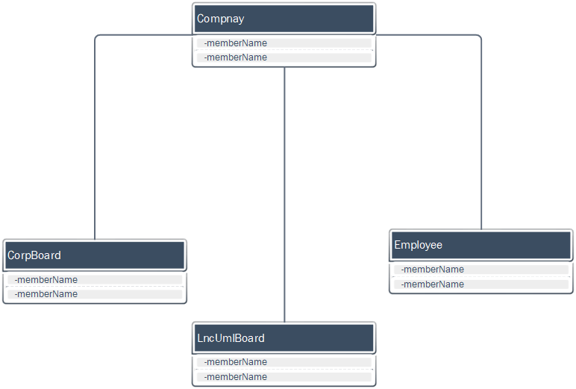

## **E94:**

**For each of the following associations, indicate whether it should be an**

**ordinary association, a standard aggregation, or a composition.**

(a) A telephone and its handset.

(b) A school and its teachers.

(c) A book and its chapters.

1. A telephone and its handset:

Composition

1. A school and its teachers:

Aggregation

1. A book and its chapters:

Composition