 

**COMSATS University Islamabad, Lahore** **Campus**

**Sessional-II Lab – Student Answer Book - Semester Spring 2021**

|  |  |  |  |  |  |  |  |  |  |  |
| --- | --- | --- | --- | --- | --- | --- | --- | --- | --- | --- |
| Course Title: | Object Oriented Software Engineering (Lab) | | | | Course Code: | | CSE304 | Credit Hours: | | 3(2,**1**) |
| Course Instructor: | Yella Mehroze | | | | Programme Name: | | BSE | | | |
| Semester: | 4th | Batch: | Fa19 - BSE | Section: | A,B | | Date: | | April 29,2021 | |
| **Time Allowed:** | **90 minutes** | | | | **Maximum Marks:** | | | | **15** | |
| Student’s Name: | **Areeb Ahmed** | | | | Reg. No. | FA19-BSE-022 | | | | |
| **Important Instructions / Guidelines:**   * Attempt all questions * Switch off your mobile phones * Download the solution format document and solve your paper in according to the template given in that document * **Upload the answer sheet (Solution format.docx (MS Word document)) on Google class room** * **Only 1 document should be uploaded** * **Turn in the document once it has been uploaded successfully** * **Your presence in the Google Meeting is mandatory throughout the examination** * **Your videos must remain ON** | | | | | | | | | | |

**Q 2: Obtained Marks: /9**

**Question 1 [Marks 9]**

Convert the given diagrams to instance diagrams (or object diagram) such that the number of instance links are in accordance (consistent) with the multiplicity of the given class diagram.

1. **Question 1 : Part 1**

**Obtained Marks: /4**

Student class and Course class

ANSWER

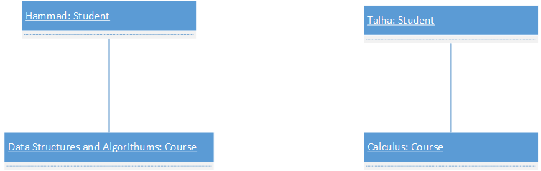

**Obtained Marks: /5**

1. **Question 1 : Part 2**

Person class, Residence class, Hobby class

ANSWER

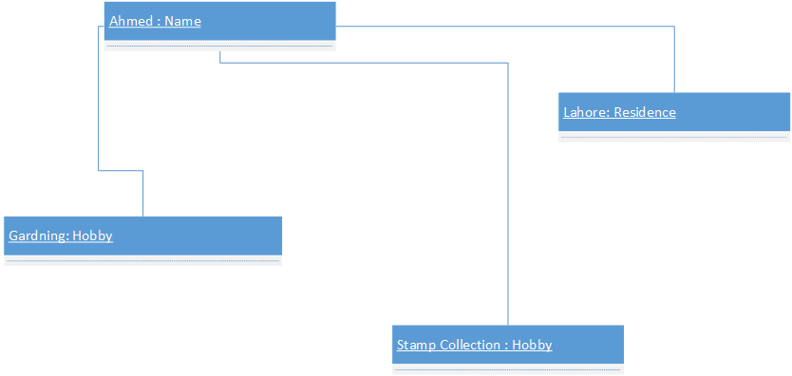

**Question 2 [Marks 6]**

**Q 2: Obtained Marks: /6**

1. **Question 2 : Part 1**

**Obtained Marks: /3**

Mention that constraint type (write its name) and write its generic syntax.

ANSWER

Constraint type: **Post Condition**

Generic syntax:

context <identifier> : : <operation> (<parameter>)

post [<constraint name>] : < boolean expression>

1. **Question 2 : Part 2**

**Obtained Marks: /3**

Build an OCL statement.

ANSWER

1. **Context Number :: printNum()**

**Post : var <= 22**

**DOWNLOAD THE SOLUTION FORMAT DOCUMENT TO SOLVE YOUR PAPER**

**CLEARLY MENTION YOUR NAME AND ID THAT DOCUMENT**

**RENAME THE DOCUMENT AS REG ID – SECTION**

**Example – FA19-BSE- 001-B**