**COMSATS**

**University Islamabad, Lahore Campus**



***LAB MANUAL – COMMUNICATION DIAGRAM***

|  |  |  |  |  |  |  |  |  |  |
| --- | --- | --- | --- | --- | --- | --- | --- | --- | --- |
| Course Title: | Object Oriented Software Engineering | | | | Course Code: | CSC 304 | | Credit Hours: | 3(2,1) |
| Course Instructor | Yella Mehroze | | | | Theory/Lab | Lab | | | |
| Semester: | 4th | Batch: | Fa19-BSE | Section: | A , B | Depart | CS | | |

# Outline

▪ **Interaction Diagrams** o **Collaboration Diagrams** o **Sequence Diagrams (Previous Lab)**

**Task 1**

**Draw the collaboration diagram for scenario as explained in online session.**

## Methodology

* Recall the process of sending email
* Write the important steps on paper
* Recall the classes
* Recall the instances
* Recall the links
* Draw the collaboration diagram on MS Visio/Visual Paradigm
* Try your best to give your diagram a simple structure and readable ▪ Keep in mind the following structure while drawing the diagram

Yella Mehroze – CS Dept

CUI Lahore Campus

**Point to Ponder**

*What is the difference between Collaboration Diagram & Sequence Diagrams???*

*Between these two diagrams which should we frequently adapt/prefer???*



### Interaction Diagram

Interaction diagrams are used for the illustration of interaction of objects through messages. These diagrams are generalization of two specialized UML diagrams (Collaboration and Sequence). Designing these diagrams (adding details to the design of object) is very important and creative step in object oriented analysis and design.

### Advantage of Interaction Diagrams

* These diagrams are used for expressing message interactions that are similar in nature.
* These diagrams put emphasis on flexibility in choice.

### Collaboration Diagrams

These diagrams illustrate interaction of objects in a graph or network format. In this format, objects can be drawn or placed anywhere in the diagram. A sample is shown in the image displayed below.

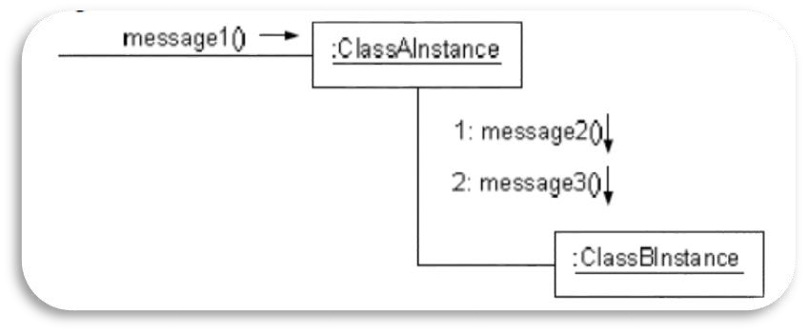

### Notations for collaboration diagram 1. Link

* Link illustrates a path of connection between **two** objects.
* Link indicates navigation/visibility between objects (if possible).
* Link is an instance of association.
* Link is the source through which messages flow.
* **Multiple messages and messages both ways can flow through same single link.**

### 2. Messages

* Each message between objects can be represented with a message expression.
* Small arrow indicates direction of message.
* A sequence number is added to every message.
* This number indicates the sequence in which the messages occur in the current thread of control.
* Legal number bearing scheme scheme can also be adapted

|  |  |
| --- | --- |
| message1() → Message 1 is | unnumbered |

.

1: message2()

1.1.message3()

*Practice problem will be covered in lecture regarding numbering, please focus on them.*

* **Multiple messages flow through the same link.**

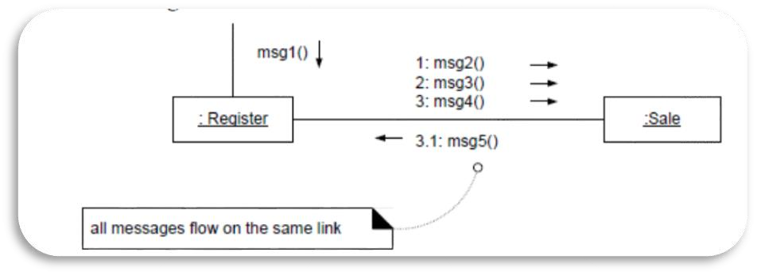

#### 2.1. Self-Messages / This Messages

* There is a possibility that a message is sent from the object to itself.
* This kind of message is illustrated by drawing a link to the object itself. ▪ The messages flow through this link.
* This is known as Messages to “this”.

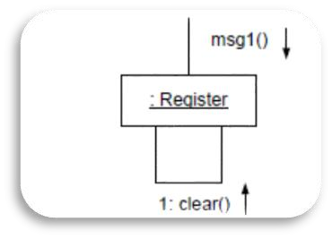

#### 2.2. Instance Creation

* Messages can be used for the creation of instance.
* For such messages always use the word “create”. ▪ This message may include different parameters. o Passing of initial values.
* In case you don’t want to use the word create, adapt this pattern i.e. <<create>>/n messageName. This is known as stereotyping.

#### 2.3. Conditional Messages

* Messages can be conditional, for illustrating such messages, sequence number is used with a conditional clause.
* This clause is written in square brackets.
* Message is sent only if the condition is true.

*1 [LabOOSE = pass] : passcourseOOSE()* → *This is written above link*

#### 2.4. Iteration / Looping

▪ Use a simple * (in case it is not important to show all the details).

1 * → Basic illustration

*1 * [i:=1..N] color := getColor ()*→ *This is written above link*

#### 2.5. Messages to Class Objects/Static Method Invocation

* This is not necessary that messages will always be sent to instance.
* Messages can be sent to class itself i.e. invoke class or static method.
* For the illustration of message being sent to class, name of the class box is not underlined. (If underlined means message is sent to instance).

|  |
| --- |
| Java.util.Collections |

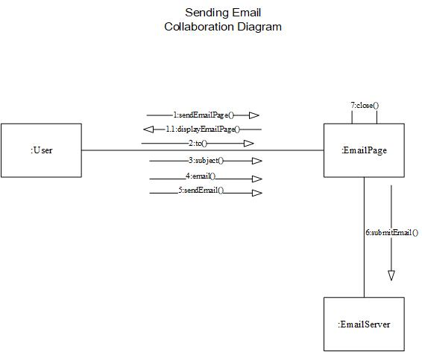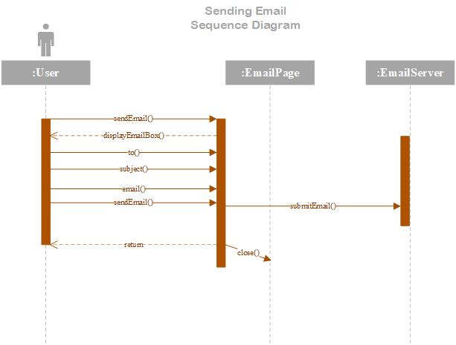

***For any queries***

***yellamehroze@cuilahore.edu.pk***

##### Office: H-Block – Room 23 (H – 23)