SCI Source Code Interviewer --- FUNCTIONAL OVERVIEW

HIGH LEVEL DESCRIPTION

With the advent of client server, Web environments, CASE, and the many other recent developments in the
Information Technology (IT) industry, providers of this technology have been faced with the problem of
how to move their mission critical legacy systems into environments that can take advantage of these
technologies. The migration to the tools that hold the promise of greater productivity has proven to be
anything but simple. What is needed is a way to retain the investment and intelligence in the legacy
systems and ease the migration to the tomorrows IT world.

Source Code Interviewer (SCI) is a highly automated reverse engineering tool designed to extract the
essential elements from an existing system and transform them into the building blocks of an INCASE
data model. Additionally, the application information retained on the SCI relational database
(data tables) can be used as static analysis data to understand a large application.
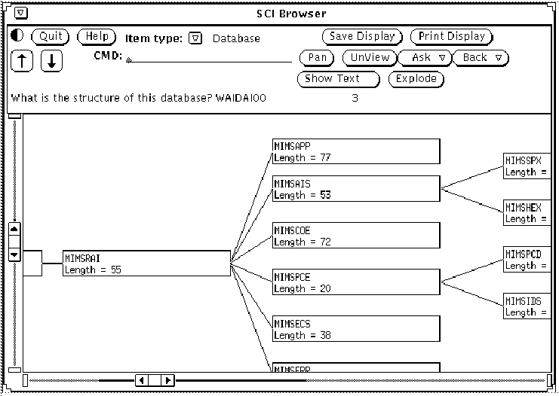

INTRODUCTION

There are a few words that should be defined to avoid confusion. These terms and their definitions are
those used by the industry in general.

Reverse engineering Extract, document, analyze, and understand application specific data
and logic from an existing application system.

Reengineering Change the application system by re-implementing the same system in
a different environment or platform with or without significant change
to the system's functionality

Redevelopment Change the application such that functionality is significantly changed.

Given these definitions it would be correct to call SCI a reverse engineering tool. It's output has been
tuned to work in a redevelopment project. The output would be used as a basis of the INCASE data
model. This would serve the bases is the forward engineering project. This diagram illustrates the flow
of a project.

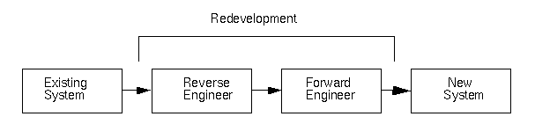

Figure 1. Redevelopment Life Cycle

SCI Goals

In it's current release, SCI is designed to extract the data tables, data elements, data table columns,
and relationships for an existing system. The goal is to extract sixty percent of the data model. In fact
SCI will very likely get ninety to ninety five percent of the tables and about the same percentage of data
elements. Because the discovery of relationships is far more difficult than that of the other objects, the
percentage of relationships which are discovered will be somewhat lower. The results of the analysis
should be used as a basis for the model in the new system. It will not be a complete model. However,
the results have proven to be of tremendous assistance in the construction of an INCASE data model.

SCI PROCESS

The SCI system is broken into three distinct phases. Each phase is composed of a series of scripts that
must be run completely in order to achieve the goal of extracting an INCASE data model. Each phase
is defined below.

Collection Phase

In this phase, the source files are collected from the customer and loaded into the SCI system. A check-
list is provided in the appendix of this document which contains a list of the various files which SCI needs
to perform it's analysis. Care should be taken when completing this step. It has been the case that when
collecting the files, some files are consistently missed. These files are typically copy members, JCL
procs or database definitions. When missing files are identified in the next step it can become necessary
to back all the way up to this point. For this reason it is essential that the step be completed correctly.

Acquisition Phase

Once the files are loaded onto the system, the analysis of those files can begin. First the JCL, screen
maps, and database definitions are parsed. The results are loaded onto the SCI database. When these
files are all parsed the SCI system has a complete knowledge of the environment in which the source
system operates. SCI can now analyze the source code. These parsers are, in essence, compilers
which generate rows in SCI's database instead of object code.

Discovery Phase

Once the source code is parsed, SCI has a complete understanding of the system. The code, now in
the form of the SCI database, is `interviewed' to determine the fundamental elements of the system
including data tables, data elements, data table columns, and relationships. These elements make up
the basis for the data model in the new system. SCI attempts to discover as much of the data model as
possible. However, the actual results are close to 60% of the model. The questions are the same type
of questions that have been asked by System Engineers for years such as `What are the files in this
system?' and `Which data elements are actually the same?'.

FEATURES

AUTOMATED DATA MODEL ACQUISITION

SCI is a highly automated system for the recovery of design elements from existing legacy systems. As
such it can operate in a mode that requires no user intervention what so ever. It is usually the case that
user intervention can significantly enhance the results of the analysis. By providing customer knowledge
of the system, decisions about what action to take on certain tables can make later automatic decisions
much easier and result in a more complete data model being produced.

SYSTEM UNDERSTANDING

Because of the way that SCI analyzes the source code and because of the thoroughness with which
the code is analyzed, the SCI database stores a complete understanding of what the system does and
how it does it. This information is available via reports and Browser.

SE PRODUCTIVITY

SCI can greatly improve the productivity of users by accelerating the speed at which data models are
developed. By starting from a point where the fundamental elements of an existing system are
transferred to INCASE, the user has a tremendous head start. Once this transfer of information has
been accomplished, the manipulation of these object is much easier in INCASE. The sooner these
objects can be imported, the faster the modeling phase will proceed. Even for well maintained systems,
analyzing the databases and files can be performed much faster by SCI than by hand.

APPRAISING CANDIDATE SYSTEMS

ARCHITECTURES/LANGUAGES

Explicitly Supported

The following languages are currently fully supported.

OS VS COBOL

COBOLII

Tandem COBOL

DEC COBOL

HP3000 COBOL

Unisys COBOL

PL/I

Implicitly Supported

Other versions of COBOL and PL/I may run through SCI. For instance, MPB COBOL and Ryan
McFarland COBOL have been successfully parsed with no changes necessary to SCI. However, there
is no guarantee that any new version will run correctly. In general if a version of COBOL is based on the
ANSI standard, SCI can handle it. The problems usually come in the form of language extensions. Every
version of COBOL will have special extensions that are implemented to take advantage of some
architectural features. Most programmers avoid using these extensions because it makes the code less
portable. If there is a version of COBOL that the user would like to be run through SCI which is not
currently supported, consult the language compatibility of this manual. Even if the extensions to the
base language cause errors in the translation, these errors may not effect the model.

DATA ACCESS METHODS

Explicitly Supported

Flat files

IDMS/DML

DB2

Tandem SQL

IMS/DB

VSAM

Implicitly Supported

In many implementations, the access to the database is restricted by calling (in COBOL with a CALL
statement) a module to do the actual access to the database. This module typically performs security
or auditing functions. These modules are referred to as Special I/O Modules in the SCI system. SCI can
treat these modules as the actual call to the database. The only negative effect of analyzing these
system is that no keys to the tables will be found because SCI can not resolve the program to the
database which the program uses. This same function handling scheme has been used to analyze
systems that use databases that are not explicitly supported. In these cases it is necessary for the SCI
team doing the analysis to be given a full understanding of the functioning of this module including all
of the parameters used by the module.

TELEPROCESSING PLATFORMS

Explicitly Supported

CICS

IMS/DC

In the current SCI release screens and screen maps are used only as documentation. They are parsed
and loaded into the SCI database and anytime a screen is used from within a program it is noted.
However, the screens are not passed to INCASE.

FACTORS AFFECTING THE DATA MODEL

Some characteristics of a system can affect the data model - some good, some bad. Negative factors
should not be a reason to withhold a system from the SCI process. What it means is that ones level of
expectation on the completeness of the data model should be influenced by these factors and be a
guide on how much user input may be required.

Data Access Method Used

Database access is generally a positive characteristic because of the explicit declaration of the keys.
This improves the ability of SCI tools to infer relationships between data tables. Because of the similarity
between relational databases and data modeling, databases like DB2 produce excellent data models.
Flat files, on the other hand, generally have a lower percentage of identified keys (unless the keys are
explicitly coded in the File Declaration section), which degrades the relationship inference ability.

Data Dictionary/Copy Member Usage

Use of a data dictionary and/or copy members helps in producing a cleaner data model by reducing the
number of duplicate data tables and data elements. Some very primitive normalization of data elements
is performed based on variable names and their attributes. This has a very positive affect on the data
model.

Special I/O Modules

Even though special I/O Modules are supported and accurate data tables are produced, this one level
of indirection prohibits the tying of an I/O structure to a database if it exists and will always prevent the
automatic identification of data table keys. This is generally seen as having a negative effect on the data
model's relationships, unless user manually identifies the keys via the SCI on-line tool Export
Maintenance.

Assembler Modules and other languages

SCI is currently structured to support third generation languages (3GL). As such it can not handle
assembler. If a significant portion of the application (excluding special I/O modules) is written in this
language, the possibility of getting the complete data model is in question. This has negative effects on
the data model.

PL/I Indirection

Due to the nature of PL/I, indirection can lead to the lack of connectivity between an I/O statement and
a database (such as IMS). The advantages of databases as described above are lost. Applications
which are coded with an very heavy use of pointers has a negative affect on the data model. Light or
`normal' use of pointers causes no problems.

EXECUTION ENVIRONMENT

There are certain architectural elements that run through all phases of the SCI system. These are listed
here and should be remembered throughout the running of the source code.

CLIENT/SERVER

The SCI system runs in a client server environment. The basic configuration is to run the SCI database
as a server and all of the SCI programs as clients. There are several ways that the work load can be
distributed among the various machines on the network.

In all cases it is desirable to dedicate a machine on which to run the Sybase server. This is a highly
intensive process that can consume most if not all of a machine's capacity. There is one exception to
this and that is the `bcpload.sh' script. This script actually loads data into the SCI database. As such, if
it is run on the same machine as the dataserver is running, the process can proceed somewhat faster
because of a decrease in network traffic.

The `translate.sh' script can run in a distributed mode. There can be several versions of this script
running on different machines on the network. This allows maximum utilization of the resource on the
network. The translation of the source code can be very resource intensive and there should be at most
one version of this script running on a machine. An ideal configuration for the translation of the source
code would look something like this:

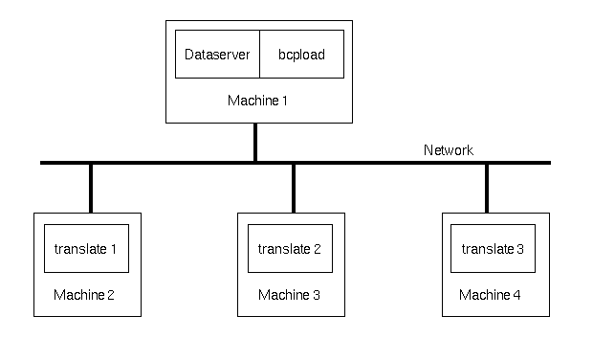

Figure 2. Distributed Client Server Environment

The specifics of each of these processes will be explained in detail in later chapters. However, the basic
point is that the user should never run any process on the machine running the dataserver unless that
process is the `bcpload.sh'. In all other situations, the dataserver should run on it's own machine.

$REPARMS ENVIRONMENT VARIABLE

Multiple SCI projects can be underway using the same SCI scripts and programs. To determine which
project's data is to be used, the SCI scripts look for a UNIX environmental variable called $REPARMS.
The user should set this before executing any script.

unix: setenv REPARMS project

Consult the Collection Phase for additional details.

SETUP.PARMS

The file `$PROJECTDIR/setup.parms.project' is generated at the start of the process when the user
runs the `re_configure.sh' script. It is a series of variables whose values are set when ever an SCI script
is started. These variables control the way in which SCI operates and controls the dataserver that SCI
runs against, the name of the database, and the user IDs under which the SCI programs run. Additional
details can be found in the Collection Phase chapter.

To have the environment variables available in the users shell, one can `source' this file. Afterwards, the
variable can be used in a command and UNIX will substitute the proper value. For example, to change
from the current directory to the projects root directory, type:

unix: setenv REPARMS project

unix: source /usr/re/setup.parms

unix: cd $PROJECTDIR

Most scripts in SCI do this as their first statement. It should never be a problem for a user to do this.

RUNCMD

Many of the scripts used by SCI are executed through a utility called `runcmd'. This program sends all
output messages from a script to the screen and simultaneously stores it in a file. It should be used
whenever indicated so that a record of the output can be preserved. See the Command Reference for
additional details.

DATABASE STRUCTURE
The SCI database consists of the following tables:
arg_list
audit
c_value
compile_unit
copy_xref
cu_maj_entity_xref
database_dd
db
db_group
db_group_element
dcb
dead_code
dead_code_arg_list (unused)
dead_code_statement (unused)
exec_bin
exec_bin_comp_unit_xref
exp_column_sample_data
exp_data_element
exp_data_table_column
exp_data_table_to_relnode
exp_logical_data_table
exp_relate_node
exp_relnode_to_data_table
field
files
generic_key
jcl_proc
job
jobstep
js_exec_file_xref
literal
loop (unused in release 2.0)
major_entity
node
opcode
person
person_cu_xref
procstep
psb
scr_field
screen_io
screen_io_var_xref
screen
screen_set
seed_table
segment
source_file
ss_mods
statement
storage_area
subsystem
sys_control
tag_compile_unix_xref
tag_xref
tags
variable

