**ASSIGNMENT:**

**NAME: MUHAMMAD AREEB**

**SID: 12067**

**ANSWER 1:**

**OUTPUT:**

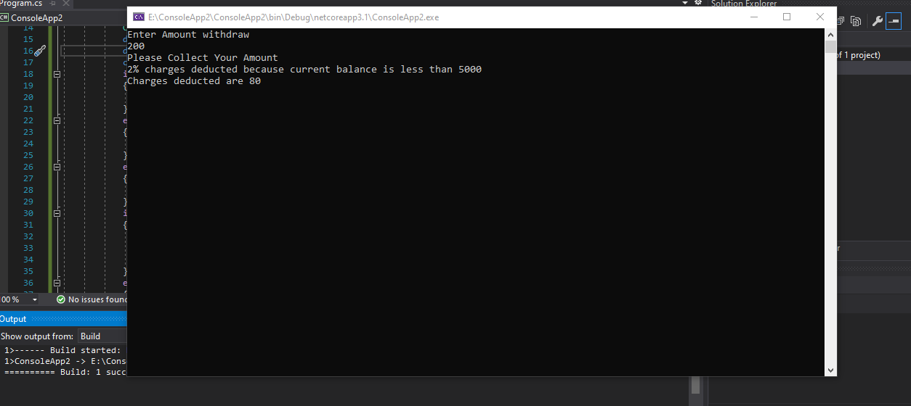

**CODING 1.1:**

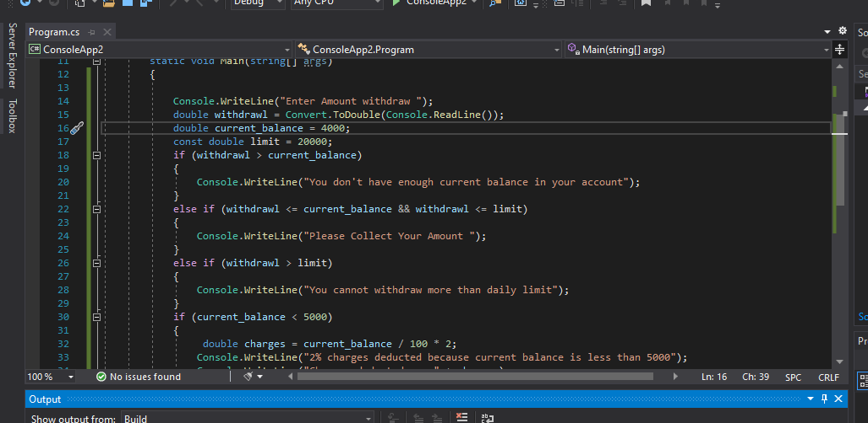

**CODING 1.2:**

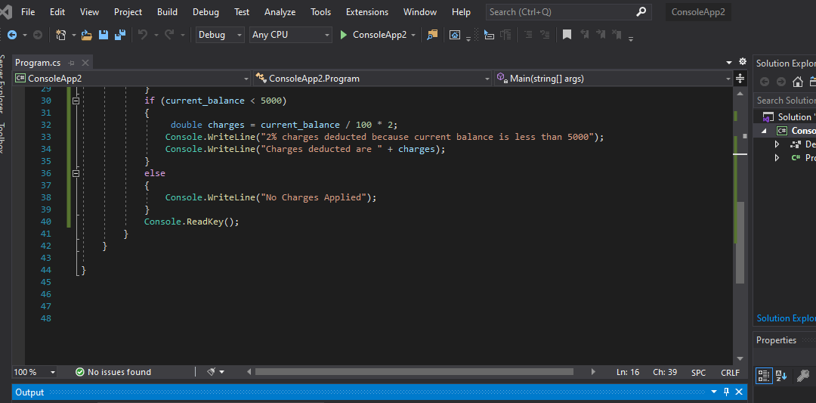

**ANSWER 2:**

**OUTPUT:**

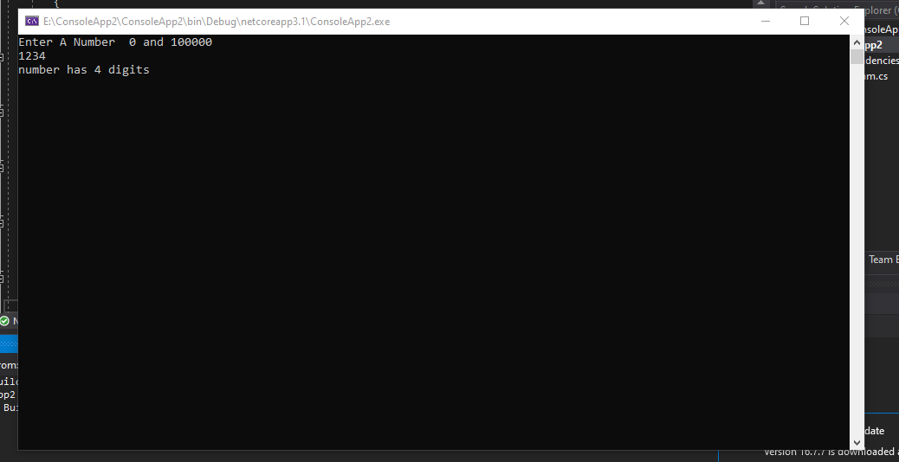

**CODING 2.1:**

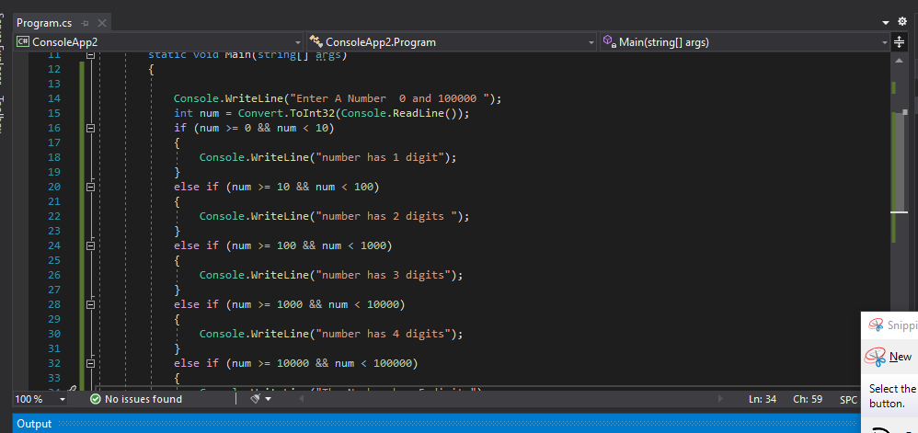

**CODING 2.2:**

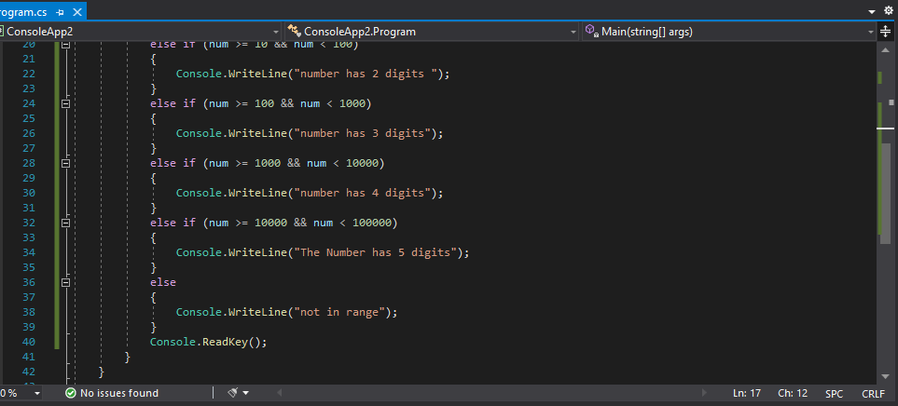

**ANSWER 3:**

**OUTPUT:**

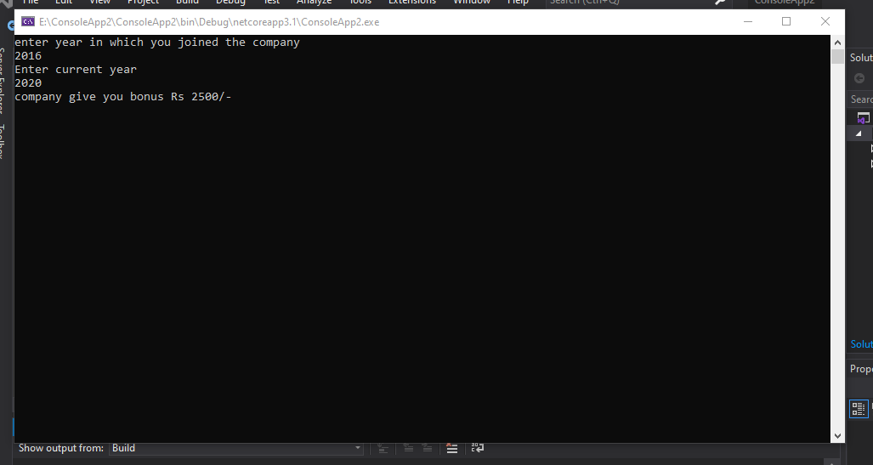

**CODING 3:**

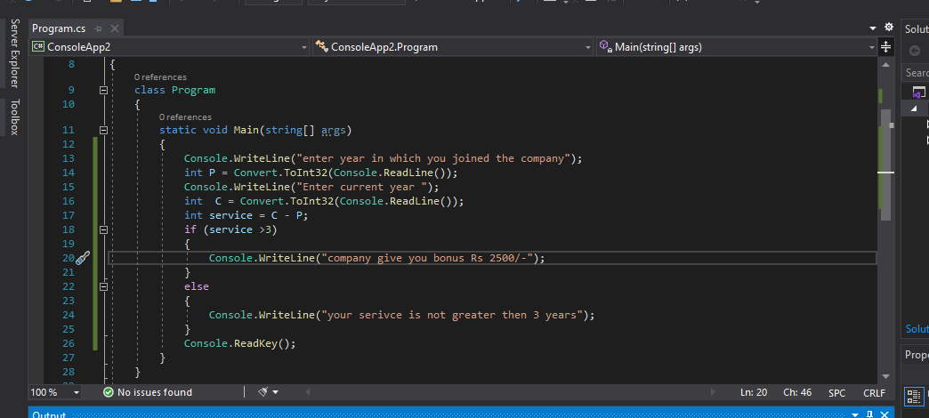

**ANSWER 4:**

**OUTPUT:**

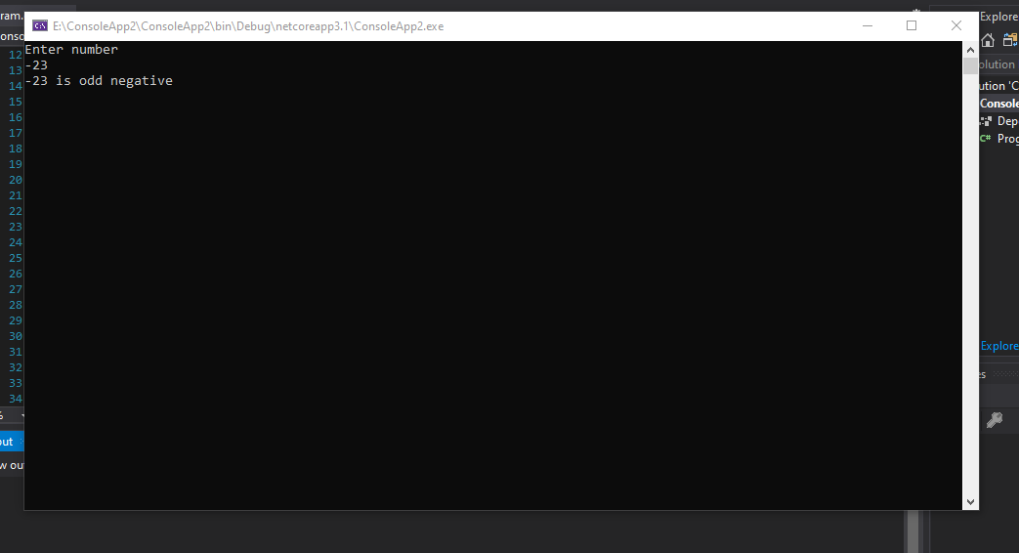

**CODING 4:**

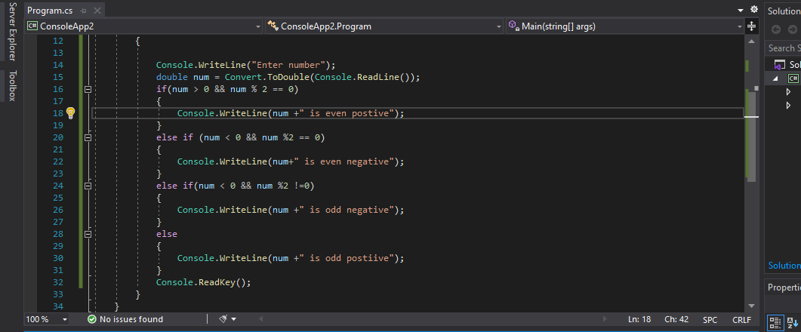

**ANSWER 5:**

**OUTPUT:**

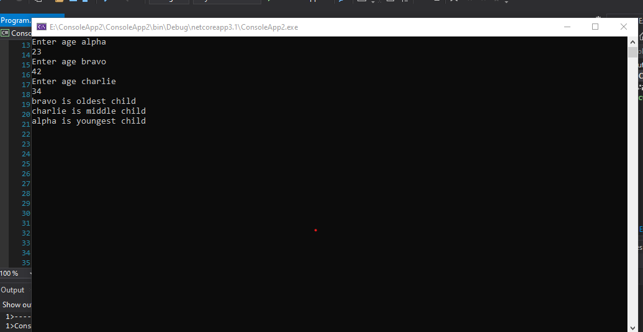

**CODING 5.1:**

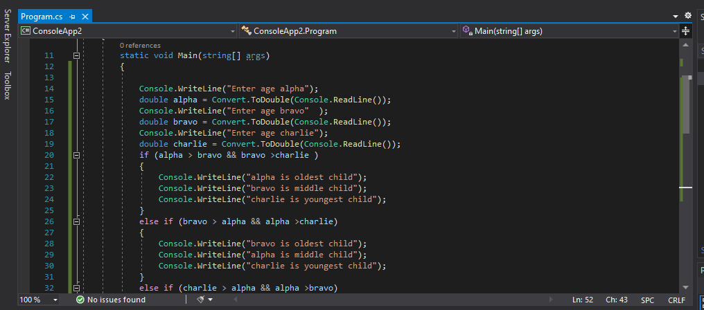

**CODING 5.2:**

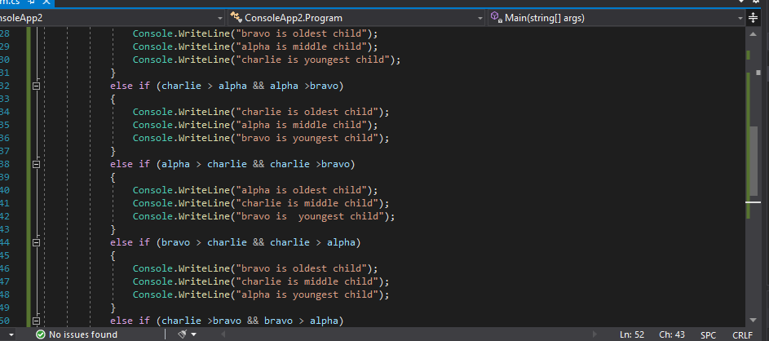

**CODING 5.3:**

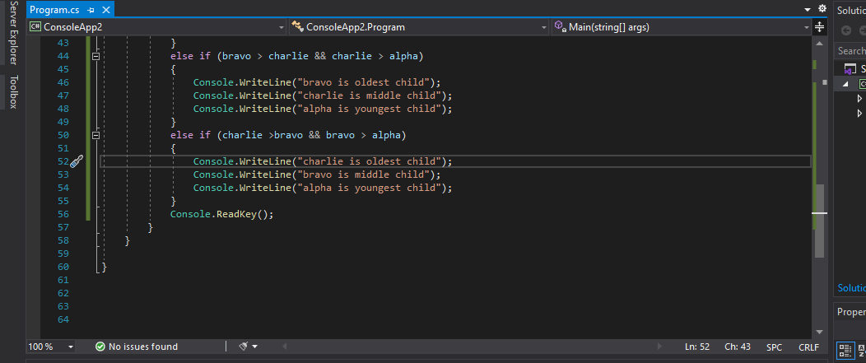

**ANSWER 6:**

**OUTPUT:**

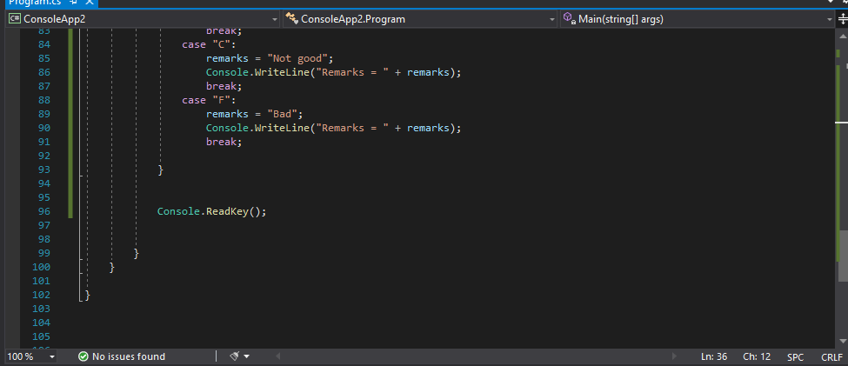

**CODING 6.1:**

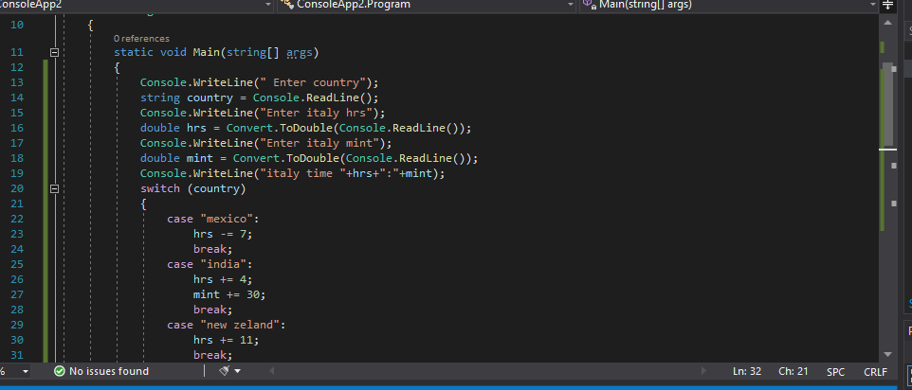

**CODING 6.2**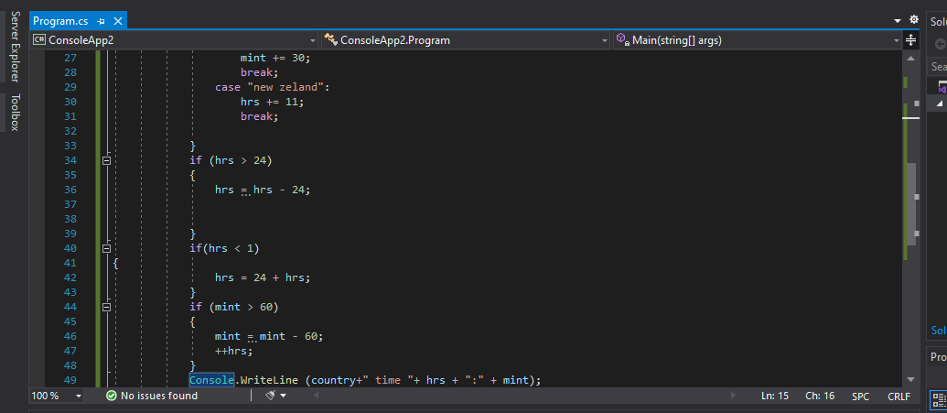

**ANSWER 7:**

**OUTPUT:**

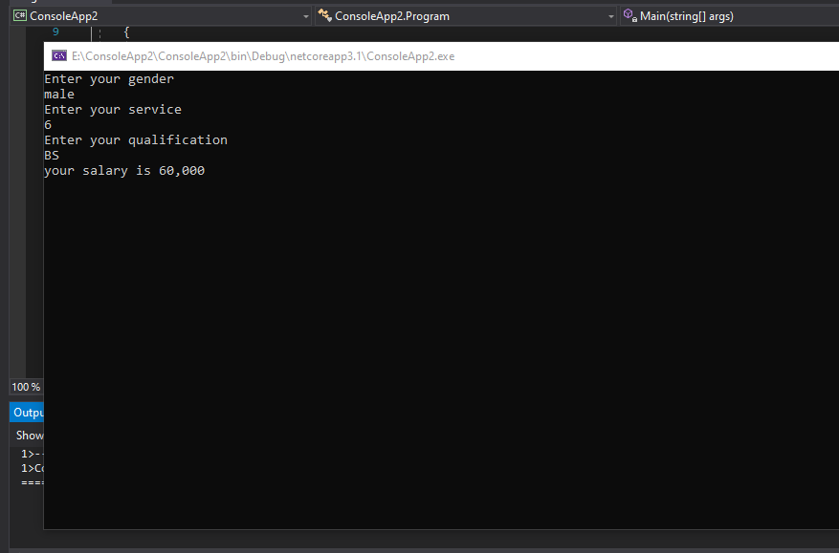

**CODING 7.1:**

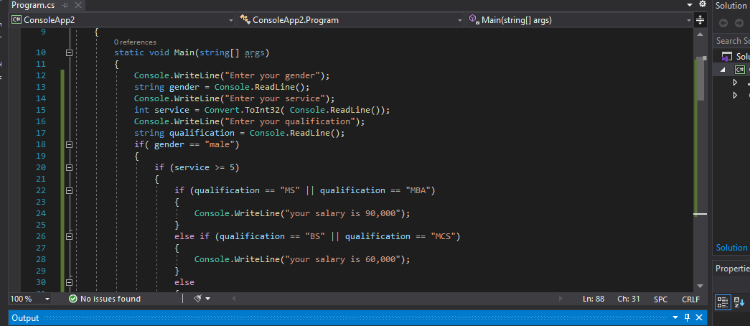

**CODING 7.2:**

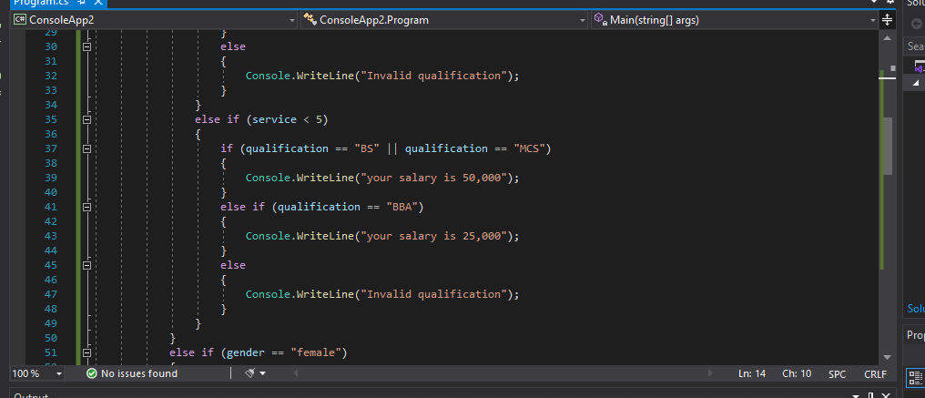

**CODING 7.3:**

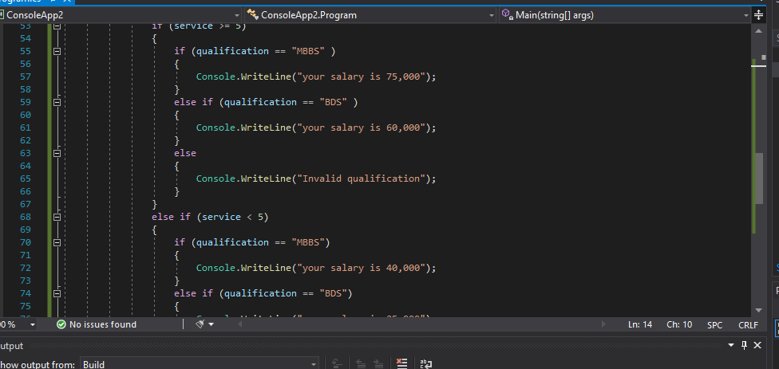

**CODING 7.4:**

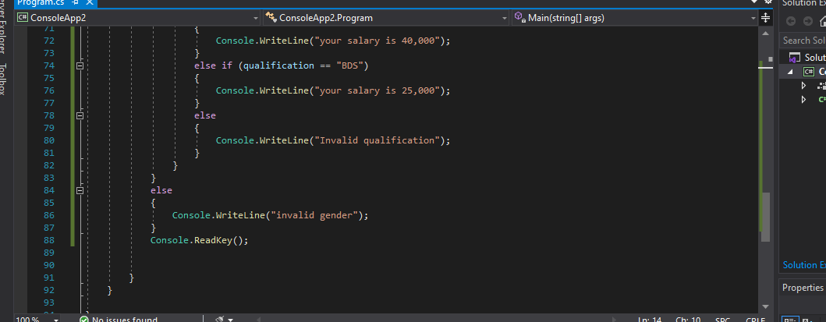

**ANSWER 8:**

**OUTPUT:**

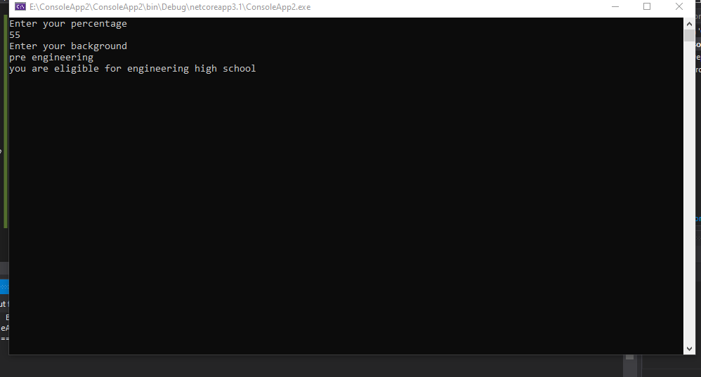

**CODING 8:**

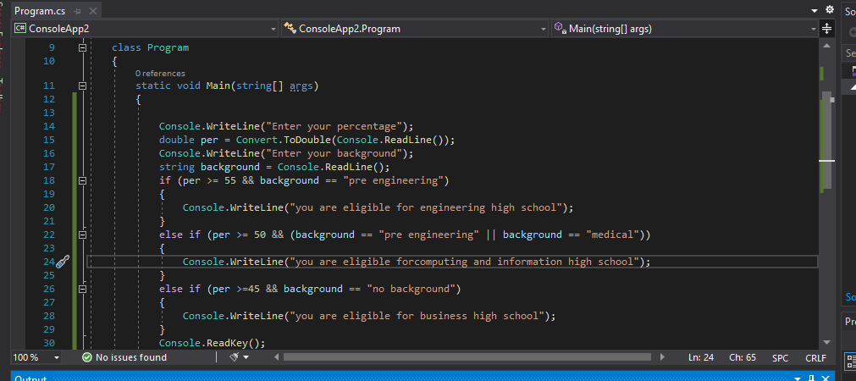

**ANSWER 9:**

**OUTPUT:**

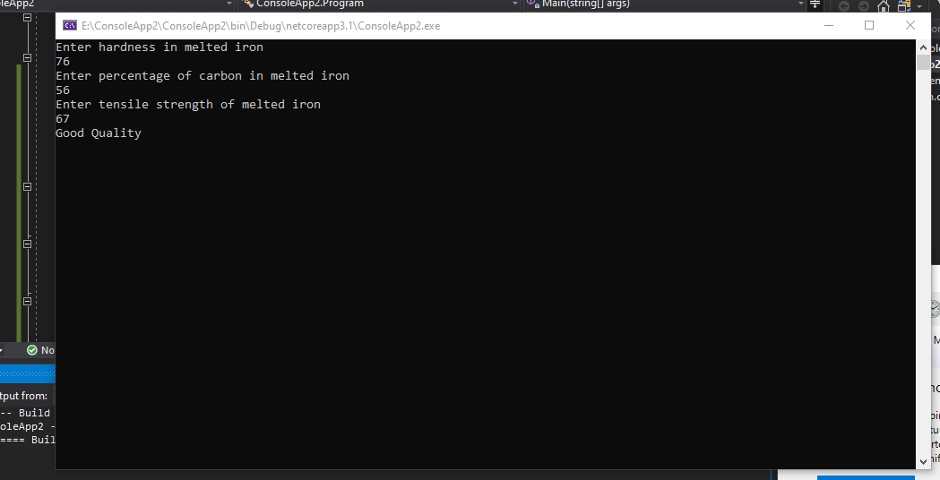

**CODING 9.1:**

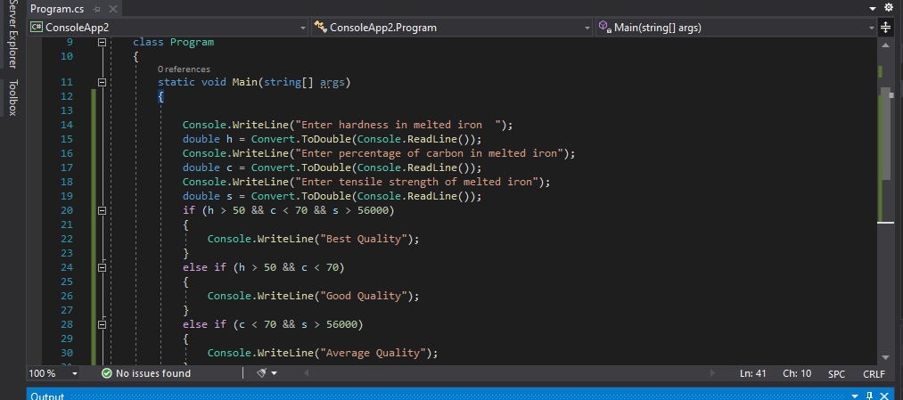

**CODING 9.2:**

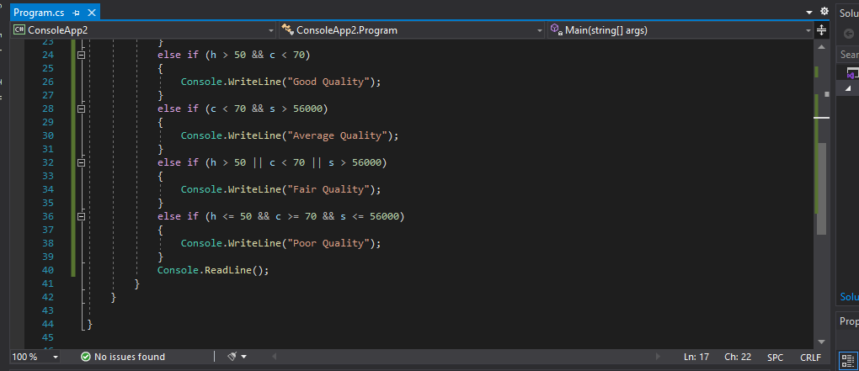

**ANSWER 10:**

**OUTPUT:**

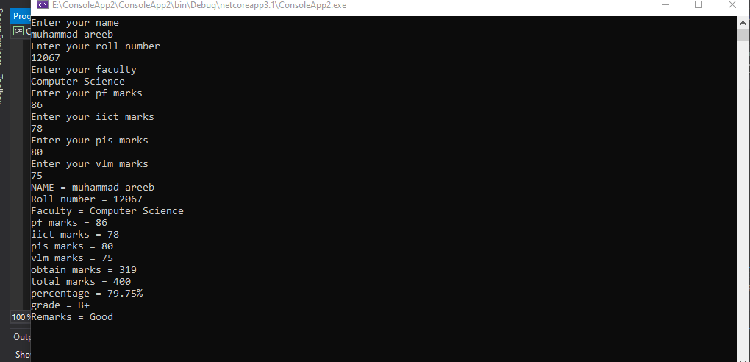

**CODING 10.1:**

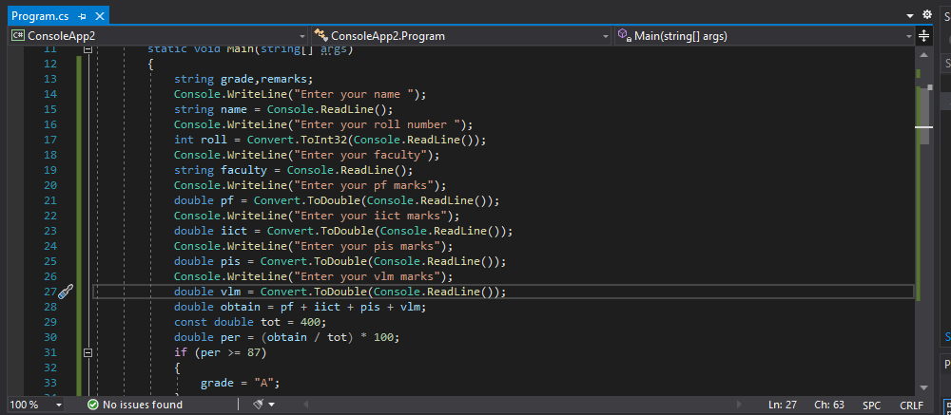

**CODING 10.2:**

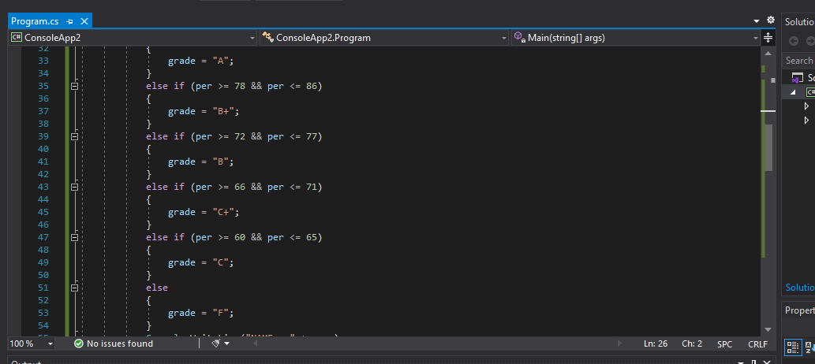

**CODING 10.3:**

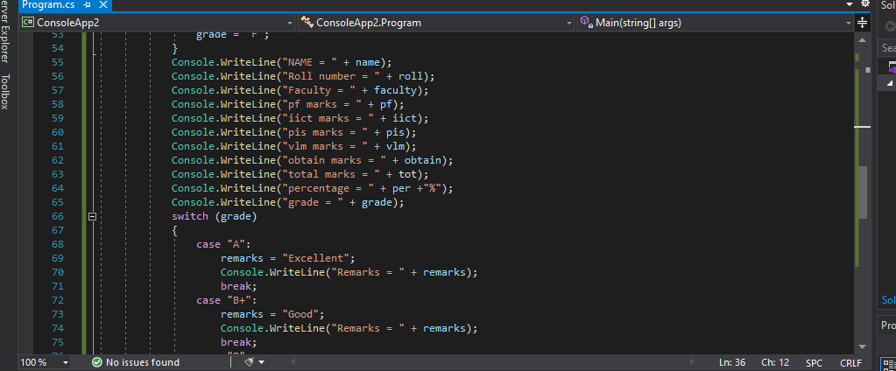

**CODING 10.4:**

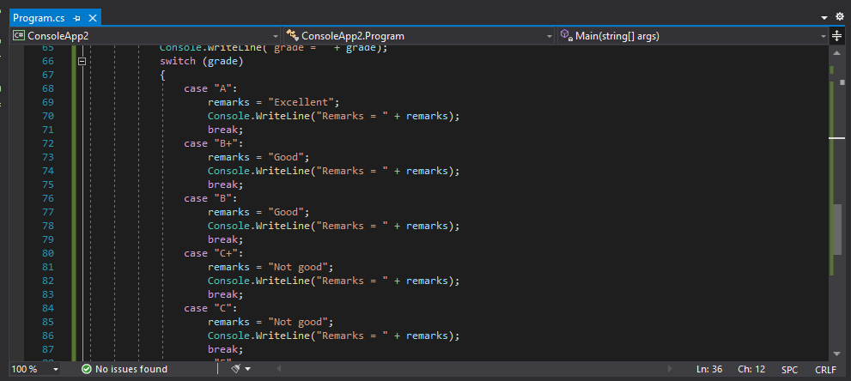

**CODING 10.5:**

