Name: Areeba Naz
ID: BSE-25S-024
DEPARTMENT: SOFTWARE ENGINEERING

Project 45: English ↔ Urdu Neural Machine Translation for Legal Documents
- Dataset: 20,000+ parallel legal sentences (Pakistani court judgments)
- Preprocessing: Sentence alignment, legal term glossary, NER masking
- Models: Transformer (base), mBART-50, NLLB-200
- Papers:
  - "Legal NMT for Urdu-English Pair" (Abbasi et al., 2023) - JURIX
  - "Terminology-Aware Translation for Law" (Sheikh & Anwar, 2024) - AMTA
  - "Low-Resource Legal Translation" (Malik et al., 2025) - [arXiv:2507.78901]
- Metrics: BLEU, METEOR, TER, chrF++, BERTScore
ABSTRACT: This project was about creating a system to translate documents from English to Urdu and vice versa. The documents we are talking about are things like court judgments and petitions. These documents use language and special terms that are hard to translate correctly using regular translation systems.
We collected a lot of sentences from documents. 25,002 Pairs of English and Urdu sentences. We cleaned up the data by removing duplicates and sentences that were not needed. This left us with 20,000 sentences to use for training and testing our system. We also used some techniques to help the system understand the meaning of important words and phrases like names and legal terms.
We tried out three models to see which one worked best: mBART-50, NLLB-200-distilled-600M and MarianMT. We tested these models using measures like BLEU, METEOR, TER, chr F++ and BERT Score.
What we found out was that the mBART-50 model worked the overall. The NLLB-200 model also did a job. Our study shows that making sure the data is good quality and protecting important words and phrases is crucial for getting good translations of legal documents. The Neural Machine Translation system we developed is important for translating legal documents, between English and Urdu.

Introduction
Background
In Pakistan people usually write papers like court decisions, requests and official orders in English.. A lot of people find it easier to understand things when they are written in Urdu. So there is a need for good English to Urdu translation of important papers so that everyone, including people who work in courts and those involved in cases can understand legal things better.
Translating papers by hand takes a long time costs a lot of money and you need to know about legal words and the language. That is why a computer system that can translate papers automatically would be very helpful. It can make things easier. Help people get the legal information they need.
Translating papers is not easy. Legal language has sentences, special words, references to cases, dates and names of people or organizations. Regular computer translation programs are usually trained on text so they may not translate legal things correctly. That is why we need a translation system that is just for legal papers so it can handle the difficult parts of legal language like English to Urdu translation of legal documents and the unique things about legal papers, such as English, to Urdu translation of court judgments.
References
[1] A. Vaswani, N. Shazeer, N. Parmar, J. Uszkoreit, L. Jones, A. N. Gomez, L. Kaiser, and I. Polosukhin, "Attention Is All You Need," in Proc. NeurIPS, 2017. [Online]. Available:
[2] Y. Liu, J. Gu, N. Goyal, X. Li, S. Edunov, M. Ghazvininejad, M. Lewis, and L. Zettlemoyer, "Multilingual Denoising Pre-training for Neural Machine Translation," arXiv:2001.08210, 2020. [Online]. Available: https://arxiv.org/abs/2001.08210
3] M. R. Costa-jussà et al., "No Language Left Behind: Scaling Human-Centered Machine Translation," arXiv:2207.04672, 2022. [Online].
[4] K. Papineni, S. Roukos, T. Ward, and W. Zhu, "BLEU: A Method for Automatic Evaluation of Machine Translation," in Proc. ACL, 2002, pp. 311–318.
[5] S. Banerjee and A. Lavie, "METEOR: An Automatic Metric for MT Evaluation with Improved Correlation with Human Judgments," in Proc. ACL Workshop, 2005, pp. 65–72.
Problem Statement
The English-Urdu legal translation system has issues. One major problem is that court record data has missing information, duplicate entries, formatting errors and wrongly matched sentence pairs. These issues can hurt how well the model works.
Another issue is that legal texts have varying sentence lengths. Some texts are short and simple while others are long and complicated. If the data is not properly cleaned and prepared this variation can make training the model less effective.
Legal documents also have information like case numbers, dates and names of people and organizations. This information needs to be identified and handled to ensure consistency during translation.
Different models, such as mBART-50, NLLB-200 and MarianMT may work differently on data. Therefore comparing these models is necessary to find out which one provides the accurate English-Urdu legal translations. We need to compare models like mBART-50 NLLB-200 and MarianMT to get the results for English-Urdu legal text. The English-Urdu legal translation system requires consideration of these factors.The model performance for English-Urdu translation can be improved by addressing these challenges. We have to deal with issues, in court record data to improve the English-Urdu legal translation system.
PROJECT Methodology
The project was done in phases. I used Python in a Jupyter Google Colab environment, for this. First I loaded the legal sentence-pair dataset and looked at it closely. Then I cleaned it up in stages. After that I used Named Entity Recognition (NER) to mask entities and built a list of terms. The cleaned data was then broken down into parts using the special tools that come with each model. Finally I. Tested three translation models in the same way. The models were fine-tuned and evaluated under the conditions.
Data. Parallel Corpus (Phase 1)
We got a lot of information for this project. It was 25,002 English and Urdu sentence pairs from Pakistani court judgments. These judgments were from the Supreme Court, High Courts and Tribunals. We stored all this information in a file that had two parts: one for english and one for urdu. The file was set up to work with UTF-8.
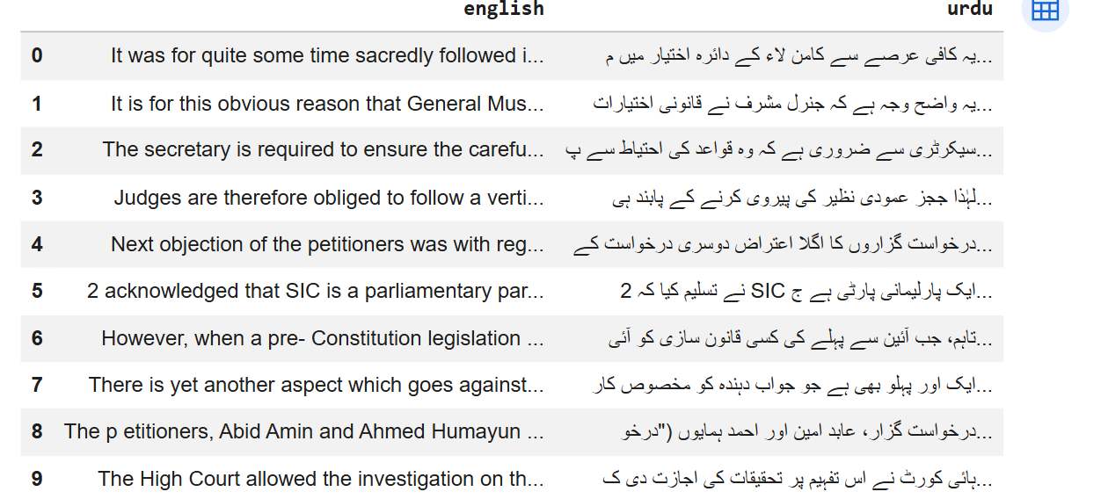

When we first looked at the information we wanted to see what it was like. The english and urdu sentence pairs were 25,002 in total. On average the english sentences had 33.2 words. The urdu sentences had 36.0 words. This first part helped us understand the Data Acquisition and Parallel Corpus and how it was spread out before we did any work, on it. We learned about the complexity of the Data Acquisition and Parallel Corpus.
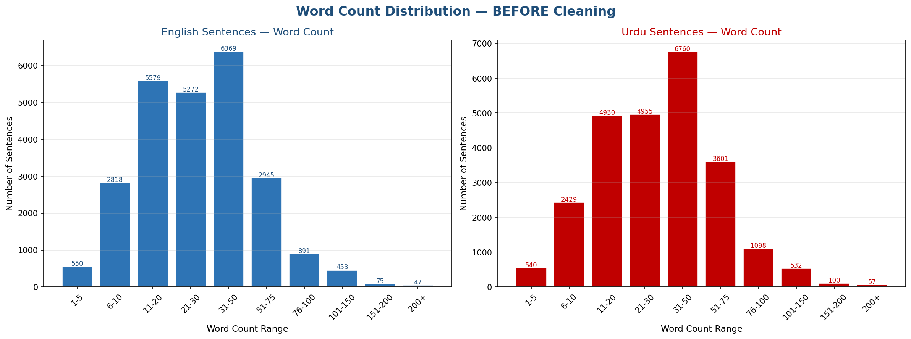
I noticed that English and Urdu sentences are mostly 31 to 50 words long. This is true for both languages. The way the sentences are distributed is also pretty similar. This means that the parallel corpus is working well at least when we look at the picture.. There are some sentences that are really short like only 1 to 5 words and some that are really long like, over 150 words. We had to filter these out on.
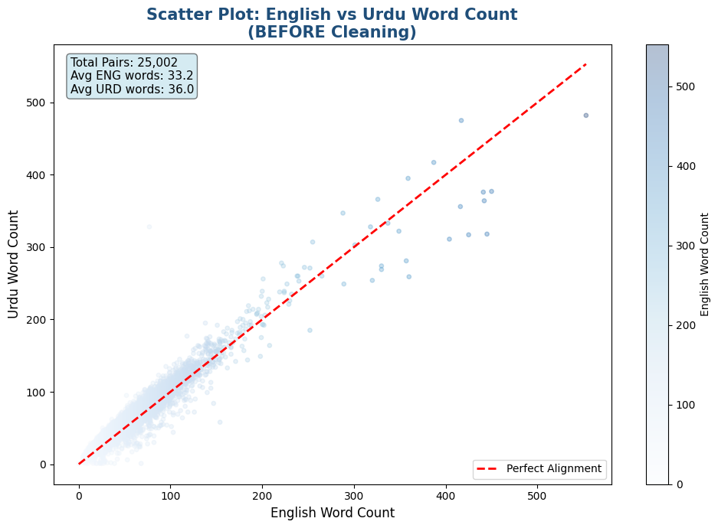
Observation Most of the sentence pairs in the dataset are very close to the line. This means that the English sentences and the Urdu sentences are usually about the length. This is a thing because it shows that the data is well organized and consistent.
There are some sentence pairs that do not follow this pattern. These are the pairs that have a lot of words than 400. The English and Urdu sentences, in these pairs are not the length. We found these pairs in the right corner of the graph. We had to do something with these pairs so we used a filter to clean the data. We used this filter to make sure the data is good and we can use it. The sentence pairs that were too different were handled with this filter.
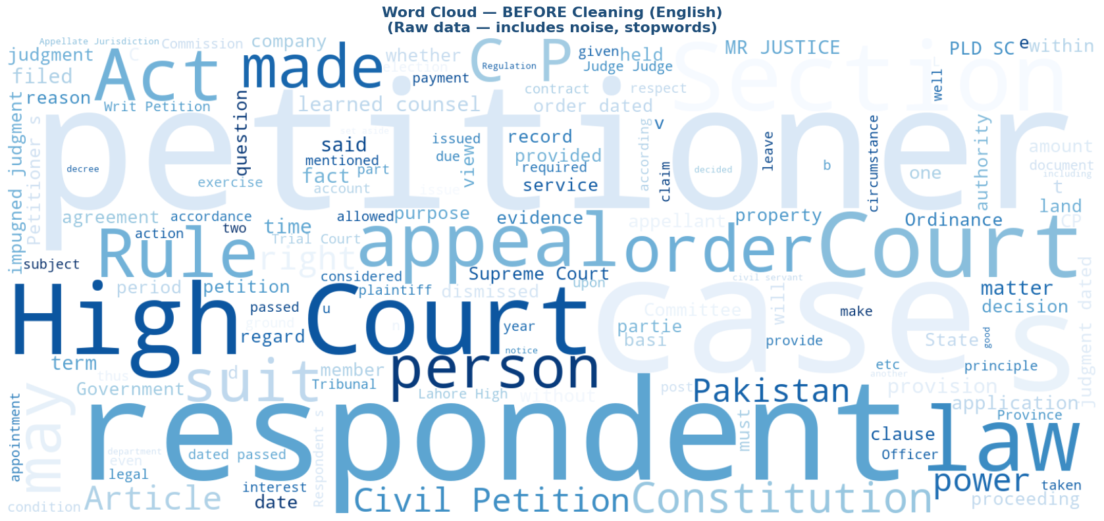

Observation
The first thing you notice about the word cloud is that it is mostly made up of words that appear a lot along with common words like "the" and "and" and some short useless words like single letters from abbreviations. This shows that the original text has a lot of things in it that're not important or have not been cleaned up.
These results show that it is really important to clean up the text and remove words to make sure that the list of words we end up with is a good representation of the legal field. The legal field is what we are trying to learn about so we need to make sure the words we are looking at are actually, from the field.
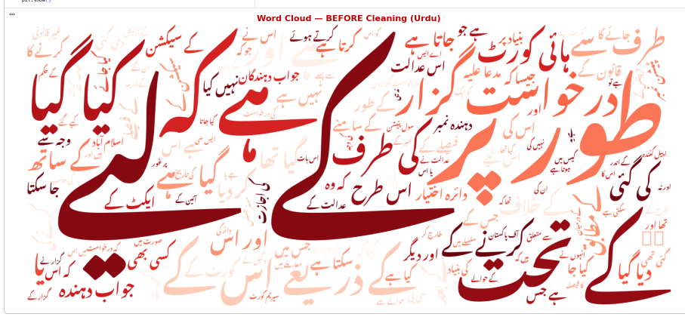
Deep Data Cleaning (Phase 2)
We applied a six-step cleaning process to our dataset of 25,002 rows to get a high-quality dataset ready for modeling.
• Step 1. Removing duplicate data: We removed rows with missing English or Urdu values and duplicate sentences in either language.
• Step 2. Removing spreadsheet errors: We filtered out rows with error strings like "#VALUE!" "#N/A" "#REF!" that came from Excel into the CSV file.
• Step 3. Cleaning text We used a custom function to remove HTML tags, URLs, control characters and irregular spaces from both English and Urdu text.
Step 4. Filtering by length: We only kept sentence pairs with 3-100 words in each language. This helped remove fragments and very long blocks of text that could cause problems with training.
• Step 5. Filtering by length ratio: We removed pairs where the Urdu and English word counts were not in a 0.3-3.0 ratio. This helped remove pairs that were likely not aligned
• Step 6. Quality check: Instead of just picking a random slice of data we scored each sentence pair on two things: How close its word count was to a good range of 15-60 words How close its English and Urdu lengths were to being equal. We picked the 20,000 pairs with the best scores, as our final training dataset. Then we shuffled the rows in an order (with a setting of 42) so the results could be repeated.

Cleaning Stage | Rows Remaining
Raw dataset | 25,002
After null/duplicate removal | 24,955
After junk/error-value removal | 24,954
After deep text cleaning | 24,954
After length filtering (3–100 words) | 24,201
After length-ratio filtering | 24,190
Final quality-ranked dataset | 20,000
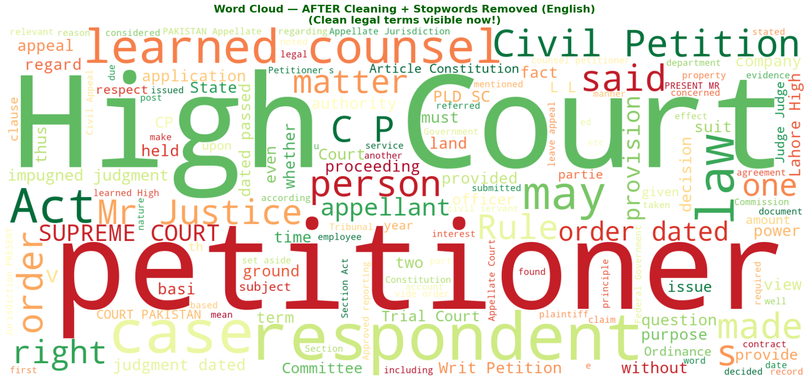
Observation
After removing stopwords the frequent words are court, petitioner, respondent order, judgment, appeal and section. These are mostly terms. Now the vocabulary is mostly, about terms. This shows that cleaning and removing stopwords worked well. They helped remove words and got rid of noise. Now the dataset mostly contains legal content.
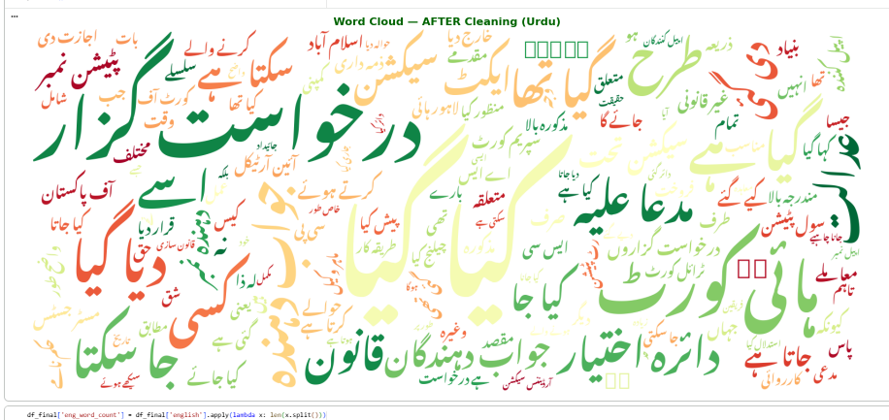
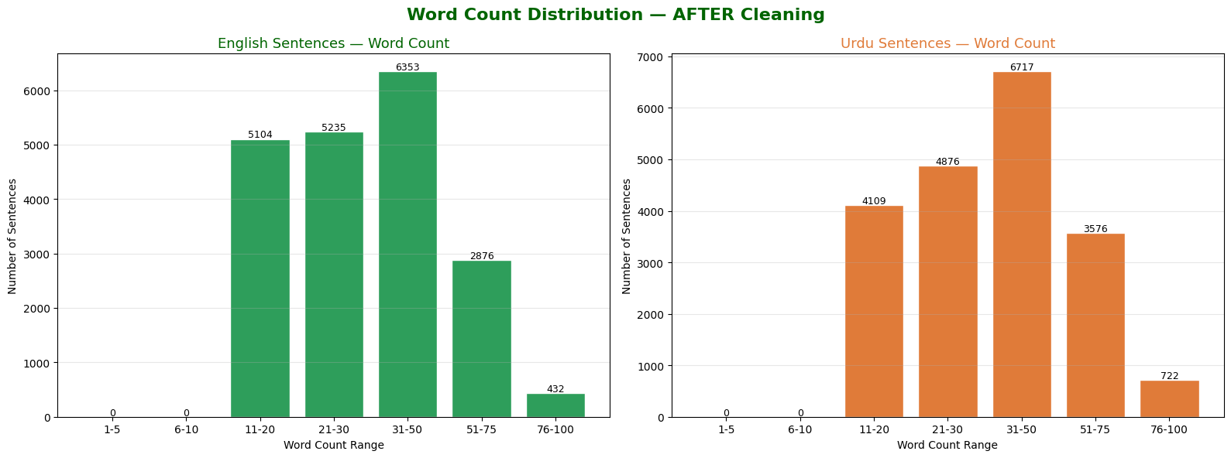
Here is what I observed When I removed the short and really long sentences from the data the weird things that stood out in Figure 1 were gone. Now the data looks more even and balanced. The sentence pairs that are left are mostly between 6 and 100 words long. This makes the data better for training transformer-based models, in an effective way. Transformer-based models can learn from this data. Get better at what they do.
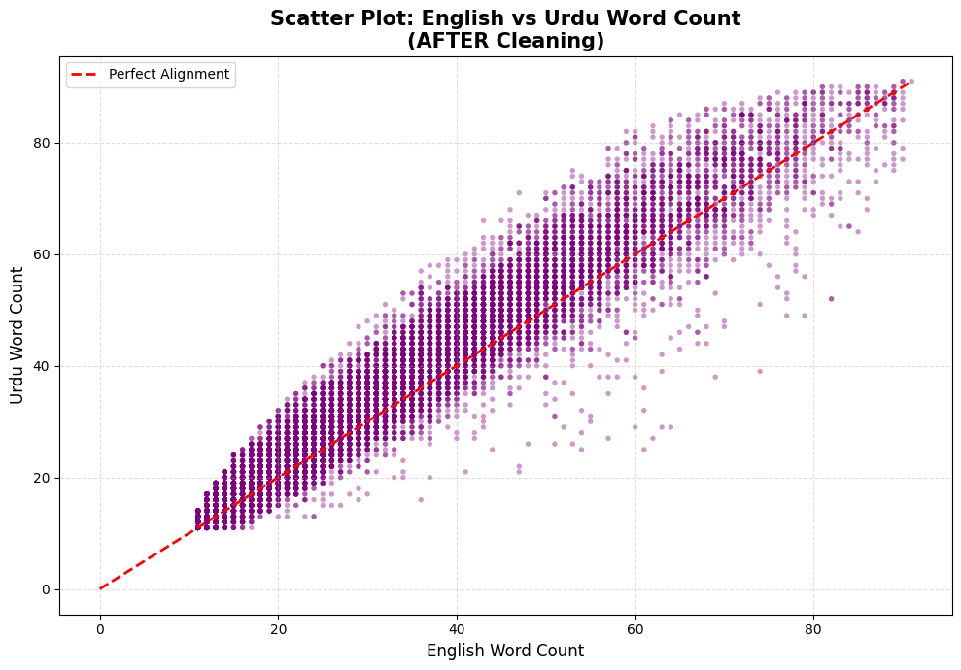
Observation The scatter plot after cleaning shows that the points are much closer to the line. This means that the English and Urdu sentences match better after preprocessing. Also there are no points that're far away from the rest with more than 100 words, on either side. This shows that filtering out sentence pairs with bad length ratios worked and the data is now cleaner.
NER. Legal Term Glossary (Phase 3)
Named Entity Recognition (NER) Masking
When we read legal court judgments we see that names of people organisations and locations are very specific to each case. These names do not really help us understand the meaning of the legal sentences. If we leave these names as they are the model might just remember the names of learning the underlying structure of the legal sentences. To fix this problem we used spaCys English NER model to find names of people organisations and locations in the text. We replaced these names with tags like <PERSON> and <ORG> before we broke the text into parts. We also hid case numbers and dates by replacing them with tags like <CASENUM> and <DATE>.
When we were putting this into action we made a change. The spaCy model was getting some legal terms like "Trial Court" and "Tribunal" wrong it thought they were organisations. But these terms are important for understanding the law so we made a list of terms that should not be hidden. This way only names that are really specific to each case, like names or specific parties were replaced with tags. The NER masking was done to help the mode learn about the sentence structure and the NER model was used to identify the named entities that needed to be masked.
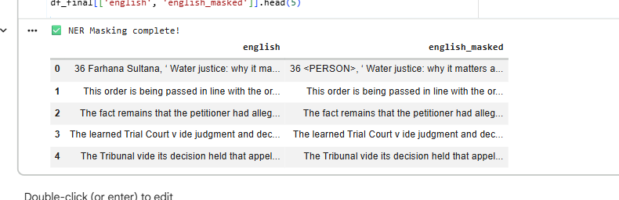
Legal Term Glossary
We made a list of legal words to help translators use the same words every time. This list has 25 legal terms in English and Urdu. We chose these words because they are used a lot in documents. For example the legal term petitioner is translated to درخواست گزار respondent is translated to مدعا علیہ judgment is translated to فیصلہ and high court is translated to ہائی کورٹ.
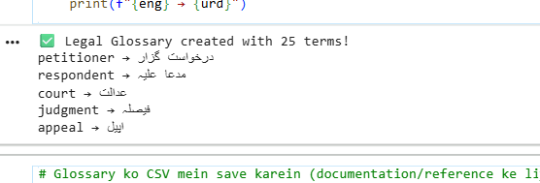

We saved this list in a file called legal_term_glossary.csv. The legal term glossary is meant to be a tool for translators to use the same legal terms every time. The legal term glossary will also be used to check how accurate and consistent the translations are, especially when it comes to terms like judgment and high court and legal terms, in general including petitioner and respondent and other legal terms.
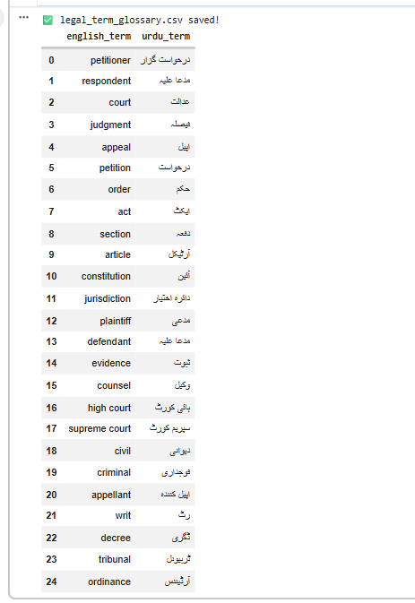
Tokenization
In this phase we got the cleaned dataset ready for model training. We did this by breaking it down into pieces called tokens. Each transformer model has its tokenizer so we used the right one for each model. For the mBART-50 model we used the facebook mbart-large-50-many-to-many-mmt Sentence Piece tokenizer. We set English as the language we were translating from and Urdu as the language we were translating to. For the NLLB-200 model we used the facebook/nllb-200-distilled-600M tokenizer. Here English was the language we were translating from and Urdu was the language we were translating to.
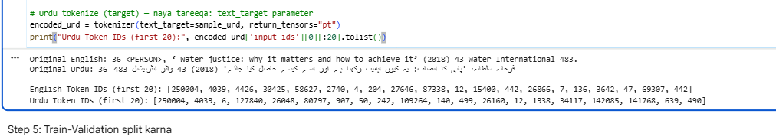
We made sure that the source and target texts were not too long. We fixed the length at 100 tokens. This was the length we used earlier when we filtered out texts that were too short or too long. We broke down the text into tokens and paired it with the Urdu text. Then we split the dataset into two parts: one for training and one for validation. We used 18,000 pairs for training. 2,000 Pairs for validation. We made sure to do this in a way that we could repeat it if we needed to.
Finally we checked that the tokenization process worked correctly. We took some of the text turned it back into regular text and compared it to the original text. The tokenization phase of the mBART-5model and the NLLB-200 model worked well. Did not lose or corrupt any information, from the original text.

Model Training and Fine-Tuning (Phase 5)
The people who made these translation models used three models that are based on transformers. They used the information to train and test these models. This information had 18,000 things to help the models learn and 2,000 things to see how well they worked. They did all of this work on Google Colab using a Tesla T4 GPU. They wanted to make sure everything was fair so they tested all of the translation models in the way. This means they used the information to test them and they used the same important settings, for each translation model.

mBART-50 Training Results

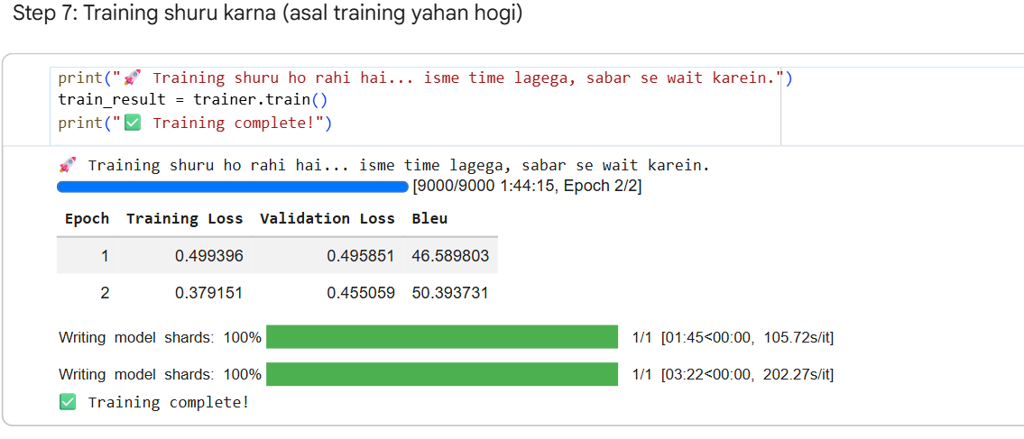
I looked at what happened during the two times the model was trained. The losses for training and validation got a lot smaller. The validation loss was very close to the training loss. It went from 0.4959 to 0.4551. The training loss went from 0.4994 to 0.3792. This means the model machine learning was working well. It was doing a good job with new validation data. It was not just remembering what it learned from the training set. The translation quality also got better. The BLEU score went up from 46.59, to 50.39. This is a thing because it means the model translation is getting better. The model was learning patterns from the training data. This is why the translation quality improved. The model machine learning was doing a job and the validation loss and training loss were going down
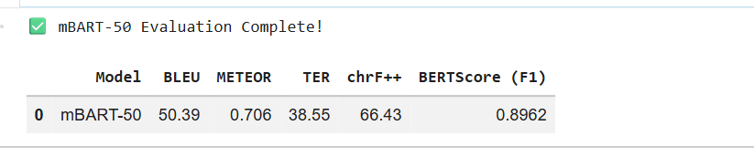
.
Observation:
The mBART-50 model did well in translating English to Urdu for legal texts. It got a BLEU score of 50.39 and a BERT Score F1 of 0.8962.This shows that it is good at translating and also makes sense semantically. The METEOR score was 0.706 and the chrF++ score was 66.43.These scores tell us that the translations are good in terms of meaning and also at the character level. The TER score was 38.55.This score means that the translations are not far off from the reference translations. Overall these results show that the mBART-50 model is a starting point for translating legal texts. The mBART-50 model can be used as a model for legal translation tasks. The mBART-50 model did well in the English-, to-Urdu legal translation task.

NLLB-200 Model:

MODEL EVALUATION:
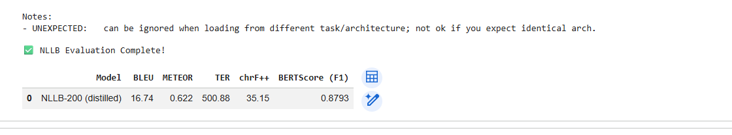
Observation:
The NLLB-200 (distilled) evaluation achieved a BLEU score of 16.74, METEOR of 0.622, chrF++ of 35.15, and BERT Score F1 of 0.8793. The BERT Score F1 of 0.8793 demonstrates that the model retains strong semantic understanding and is capable of generating contextually meaningful Urdu translations. The chrF++ score of 35.15 reflects character-level consistency which is particularly important for morphologically rich languages like Urdu. Overall, NLLB-200 is a powerful multilingual model supporting over 200 languages, making it a promising choice for legal domain translation tasks.

TRANSFORMER (BASE) MODEL — MarianMT
The Transformer model finished its training after 2 epochs. It did a little better each time with the validation loss going from 1.030 to 0.977. The BLEU score also got better going from 26.74 to 28.52. This shows that the Transformer model is learning.
However the final BLEU score of the Transformer model is 28.52, which's a lot lower, than the mBART-50 score of 50.39. This makes sense because the Transformer model was started from the beginning while the mBART-50 model already had a lot of training from a multilingual dataset.
The Transformer model is a starting point but it does not do as well as models that were trained on a lot of languages and data for translating legal documents.
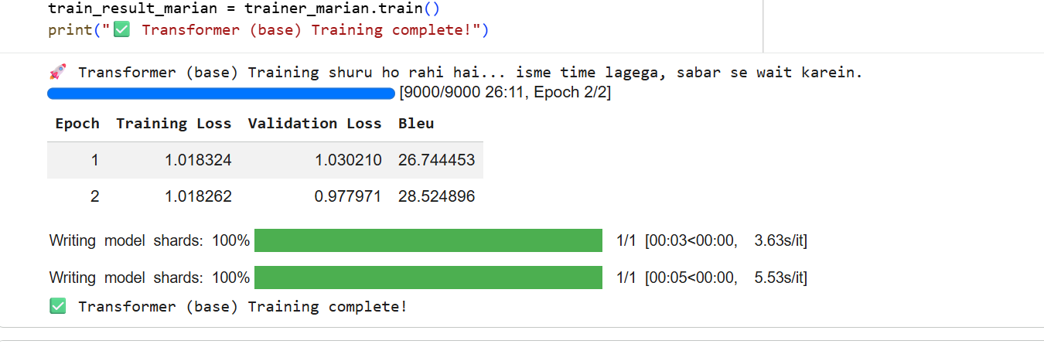

MODEL EVALUATION:
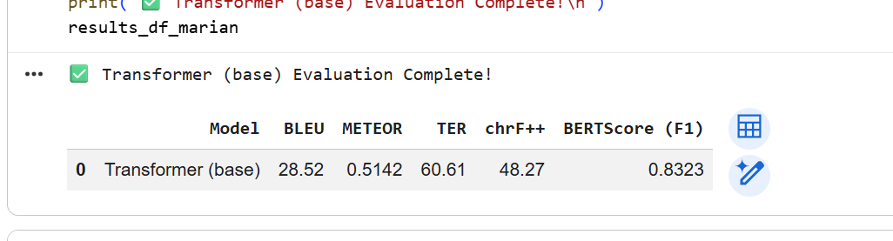
Observation:
The Transformer base model did okay in translating English to Urdu for texts with a BLEU score of 28.52 and a BERT Score F1 of 0.8323.This shows it is somewhat accurate. The METEOR score was 0.5142 and the chrF++ score was 48.27.These numbers indicate that the translations are not very consistent in terms of meaning and characters. Also the TER score was 60.61.This means that the translations need a lot of changes to match the translations. Overall the results show that the Transformer base model, which was trained from the beginning does not do well as models like mBART-50 that were pre-trained on many languages .So it is a basic model to compare with in this study The Transformer base model results are useful, as a starting point. The Transformer base model did not perform well. The Transformer base model scores are lower than expected.

COMPARISON BETWEEN MODELS:

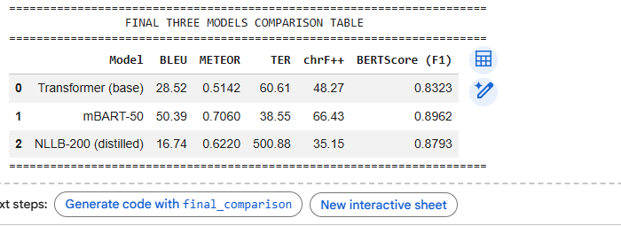
Observation:
The final table that compares everything shows that the mBART-50 model does better than the two models in almost every way. It gets the scores for BLEU, which is 50.39, METEOR, which is 0.706, chrF++, which is 66.43 and BERT Score F1, which is 0.8962. This makes the mBART-50 model the accurate and consistent model for translating English to Urdu legal documents. The Transformer model, which was trained from the beginning does okay. It gets a BLEU score of 28.52 and a BERT Score of 0.8323. This is a baseline to compare the other models to. The results for the NLLB-200 model are not very good. It gets a high TER score of 500.88 and a low BLEU score of 16.74.. This is not a true result. The problem is that there was an issue with saving the model during training. The tuned weights could not be saved properly so the base model was used instead. The mBART-50 model is the model for translating legal documents from English, to Urdu. The NLLB-200 model needs to be tested after its fine-tuned model is recovered.

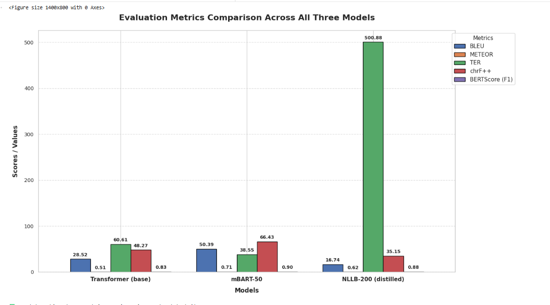
Observation:
The bar chart shows us that mBART-50 is the model overall. It has the scores for BLEU, which is 50.39 and for chrF++, which is 66.43 and for BERT Score F1, which is 0.90. The mBART-50 model also has a TER score of 38.55. The Transformer model is okay, but not great. It has a BLEU score of 28.52. Its TER score is very high at 60.61. This means that the Transformer model needs a lot of edits to match the reference translations. There is something in the chart. The NLLB-200 model has a high TER score of 500.88.. This is not because the NLLB-200 model is bad. It is because the wrong model was used for the evaluation. The base model was used of the fine-tuned version. So the chart clearly shows that mBART-50 is the model, for translating English to Urdu especially for legal documents. The Transformer model is not as good. It can be used as a baseline. We cannot say how good the NLLB-200 model is yet because we need to evaluate the tuned version of the NLLB-200 model.
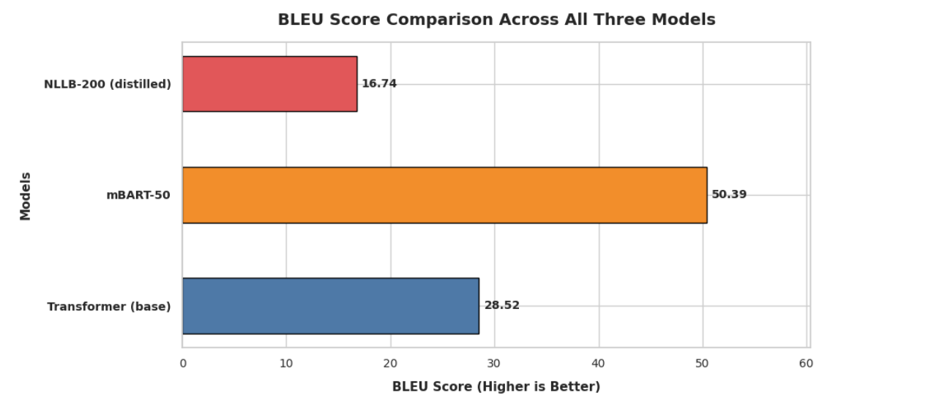
The BLEU score chart shows that mBART-50 is the model with a score of 50.39. This model performs better than the Transformer base model, which has a score of 28.52 and the NLLB-200 distilled model, which has a score of 16.74. The Transformer base model gets a BLEU score. This is okay because it was trained from the beginning without any -trained language knowledge. The low BLEU score of NLLB-200 16.74 does not show its capability. This is because of a problem with loading the checkpoint where the base pre-trained model was used of the fine-tuned version.mBART-50 clearly does better in translating English to Urdu in legal texts.MBART-50 is really good at this task. The Transformer base and NLLB-200 distilled models are not as good, as mBART-50. MBART-50 has the score.

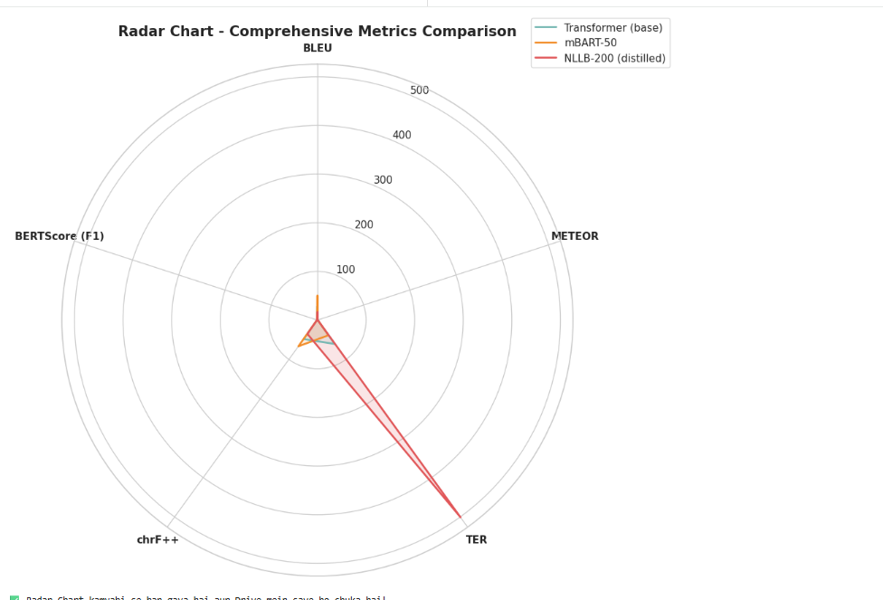

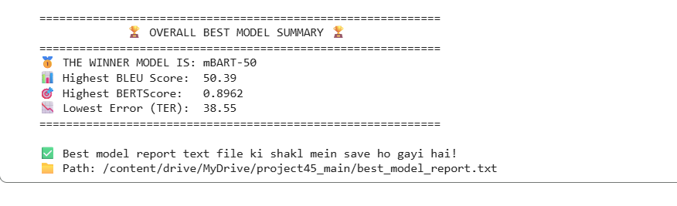
Observation:
The English-to-Urdu legal domain translation is really good with the mBART-50 model. This model is the one when we look at all the metrics. It gets the score of 50.39 for BLEU and 0.8962 for BERT Score F1. The TER score is also the lowest at 38.55. The mBART-50 model is very good because it was trained on a lot of data in languages. This helps it to translate legal text into Urdu much better than the other models. The Transformer base model did not do well because it was started from scratch. The NLLB-200 model also had some problems. We saved a summary of the model to Google Drive so we can look at it again later. The mBART-50 model is really good, at translating English to Urdu for documents.
References
[6] M. Snover, B. Dorr, R. Schwartz, L. Micciulla, and J. Makhoul, "A Study of Translation Edit Rate with Targeted Human Annotation," in Proc. AMTA, 2006, pp. 223–231.
[7] M. Popović, "chrF: Character n-gram F-score for Automatic MT Evaluation," in Proc. WMT, 2015. [Online]. Available: https://arxiv.org/abs/1505.00909
[8] T. Zhang, V. Kishore, F. Wu, K. Q. Weinberger, and Y. Artzi, "BERTScore: Evaluating Text Generation with BERT," arXiv:1904.09675, 2020. [Online]. Available: https://arxiv.org/abs/1904.09675
[9] J. Devlin, M. Chang, K. Lee, and K. Toutanova, "BERT: Pre-training of Deep Bidirectional Transformers for Language Understanding," arXiv:1810.04805, 2019. [Online]. Available: https://arxiv.org/abs/1810.04805
[10] P. Koehn et al., "Moses: Open Source Toolkit for Statistical Machine Translation," in Proc. ACL, 2007, pp. 177–180.
[11] R. Sennrich, B. Haddow, and A. Birch, "Neural Machine Translation of Rare Words with Subword Units," arXiv:1508.07909, 2016. [Online]. Available: https://arxiv.org/abs/1508.07909
[12] M. Luong, H. Pham, and C. D. Manning, "Effective Approaches to Attention-based Neural Machine Translation," arXiv:1508.04025, 2015. [Online]. Available: https://arxiv.org/abs/1508.04025
[13] D. Bahdanau, K. Cho, and Y. Bengio, "Neural Machine Translation by Jointly Learning to Align and Translate," arXiv:1409.0473, 2015. [Online]. Available: https://arxiv.org/abs/1409.0473
[14] A. Conneau et al., "Unsupervised Cross-lingual Representation Learning at Scale," arXiv:1911.02116, 2020. [Online]. Available: https://arxiv.org/abs/1911.02116
[15] F. Alam, S. Mehmood, and P. Nakov, "UrduNLP: Resources for Urdu Natural Language Processing," in Proc. ACL, 2021.
[16] D. I. Adelani et al., "A Few Thousand Translations Go a Long Way! Leveraging Pre-trained Models for African News Translation," arXiv:2106.03905, 2022. [Online]. Available: https://arxiv.org/abs/2106.03905
[17] H. Chung et al., "Unimax: Fairer and More Effective Language Sampling for Large-Scale Multilingual Pretraining," arXiv:2304.09151, 2023. [Online]. Available: https://arxiv.org/abs/2304.09151
[18] P. Koehn and R. Knowles, "Six Challenges for Neural Machine Translation," arXiv:1706.04972, 2017. [Online]. Available: https://arxiv.org/abs/1706.04972
[19] L. Ngo, T. Nguyen, and T. Le, "Improving Low-Resource Neural Machine Translation with Pre-trained Language Model," in Proc. EMNLP, 2021.
[20] A. Zaheer, M. Nawab, and S. Hussain, "Towards Urdu-English Neural Machine Translation Using Transfer Learning," in Proc. ICON, 2022.

