**Express.js**

* Fast and framework of node.js
* Server-side backend and can be used for API too
* Use to build full-stack applications
* For render view either plain HTML or template enignes like handlebar or pug can be used.

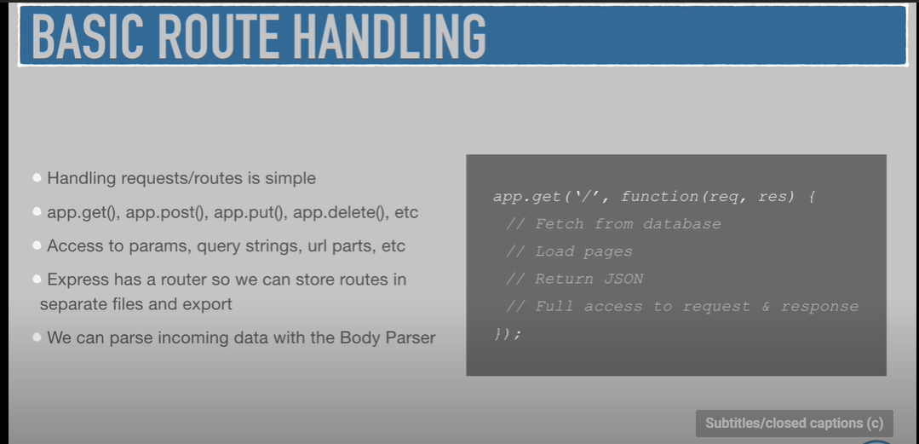

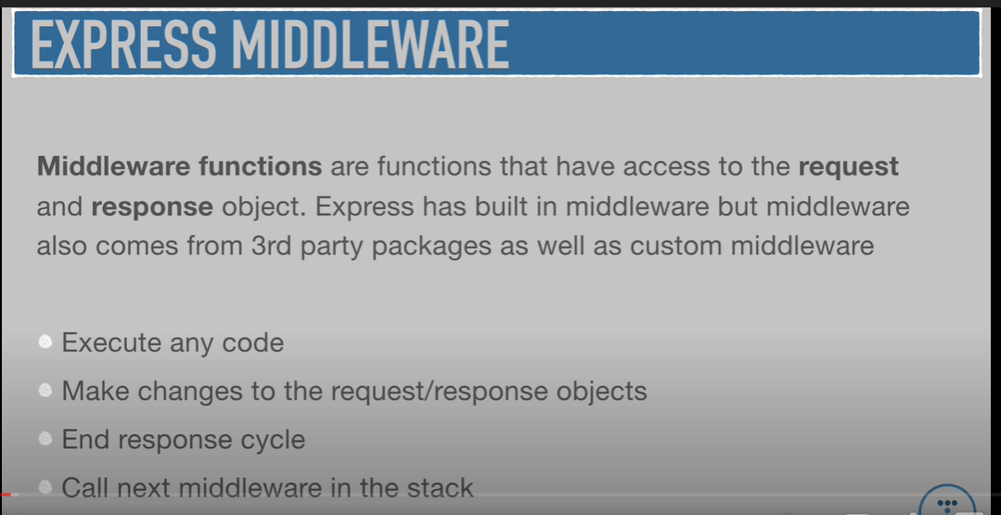

* To make sure we do not have to restart everytime , install nodemon

*npm I –D nodemon*

and then make change to package.json script function as

×     "test": "echo \"Error: no test specified\" && exit 1"

→  "start": "node index",

    "dev": "nodemon index"

* **Moment is a third party API which deals with dates**