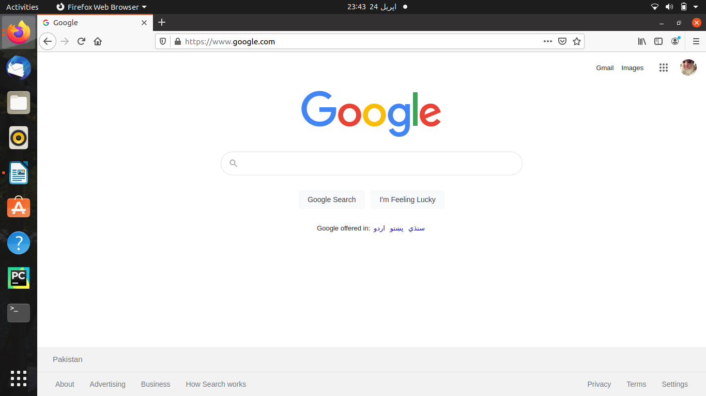

- Open your browser and visit google.com

2.In the search box start typing the title of this lecture “introduction to text”..
Noticee as you continue typing a list of suggestion appears….

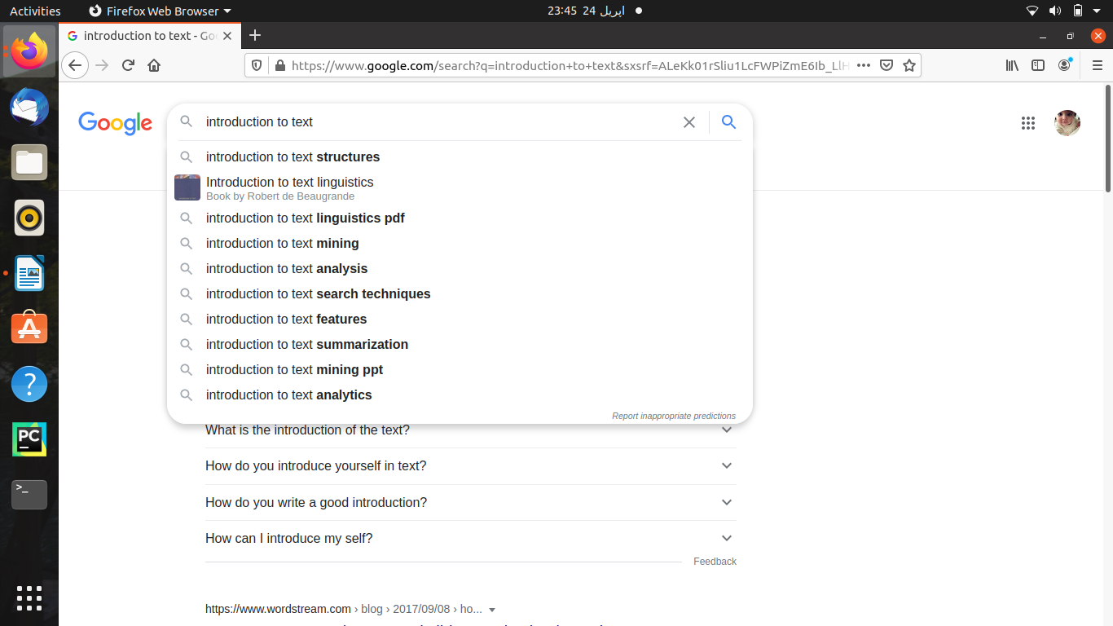
Q:what do you oobserve in the list of suggestion?are there any pattern?
As I have seen there is a pattern in a stable way because google can reach the path in ralevant way it can reach the pages that what you want when we type something in search engine they provide more better options and better pattern…….


SEARCH ENGINE (duckduckgo.com)

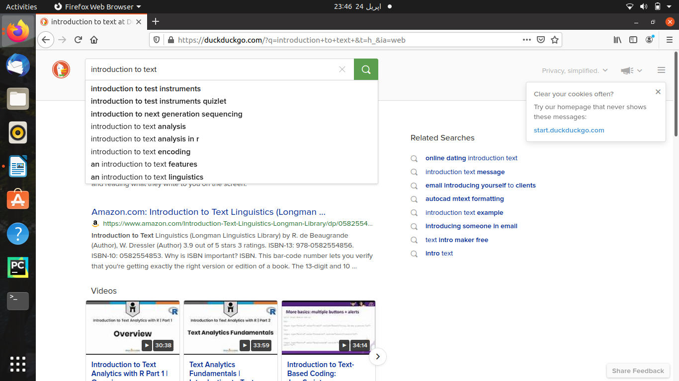

SEARCH ENGINE(bing.com)


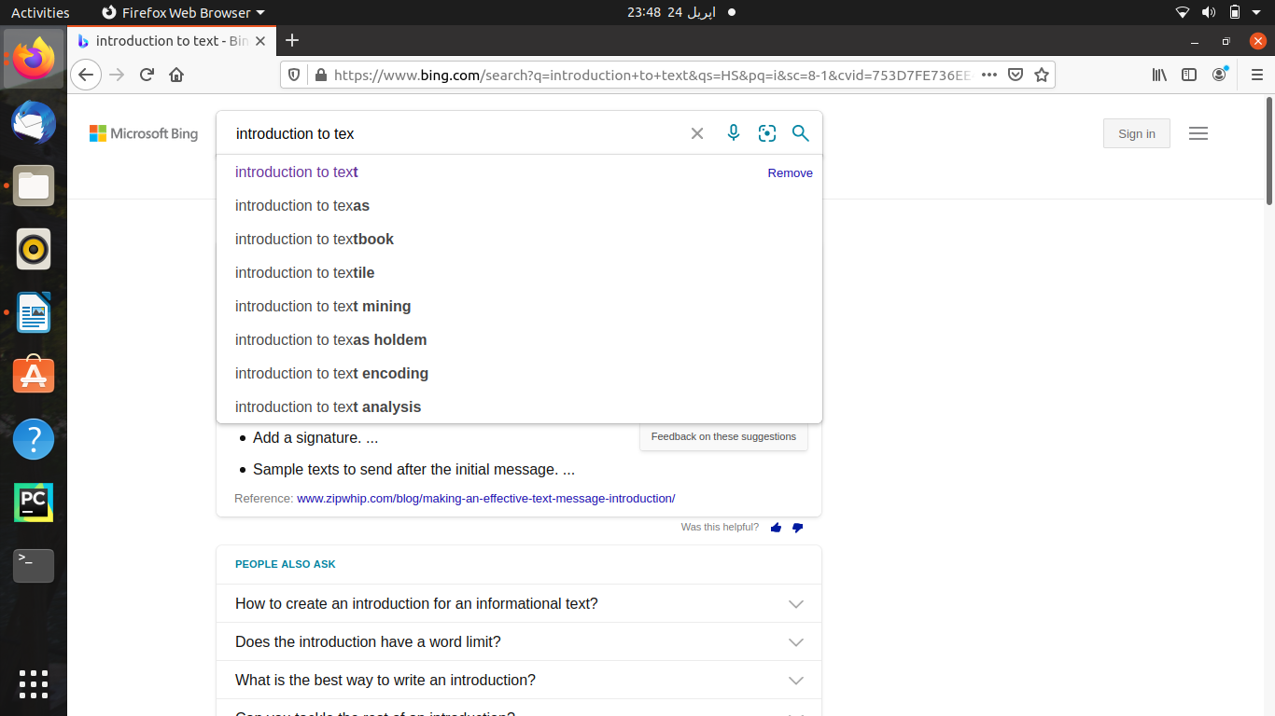

Q:which search engine list of suggestion is better and why​​​??
*I think google search is the best option...because when a use type a query,google tries to find the most relevant answer from it index based on many factors..google tries to determine the highest quality answer and factor in other consideration that will provide the best user experience and most appropriate answer…….everytime we search there are million of webpages with helpful information……..

Search engine with otherr text
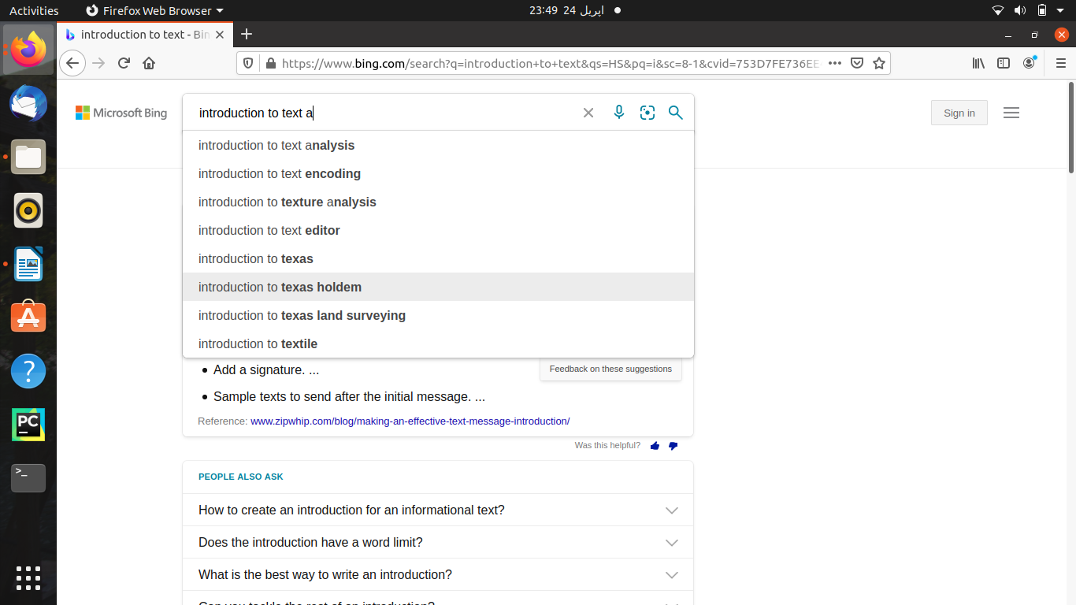
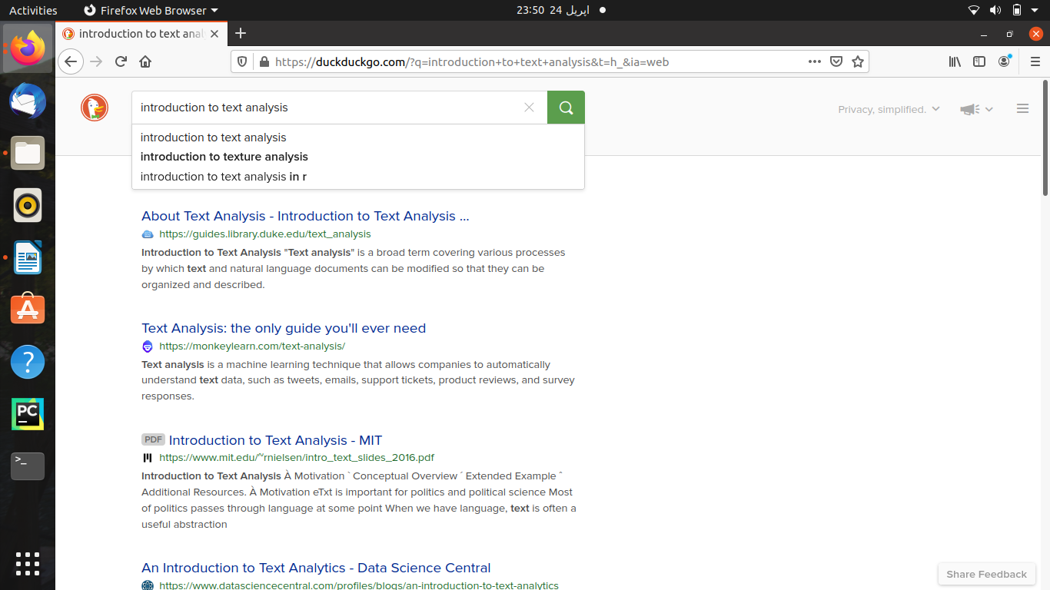
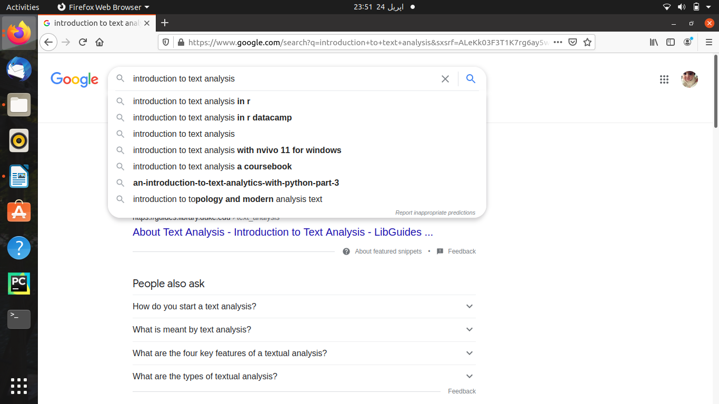
Q:Do all search engines return the same result???????????
-I think the duckduckgo and google almost give the same result the bing.com is different from them …..

Q:Do you think that the order of the websites in the search results is important???
-Todays consumers rely on search engines to help them find everything I think this is important for our...it made me think I should write an article on why having a website is impotant for ….According to field the search result is important….

Q:Try to find which algorithm/formula are being used to order the result????
- Algorithms like Panda to assist Google in judging, filtering, penalizing and rewarding content based on specific characteristics, and that algorithm likely included a myriad of other algorithms within in……. Stable sorting algorithms maintain the relative order of records with equal keys. If all keys are different then this distinction is not necessary. But if there are equal keys, then a sorting algorithm is stable …...

