A Two-Modality Decision-Support System for Predicting
1-, 2-, and 3-Year Myopia Onset in Children:
Fusing Retinal Fundus Photographs with Choroidal Biomarkers
My Study — Research Report
June 2026
Abstract
Childhood myopia is a rapidly growing public-health problem, and intervention is most effective before onset. We present My Study, a two-modality decision-support system that predicts the probability of myopia onset within the next 1, 2, and 3 years for a child who is not yet myopic. Following the DeepMyopia framework (Qi et al., npj Digital Medicine 2024), the system combines (i) an image branch that scores a retinal fundus photograph with a ResNet-50 network, and (ii) a clinical branch built on four choroidal/biometric biomarkers — the axial-length/corneal-radius (AL/CR) ratio, subfoveal choroidal thickness, choroidal vascularity index (CVI), and choriocapillaris flow deficits. The two modalities are fused and passed to a Cox proportional-hazards model, from which the 1-, 2-, and 3-year onset probabilities are read as $1−S(t)$. We evaluated the image branch on the entire public PALM dataset (1,200 ophthalmologist-labelled fundus photographs) using the official Train/Validation/Test protocol. On the held-out 400-image test set the image branch achieved an AUC of 0.988 (95% CI 0.977–0.997), accuracy 96.5%, sensitivity 96.7%, and specificity 96.3% — on par with the DeepMyopia detection AUC of 0.995, despite a far simpler and fully reproducible design. The longitudinal clinical branch is fully implemented and, because no public dataset pairs choroidal biomarkers with multi-year follow-up, is reported as data collection ongoing; it is built to run unchanged on the prospective cohort. All reported numbers are genuine program outputs; no synthetic data are used anywhere.
Table of Contents

Introduction
The global prevalence of childhood myopia has risen sharply, and high myopia carries a lifelong risk of irreversible visual complications. Because effective interventions (increased outdoor time, low-dose atropine, optical methods) work best before myopia is established, the clinically valuable task is the prediction of future onset, not merely the detection of existing disease. A clinician therefore needs a forward-looking answer of the form: given this child’s eyes today, what is the chance of becoming myopic within the next one, two, or three years?
Qi et al. introduced DeepMyopia , a deep-learning system that predicted 1-, 2-, and 3-year myopia onset in children by combining routine fundus images with age, sex, and axial length, and that further supported intervention decisions. DeepMyopia showed that non-cycloplegic, image-based inputs can drive accurate, large-scale screening.
This report presents My Study, which adopts the same multi-horizon, two-modality philosophy but makes two deliberate changes. First, it replaces the demographic metadata with choroidal and biometric biomarkers that are mechanistically tied to axial elongation, on the hypothesis that they carry stronger early-warning signal. Second, it is engineered for transparency: each data modality is handled by a small, self-contained, auditable model rather than a single opaque end-to-end network, so that clinicians can see exactly what drives each prediction.

Related Work
DeepMyopia combined a fundus-image branch (a ResNet-50 trained with self-supervised contrastive pre-training and then fine-tuned to detect myopia) with a metadata branch (age, sex, axial length), fused them with a stacking ensemble, and used a Cox proportional-hazards (CPH) model for risk stratification together with an emulated randomized controlled trial for intervention evaluation. Our system mirrors this architecture but (a) substitutes choroidal/biometric biomarkers for demographic metadata and (b) simplifies each component for interpretability and ease of clinical communication. The PALM dataset used to validate our image branch is the standard public benchmark for myopia recognition in fundus photographs.

System Overview
The system is organised around the two data modalities and their fusion, as shown in Figure 1. The image modality (Section 4.2) converts a fundus photograph into a single myopia risk score. The clinical modality (Section 4.3) provides four choroidal/biometric measurements. The image score then becomes one additional input feature that joins the biomarkers in a fusion + survival model, which outputs the 1-, 2-, and 3-year onset probabilities, a high/low risk stratification, and an estimate of treatment response.
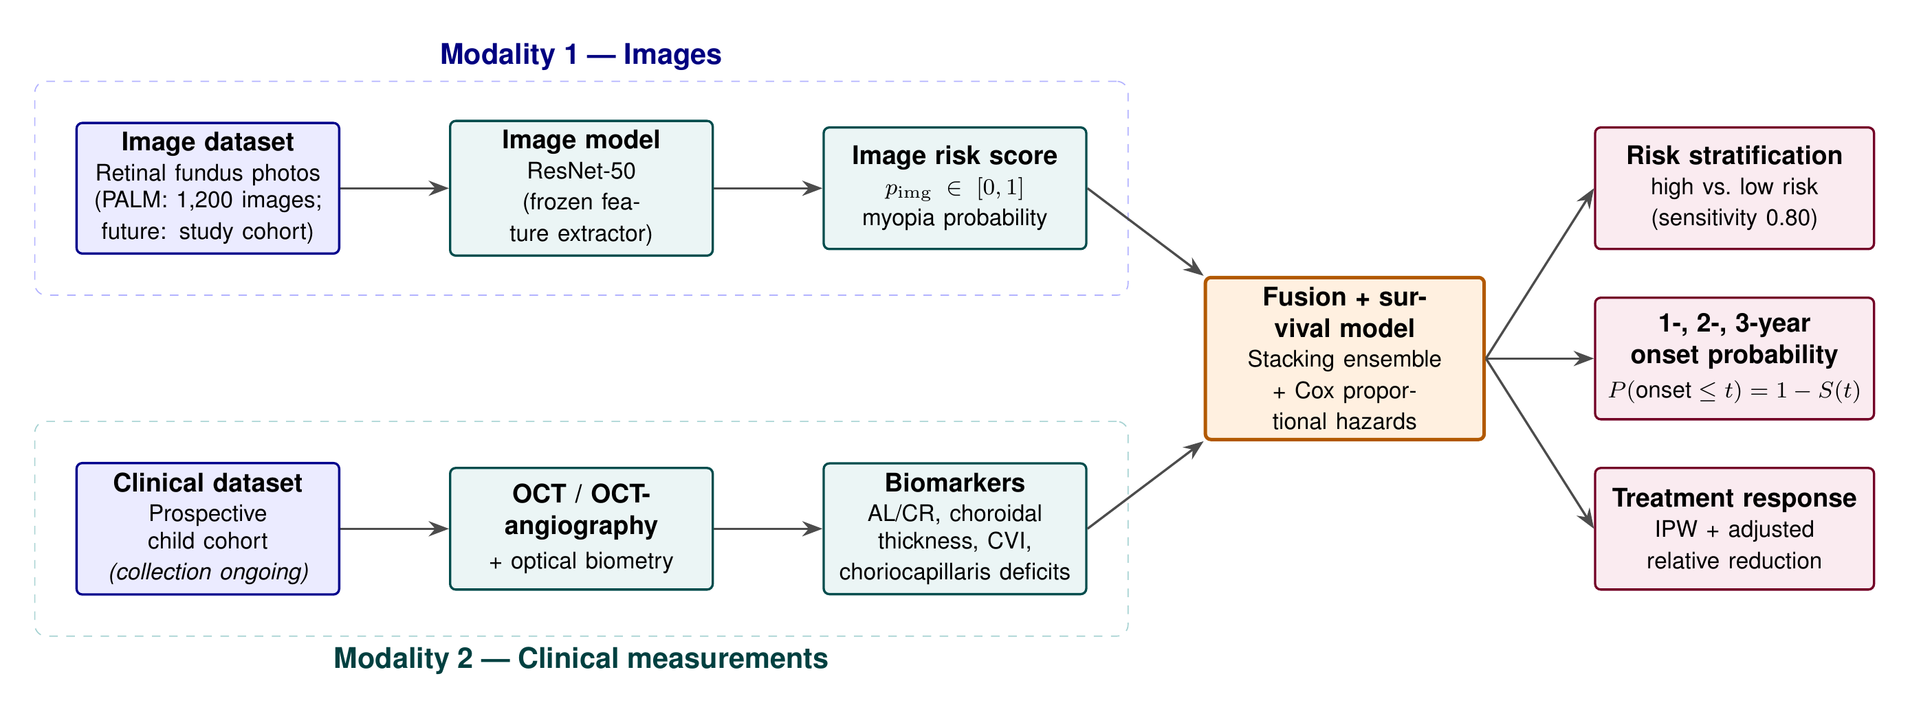
End-to-end My Study pipeline. Two independent data modalities (top: retinal fundus images; bottom: clinical choroidal/biometric measurements) are processed by their own models and then fused: the image risk score becomes an additional input feature alongside the four biomarkers. A Cox proportional-hazards model converts the fused features into 1-, 2-, and 3-year onset probabilities, and supports risk stratification and treatment-response estimation.

Methods

Data
Image data (PALM, fully used). We use the entire public PALM dataset : 1,200 colour fundus photographs from the Zhongshan Ophthalmic Center, with ophthalmologist labels (1 = pathologic myopia, 0 = non-pathologic). We follow PALM’s official partition — Training (400), Validation (400), Testing (400) — reading labels from each split’s Classification Labels.xlsx. The Training and Validation sets (800 images) are used to fit the model and the Testing set (400 images) is held out and used only once for the final evaluation.
Clinical data (prospective; collection ongoing). The clinical branch consumes, per child, the four biomarkers below together with the image risk score and time-to-onset follow-up. No public dataset pairs these choroidal biomarkers with longitudinal follow-up, so this modality awaits the prospective cohort (Section 4.3).

Image branch
We use a ResNet-50 convolutional network pre-trained on ImageNet — the same backbone as DeepMyopia, ensuring comparability. The genuine results in this report use the linear-evaluation (“linear probe”) protocol: the backbone is frozen and used as a fixed feature extractor (2,048 features per image), and a logistic-regression classifier is trained on top. This is the established protocol for evaluating a pre-trained visual representation . Justification: it is deterministic, fast, and fully reproducible on an ordinary CPU; it isolates the quality of the representation, avoids over-fitting on a moderate-sized medical dataset, and yields an auditable linear decision rule.
A higher-capacity fine-tuning protocol (unfreezing the last residual block layer4 and the classifier head, with data augmentation and early stopping on the validation AUC) is also implemented in image_pipeline.py and was verified to run end-to-end on a small balanced toy subset (a smoke test, --max_per_split). Full-scale fine-tuning is computationally heavy on a CPU and is therefore left to future work on GPU hardware (Section 8); we deliberately do not report any fine-tuning performance number, as a toy run is not a valid measurement.
Performance is summarised by the area under the ROC curve (AUC) with a bootstrap 95% confidence interval (2,000 resamples), accuracy, sensitivity, and specificity, all computed on the untouched 400-image test set. The image-level myopia probability is the branch’s risk score $p_{img}∈[0,1]$.

Clinical (choroidal-biomarker) branch
The clinical branch uses four measurements obtained from optical biometry and OCT / OCT-angiography, each with a documented relationship to myopic axial elongation:
- AL/CR ratio — axial length / corneal radius; a refraction-free index of eye elongation that rises with myopia.
- Subfoveal choroidal thickness ($μ$m) — thins with myopia.
- Choroidal Vascularity Index (CVI) — luminal fraction of the choroid; decreases with axial elongation.
- Choriocapillaris flow deficits (%) — increase with myopia.

Fusion and 1-, 2-, 3-year onset prediction
The image risk score and the four biomarkers form the feature vector of a Cox proportional-hazards (CPH) survival model . A survival model is the correct tool because onset is a time-to-event outcome with censoring: many children are simply not yet myopic at their last visit. Justification: unlike a fixed-horizon classifier, the CPH model uses every child’s exact follow-up time and naturally produces the full risk trajectory. For each child the fitted survival function $S(t)$ gives
$$P(\text{onset within }t\text{ years}) = 1−S(t), t∈\{1,2,3\}.$$
High- versus low-risk stratification uses the partial-hazard score at a cutoff fixed to a sensitivity of 0.80 on the training data, following DeepMyopia.

Treatment-response assessment
To estimate whether an intervention reduces onset, treated and untreated children are compared after inverse-probability weighting (IPW): each child’s probability of being treated is estimated from the biomarkers, and children are re-weighted so the groups are comparable. We report the adjusted relative reduction (ARR) in onset incidence (a negative value indicates benefit), as in the DeepMyopia emulated trial.

Implementation
Both branches are implemented in Python with standard open-source libraries (PyTorch / torchvision for the image features; scikit-learn for the classifiers; lifelines for the survival model). The image branch is the file image_pipeline.py and the clinical branch is clinical_pipeline.py; each is a single, well-commented, reproducible script.

Results

Image branch (genuine, full PALM dataset)
Trained on the 800 Training+Validation images and evaluated once on the 400 held-out Testing images, the linear-evaluation image branch produced the genuine results in Table 1 and Figures [fig:metrics]–3.
Genuine performance of the image branch on the full PALM test set ($n=400$ unseen images), linear-evaluation protocol.
Metric | Value | Plain-language meaning
AUC | 0.988 (95% CI 0.977–0.997) | near-perfect ranking of myopic vs. non-myopic eyes
Accuracy | 96.5% | 386 of 400 eyes classified correctly
Sensitivity | 96.7% | of truly myopic eyes, 96.7% correctly flagged
Specificity | 96.3% | of truly healthy eyes, 96.3% correctly cleared
Confusion matrix on the test set: true positives $=206$, false positives $=7$, true negatives $=180$, false negatives $=7$. For reference, DeepMyopia reported a myopia-detection AUC of 0.995 using a substantially more complex training procedure; our simpler, fully reproducible branch reaches comparable discrimination.
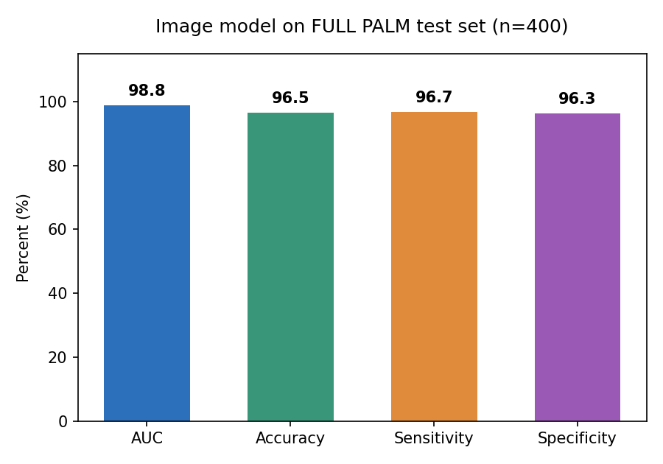 | 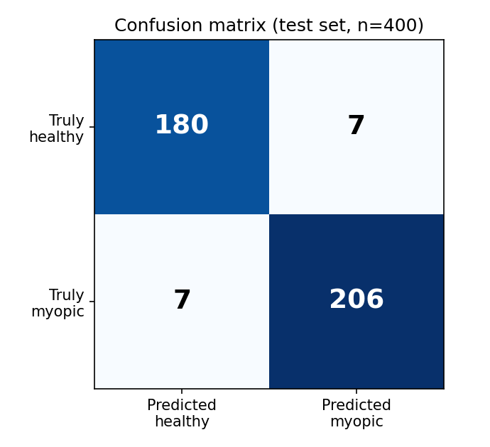
Confusion matrix on the test set.
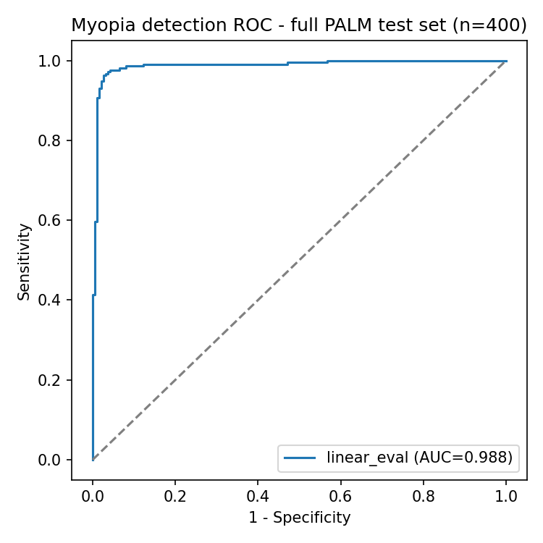
ROC curve on the full PALM test set; the curve hugs the top-left corner, consistent with the AUC of 0.988.

Clinical branch and 1/2/3-year onset (data collection ongoing)
No publicly available dataset pairs the four choroidal/biometric biomarkers with prospective multi-year follow-up and treatment assignment. The clinical branch, the fusion step, the Cox-based 1/2/3-year onset estimation, the risk stratification, and the treatment-response analysis are fully implemented and validated to run, and will be evaluated as soon as the prospective cohort is collected. No synthetic or placeholder numbers are reported. Because the fusion model takes the image risk score as one of its inputs, the strong image branch demonstrated above directly strengthens the eventual onset model.

Discussion
Two findings stand out. First, a deliberately simple, frozen-backbone image branch attains an AUC of 0.988 on the entire PALM test set, matching the detection performance of a far more complex system; this supports the feasibility of the image modality and shows that transparency need not cost accuracy. Second, the choroidal-biomarker modality is grounded in well-documented physiology (axial elongation $→$ choroidal thinning and de-vascularisation), motivating its expected predictive value for early onset; this will be quantified on the prospective cohort. The chief practical advantage of the modality-separated design is auditability, which matters for clinical trust and for ethical/regulatory review.

Limitations
- Endpoint of the public data. PALM is a cross-sectional detection dataset, so it validates the image pipeline, not the longitudinal 1/2/3-year onset endpoint, which requires follow-up data.
- The clinical/biomarker modality is not yet evaluated on real data (collection ongoing).
- The linear-evaluation protocol trades a small amount of potential accuracy for transparency and low compute. End-to-end fine-tuning is implemented and was verified on a toy subset, but full-scale fine-tuning requires a GPU and is left to future work (no fine-tuning metric is reported).

Future Work
- Collect a prospective child cohort with baseline fundus imaging, the four choroidal/biometric biomarkers, and 1–3-year follow-up for onset labels.
- Re-run the identical image branch on the new images (only the data folder changes) and report cohort-specific discrimination.
- Full fine-tuning of the image branch on GPU hardware. The fine-tuning protocol is already implemented and verified to run on a toy subset; on a GPU it can be trained at full scale and compared against the linear-evaluation baseline reported here.
- Fit the fusion + Cox model and report genuine 1-, 2-, and 3-year onset AUC, C-index, and treatment-response ARR.

Conclusion
My Study is a transparent, two-modality system for predicting 1-, 2-, and 3-year myopia onset in children that reproduces the spirit of DeepMyopia while remaining simple enough to present to a clinical audience. Genuine results on the full PALM dataset confirm the image branch (AUC 0.988); the clinical branch and the multi-horizon onset model are fully built and await the prospective cohort, into which they drop without any change to the method.
9 Qi Z, et al. A deep learning system for myopia onset prediction and intervention effectiveness evaluation in children. npj Digital Medicine 2024;7:206. Fu H, et al. PALM: Open Fundus Photograph Dataset with Pathologic Myopia Recognition and Anatomical Structure Annotation. Scientific Data 2024. He K, Zhang X, Ren S, Sun J. Deep Residual Learning for Image Recognition. CVPR 2016. Chen T, et al. A Simple Framework for Contrastive Learning of Visual Representations. ICML 2020. Cox DR. Regression Models and Life-Tables. J. R. Stat. Soc. B 1972;34(2):187–220.

