Software Requirement Specifications

AI Shopping Assistant with Intelligent Product Recommendation System



Submitted by
Areeba Amir (S23BINFT1M01154)

Submitted to
Dr. Omer Riaz

Department of Information Technology
Faculty of Computing
The Islamia University of Bahawalpur

Meeting Details
Sr No | Details | Date | Supervisor Signature
 | Proposal Submission and title assignment | 27-4-2026
2. | Review of SRS Document | 22-4-2026

Summary
This Software Requirements Specification (SRS) describes an AI-based shopping assistant designed to improve users' shopping experience through intelligent recommendation and decision support. This system allows users to interact using natural language queries and search for products based on their preferences.
The system analyzes user input to identify key requirements such as product type and budget. The system guides by providing a suitable price range and options, helping users make informed purchasing decisions.
This system aims to reduce user efforts and confusion by offering a more attractive and user-friendly shopping experience.

Table of Contents
1. Introduction 6
1.1. Purpose 6
1.2. Scope 6
1.3. Product Perspective 7
1.4. User Characteristics 7
1.5. Similar apps and systems 7
1.6. Proposed Technologies 8
2. Requirements 8
2.1 Function Requirements 8
2.1.1. Sign Up 8
2.1.2. Log In 9
2.1.3. User Query Input 9
2.1.4. Query Processing 9
2.1.5. Information Extraction 10
2.1.6. Decision Support Suggestion 10
2.1.7. Product Recommendation 10
2.1.8. View Products Details 10
2.1.9. Admin Login 11
2.2. Non-Functional Requirements 11
2.2.1. Performance Requirements 11
2.2.2. Security Requirements 11
2.2.3. Usability Requirements 12
2.2.4. Reliability Requirements 12
3. Use Cases and Flow of Processes 12
3.1.1. Sign Up 12
3.1.2. Login 14
3.1.3. User Query Input 15
3.1.4. Query Processing 16
3.1.5. Information Extraction 17
3.1.6. Decision Support Suggestion 19
3.1.7. Product Recommendation 20
3.1.8. View Product Details……………………………………………………………………….20
3.1.9. Admin Login…………………………………………………………………………………21
3.1.10. System Level Diagram……………………………………………………………………....22

- Introduction
The rapid growth of e-commerce platforms has made online shopping more convenient, but it has also introduced challenges, such as difficulty in selecting the most suitable products. Users often spend a significant amount of time searching and filtering products before making a purchase. The proposed system is an AI-based shopping assistant designed to make the shopping process easier for users. It allows users to interact through a conversational interface and describe their requirements in the form of natural language queries. Instead of a time-consuming manual search, users can enter their queries, and the system provides recommendations according to their needs.
The system not only suggests relevant products but also assists users in making better decisions. The system explains suitable price ranges and options based on user requirements. This reduces user confusion and improves the overall shopping experience.
  - Purpose
The purpose of this SRS document is to define the requirements of the proposed system. It describes the overall system functionality and features to provide a clear understanding of how the system will work. This document is intended for developers, supervisors, and stakeholders who are involved in the design and development of the system.
  - Scope
The proposed system is a web-based AI shopping assistant designed to help users to find desired products through a conversational interface. Users can enter their queries in natural language, and the system will provide recommendations based on their preferences and defined requirements.
This system has core functionalities such as user interaction through a chat interface and a recommendation process that suggests items based on user preferences. The System is aims to reduce the effort required in manual search and filtering products, making the shopping process easier and more efficient.
The scope of this project is intended for academic purposes. Therefore, certain advanced features will not be included; these include integration with external e-commerce platforms, real-time payment processing, and complex deep learning-based recommendation models.
  - Product Perspective
The system is a web-based application that can function as a standalone assistant. It interacts with users through a simple interface and processes queries using a natural language processing technique. The system connects to a product database where all product-related information is stored. It also uses rule-based logic to provide recommendations and decision support.
  - User Characteristics

The system is designed for general users who have basic knowledge of using websites and online shopping platforms. Users are not required to have any technical background to use the system. The admin is expected to have basic technical knowledge to manage product data, including adding, updating, and deleting products.

  - Similar apps and systems
Many e-commerce platforms, such as Amazon and Daraz, provide product search and filtering features to assist users in finding suitable products. However, the searching procedure can be time-consuming because these systems require users to search manually through a large number of products.
Recommendation systems are used to make product recommendations based on user preferences and queries, and enhance user experience. Additionally, conversation-based Chabot systems are being used by many platforms, allowing users to interact using natural language. The proposed system provides the conversational recommendation feature to make the system user-friendly and easy to use.
  - Proposed Technologies
The proposed system is a web-based application, and the technologies used for this system are,
- Frontend: HTML, CSS, JavaScript
- Database: MySQL
- Backend: Python framework Django
- AI Technique: Natural Language Processing (NLP)

Requirements

The system offers secure login and user registration features. Through a conversational interface, the user can enter a product-related query in natural language. The system uses natural language processing to understand user queries and extract key details about the product, such as product type and price range. The system provides support in decision-making by recommending appropriate price ranges and product categories based on the extracted information. After that, it shows the user suitable product recommendations.
  - Function Requirements
This section describes the functional requirements of the proposed system. It explains the core functionalities of the system.

2.1.1. Sign Up
- Name: FR001
- Purpose: The sign-up process is required for a user to become a member of the system.
- User(s): User
- Input:
  - Name: User’s name.
  - Password: Must be 8 characters long and must include a number
  - Email: User’s valid email address
- Output: User’s account is created and stored in the system.

    - Log In
- Name: FR002
- Purpose: The login process is required to allow users to securely access the system.
- User(s): User
- Input:
  - Email: User’s registered email address.
  - Password: User’s password that he entered during registration.
- Output: User is authenticated, and access is granted.

    - User Query Input
- Name: FR003
- Purpose: It allows users to enter product-related queries in natural language.
- User(s): User
- Input:
  - Query Text: user input, i.e., mobile phone under 70,000
- Output: Query is submitted for processing.

    - Query Processing
- Name: FR004
- Purpose: This process understands the user query and shows output accordingly.
- User(s): System
- Input:
  - Query: User’s query text.
- Output: A processed query is further analyzed.

    - Information Extraction
- Name: FR005
- Purpose: Extract key details such as product type and price range from user input.
- User(s): System
- Input:
  - Query: Processed Query
- Output: Extracted attributes are identified and passed for further processing.

    - Decision Support Suggestion
- Name: FR006
- Purpose: To assist the user in purchasing by suggesting a suitable price range and product category.
- User(s): System
- Input:
  - Query: Extracted preferences from user query.
- Output: The system suggests appropriate price ranges or categories based on user preferences assuming default values when required.

    - Product Recommendation
- Name: FR007
- Purpose: To generate and present recommendations based on user input and system logic.
- User(s): System
- Input:
  - Query: Processed query
  - Product Details: Product details from the database.
- Output: System shows the recommended products.

    - View Products Details
- Name: FR008
- Purpose: To allow the user to view details about the recommended product.
- User(s): User
- Input:
  - Product Type: Selected product
- Output: Detailed product information is displayed.

    - Admin Login
- Name: FR009
- Purpose: To allow administrator to securely access the admin panel.
- User(s): Admin
- Input:
  - Username/ Email: Admin’s user name or email address.
  - Password: Admin’s password
- Output: Admin is authenticated and access granted.

  - Non-Functional Requirements
This section describes the non-functional requirements of the proposed system. These requirements define how well the system should perform and the constraints under which it operates.
    - Performance Requirements
NFR-01: The system shall respond to user queries within 2–5 seconds under normal operating conditions.
    - Security Requirements
NFR-02: The system shall ensure secure user authentication and protect user data from unauthorized access.
    - Usability Requirements
NFR-03: The system shall provide a user-friendly interface.
NFR-04: The system shall allow easy interaction through a simple conversational interface.
    - Reliability Requirements
NFR-05: The system shall provide consistent and reliable recommendations based on user input.
NFR-06: The system shall handle invalid or incomplete user input without system failure.
- Use Cases and Flow of Processes

This section describes the use case that represents the interaction between users and the system functionalities. It identifies the different actors involved and the actions they can perform within the system. These use cases are defined from the functional requirements and describe how the system responds to user inputs. The use case diagrams help in understanding the overall workflow and behavior of the proposed system.

    - Sign Up
ID | UC001
Name | Sign Up
Description | This use case describes the process of creating a new user account in the system.
Requirement(s) | FR001
Actor(s) | User
Precondition | User must not already have an account
Post condition | User account is successfully created
Basic Flow | Basic Flow  - User interacts with the system  - User enters required details  - The following fields are required  - Name  - Email  - Password  - System validates the input credentials  - Email format is valid  - Password must be 8 characters, including a number  - On successful validation, the system will create a new user  Alternative Flow  - User already registered  - System detects existing email  - System displays message “Email already exists.”  Exceptions  - Invalid Inputs  - System fails to create an account

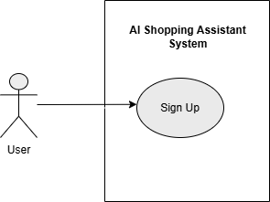

    - Login
ID | UC002
Name | Login
Description | This use case allows a registered user to log in to the system.
Requirement(s) | FR002
Actor(s) | User
Precondition | User must already have an account
Post condition | User is successfully logged in
Basic Flow | Basic Flow  - User enters email and password  - System validates credentials  - System grants access  Alternative Flow  1. Incorrect Credentials  - System displays an error message  Exceptions  - System authentication failure

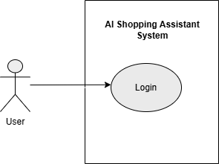

    - User Query Input
ID | UC003
Name | User Query Input
Description | This use case allows the user to enter a product-related query in natural language
Requirement(s) | FR003
Actor(s) | User
Precondition | User has access to the system interface
Post condition | The query is submitted to the system
Basic Flow | Basic Flow  - User opens conversational interface  - User enters a product-related query  - System receives the query  - System forwards the query for processing  Alternative Flow  - User enters a general or incomplete query  - System proceeds using available information  Exceptions  - System fails to receive query

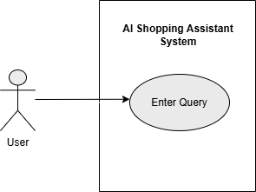

    - Query Processing
ID | UC004
Name | Query Processing
Description | This use case processes the user query for analysis.
Requirement(s) | FR004
Actor(s) | System
Precondition | Query is received
Post condition | The query is prepared for further processing
Basic Flow | Basic Flow  - System receives the query  - System processes the query  - System prepares data for extraction  Alternative Flow  - Query is unclear  - System interprets the best possible meaning  Exceptions  - System fails to process the query

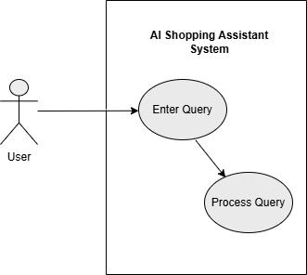

    - Information Extraction
ID | UC005
Name | Information extraction
Description | This use case extracts important details from the query.
Requirement(s) | FR005
Actor(s) | System
Precondition | Query is processed
Post condition | Key information is extracted
Basic Flow | Basic Flow  - The system analyzes the query  - System identifies product type  - System identifies price range  - System forwards extracted information  Alternative Flow  - Some details are missing  1.1. System is continuous with available information  Exceptions  - System fails to extract key details
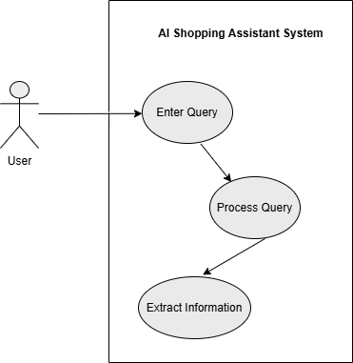

    - Decision Support Suggestion
ID | UC006
Name | Decision support suggestion
Description | This use case provides guidance to help users choose suitable options.
Requirement(s) | FR006
Actor(s) | System
Precondition | Key information from the user query is available
Post condition | Suggestions are generated
Basic Flow | Basic Flow  - System evaluates extracted information  - System determines suitable options  - System generates suggestions  Alternative Flow  - Limited Information  - System applies default assumptions  Exceptions  - System fails to generate a suggestion
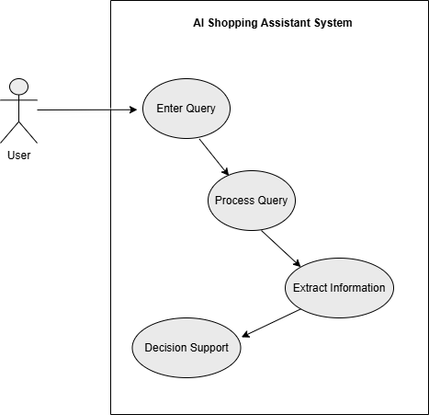

    - Product Recommendation
ID | UC007
Name | Product Recommendation
Description | This use case provides product recommendations to choose the best option
Requirement(s) | FR007
Actor(s) | System
Precondition | Decision support is completed
Post condition | The product is recommended
Basic Flow | Basic Flow  - System retrieves product data  - System filters relevant products  - System ranks products  - System displays recommendations  Alternative Flow  - No exact match found  - System shows alternative options  Exceptions  - System fails to retrieve data from data base
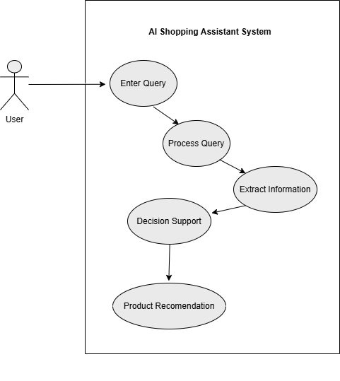

    - View Product Details
ID | UC008
Name | View product details
Description | This use case allow users to view product details.
Requirement(s) | FR008
Actor(s) | User
Precondition | Product list is displayed
Post condition | Product details are shown
Basic Flow | Basic Flow  - User selects a product  - System retrieves product details  - System displays details  Alternative Flow  1. Product not available  - System shows a message  Exceptions  - System fails to load product details

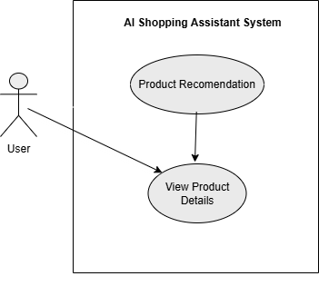

    - Admin Login

ID | UC009
Name | Admin login
Description | This use case allows the admin to access the system.
Requirement(s) | FR009
Actor(s) | Admin
Precondition | Admin account exists
Post condition | Admin is logged in
Basic Flow | Basic Flow  - Admin enters credentials  - System validates credentials  - System grants access  Alternative Flow  1. Invalid credentials  - System shows an error message  Exceptions  - Authentication failure

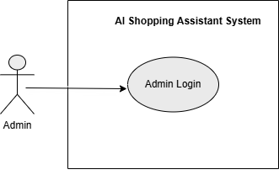

    - System Level Use Case Diagram

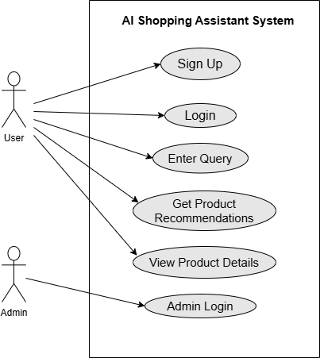

The system-level use case diagram illustrates the interaction between the user, admin, and the AI shopping assistant system. It shows that users can register, log in, enter product queries, and receive product recommendations. The system also allows users to view detailed product information, while the admin can securely access the system.
This diagram provides a clear high-level overview of the system’s functionalities and user interactions.

