**LAB # 3**

1) How do you declare an empty list in Dart?

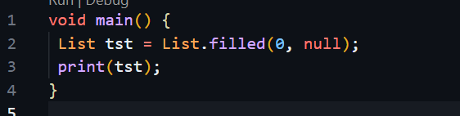

4) How do you remove an element from a specific index in a Dart list?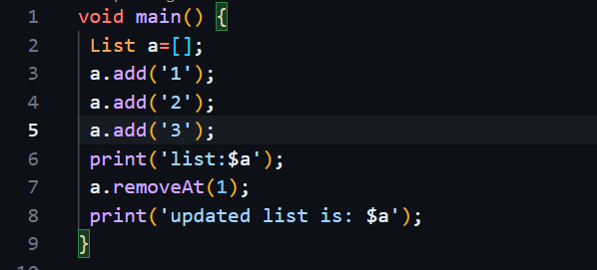

2) How do you access elements in a Dart list?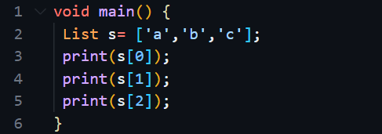

3) Explain how to add an element to the end of a Dart list

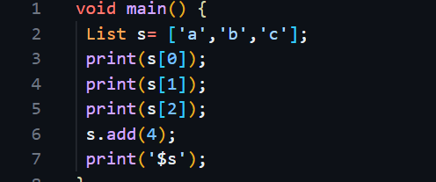

What is the length property of a Dart list?