
FATIMA JINNAH WOMEN UNIVERSITY
Department of Software Engineering

CLOUD COMPUTING (BSE-V)
BS(SE) – Semester V
ASSIGNMENT 01
Git, Gitea, GitHub, Git LFS, and GitHub Pages
Student Name | Areeba Habib
Registration Number | FA24B1-SE-011
GitHub Username | areebahabib
Gitea Username | areebahabib
Class / Section | BS(SE)-V
Submitted To | Mr. Waqas Saleem
Total Marks | 10
Submission Date | October 10, 2026

1. Introduction and Objective
This report documents the practical work completed for Assignment 01 of Cloud Computing (BSE-V). In this assignment, I installed and ran a self-hosted Gitea service on an Ubuntu server using Docker Compose, created and managed a local Git repository on the same server, pushed it to both Gitea and GitHub using multiple remotes, tracked large files using Git LFS, and published a portfolio website using GitHub Pages.
By completing this assignment, I demonstrated the ability to:
- Install, run, and access a Gitea service on an Ubuntu server.
- Create and manage a Git repository from an Ubuntu server.
- Work with multiple Git remotes.
- Authenticate safely without exposing credentials.
- Track and push large files with Git LFS.
- Publish a static portfolio or CV with GitHub Pages.

Screenshot Index
No. | Screenshot File | Purpose
1 | task1_gitea_running.png | Gitea and PostgreSQL containers running, HTTP 200
2 | task1_gitea_push.png | Initial push to the Gitea remote
3 | task1_gitea_repository.png | Gitea repository page with rendered README
4 | task2_remotes.png | Both gitea and github remotes listed
5 | task2_github_push.png | Successful push to GitHub
6 | task2_github_repository.png | GitHub repository page with rendered README
7 | task3_lfs_setup.png | Git LFS installed and *.bin tracking rule
8 | task3_lfs_files.png | Three LFS files listed with sizes above 100 MiB
9 | task3_lfs_push.png | LFS objects uploaded to GitHub
10 | task4_pages_repository.png | Portfolio repository with index.html and styles.css
11 | task4_pages_deployment.png | GitHub Pages settings showing site is live
12 | task4_portfolio_live.png | Live portfolio at github.io URL

Task 1: Install Gitea and Push a Repository from the Ubuntu Server
Task meaning: Install Gitea (a self-hosted Git service) on the Ubuntu server using Docker Compose, create a local repository on the same server, and push it to Gitea.

Step 1.1: Install and Run Gitea
Docker and Docker Compose were installed, Gitea and PostgreSQL containers were started, and Gitea responded on port 3000.

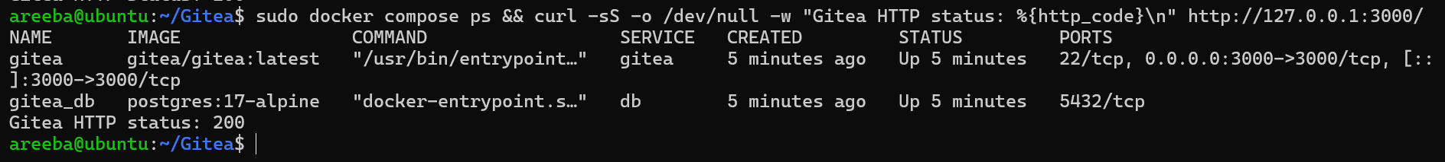
Figure 1: task1_gitea_running.png

Step 1.2: Create and Push the Initial Repository
A local Assignment01 repository with README.md (name and registration number) was created and pushed to Gitea using a personal access token.
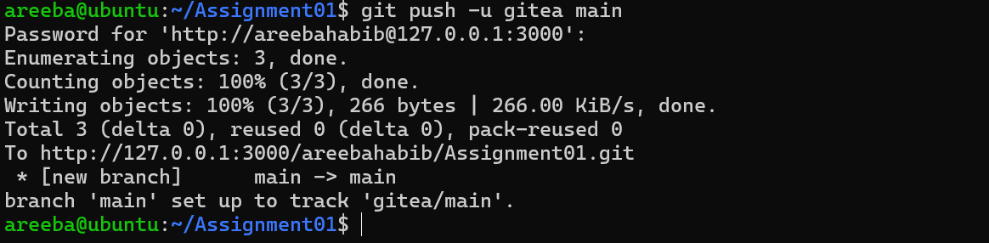
Figure 2: task1_gitea_push.png

Step 1.3: Verify the Gitea Repository
The repository was opened in Gitea to confirm it is public and the README is rendered.
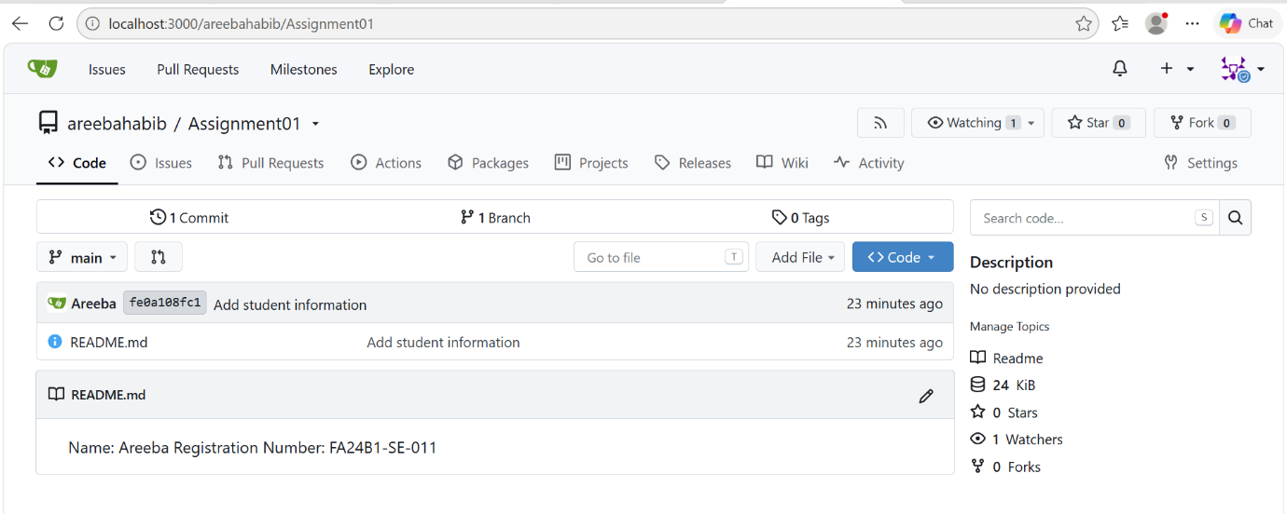
Figure 3: task1_gitea_repository.png

Task 2: Push the Same Repository to GitHub
Task meaning: Add GitHub as a second remote to the same local repository and push the main branch to it, so one repository is available on both Gitea and GitHub.

Step 2.1: Create the GitHub Repository and Verify Both Remotes
An empty public Assignment01 repository was created on GitHub and added as the github remote.
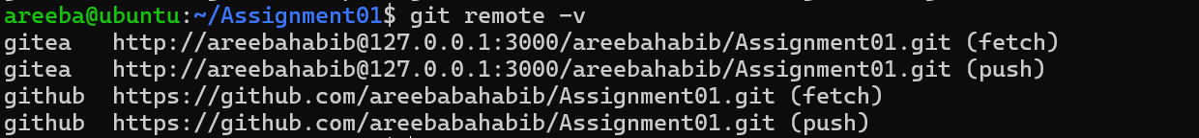
Figure 4: task2_remotes.png

Step 2.2: Push to GitHub
The main branch was pushed to the github remote.
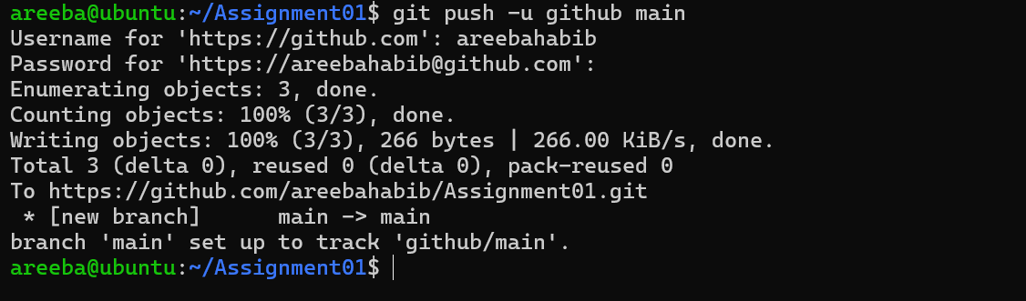Figure 5: task2_github_push.png
Step 2.3: Verify the GitHub Repository
The GitHub repository page was opened to confirm owner, name, public status and README.
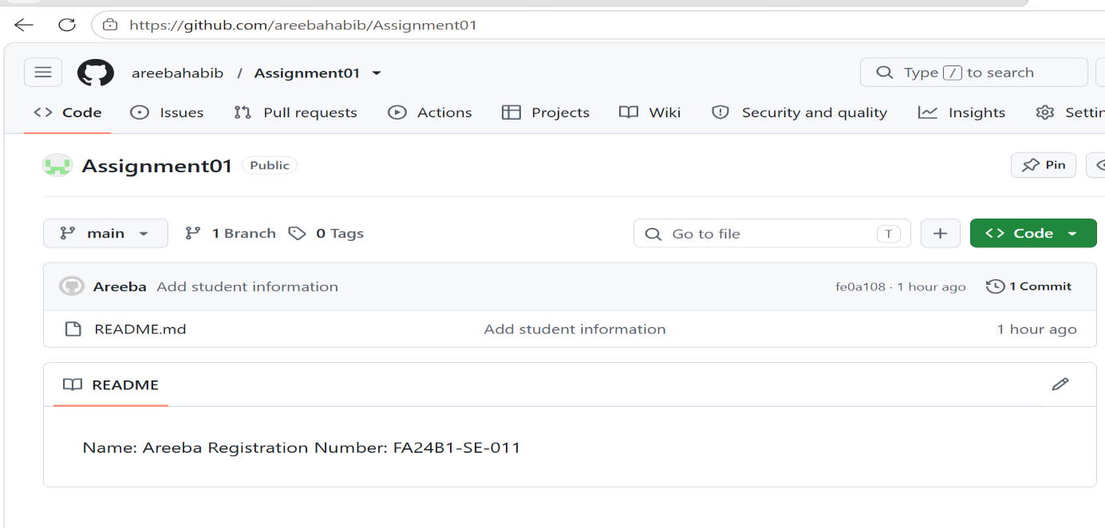Figure 6: task2_github_repository.png

Task 3: Track Three Large Files with Git LFS
Task meaning: GitHub does not accept normal files above 100 MiB. Git LFS stores large files separately and keeps only small pointers in the repository. Three files larger than 100 MiB were tracked and pushed with LFS.

Step 3.1: Configure Git LFS
Git LFS was initialized and *.bin files were set to be tracked.
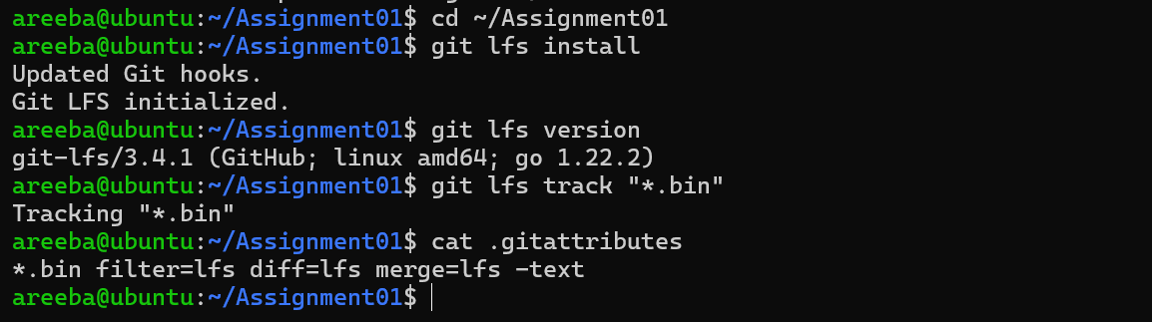
Figure 7: task3_lfs_setup.png

Step 3.2: Create and Verify Three LFS Files
Three .bin files (101M, 102M, 103M) were created, staged, and checked with Git LFS.
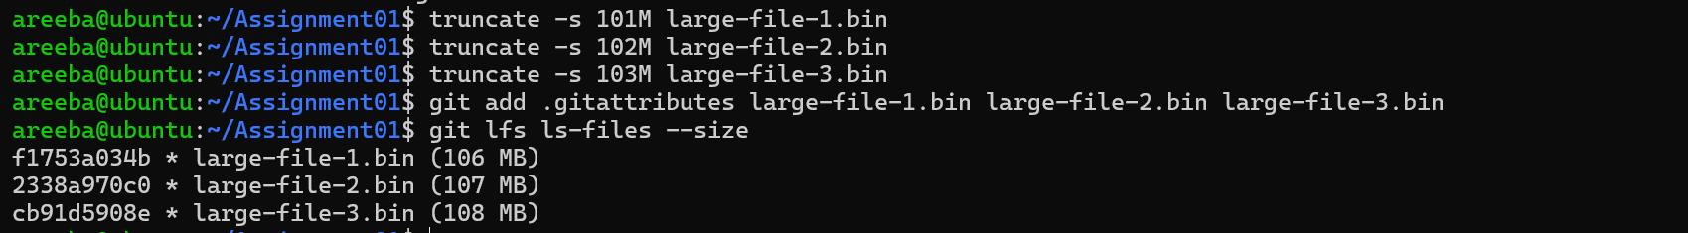
Figure 8: task3_lfs_files.png

Step 3.3: Commit and Push the LFS Files
The files were committed and pushed to GitHub; LFS uploaded the large objects.
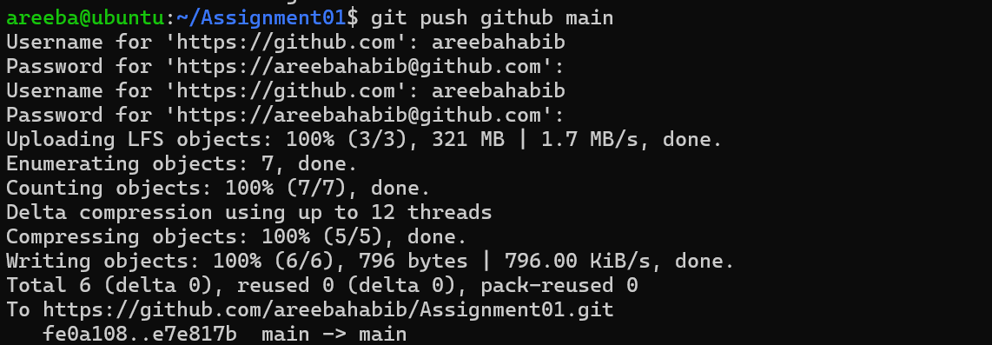

Figure 9: task3_lfs_push.png

Task 4: Create a Portfolio or CV with GitHub Pages
Task meaning: Build a portfolio website using HTML and CSS (About Me, Education, Skills, Projects) and publish it as a live site with GitHub Pages.

Step 4.1: Create and Push the Portfolio Repository
A public <username>.github.io repository was created with index.html and styles.css and pushed to main.

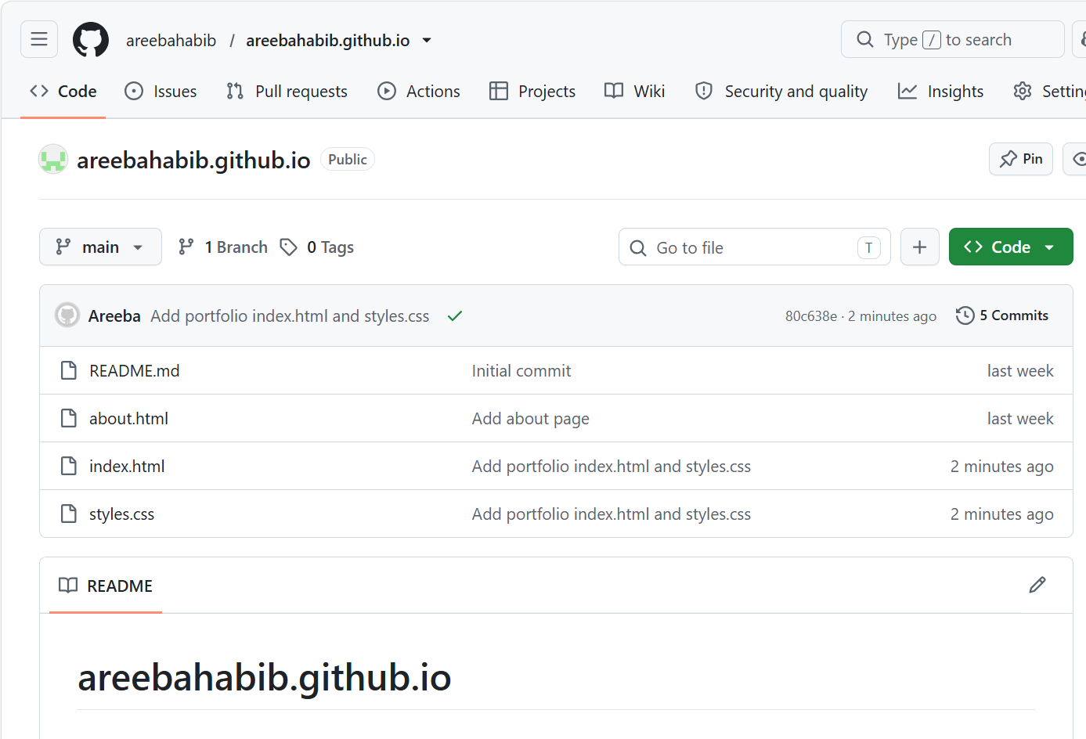Figure 10: task4_pages_repository.png

Step 4.2: Publish with GitHub Pages
Pages was set to Deploy from a branch (main, / root) and the site went live.
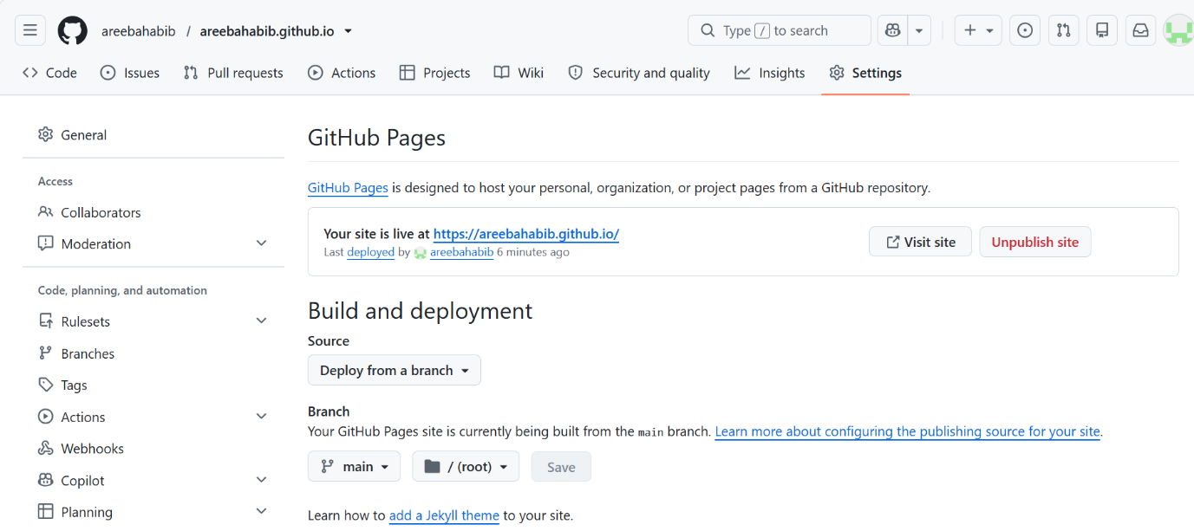

Figure 11: task4_pages_deployment.png

Step 4.3: Verify the Live Portfolio
The live site was opened in the browser.

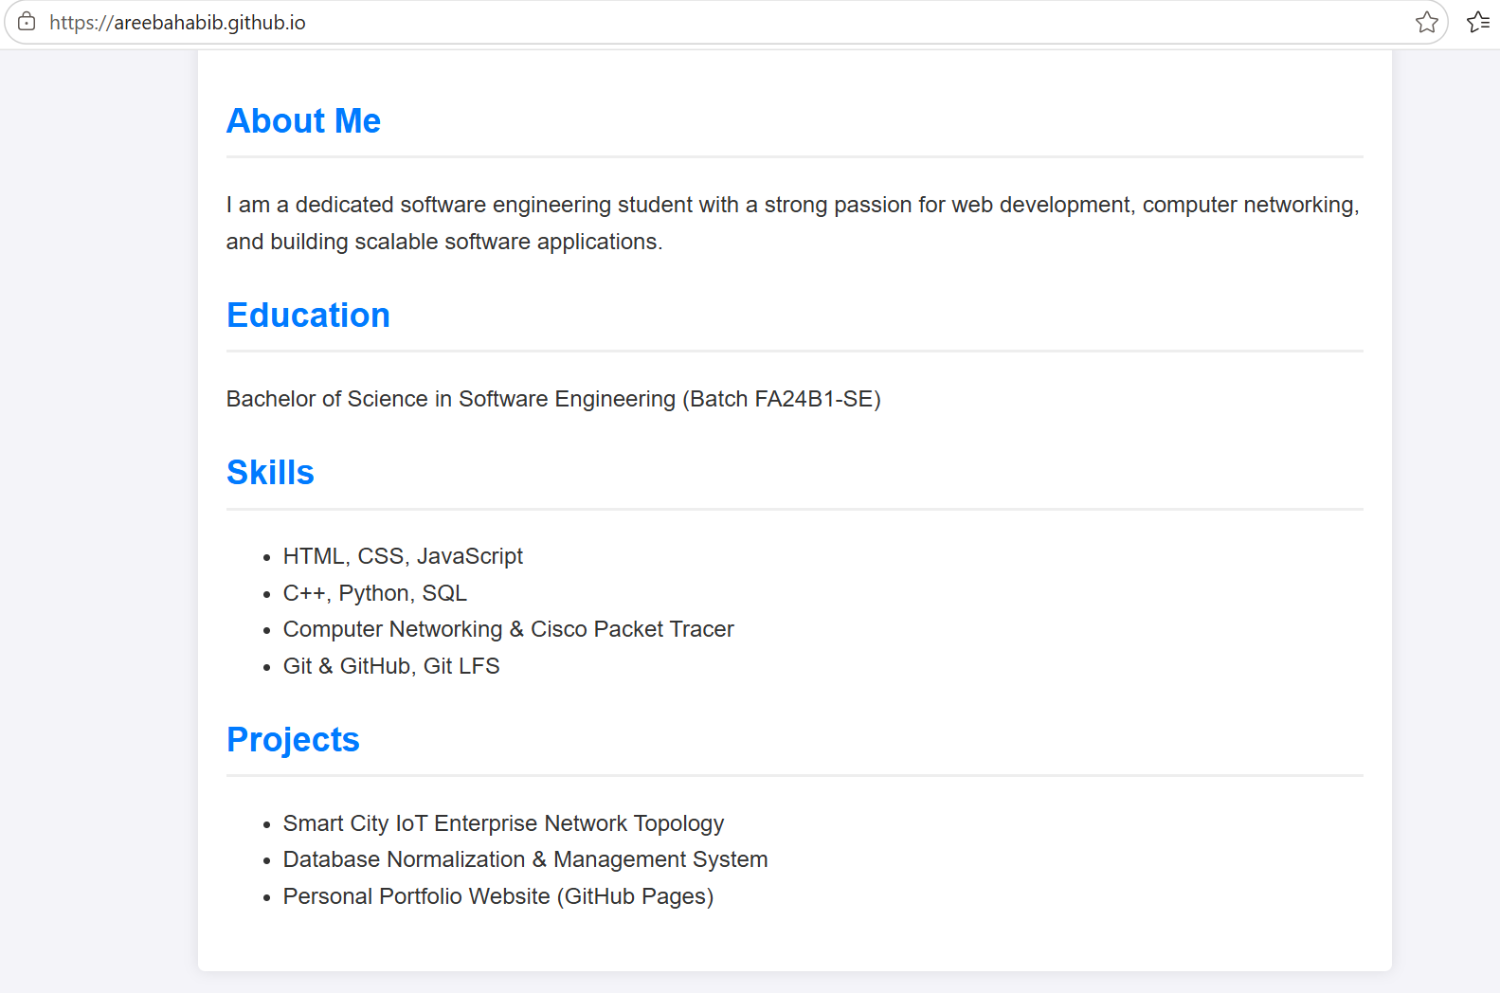Figure 12: task4_portfolio_live.png

Submission Links
Item | Link
CC repository | https://github.com/areebahabib/CC
GitHub Assignment01 | https://github.com/areebahabib/CC/tree/main/Assignments/Assignment01
Portfolio repository | https://github.com/areebahabib/areebahabib.github.io
Live portfolio | https://areebahabib.github.io/
Gitea Assignment01 | http://localhost:3000/areebahabib/Assignment01

