**FOOD RESTAURANT**



**THESIS SUBMITTED OF THE REQUIREMENT OF KHAN E FARHANG, FOR THE AWARD OF ADVANCED DIPLOMA IN INFORMATION TECHNOLOGY**

**SUBMITTED BY**

**NAME GR NUMBER**

**AREEBA FATIMA 3764**

**SUPERVISOR**Sir Khizer Mir  
Computer Instructor

**CO-SUPERVISOR**

**Miss Hafsa Rao**

**Computer Instructor**

**DEPARTMENT OF COMPUTER AND TECHNOLOGY**

**KHANA E FARHANG**

**Cultural Center of Islamic Republic of Iran**

**2022**

# certificate

**FOOD RESTAURANT**

**AREEBA FATIMA(3764)**

|  |
| --- |
| **\_\_\_\_\_\_\_\_\_\_\_\_\_\_\_\_\_\_\_\_\_\_\_\_\_\_\_\_\_\_** |
| **Supervisor** |
|  |
|  |
|  |
|  |
|  |
| **\_\_\_\_\_\_\_\_\_\_\_\_\_\_\_\_\_\_\_\_\_\_\_\_\_\_\_\_\_\_** |
| **Principal** |
|  |
|  |
|  |
|  |
|  |
|  |
|  |
|  |
|  |

# ACKNOWLEDGMENT

I’m thankful with the core of my heart to almighty Allah. Lord of the universe, who made it possible to complete my project successfully. The success of a project depends on the contributions and supports of many people and I would like to appreciate for their support in the duration of this project. I would like to express my gratitude to my supervisors Sir Khizer Mir and Miss Hafsa Rao who are responsible for supervising and monitoring my progress of this project thesis. Secondly my friend(Mustafa) and elder sister(Faryal) for offering their guidance and encourage to me. Otherwise, this project would not have been possible to be developed properly.

I’m specially thankful to my family who always stands with me no matter what happens. Their full support and encouragement were such a boost for my capabilities and confidence to undergo this period last but certainly not least, I also want to thank all my friends for their invaluable assistance towards this project thesis.

Special thanks to everyone who involve in this project either direct or indirectly. I must admit here that it was impossible for me to completing my project thesis without the supports of them that I mentioned above.

# ABSTRACT

* Eating is one of life’s pleasure and pride – so is cooking and serving good food to others. Food restaurant is website that have interactive menus allowing customer to place orders with free delivery.
* A restaurant is an eating place where people are served food, drinks and desserts for their money. The food is served normally within a building even though presently, one can be given packed food to be eaten away. Food in a restaurant is prepared by chefs. Sometimes, restaurants specialize in the kind of food they offer.
* You save a lot of time and money if you buy food from my restaurant because it offer you online order and free delivery.
* On the other hand, you have to waste your time to buy your food also you don’t have to care about the car or other vehicle to deliver the food because we offer you great deals with reasonable price to you.

# List of Figures

[Figure 5‑1: Login 9](#_Toc92235009)

[Figure 5‑2: Sin up 10](#_Toc92235010)

[Figure 5‑3:](../../../../C:/Users/raoha/Downloads/Thesis-Sample-2020.docx" \l "_Toc92235011) Offers 11

# Contents

[certificate I](#_Toc92318591)

[ACKNOWLEDGMENTS II](#_Toc92318592)

[ABSTRACT III](#_Toc92318593)

[List of Figures IV](#_Toc92318594)

[Contents V](#_Toc92318595)

[Chapter No. 1 INTRODUCTION 1](#_Toc92318596)

[1.1 Introduce your project 1](#_Toc92318597)

[1.2 OBJECTIVES 1](#_Toc92318598)

[1.3 SCOPE 2](#_Toc92318599)

[Chapter No. 2 Background 3](#_Toc92318600)

[2.1 THE WEBSITE 3](#_Toc92318601)

2.2 HOME PAGE …………………………………………………………..

2.3 MENUS …………………………………………..

2.4 OFFER/DEALS…………………………………….

2.5 CONTACT……………………………………..

2.6 ABOUT.……………...

[Chapter No. 3 TOOL & TECHNOLOGIES 6](#_Toc92318607)

[3.1 OVERVIEW OF TOOLS 6](#_Toc92318608)

[3.2 HTML/CSS 6](#_Toc92318609)

[3.2.1 HTML5 7](#_Toc92318610)

[3.2.2 Cascading Style Sheets (CSS) 7](#_Toc92318611)

[Chapter No. 4 Code 8](#_Toc92318612)

[4.1 CSS (Paste CSS Code) 8](#_Toc92318613)

[4.2 HTML (Paste HTML Code of Various pages here) 11](#_Toc92318614)

[4.2.1 Home Page: 11](#_Toc92318615)

[Chapter No. 5 RESULT AND CONCLUSION 17](#_Toc92318616)

[5.1 RESULT 17](#_Toc92318617)

[5.2 Home Page 17](#_Toc92318618)

[5.3 Information: 18](#_Toc92318619)

[5.4 CONCLUSION 18](#_Toc92318620)

# INTRODUCTION

## Introduce your project

A site or website is a central location of web pages that are related and accessed by visiting the home page of the website using a [browser](https://www.computerhope.com/jargon/b/browser.htm). For example, Computer Hope is considered a website, which contains different web pages. Any person person can create a website on the Internet. Today, the Internet consists of billions of websites created by billions of different people. You can even create a website or blog on the Internet.

Online food ordering is the process of ordering food from a website or other application. The product can be either ready-to-eat food (e.g., direct from a home-kitchen, restaurant, or a ghost kitchen) or food that has not been specially prepared for direction consumption (e.g., vegetables direct from a farm/garden, fruits, frozen meats. Etc).

In restaurant-controlled online food ordering, the restaurants create their own website and app. A customer can choose to have the food delivered or for pick-up/take-away. The process consists of a customer choosing the restaurant of their choice, scanning the menu items, choosing an item, and finally choosing for pick-up or delivery.

Here we have multiple cooks for different types of food. We have expert that make delicious food which you will enjoy and want to eat again. We offer you different deals with reasonable price and make you feel happy. We have free food for the first three customers of the day so don’t waste your time and order now to eat the special dishes of my our restaurant.

## OBJECTIVES

our restaurant closes at night but website does not. Customers can see our menu and schedule orders any time day or night for when we are open. Our online “waiter” will never complain!

Our objective is to save your time and money by free delivery. We offer you great deals with reasonable price and you have a choice to make your food by your favorite cook.

* To use for order food.
* Give you different offers.
* To save your time and money.

## SCOPE

The scope of the Food restaurant to give advance order system where customer can order and buy different food items. the Dynamic Interface of Food restaurant site is a responsive website customized viewing experience for different browser platform (laptop, tablet, and smart phones). Through this dynamic web interface customers can make their own account and also sin up their account. We have attractive look of our website that will attract you and also it is simple for you. We can order simply by entering your name phone no and order item. The user also login their accounts by social media apps like facebook, instagram and snapchat.

# Background

## THE WEBSITE

A **website**, also written as **Web site**, **web site**, or simply **site**,is a set of related web pages served from a single web domain. A website is hosted on at least one web server, accessible via a network such as the Internet or a private local area network through an Internet address known as a Uniform resource locator. All publicly accessible websites collectively constitute the World Wide Web.

A web page is a document, typically written in plain text interspersed with formatting instructions of Hypertext Markup Language (HTML, XHTML). A webpage may incorporate elements from other websites with suitable markup anchors.

Web pages are accessed and transported with the Hypertext Transfer Protocol (HTTP), which may optionally employ encryption (HTTP Secure, HTTPS) to provide security and privacy for the user of the webpage content. The user's application, often a web browser, renders the page content according to its HTML markup instructions onto a display terminal.

## HOME PAGE

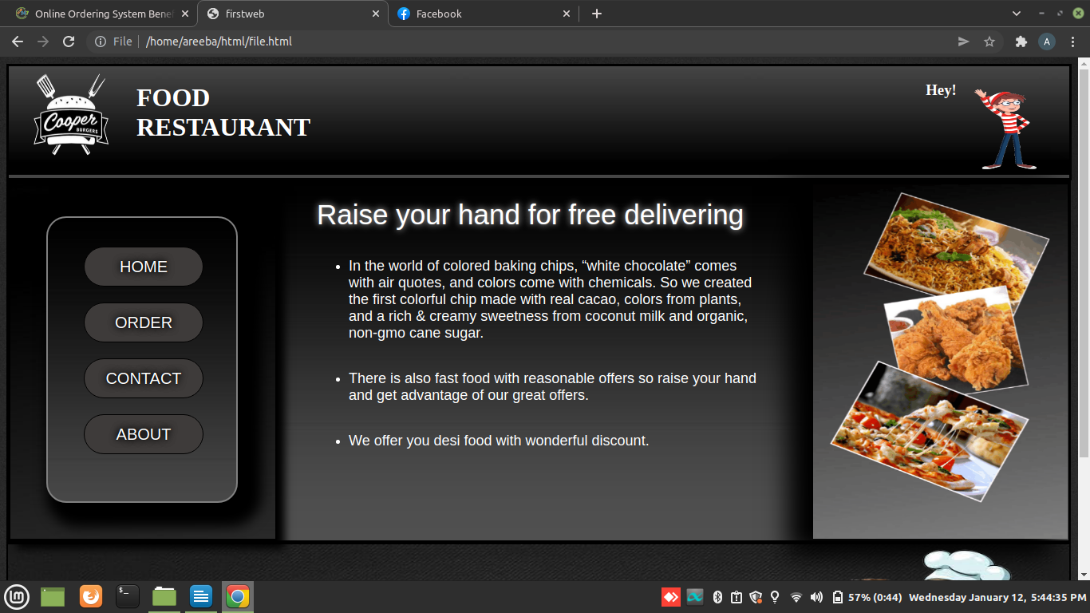

# 2.3 Menus

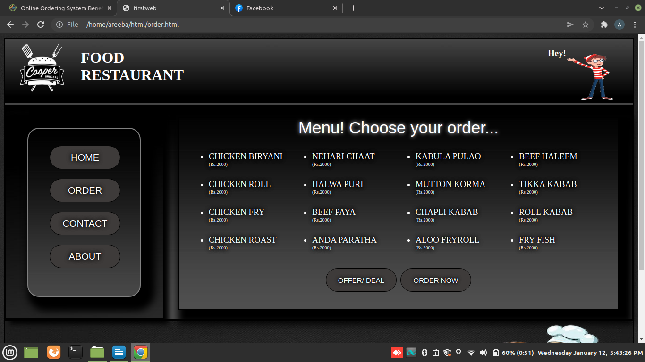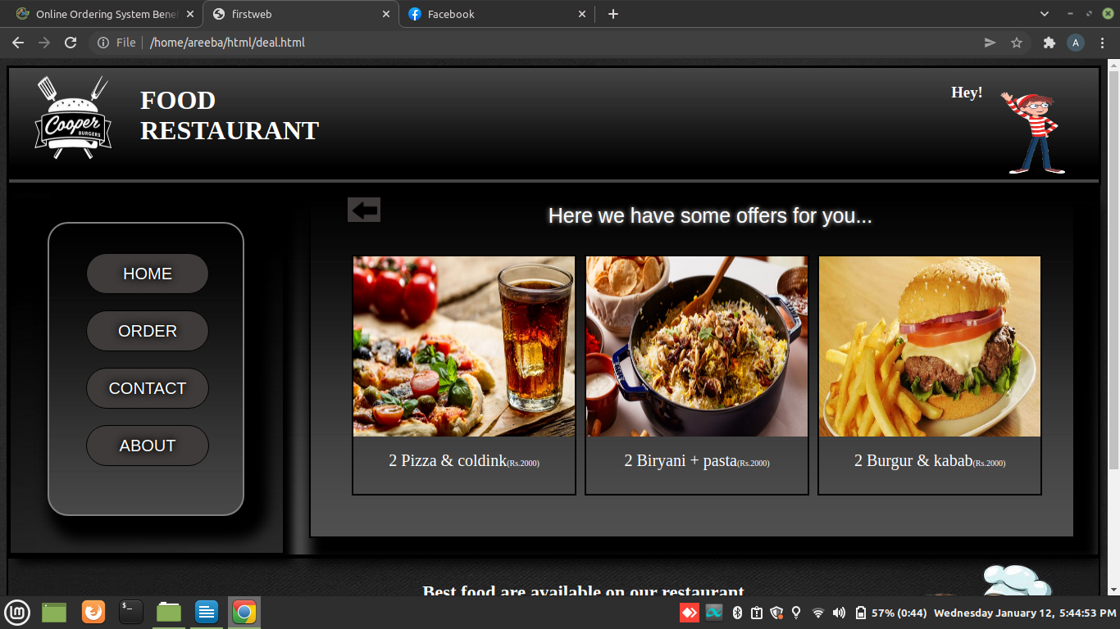

2.4 **DEALS/ OFFERS**

# 

1. **2.5 CONTACT**
2. **2.6 ABOUT**

# 

# TOOL & TECHNOLOGIES

## OVERVIEW OF TOOLS

A software development tool is program or application that software developers use to create debug, maintain, or otherwise support other programs and applications. The term usually refers to relatively simple programs that can be combined together to accomplish a task, much as one might use multiple hand to fix a physical object.

## HTML/CSS

HTML (Hypertext Markup Language) is the set of markup symbols or codes inserted in a file intended for display on a World Wide Web browser page. The markup tells the Web browser how to display a Web page's words and images for the user.

HTML defines the structure and layout of a Web document by using a variety of tags and attributes.

HTML language, called tags are words surrounded by brackets. HTML tags are written as pairs, there must be a beginning tag and an ending tag in order to make the code display correctly. The firs tag designates how the following text will be grouped or displayed, and the closing tag (with a backslash) designates the end of this group or display.

The correct structure for an HTML document starts with,

<HTML><HEAD> (enter here what document is about)

<BODY>

All the information you'd like to include in your Web page fits in between these tags.

</BODY>

</HTML>

### HTML5

HTML5 is the latest version of Hypertext Markup Language, the code that describes web pages. It's actually three kinds of code: HTML, which provides the structure; Cascading Style Sheets (CSS), which take care of presentation; and JavaScript, which makes things happen. One of the design goals for HTML5 is to support for multimedia on mobile devices.

### Cascading Style Sheets (CSS)

**Cascading Style Sheets (CSS)** is a style sheet language used for describing the presentation of a document written in a markup language. CSS describes how HTML elements are to be displayed on screen, paper, or in other media. CSS saves a lot of work. It can control the layout of multiple web pages all at once. External style sheets are stored in CSS files. CSS gives more control over the appearance of a Web page to the page creator than to the browser designer or the viewer. With CSS, the sources of style definition for a given document element are in this order of precedence:

1. The STYLE attribute on an individual element tag
2. The STYLE element that defines a specific style sheet containing style declarations or a LINK element that links to a separate document containing the STYLE element. In a Web page, the STYLE element is placed between the TITLE statement and the BODY statement. [7]

**3.2.3 Dream weaver**

Dream weaver CC is to design, code, and publish websites and web applications that look amazing on any screen size. Dream weaver CC is a web development software that allows you to create and manage dynamic websites easily with adaptive user-friendly coding engine. Dream weaver CC is for anyone who wants to learn to develop websites and web applications. There are hints and visual aids as you work to quickly learn HTML, CSS, and more all while helping you find errors to speed up development.

# Code

## CSS (Paste CSS Code)

body{

background-image: url("image.jpg");

background-size: cover;

}

.header{

display: flex;

border: 3px outset black;

background-image: url("div.jpeg");

}

.img:hover{

box-shadow: 5px 5px 5px black;

margin-top: 5px;

}

button{

color: white;

text-shadow: 0 0 0.07em black, 0 0 0.5em black, 0 0 0.5em black;

font-size: 20px;

background-color: #3E3B3A;

border: 1px solid black;

height: 50px;

width: 150px;

margin-top: 20px;

margin-left: 5px;

border-radius: 25px;

}

a{

color: white;

text-decoration: none;

font-size: 20px;

}

button:hover{

background-color: #8B837E;

}

.seven{

padding-left: 5px;

text-align: left;

text-shadow: 0 0 0.07em black, 0 0 0.5em black, 0 0 0.5em black;

font-size: 20px;

height: 70px;

width: 400px;

}

.btnn{height: 30px; width: 40px; border: none; border-radius: 0px}

.btn{ background-color: #3E3B3A;}

.btn:hover{background-color: #8B837E;}

.Rinput{

float: left;

margin-top:10px;

height: 30px;

width: 200px;

}

.two{

border: 2px solid black;

display: flex;

background-image: url("backkk.jpg");

background-size: 100%;

background-repeat: no-repeat;

height: 200px;

width: 99.6%;

color: white;

}

.three{

height: 120px;

width: 20%;

margin: 50px 0px 0px 50px;

color: white;

font-size: 20px;

}

.L2{

margin:50px 20 0 0;

}

I1{

height: 70px;

width: 250px;

}

.four{

height: 160px;

width: 40%;

margin: 20px 0px 0px 100px;

color: white;

}

.five{

margin-left: 100px;

width: 300px

}

.marq{

color: white;

border: solid 1px black;

background-color: #191919;

height: 23px;

}

## HTML (Paste HTML Code of Various pages here)

### Home Page:

<!DOCTYPE>

<html>

<head>

<title>firstweb</title>

<link rel="stylesheet" type="text/css" href="style.css">

<!-- <meta http-equiv="refresh" content="1"> !-->

</head>

<body>

<!-- Header !-->

<div class="header">

<div class="one">

<!-- logo pic and name !-->

<img src="img4.png" height="120px" width="160px" >

<h1>FOOD <br>RESTAURANT<h1>

</div>

<div class="twoo">

<!-- hello pic and text !-->

<h3 style="padding:0px">Hey!<h3>

<img src="image1.gif" height="110px" width="100px">

</div>

</div>

<!-- Main div !-->

<div class="sec">

<div class="third">

<div class="fourth">

<ul id="one">

<li><button> <a href="file.html"; >HOME</a> </button></li>

<li><button> <a href="order.html"; >ORDER</a> </button></li>

<li><button> <a href="contact.html"; >CONTACT</a> </button></li>

<li><button> <a href="about.html"; >ABOUT</a> </button></li>

</ul>

</div>

</div>

<div style="margin: 20px 50px 10px 50px; width: 42%">

<label class="L1">Raise your hand for free delivering</label>

<br><br>

<ul style="color: white;">

<li><span class="S1">

In the world of colored baking chips, “white chocolate” comes with air quotes,

and colors come with chemicals. So we created the first colorful chip made with

real cacao, colors from plants, and a rich & creamy sweetness from coconut milk

and organic, non-gmo cane sugar.

</span></li>

<br><br>

<li><span class="S1">

There is also fast food with reasonable offers so raise your hand and get advantage of our great offers.

</span></li>

<br><br>

<li><span class="S1">

We offer you desi food with wonderful discount.

</span></li>

</ul>

</div>

<div class="fifth">

<img src="gif.gif" style=" margin-top: 0px; height:110%; width:120%; ">

</div>

</div> <!-- Main div end !-->

<!-- Footer --!>

<div class="two">

<div class="three">

<label class="L2">COMMENTS:</label>

<br><br>

<input style="height: 70px; width: 250px;">

</div>

<div class="four">

<center><h2>Best food are available on our restaurant</h2>

<p>MANAGER: SAIRA ZAKIR</p>

<p>STAFF: 3 MALE 2 FEMALE COOK <br> AVAILABLE ON ANY TIME <br>(Free delivery)</p>

</div>

<div class="five">

<img src="img6.png" height= "100%"; width="80%">

</div>

</div> <!-- End div --!>

<!-- Marquee tag --!>

<marquee class="marq" onmouseover=" this.stop(); " onmouseout= "this.start();">

Thanks for visiting my site. Hope it will be useful to you.

</marquee>

</body>

</html>

# RESULT AND CONCLUSION

## RESULT

By completing this system, I have achieved the goal of providing the users a platform to order their food and see menus at any time.

## Header



## Footer

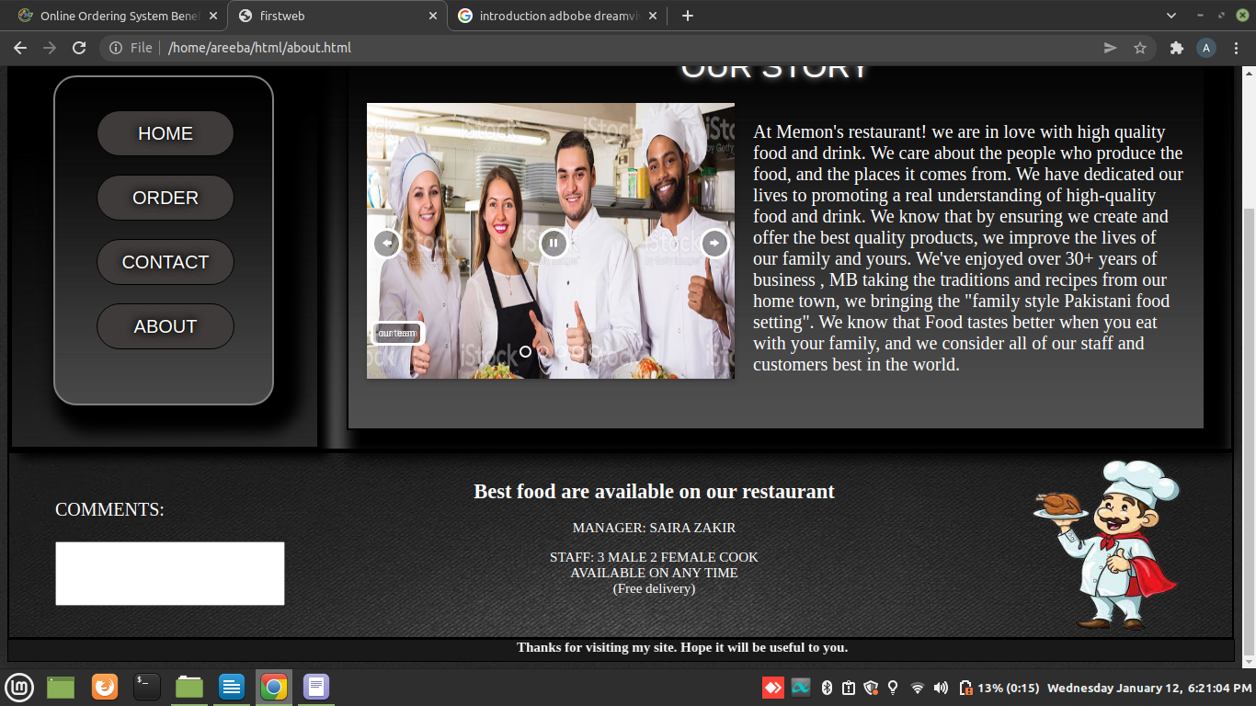

## CONCLUSION

The internet has become a major resource in online business but in every field of life, thus the website of Food restaurant has gained significance not only from the presentation of site in best way but also in the online order point of view. Hence, we have designed the project to provide the user with easy Button list and necessary feedback as must as possible.

A good website must be accompanied with user-friendly interface. It should convenient for the user to view the content of their interest and to be able to fulfill their requirements. The website describes in this project provide the number of features. Those are designed to make the user more comfortable at their Comfort ends.