**A statement of the task to be undertaken. A preliminary requirements analysis:**

Requirements analysis is the analysis definition process of requirements, is the start of the planning and development period of the project. Needs analysis task is to thoroughly describe the function and performance of the software, identify limits of software design and software interface details with other elements of the system, defining the effectiveness of software requirements. Requirements analysis includes business requirements, functional requirements and development requirements. This section contains all the software requirements at a level of Hotel Management System details.

1. Room booking capability can handle customer bookings by various means, such as phone book, online bookings, and reservations at the front desk.
2. SOFTWARE REQUIREMENTS

-Visual Basic.net as frontend

-Oracle Database as backend

-Windows 7 home Premium

3) HARDWARE REQUIREMENTS

-Pentium- 4 processor

-40 & more GB for data storage

-128 to 512 KB RAM

-Printer for reporting and printing

4) Rooms of the hotel have different grades, and require the system to be able to categorize the room management, and according to book different types of rooms to offer available prices, booking discount timing function settings such as lowest price, easy to fit individual traveler and group reservations

5) Keep abreast of the current state of all whether it is available, such as clean the room, which was checked out, to track whether the guest stay. Based on client occupancy information, you need to provide a guest information management function, in order to achieve unified management to the guests of the hotel information, such as ID number for customer inquiries, queries according to the checking dates, change the guest contact information and so on.

6) A hotel management system should have recognition module in order to distinguish each business (accommodation, registration, cashier, hospitality, and other services) to which staff action is, that means the system should set login module

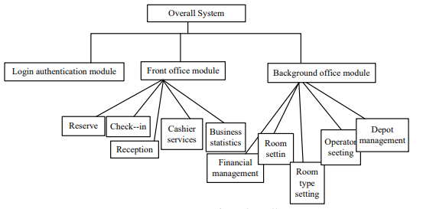

7)Functional Requirements:

**Inputs:**

The major inputs for Integration of Web based Accommodation Upholding Maintenance System can be categorized module -wise. Basically all the information is managed by the software and in order to access the information one has to produce one's identity by entering the user-id and password. Every user has their own domain of access beyond which the access is dynamically refrained rather denied.

**Output:**

The major outputs of the system are tables and reports. Tables are created dynamically to meet the requirements on demand. Reports, as it is obvious, carry the gist of the whole information that flows across the institution. This application must be able to produce output at different modules for different inputs.

8) Safety Requirement:

Database should be backed up every hour.

Under failure, system should be able to come back at normal operation under an hour.

9) Security Requirements

All external communications between the data’s server and client must be encrypted

All data must be stored, protected or protectively marked.

**Suggested deliverables:**

Requirements Analysis – a document and a presentation to go over the formal

* Requirements Analysis – a document and a presentation to go over the formal

Requirements of the project, both functional and non-functional. This deliverable ensures that the Group is working on a system that closely matches to the wishes of the Client.

Design Document – a document and a presentation to go over the design of the system.

This is the Group’s opportunity to go over how the project is to be implemented to the

Client.

Source Code – a document, presentation along with the source code of the final Completed project. This final deliverable wraps up and concludes the project.

This final deliverable wraps up and concludes the project. In this deliverable, the Group delivers the final implementation based on the requirements specified and the design developed in previous stages. The system would have been tested thoroughly with unit tests and with a final acceptance test and would be ready for deployment to the production system.

**Technical Deliverables:**

• A database with tables that going to support the system. These tables will be used to

Store the information that are needed for reservation and payment; such as, guests detail,

Rooms detail, reservation date and employees, who do the reservation, detail.

• A reception interface to add, delete and modify for reservations, guests, rooms,

Employees and payments. Searching for specific guest and reservation.

Survey

11)What do you expect from the application at the end of the development process?   
12)Who is responsible for the approval of the design and tech approaches on the clientâ€™s side?  
13)What are the critical dates for the product?  
14)How do you want to receive feedback from your customers?  
15)Is there some groundbreaking feature you want to implement?