HOSPITAL PATIENT CARE
OPERATIONS ANALYTICS
Power BI Business Intelligence Project Report
Case Study: CarePlus Hospital
Prepared by: Mohammad Areeb Ruafi
Role: BI Analyst | Focus: Patient demand, treatment performance and resource activity

1. Executive Summary
This project develops an interactive Power BI analytics solution for CarePlus Hospital. It brings together patient profiles, appointment activity, treatment encounters, doctor details, room attributes and a calendar table to examine appointment demand, patient behaviour, treatment performance, doctor workload, operational exceptions and room activity.
The report is organized into six pages: Executive Summary, Patient Behaviour Analysis, Treatment Performance Analysis, Doctor & Room Performance, Appointment & Treatment Problems Analysis, and Room Utilization & Resource Insights. The dashboards are designed to help Hospital Operations and Patient Services monitor activity and identify areas for further investigation.
The current screenshots display 3K appointments, 400 unique patients, 50 treatments, 80 doctors, 40 active rooms, 37 completed treatments, 244 urgent appointments and 13 non-completed treatments. These are provisional dashboard values. The project brief lists 3,505 raw treatment rows, so the current treatment count of 50 must be reconciled before final reporting.
Headline KPI | Current display | Validation note
Total Appointments | 3K | Brief reports 3,005 appointment rows; displayed value is rounded.
Unique Patients | 400 | Confirm whether counted from patient dimension or appointment fact.
Total Treatments | 50 | Unreconciled with source description of 3,505 raw rows.
Treatment Cost | 102.88K | Confirm currency, duplicates and filter scope.
Completed Treatments | 37 | Check against the validated treatment cohort.
Non-Completed Treatments | 13 | Displayed status totals currently sum to 50.
Urgent Appointments | 244 | Validate normalized priority values.
Doctors / Active Rooms | 80 / 40 | Confirm unique keys and active-flag meaning.

The dashboards provide a consistent visual framework. Priority actions are to certify treatment records and room relationships, reconcile data-quality counts, clarify KPI definitions, and then refresh all conclusions.

2. Business Background and Problem Statement
CarePlus Hospital is modeled as a multi-specialty healthcare provider. Patients schedule consultations, diagnostic tests, follow-ups, procedures and emergency care. Doctors deliver treatment encounters using hospital rooms and resources. The operations teams need a consolidated view of demand, patient appointment behaviour, treatment status, waiting time, duration, cost, workload and room activity.
Without a connected analytical model, stakeholders may struggle to compare demand across time, service types and booking channels or distinguish data-quality problems from operational patterns. This Power BI project addresses those needs through an interactive report.

3. Project Objectives
- Explore and profile the supplied healthcare operations datasets.
- Clean and transform source data using Power Query while retaining auditable Applied Steps.
- Build and validate a relational data model for patients, appointments, treatments, doctors, rooms and dates.
- Create dynamic DAX measures for demand, treatment outcomes, costs, waiting time and resource activity.
- Design six report pages with clear business questions and consistent visual styling.
- Identify preliminary patterns and recommend practical next steps without overstating unsupported conclusions.

4. Dataset Description
The project uses six supplied CSV tables:
Table | Raw shape / coverage | Purpose / key fields
patients | 402 rows; 8 columns | Patient profile and segmentation; patient_id.
appointments | 3,005 rows; 8 columns | Appointment-level demand; appointment_id, patient_id, doctor_id, appointment_date, service_type, priority, booking_channel, estimated_cost.
treatments | 3,505 rows; 10 columns | Encounter status, treatment cost, waiting time, duration and actual treatment date; treatment_id, appointment_id, doctor_id, room_id.
doctors | 81 rows; 7 columns | Doctor profile and specialty; doctor_id, specialty and doctor attributes.
rooms | 51 rows; 7 columns | Room identifiers, type and availability/active flags.
date_table | 2024-01-01 to 2025-12-31 | Calendar dimension for time-based analysis.

The raw source shapes describe supplied files; final loaded row counts may differ after documented exact-duplicate removal and other validated cleaning steps.

5. Data Understanding and Cleaning
The CSV files were imported through Power BI Desktop (Get Data → Text/CSV). Power Query profiling was used to inspect column quality, distribution, data types, blanks and duplicate values.
- Reviewed column names, data types, column quality, distribution and profile.
- Applied Trim and Clean to relevant text fields and standardized category casing where appropriate.
- Investigated blank values in non-key columns; missing cost values were not replaced with zero.
- Inspected duplicate rows and identifier uniqueness, especially for dimension keys.
- Preserved legitimate repeated patient and entity references in fact tables.
- Checked foreign-key references and validated row counts after transformation.
- Kept the source CSVs unchanged and retained Power Query Applied Steps for reproducibility.

Data Cleaning Evidence
Power Query evidence captured from the cleaned doctor, patient, room, treatment and appointment queries is included below. These screenshots document the visible Applied Steps and profiling state; verify exact final row counts in Power BI.

- Doctors query — text normalization, duplicate handling, promoted headers and data types.
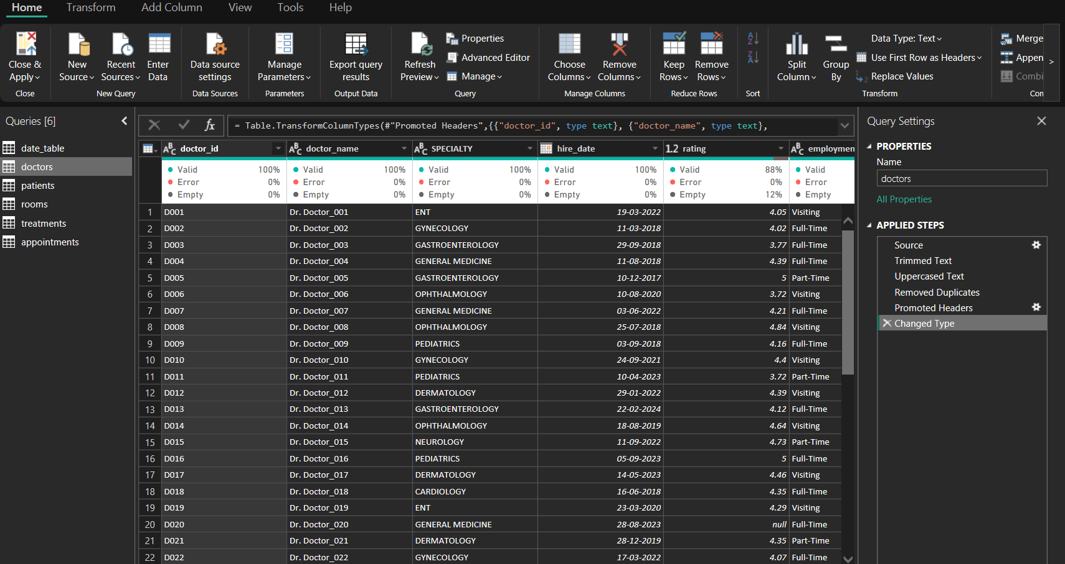

- Patients query — duplicate and filter/sort steps visible; confirm the business rule behind each removed-duplicate step.
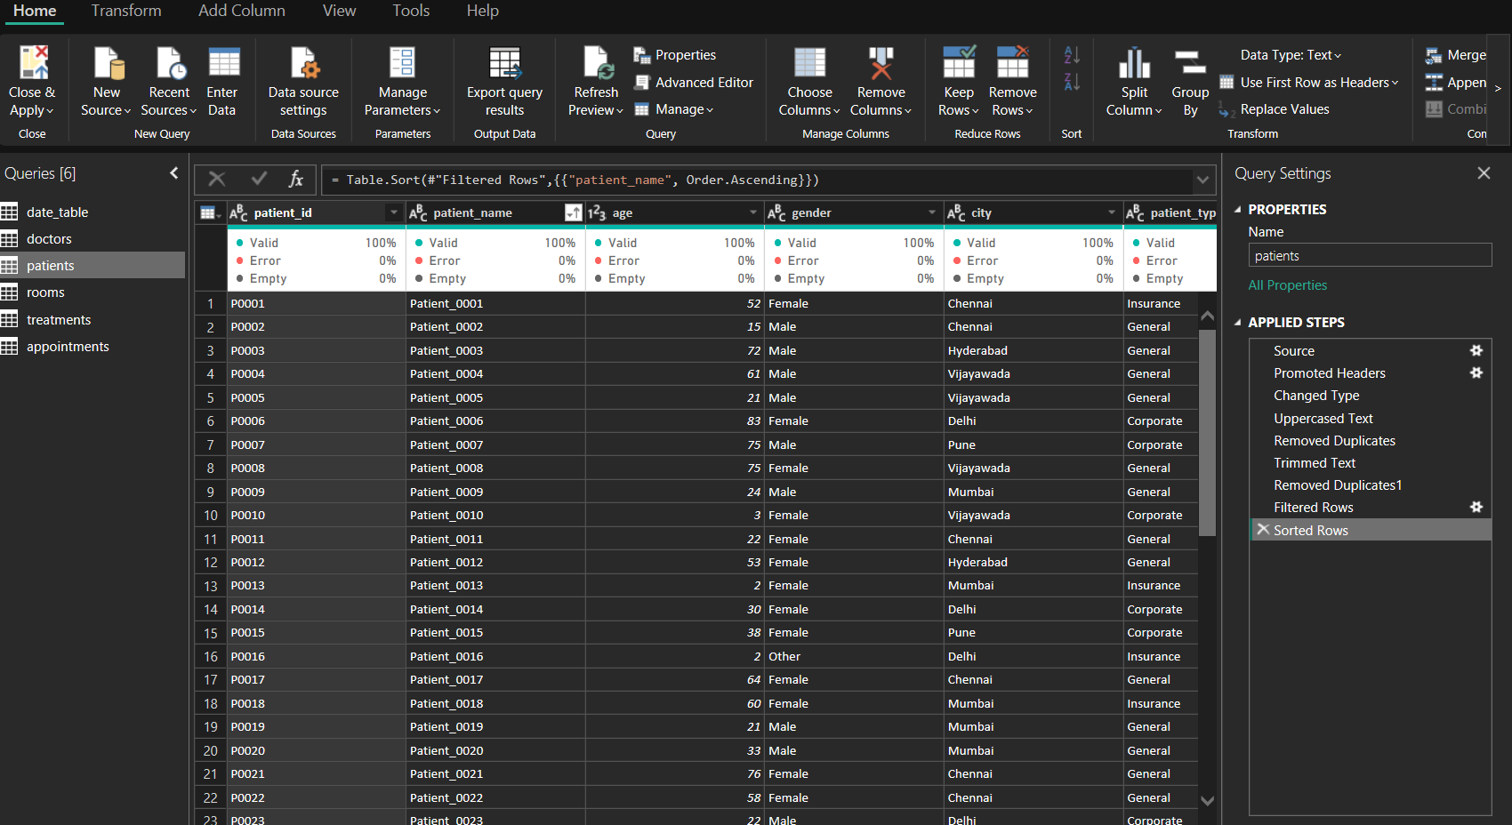

- Rooms query — exact-row duplicate removal; uniqueness of room_id must be checked separately.
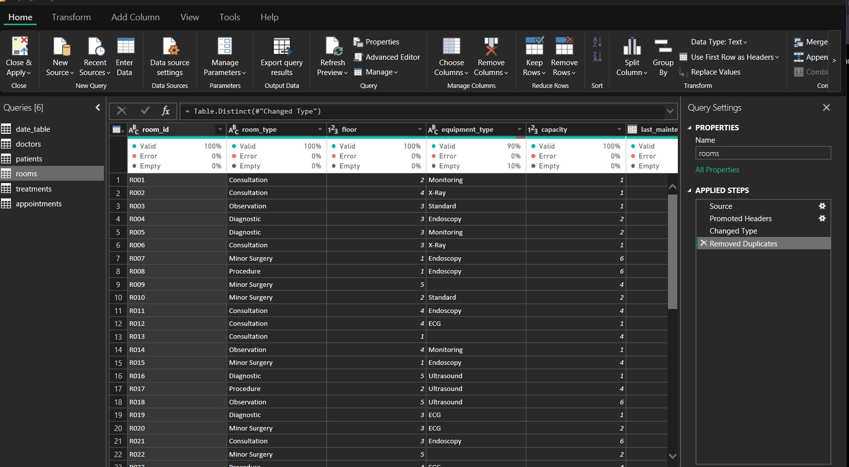
- Treatments query — multiple duplicate-removal steps are visible; inspect key-level conflicts before accepting them.
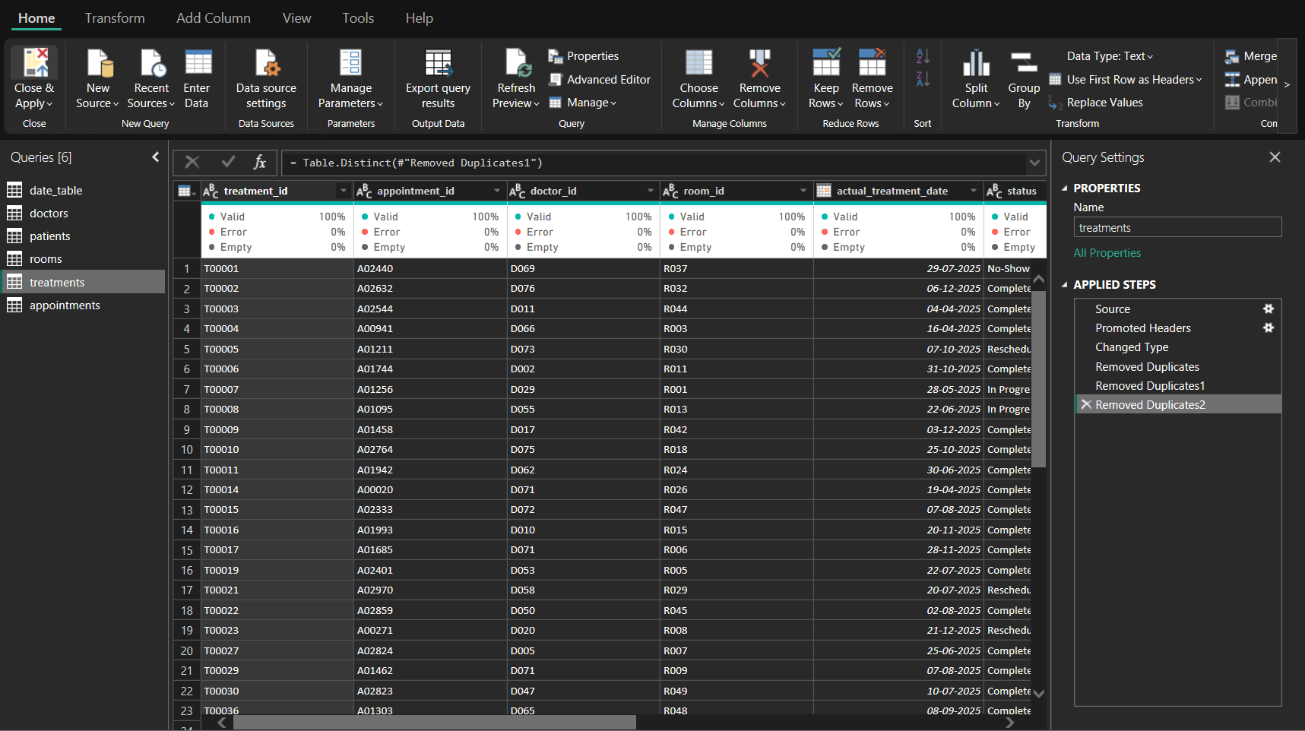

- Appointments query — text casing and trimming applied; standardize priority and inspect missing booking channels.
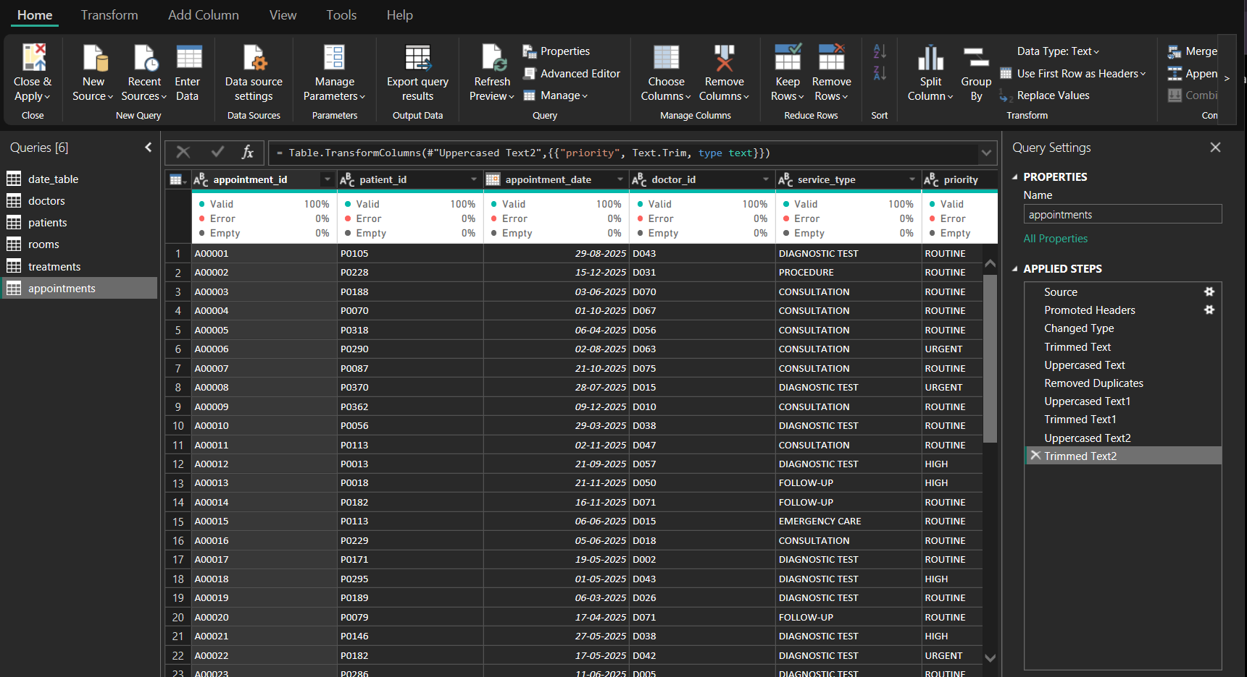
Doctor dimension: an exact duplicate record with doctor_id D054 was identified and removed during cleaning. The resulting doctor dimension contains 80 unique doctors.
Appointments: initial profiling identified six null estimated_cost values, while the dashboard exception KPI displays eight. Reconcile the filter context, counting logic and cleaned query before confirming the final exception total.
Treatments and rooms: duplicate-removal steps are visible in Power Query. Remove only exact duplicate records after confirming they are true duplicate entries; if an identifier has conflicting attribute values, investigate and resolve using a documented rule. Confirm unique room_id and treatment_id keys and referential integrity before refreshing KPI results.
Text normalization: priority labels such as HIGH and High should be standardized. Investigate blank booking_channel categories and document the chosen treatment.

6. Data Model and Relationships
Recommended starting relationships:
- patients[patient_id] 1 → * appointments[patient_id]
- doctors[doctor_id] 1 → * appointments[doctor_id]
- appointments[appointment_id] 1 → * treatments[appointment_id]
- doctors[doctor_id] 1 → * treatments[doctor_id]
- rooms[room_id] 1 → * treatments[room_id]
- date_table[Date] 1 → * appointments[appointment_date] (active)
- date_table[Date] → treatments[actual_treatment_date] (inactive; activate using USERELATIONSHIP for treatment-date measures)
Use unique keys on the one-side dimensions and normally retain single-direction filtering from dimensions to facts. Do not switch to many-to-many merely to bypass duplicate-key errors. Test relationships with simple distinct-count visuals and reconcile totals.

Data Model Evidence
Model view screenshot supplied with the project is inserted below. Validate every relationship's cardinality, cross-filter direction, and active/inactive state against the required model before final submission.
Power BI Model View — relationship overview
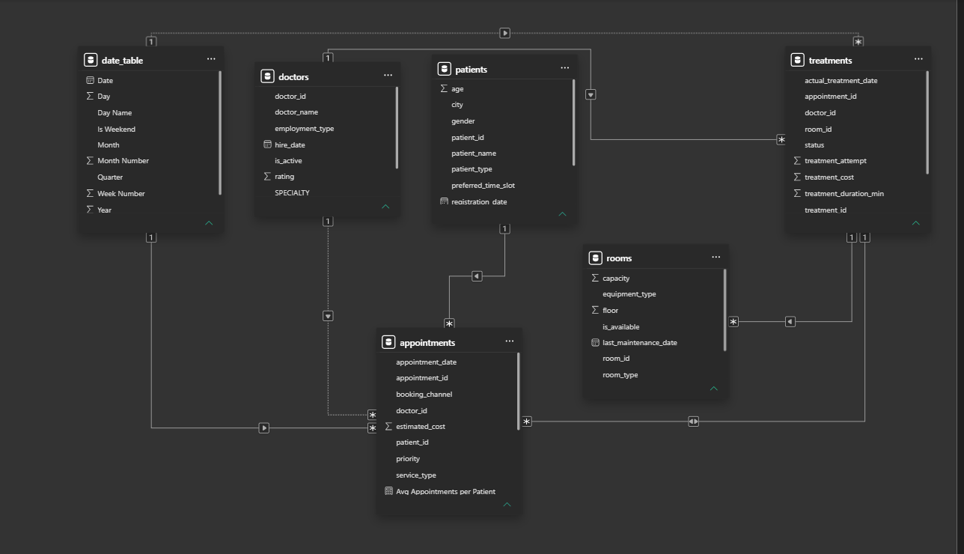
For treatment-date analysis, explicitly activate the inactive calendar relationship in the relevant measure. Ensure date columns use compatible data types and the calendar table is configured appropriately.

7. DAX Measures and Calculated Columns
The following are suggested measure patterns. Match field names and actual status/flag values in the final model, and validate outputs against source records.
Measure | Suggested DAX / definition
Total Appointments | Total Appointments = DISTINCTCOUNT(appointments[appointment_id])
Unique Patients | Unique Patients = DISTINCTCOUNT(appointments[patient_id])
Total Treatments | Total Treatments = DISTINCTCOUNT(treatments[treatment_id]) — use only after ID validation.
Completed Treatments | Completed Treatments = CALCULATE(DISTINCTCOUNT(treatments[treatment_id]), treatments[status] = "Completed")
Non-Completed Treatments | Define eligible status values explicitly; avoid treating blank status as a normal outcome.
Urgent Appointments | Urgent Appointments = CALCULATE(DISTINCTCOUNT(appointments[appointment_id]), appointments[priority] = "Urgent")
Average Waiting Time | Average of eligible treatments[waiting_time_min]; document blank and outlier handling.
Average Treatment Duration | Average of eligible treatments[treatment_duration_min]; label units.
Total Treatment Cost | SUM(treatments[treatment_cost]); validate currency and duplicate handling.
Missing Estimated Cost | Count appointment records where estimated_cost is blank; reconcile with profiling.
Active Rooms | Distinct room IDs filtered to the actual active flag value.
Room Activity | Distinct treatment IDs by room; this is activity volume, not utilization percentage.

A treatment completion rate should use a clearly defined denominator and eligible statuses. A no-show or cancellation rate should be computed only when the underlying status represents the corresponding event at the correct grain. Room utilization percentage requires occupied time and available capacity-hours; room counts alone cannot produce it.

8. Dashboard Design and Analysis

8.1 Executive Summary Dashboard
The landing page combines appointment and treatment KPI cards with monthly appointment trend, service type, priority, booking channel, patient type and weekend comparison.
Key observation from current dashboard: The service type visual shows Consultation as the largest category (1,183 displayed), while Routine appointments dominate the priority chart (about 2.2K displayed). These values should be rechecked after category cleanup and filter review.
Analysis / improvement: Clarify card titles and aggregation units. Normalize blank booking channels and present weekday/weekend labels in business-friendly language. 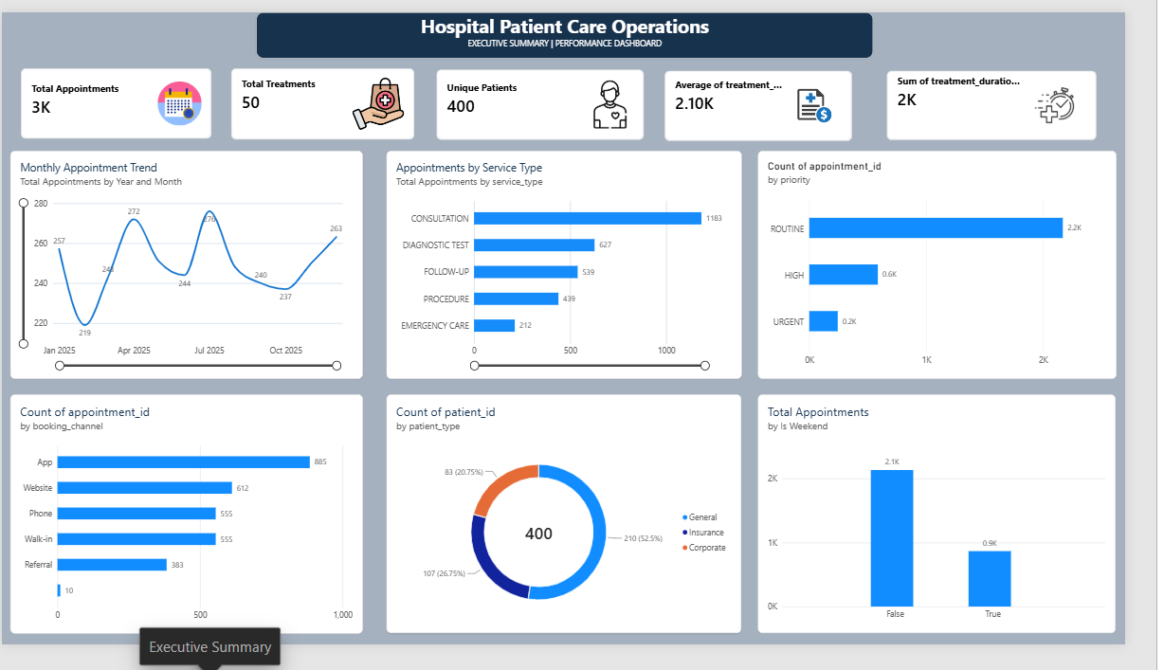

Figure: Current report page — Executive Summary

8.2 Patient Behaviour Analysis Dashboard
This page presents unique patients, average patient age, returning patients and average appointments per patient, alongside patient-type volume, service mix, top patient appointment volume and a monthly appointment trend.
Key observation from current dashboard: The current page displays 400 unique patients and 397 returning patients. Interpret retention only after confirming the repeat-patient definition and selected time period.
Analysis / improvement: Define returning patients consistently (for example, at least two distinct appointments in the selected period). Consider monthly aggregation for a less crowded trend and retain pseudonymous patient IDs.
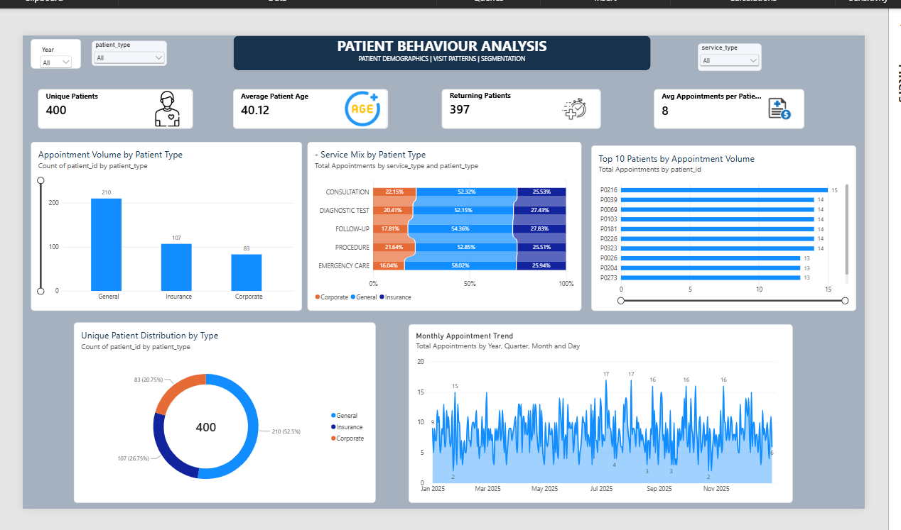
Figure: Current report page — Patient Behaviour Analysis

8.3 Treatment Performance Analysis Dashboard
This page includes treatment volume, treatment cost, average cost, patients, monthly trend, doctor workload, treatment status, waiting time by doctor, average duration by doctor and cost by service type.
Key observation from current dashboard: The dashboard currently shows 50 treatments and 37 completed. These results imply a 50-record cohort in the shown view, but the source description lists 3,505 raw treatment rows.
Analysis / improvement: Resolve data loading, filters, relationships, identifier duplication and count measures before drawing operational conclusions. Ensure cost and duration labels accurately describe sum versus average.
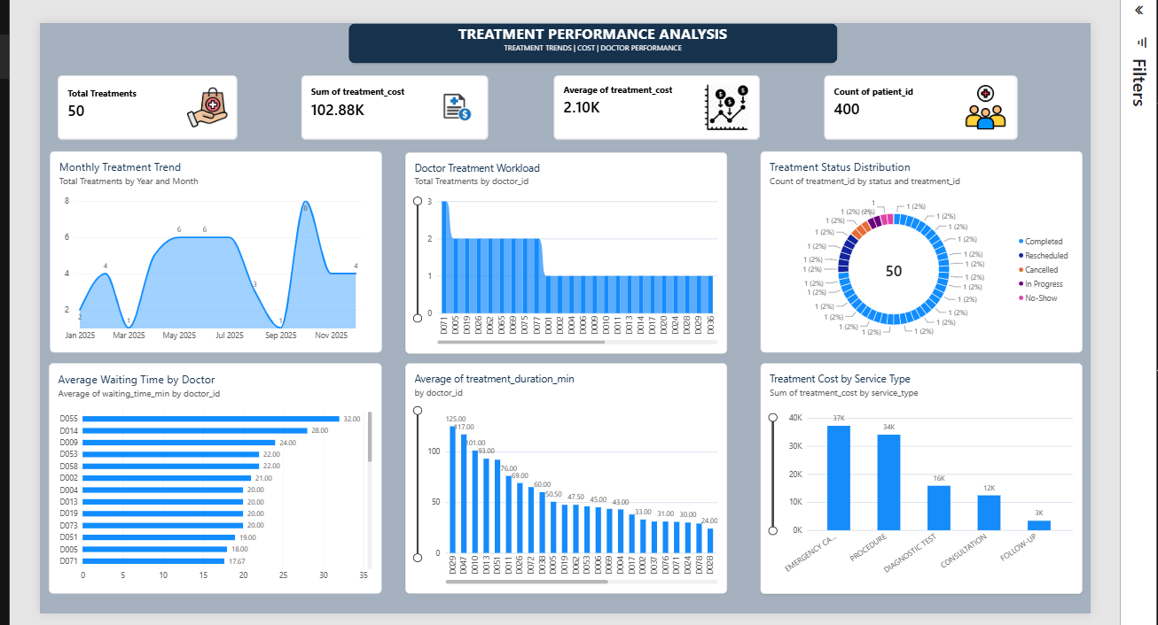
Figure: Current report page — Treatment Performance Analysis

8.4 Doctor & Room Performance Dashboard
This page compares doctor workload, completed treatments by specialty, room-associated treatment counts, completed activity by room type, waiting-time rankings and doctor-level detail.
Key observation from current dashboard: The room count visual appears to show one treatment per room, and completed treatments by room type repeats 37 across categories. These patterns may reflect relationship or measure issues rather than actual performance.
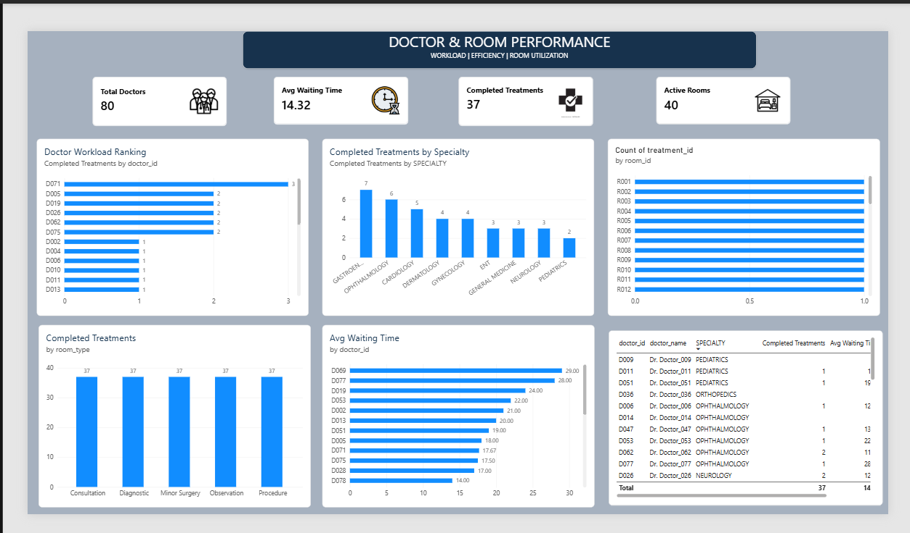
Figure: Current report page — Doctor & Room Performance
Analysis / improvement: Validate room and doctor relationships, then replace any visual that continues to show repeated or misleading totals. Do not use rankings until the treatment scope is certified.

8.5 Appointment & Treatment Problems Analysis Dashboard
This page highlights urgent appointments, non-completed treatments and missing estimated cost, supported by priority volume, treatment status, average cost by status and an appointment exception table.
Key observation from current dashboard: The current display shows 244 urgent appointments and 13 non-completed treatments. Missing estimated cost displays eight, which differs from earlier profiling.
Analysis / improvement: Normalize priority labels; reconcile missing-cost count; distinguish true zero cost from blank/no-record categories; document non-completed status logic.
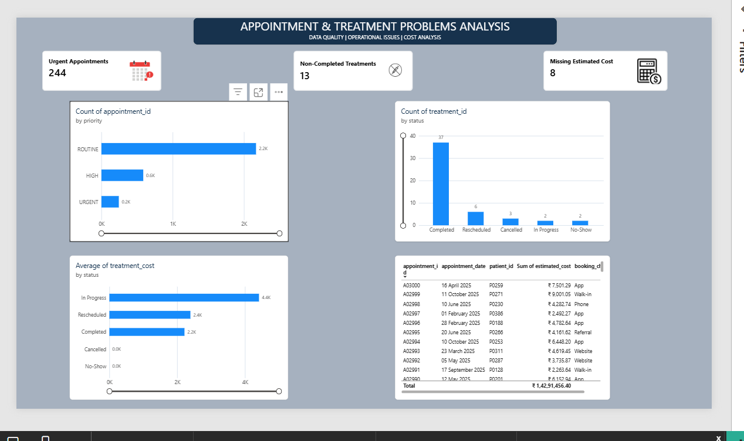
Figure: Current report page — Appointment & Treatment Problems Analysis

8.6 Room Utilization & Resource Insights Dashboard
This page shows total rooms, active rooms, rooms with treatments and average treatments per used room, with room status, treatment status by room and room-level duration visuals.
Key observation from current dashboard: The dashboard displays 50 rooms with treatments and average treatments per room of 1.00. These figures need validation alongside the 50-treatment count and room-key uniqueness.
Analysis / improvement: Until occupied duration and available room capacity are available, rename this page Room Activity & Resource Insights. Match duration aggregation to its title and validate the active/available flags.
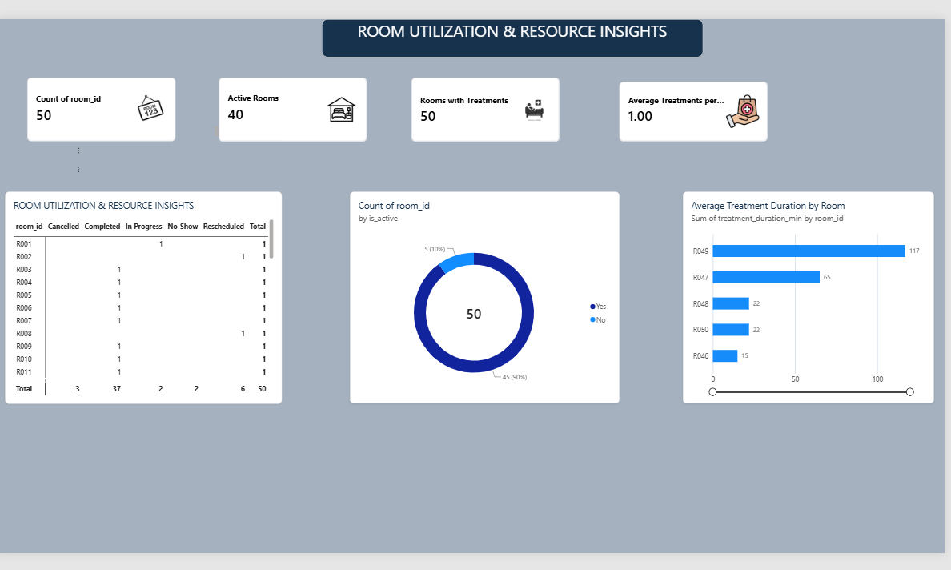
Figure: Current report page — Room Utilization & Resource Insights

9. Business Recommendations
Recommendations below are preliminary and should be finalized after reconciliation of the treatment and room metrics.
- Review month-level appointment demand alongside staffing and clinic schedules before planning capacity.
- Use validated service-type and priority mix to align front-desk and clinical workflows; monitor urgent demand separately.
- Establish a repeat-patient definition and track follow-up behaviour over consistent reporting periods.
- Separate rescheduled, cancelled, in-progress and no-show treatment records; assign owners and review reasons rather than combining them into one operational issue.
- Improve completeness of booking channel and estimated cost fields, and establish routine data-quality checks.
- Review doctor waiting-time variation only after validating encounter counts, outliers and cohort comparability.
- Use room activity counts as volume indicators. Obtain room occupied time and scheduled/available capacity-hours before measuring utilization.
Avoid causal claims about clinical quality, patient satisfaction, efficiency or under-utilization from the current visuals alone.

10. Conclusion
The project establishes a six-page Power BI framework for hospital operations analytics, covering appointment demand, patient behaviour, treatment performance, doctor and room activity, and operational exceptions. Its consistent visual design provides a strong presentation foundation. The key remaining task is analytical validation: reconcile treatment counts, validate dimension keys and relationship behavior, resolve exception-count differences, and refresh the final measures and recommendations.

Submission Checklist
- Final PBIX includes cleaned queries, documented relationships and validated DAX measures.
- Power Query Applied Steps screenshot is included.
- Model view screenshot documents relationship design.
- All six dashboard pages are refreshed and navigation buttons are tested.
- PDF export is checked for clipped visuals, small text and page layout.
- KPI definitions, cleaning decisions and limitations are documented.
- Findings are updated after treatment-count reconciliation.

