Cloud computing
Lab 14

Submitted by :
Areej Fatima
2023-BSE-010

Semester:
V-A

Submitted To:
Sir Shoaib

Task 0 – Lab Setup (Codespace & GH CLI)
task0_codespace_open.png
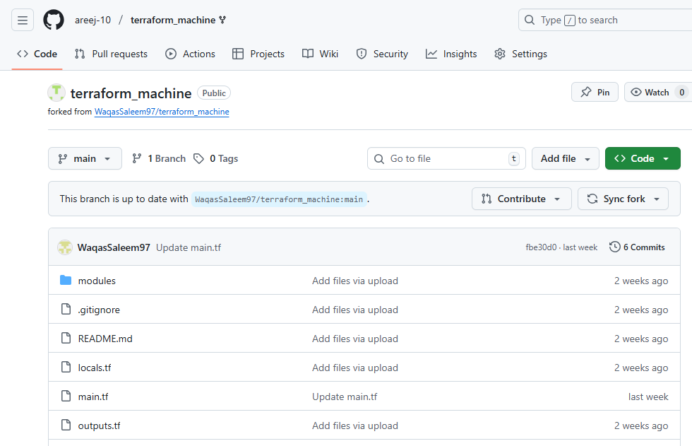
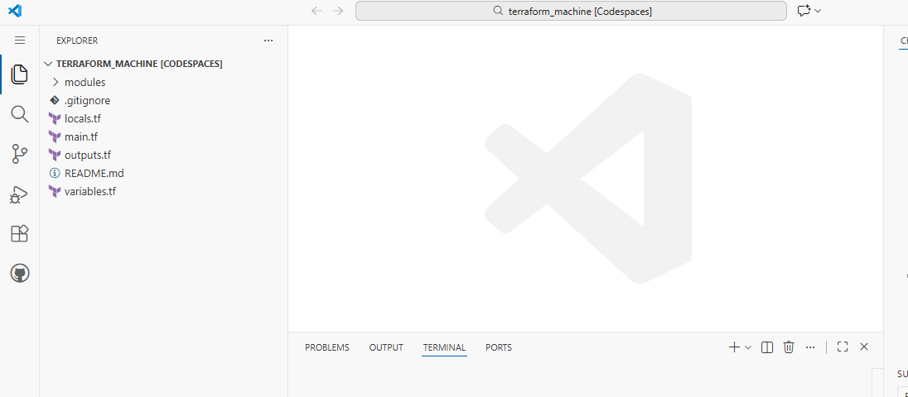

task0_env_check.png 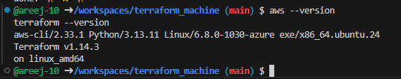

task0_aws_config.png
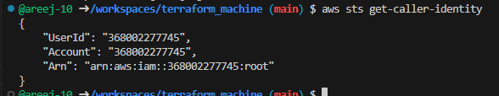

Task 1 – Generate ssh key and Initial Terraform apply
task1_ssh_keygen_before.png
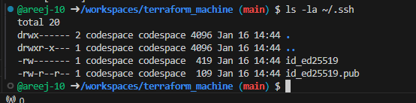
task1_ssh_keygen.png
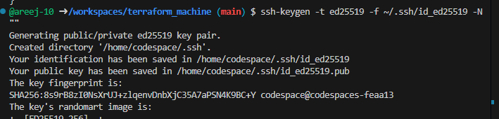
task1_ssh_keygen_after.png
task1_terraform_tfvars_created.png
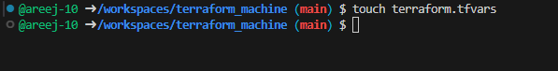
task1_terraform_tfvars.png
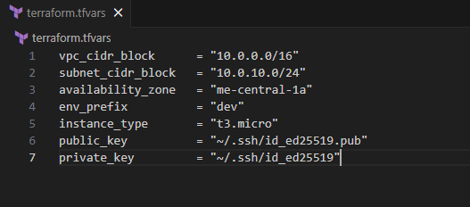
task1_terraform_init.png
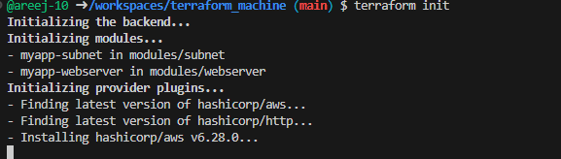
task1_terraform_apply_2_instances.png
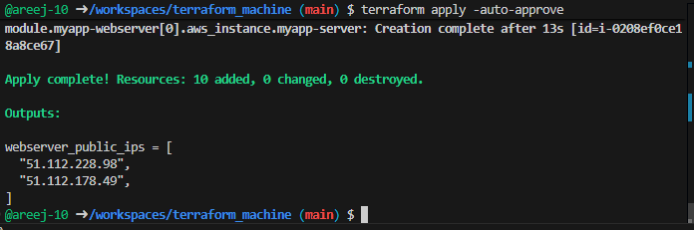
task1_terraform_output_ips.png
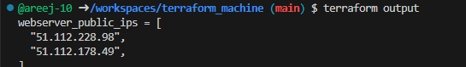

Task 2 – Static Ansible inventory with two EC2 instances
task2_ansible_install.png
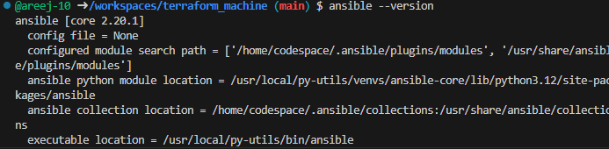
task2_terraform_output_ips.png

task2_hosts_created.png
task2_hosts_initial.png
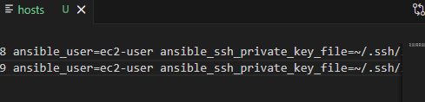

task2_ansible_ping_success.png
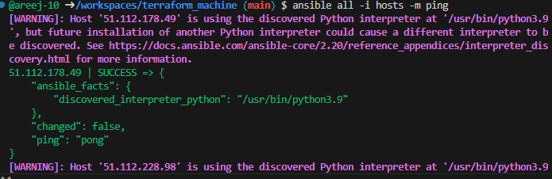

Task 3 – Scale to three instances & group-based inventory
task3_main_tf_count_3.png
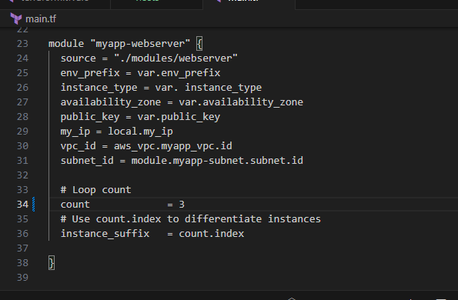
task3_terraform_apply_3_instances.png
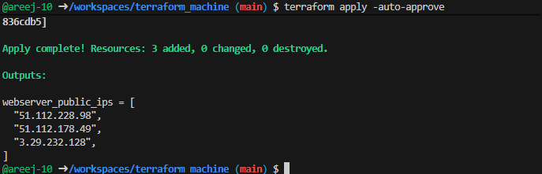
task3_terraform_output_3_ips.png
task3_hosts_grouped.png

task3_ansible_ec2_ping.png
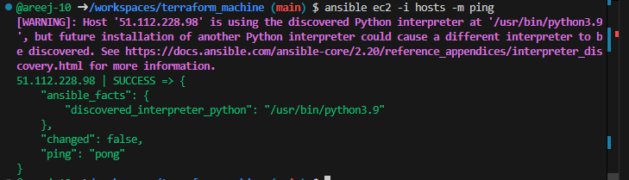
task3_ansible_single_ip_ping.png
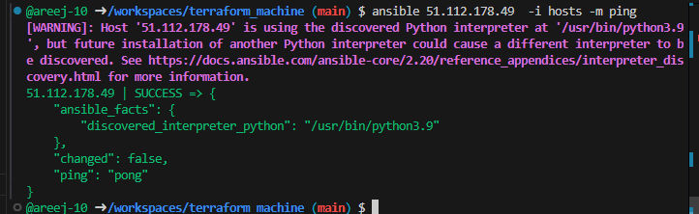
task3_ansible_droplet_ping.png
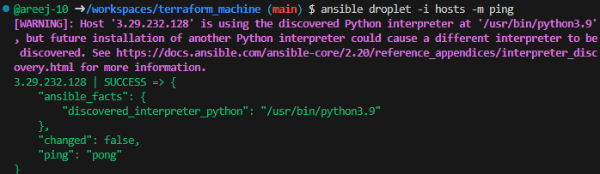
task3_ansible_all_ping.png
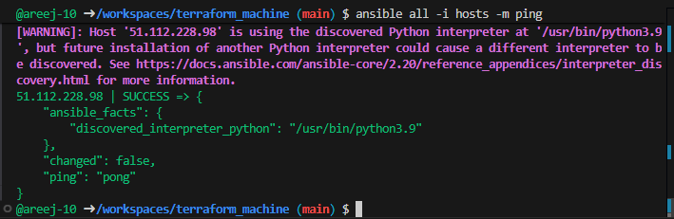

Task 4 – Global ansible.cfg & first nginx playbook
task4_global_ansible_cfg.png
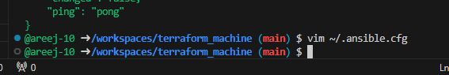
task4_hosts_without_common_args.png
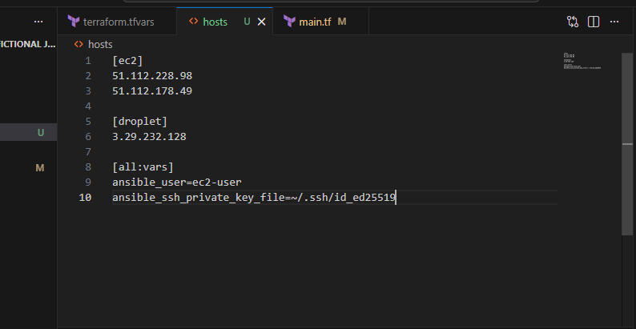
task4_ansible_ping_after_cfg.png
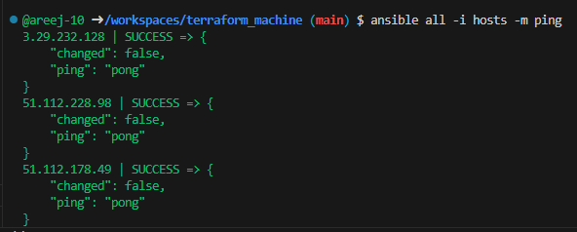
task4_my_playbook_created.png
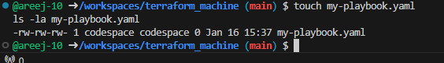
task4_my_playbook_ec2.png
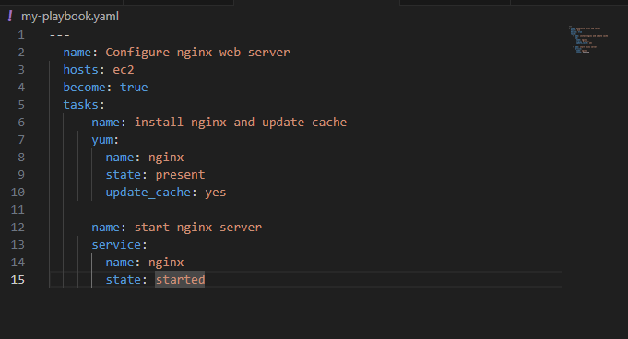
task4_ansible_play_ec2.png
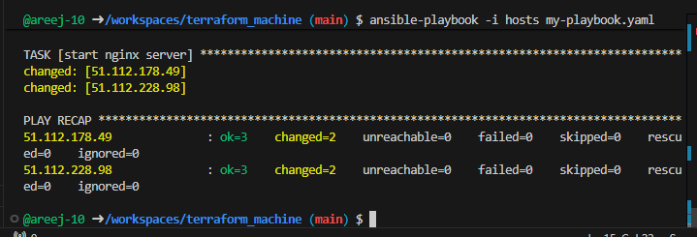
task4_nginx_browser_ec2.png
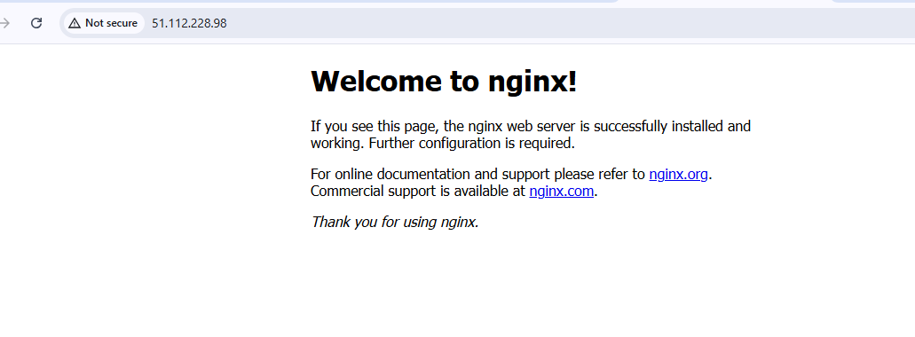
task4_my_playbook_droplet.png
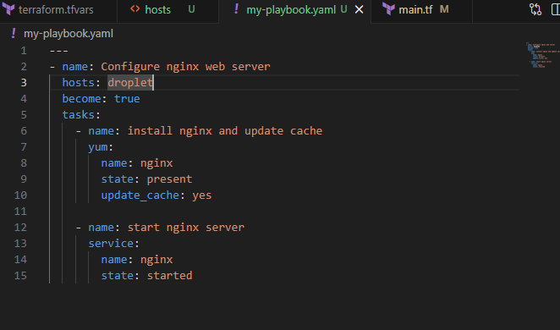
task4_ansible_play_droplet.png
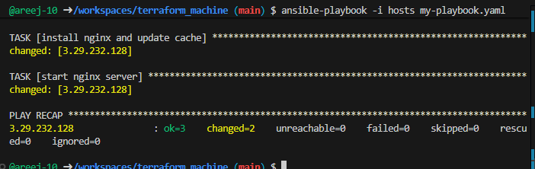
task4_nginx_browser_droplet.png
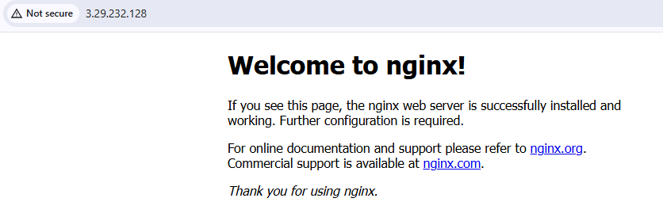

Task 5 – Single nginx target group & HTTPS prerequisites
task5_project_ansible_cfg_created.png
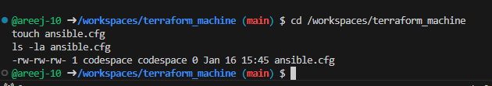
task5_project_ansible_cfg.png
task5_main_tf_count_1.png
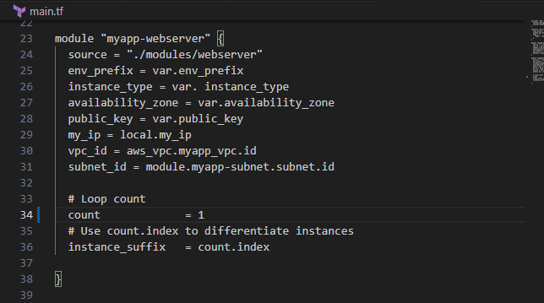
task5_terraform_apply_one_instance.png
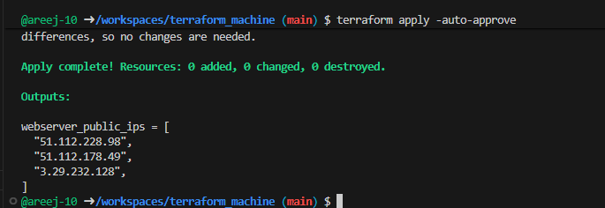
task5_terraform_output_single_ip.png
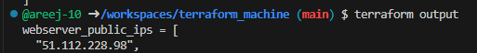
task5_hosts_nginx_group.png
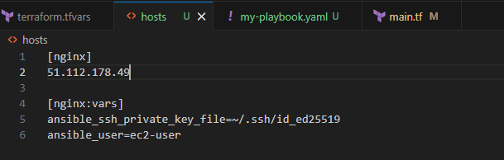
task5_my_playbook_nginx_group.png
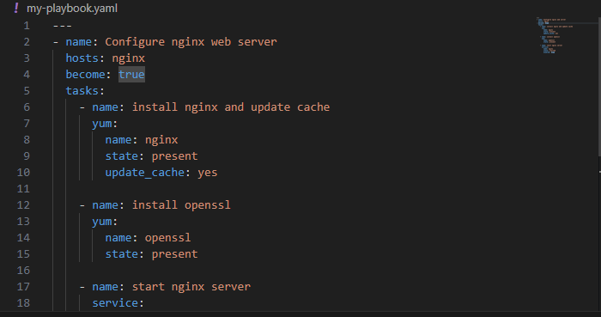
task5_ansible_play_nginx_group.png
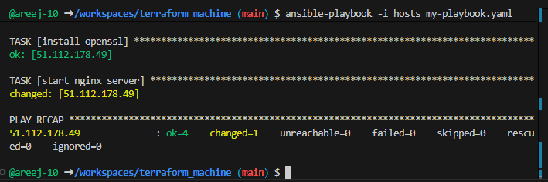
task5_nginx_browser_single.png
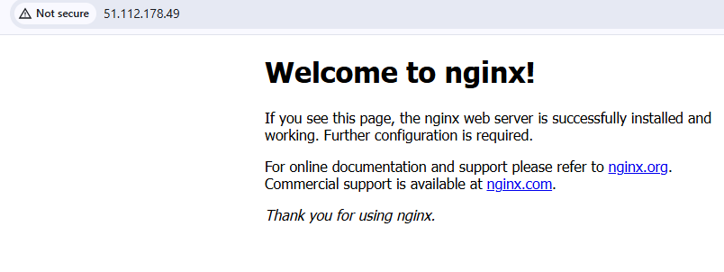

Task 6 – Ansible-managed SSL certificates
task6_my_playbook_ssl_section.png
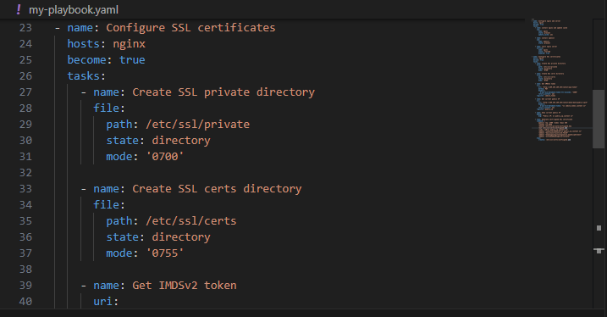
task6_ansible_play_ssl.png
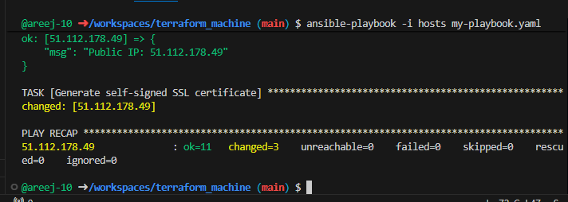
task6_ssl_cert_file.png
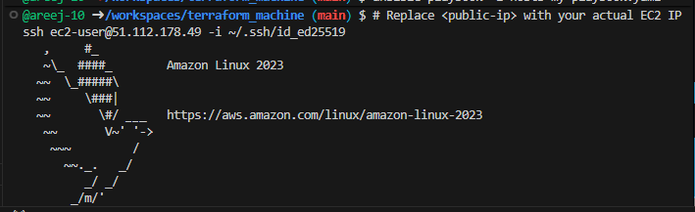
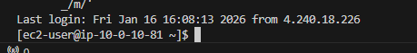
task6_ssl_key_file.png

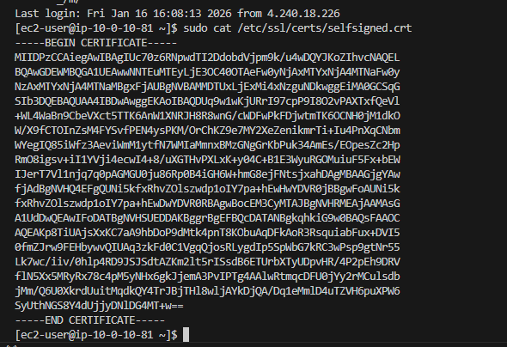
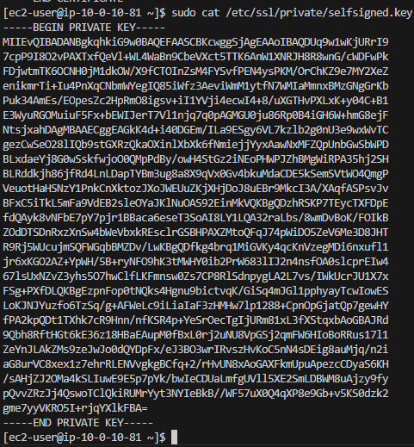
Task 7 – PHP front-end deployment with templates
task7_files_templates_created.png
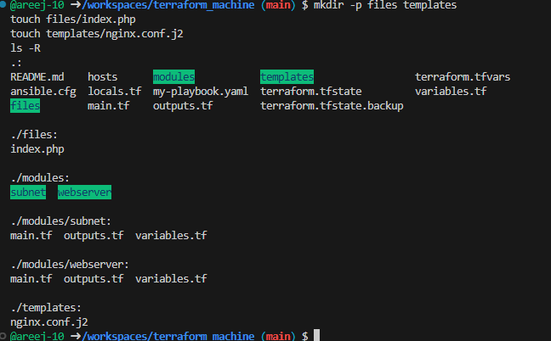
task7_index_php_content.png
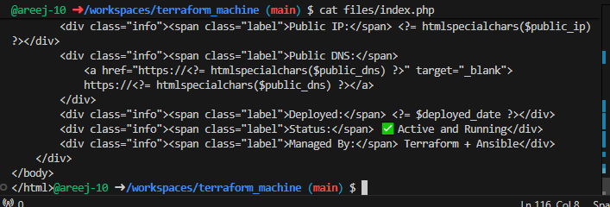
task7_nginx_conf_template.png
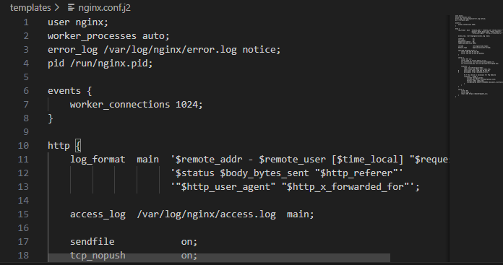
task7_my_playbook_web_deploy.png
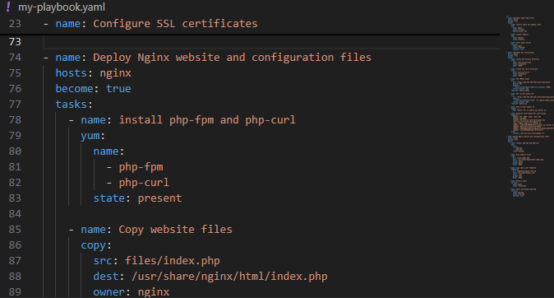
task7_ansible_play_web_deploy.png
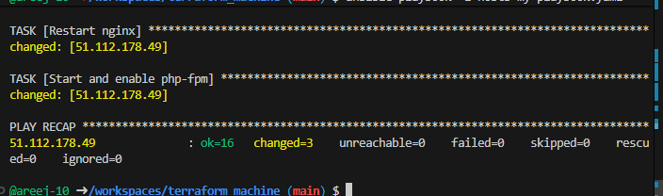
task7_php_https_browser.png

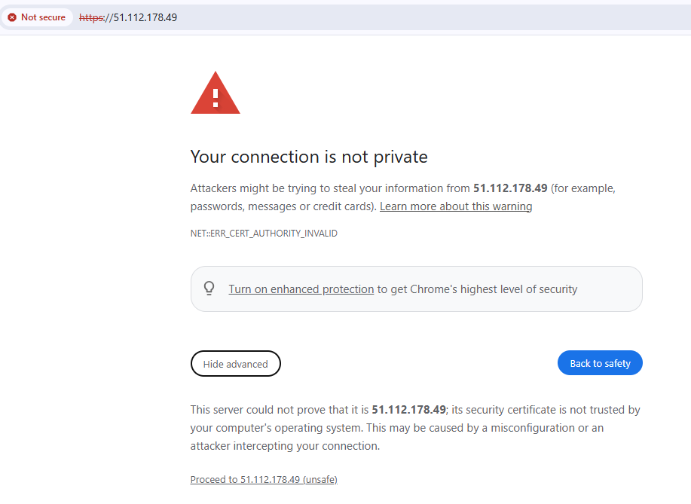

Task 8 – Docker & Docker Compose provisioning via Ansible
task8_terraform_destroy_old.png
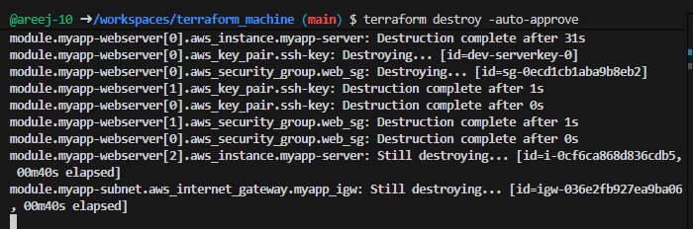
task8_terraform_apply_docker_instance.png
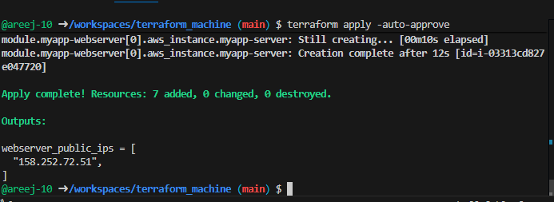
task8_terraform_output_new_ip.png
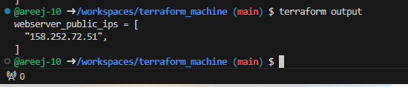
task8_hosts_docker_servers.png
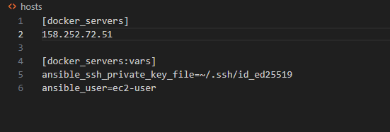

task8_my_playbook_docker.png
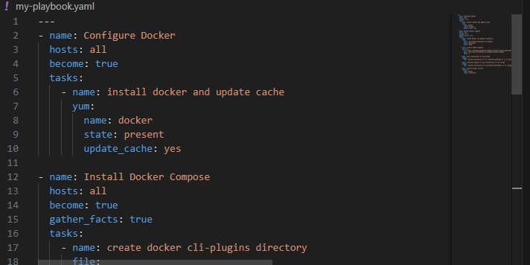
task8_ansible_play_docker.png
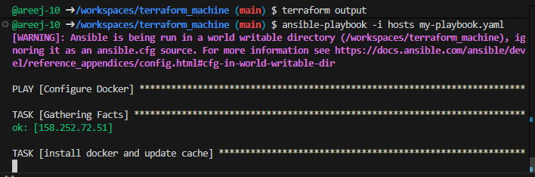
task8_docker_ps_remote.png
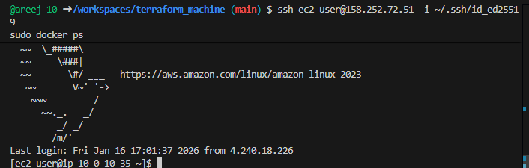

Task 9 – Gitea Docker stack via Ansible + Terraform security group update
task9_my_playbook_add_user_to_docker.png
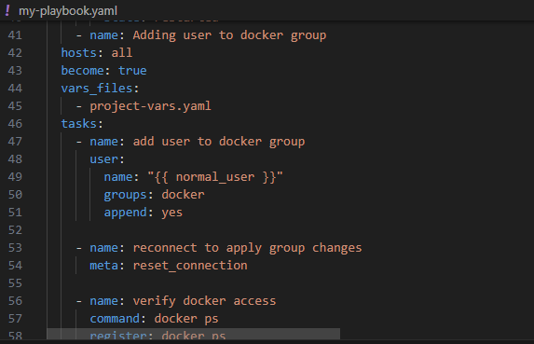
task9_project_vars.png
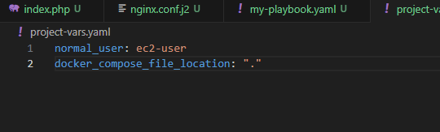
task9_my_playbook_deploy_containers.png
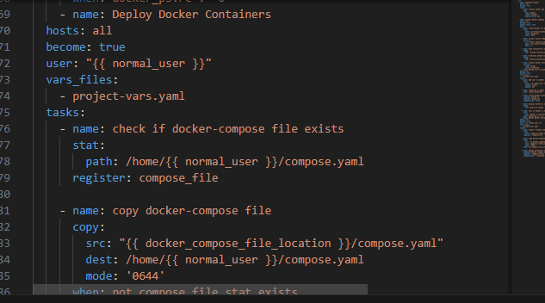
task9_compose_yaml.png
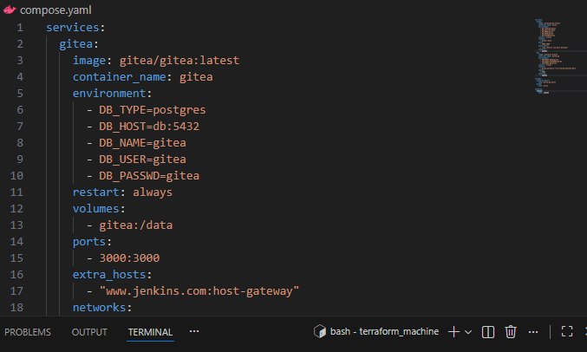
task9_ansible_play_gitea.png
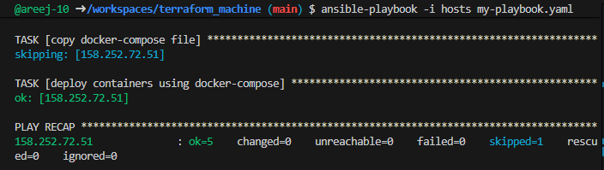
task9_sg_ingress_3000.png
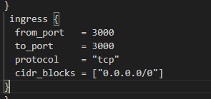
task9_terraform_apply_sg_3000.png
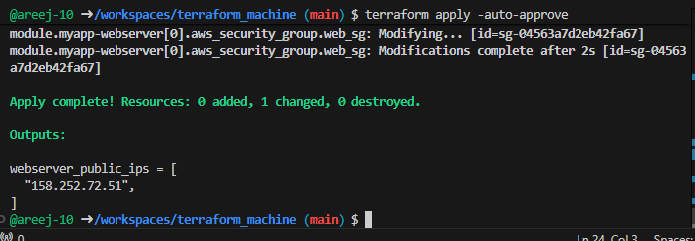
task9_gitea_browser.png

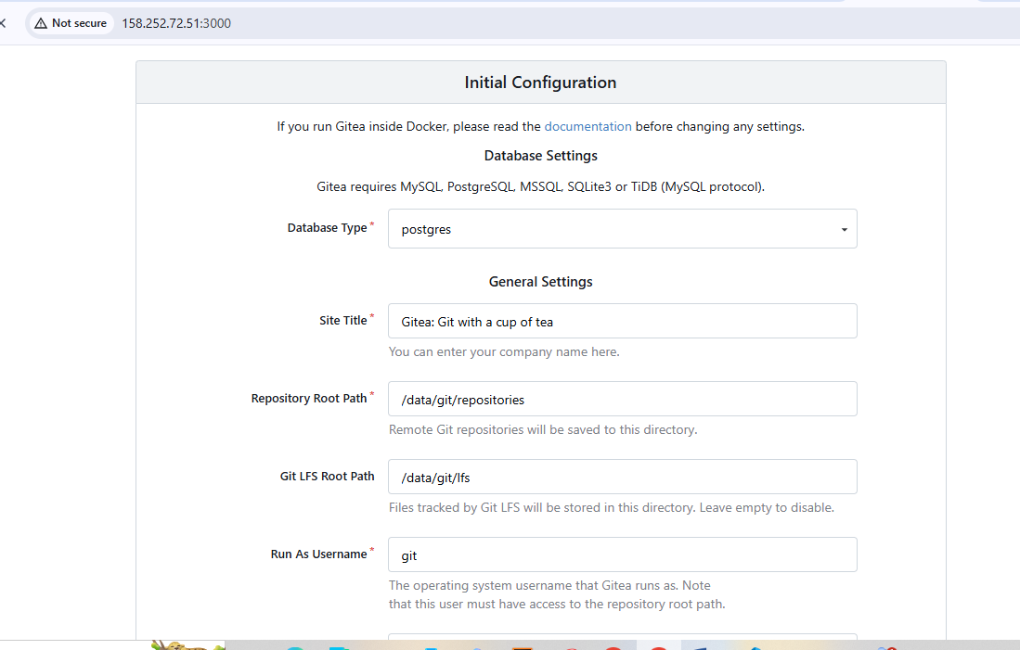

Task 10 – Automating Ansible with Terraform (null_resource)
task10_null_resource_main_tf.png
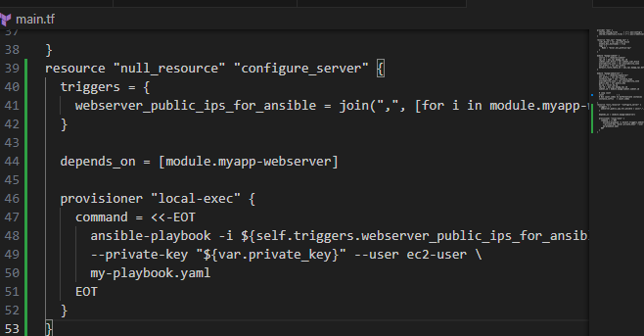

task10_terraform_destroy_before_null.png
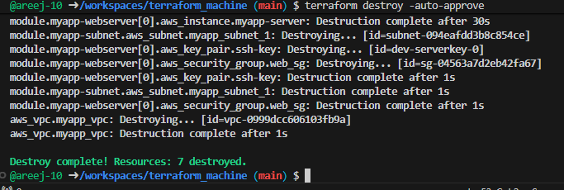
task10_terraform_apply_with_local_exec.png
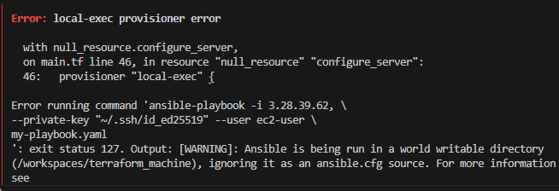
task10_my_playbook_wait_for_ssh.png
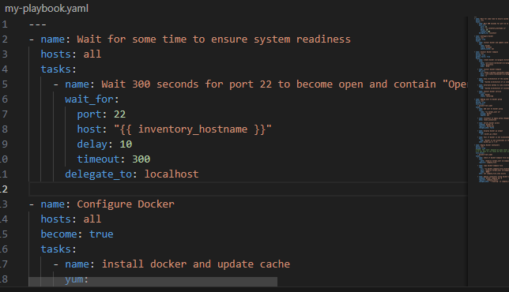
task10_terraform_apply_after_wait.png
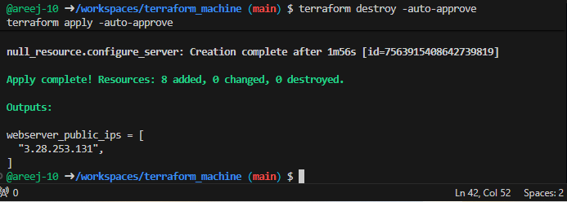
task10_app_browser_post_null_resource.png
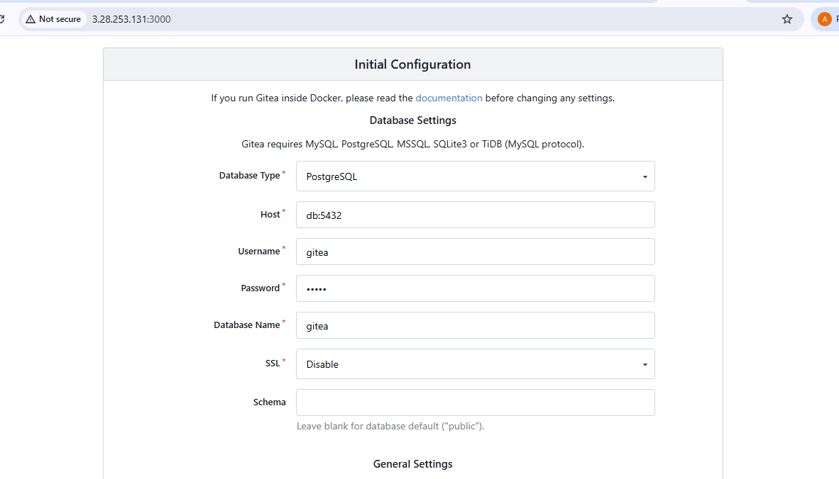

Task 11 – Dynamic inventory with aws_ec2 plugin
task11_ansible_cfg_aws_ec2.png
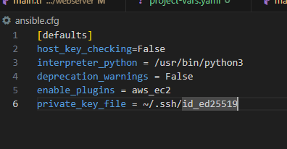
task11_inventory_aws_ec2_created.png
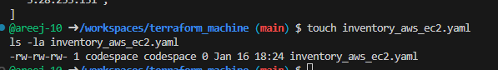
task11_inventory_aws_ec2_initial.png
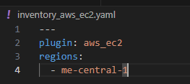
task11_main_tf_dev_prod_modules.png
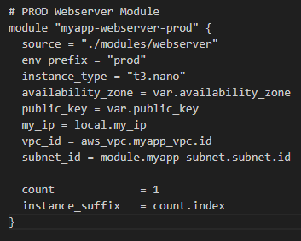
task11_outputs_tf_dev_prod_ips.png
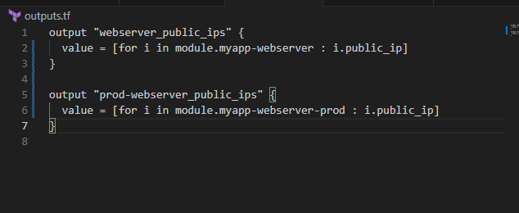
task11_terraform_apply_dynamic_setup.png
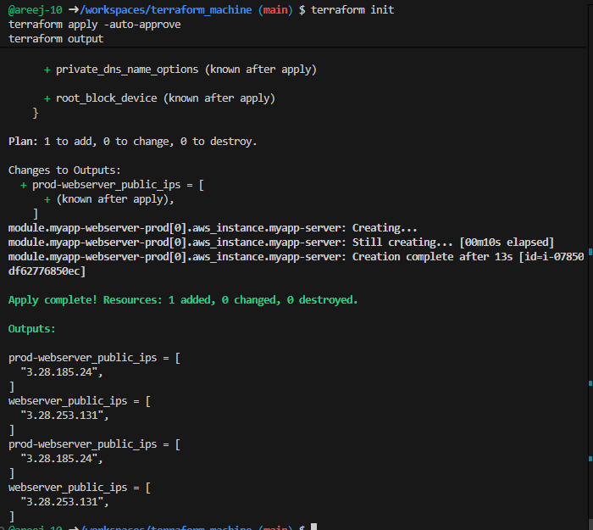
task11_terraform_output_dynamic_ips.png
task11_boto_install.png
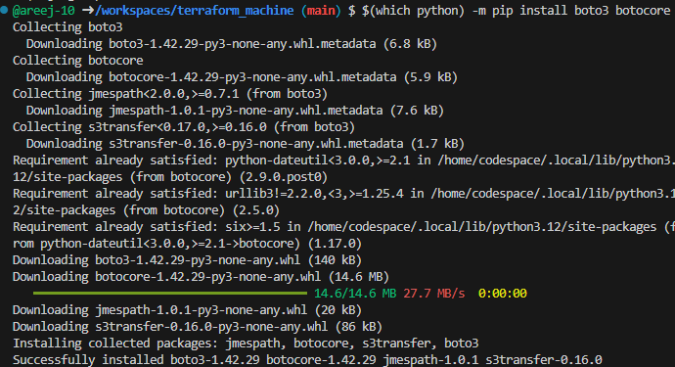
task11_boto_version.png
task11_ansible_inventory_graph_initial.png

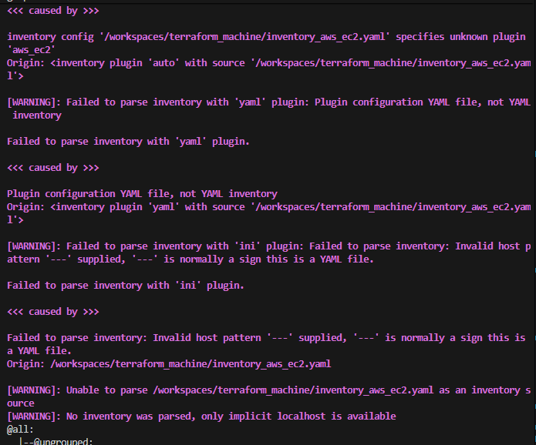

Task 12 – Filtering EC2 instances by tags & instance type
task12_inventory_aws_ec2_tag_groups.png
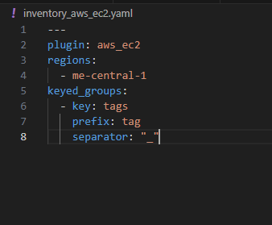
task12_inventory_graph_tag_groups.png
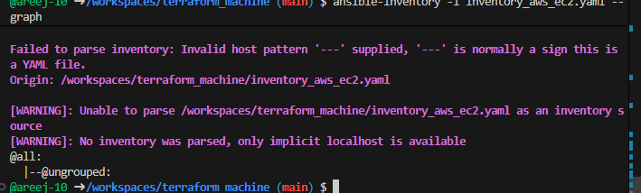
task12_inventory_aws_ec2_instance_type_groups.png
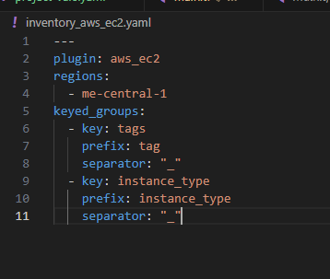
task12_inventory_graph_full.png
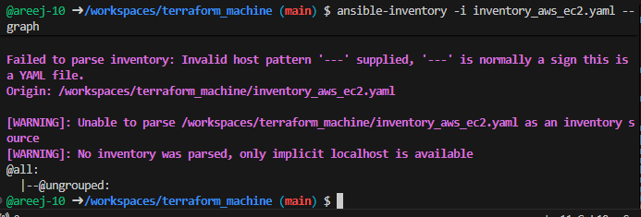
task12_my_playbook_all_hosts.png
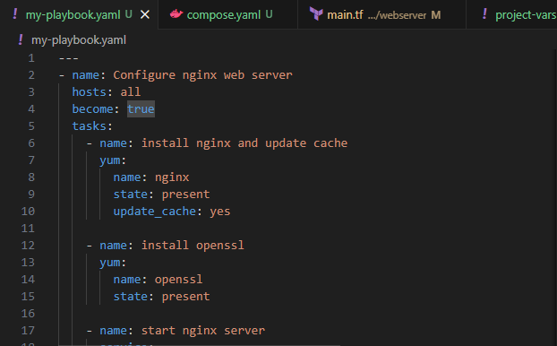
task12_ansible_play_all.png
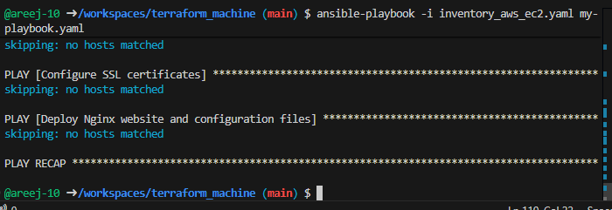

task12_ansible_play_dev_only.png
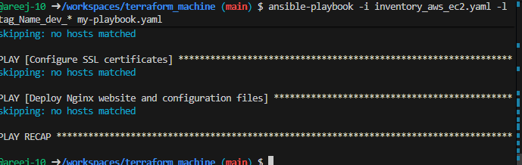
task12_ansible_play_prod_only.png
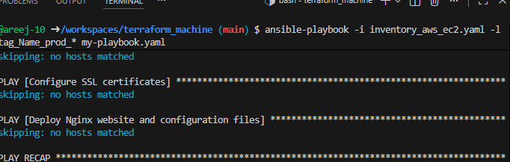
task12_ansible_play_t3_micro.png
task12_ansible_play_t3_nano.png
task12_ansible_cfg_inventory_default.png
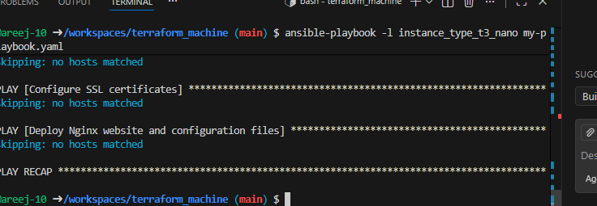

Task 13 – Ansible roles: nginx, ssl, webapp
task13_main_tf_single_dev.png
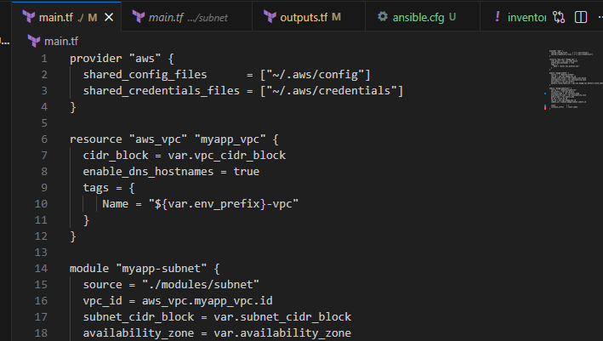
task13_ansible_structure_created.png
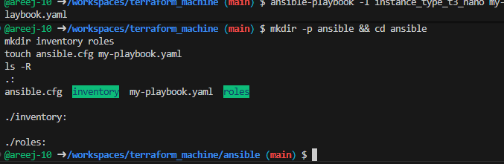
task13_ansible_cfg_project.png
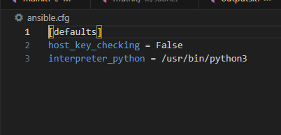
task13_webapp_tasks_main.png
task13_php_https_browser_roles.png

Cleanup
cleanup_terraform_destroy.png
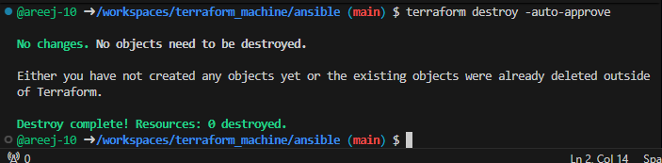
cleanup_tfstate.png

cleanup_aws_console.png

