Lab7

task1_printenv_all.png
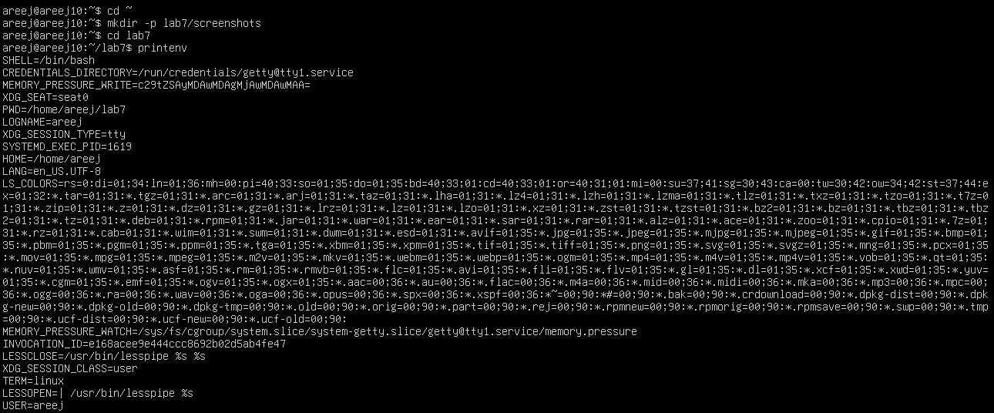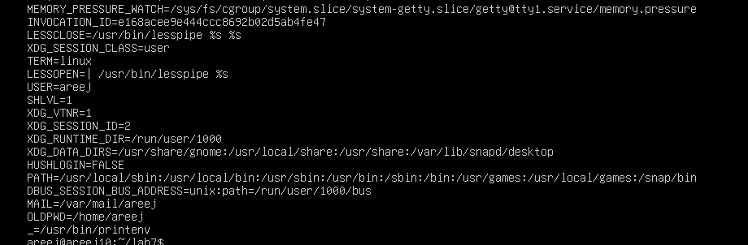
task1_grep_shell_home_user.png
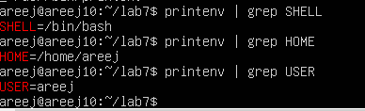

Task 2 — Export DB_* variables temporarily and observe scope
task2_exports_all.png
task2_echoes_all.png
task2_printenv_grep_db.png
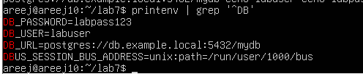
task2_after_restart_checks.png
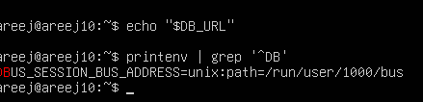

Task 3 — Make DB_* variables persistent in ~/.bashrc
task3_bashrc_added.png
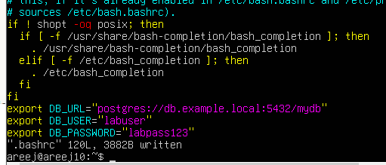
task3_source_and_verification.png
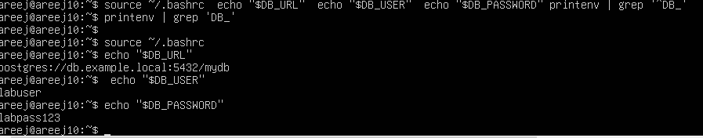
task3_after_restart_persistent.png

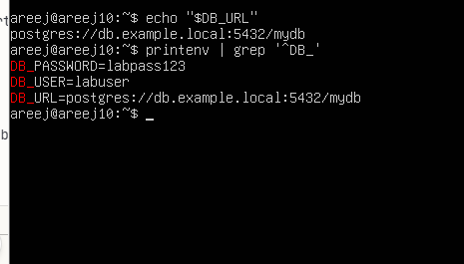

Task 4 — System-wide environment variable, welcome script, and PATH
task4_etc_environment_before.png
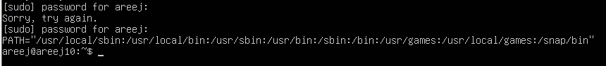
task4_echo_path_before.png
task4_etc_environment_edit_vim.png
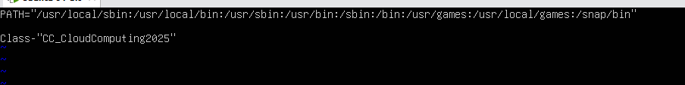
task4_etc_environment_after.png
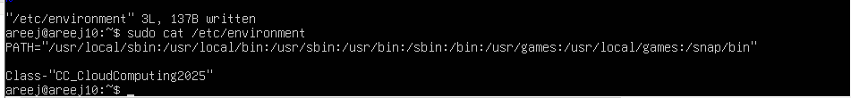
task4_echo_class_and_path.png
task4_welcome_create_and_chmod.png
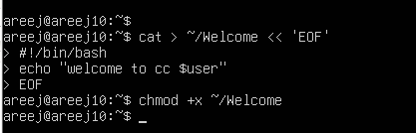
task4_welcome_run_dot.png
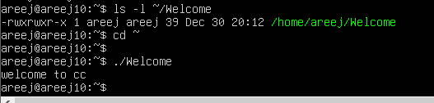
task4_bashrc_path_line.png
task4_bashrc_source_and_welcome.png
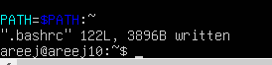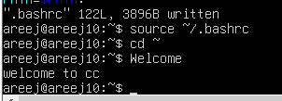

Task 5 — Block and allow SSH using ufw (firewall)
task5_ufw_enable_and_status.png
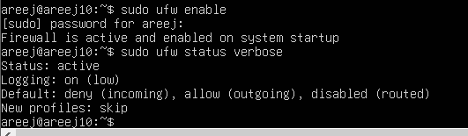
task5_ufw_deny_22_and_status.png
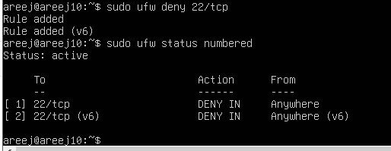
task5_ssh_attempt_blocked.png
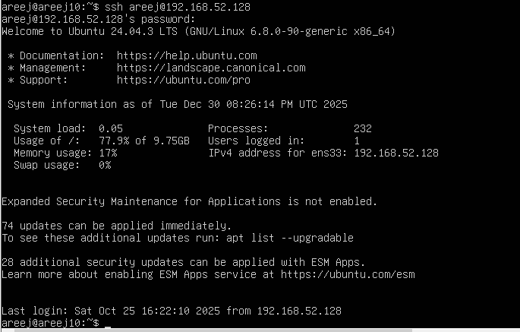
task5_ufw_allow_reload_status.png
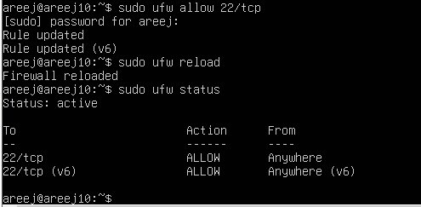
task5_ssh_success_after_allow.png
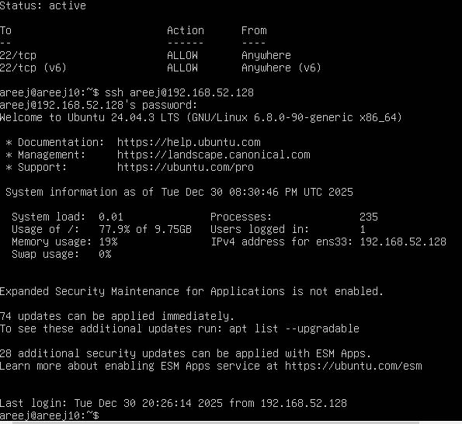
TASK 6: Configure SSH Key-Based Login
task6_windows_sshkey_and_list.png
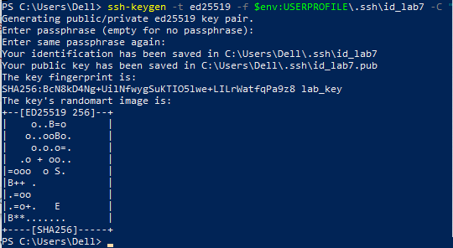
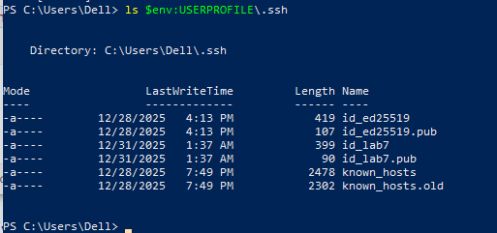
task6_windows_public_key.png

task6_windows_known_hosts_cleared_and_empty.png
task6_windows_ssh_accept_hostkey_and_login.png
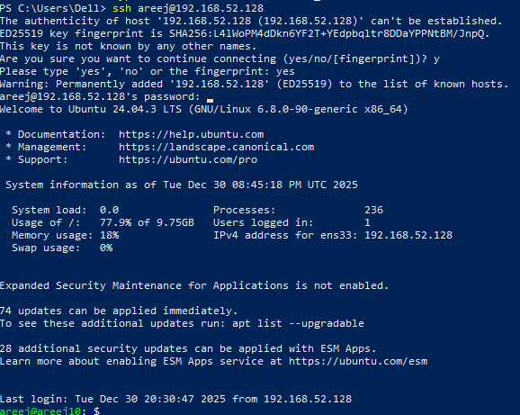
task6_windows_known_hosts_after_connect.png
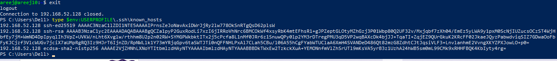
task6_server_clear_authorized_keys.png
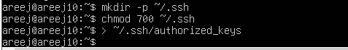
task6_server_add_key_and_show.png
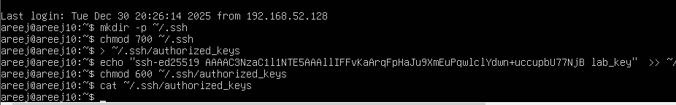
task6_ssh_passwordless_login.png
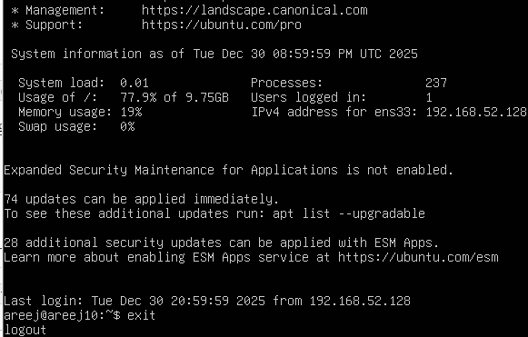
task6_ssh_with_identity_file.png
