Missing Values Report
Objective
The purpose of this task is to identify missing values in the Customer Personality Analysis dataset and determine the percentage of missing data in each variable. Missing value analysis is important because incomplete data can affect the accuracy of data analysis and machine learning models.

Missing Value Analysis
The dataset was inspected using the Pandas library to identify missing values in every column.
A summary table was generated showing the number of missing values and the percentage of missing data for each variable.
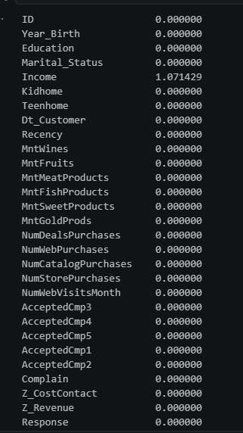
Observations
- Most variables in the dataset contain no missing values.
- The Income column contains missing values.
- The percentage of missing values in the dataset is relatively low.
- All remaining variables have complete records.

Conclusion
The missing value analysis indicates that the dataset has very few missing values. These missing values will be handled during the data preprocessing stage before performing machine learning analysis.

