Activity 9 – Outlier Detection Report
Objective
The objective of this activity was to identify outliers in the numerical variables of the Customer Personality Analysis dataset. Outliers were detected using the Interquartile Range (IQR) method and visualized with boxplots.

Variables Reviewed
The following numerical variables were analyzed:
- Income
- MntWines
- MntFruits
- MntMeatProducts
- MntFishProducts
- MntSweetProducts
- MntGoldProds

Method Used
The Interquartile Range (IQR) method was applied using the following formula:
- Q1 = 25th percentile
- Q3 = 75th percentile
- IQR = Q3 − Q1
- Lower Bound = Q1 − (1.5 × IQR)
- Upper Bound = Q3 + (1.5 × IQR)
Values outside these limits were considered outliers.

Outlier Summary
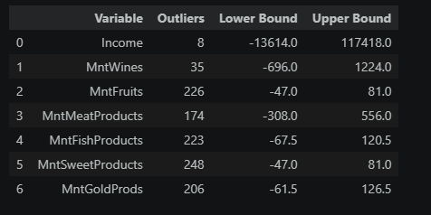
Observations
The analysis revealed that several numerical variables contain outliers, particularly Income and some product spending variables. These extreme values may represent either genuine high-value customers or unusual observations. Their impact will be evaluated before deciding whether to remove, cap, transform, or retain them.

Conclusion
Outliers were successfully identified using the IQR method and visualized through boxplots. The results provide a basis for selecting appropriate outlier treatment methods in the next activity.

