Activity 11 – Validation Report
Objective
The objective of this activity was to validate the cleaned dataset after completing all preprocessing tasks. The validation process ensured that the dataset met quality standards required for exploratory data analysis and machine learning.
Validation Performed
The following checks were conducted:
- Verified that missing values were handled.
- Confirmed that duplicate rows and duplicate customer IDs were absent.
- Verified that the Dt_Customer column was correctly converted to the DateTime format.
- Confirmed that categorical variables were standardized.
- Verified that unrealistic customer ages had been removed.
- Confirmed that outliers were handled using the IQR-based Winsorization technique.
Validation Checklist
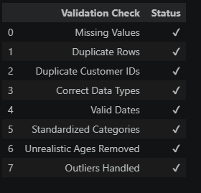
Summary
The validation process confirmed that the Customer Personality Analysis dataset has been successfully cleaned and preprocessed. All identified data quality issues have been addressed, and the dataset is now reliable for exploratory data analysis, visualization, and machine learning model development.
Conclusion
The cleaned dataset satisfies the required data quality standards. It contains consistent data types, standardized categorical variables, valid dates, no duplicate records, no unresolved missing values, and appropriately treated outliers. The dataset is now ready for the next phase of the project.

